**ASCII** (American Standard Code for Information Interchange) is the most common format for text files in computers and on the Internet. In an **ASCII** file, each alphabetic, numeric, or special character is represented with a 7-bit binary number (a string of seven 0s or 1s). 128 possible characters are defined.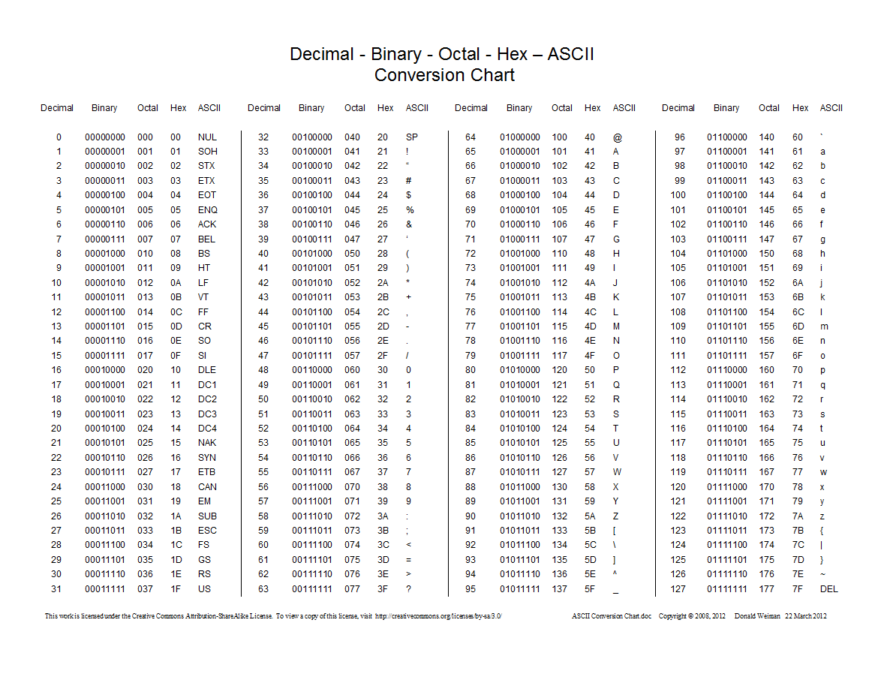

Courtesy of: <http://web.alfredstate.edu/weimandn/miscellaneous/ascii/ascii_index.html>

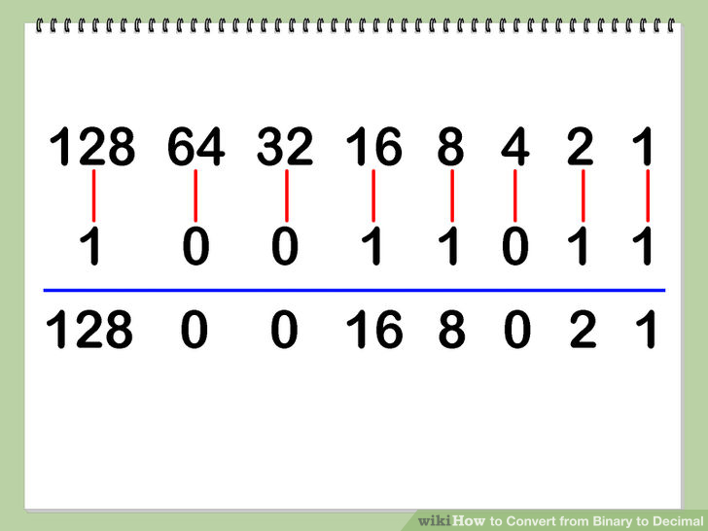

In the above we have: 128 + 16 + 8 + 2 + 1 = Decimal 155.

67 104 101 101 114 115 (Decimal)

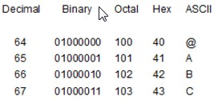

So 67 = 01000011 = C

Do you see how we get 67 from the Binary number above?