AIRLINE RESERVATION SYSTEM

Use case diagram.

Class diagram :

State Diagram :

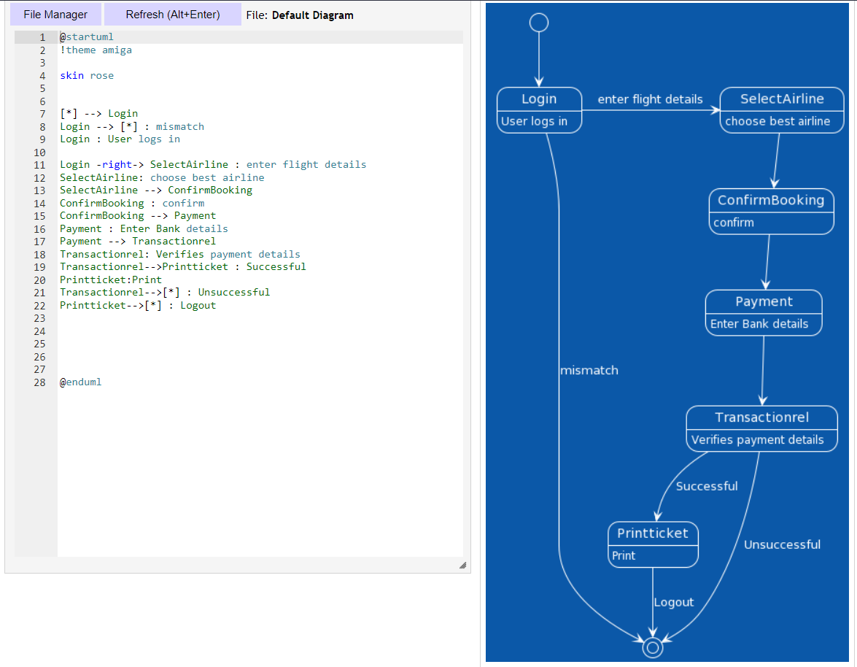

Sequence Diagram :

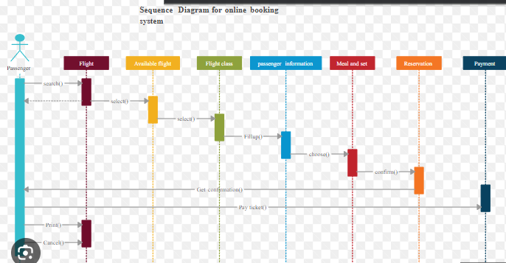

Activity Diagram :

DFD lvl 1

JSD

