National University of Computer and Emerging Sciences, Karachi
FAST School of Computing - Spring 202x6
CS3001 - Computer Networks
Documentation
Assignment III – Reliable Data Transfer
Huzaifa Zafar – 24K-2044

1. Objective
The objective of this assignment is to implement three reliable data transfer protocols over a simulated unreliable network channel. The protocols implemented are rdt 3.0 (Stop-and-Wait), Go-Back-N (GBN), and Selective Repeat (SR). Each protocol is modeled using Finite State Machines (FSMs) for both the sender and receiver sides.
The simulation demonstrates uni-directional data transfer where data flows from sender to receiver, and control information (acks) flows in the reverse direction. The underlying network channel is intentionally unreliable and randomly introduces three types of problems: packet loss, packet corruption, and transmission delays. Each protocol must detect and recover from these problems to guarantee reliable delivery of all data in the correct order.

2. Implementation Overview
packet.py — Core Infrastructure
Contains the Packet class with fields for sequence number, data, checksum, and ACK information. Checksum is calculated by summing ASCII values of all characters in the data — the receiver recomputes this on arrival to detect corruption. Also contains the UnreliableChannel class which randomly applies loss, corruption, or delay to any packet passing through it based on configurable probabilities. This file is imported and shared by all three protocol files.
rdt30.py — Stop-and-Wait Protocol
Implements rdt 3.0 where the sender transmits exactly one packet and waits for an ACK before sending the next. The sender FSM has two states: ready to send, and waiting for ACK. On timeout or a bad ACK it retransmits the same packet. Sequence numbers alternate between 0 and 1. The receiver detects corruption via checksum and sends a NAK (previous sequence ACK) to trigger retransmission.

gbn.py — Go-Back-N Protocol
Implements a sliding window of size N. The sender keeps all in-flight packets buffered and on any timeout resets back to the base and retransmits the entire window. ACKs are cumulative — ACK(n) confirms all packets up to n. The receiver has no buffer and discards any out-of-order packet immediately, re-sending the last valid ACK.
sr.py — Selective Repeat Protocol
Also uses a sliding window of size N but retransmits only the specific lost or corrupted packet on timeout. The sender tracks each packet's acknowledgment individually and the window slides only when the base packet is confirmed. The receiver buffers out-of-order packets within its receive window and delivers them in order once the missing gap is filled.
main.py — Menu and Test Runner
Entry point of the program. Provides an interactive menu to choose a protocol and scenario. All parameters are configurable including packet count, size, window size, and channel probabilities. Option 4 runs all three protocols across all four test scenarios automatically, which is the recommended option for the demo.

3. FSM Diagrams
Source Link: https://excalidraw.com/#json=6-a65NpNRoWeB_X4J1Jf2,jCcrx1C3z6myb0ysQDcY-Q

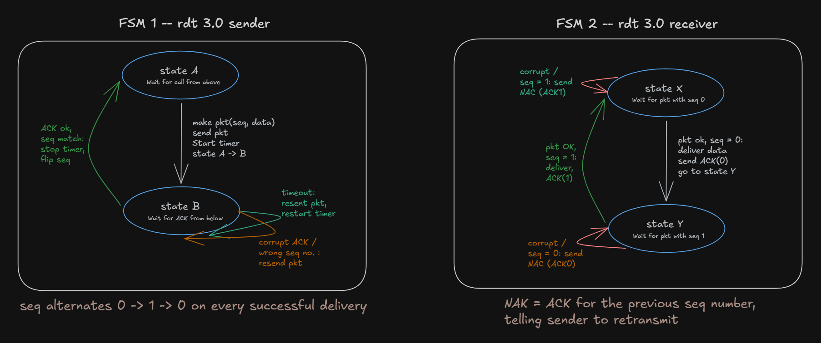
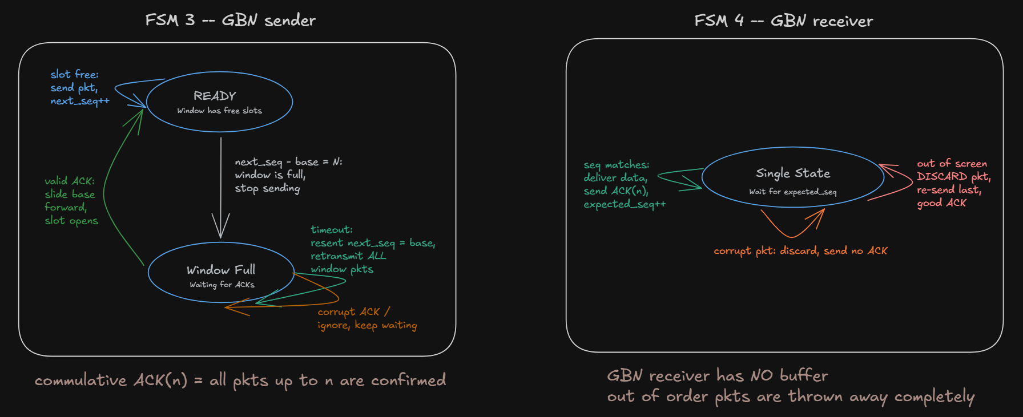
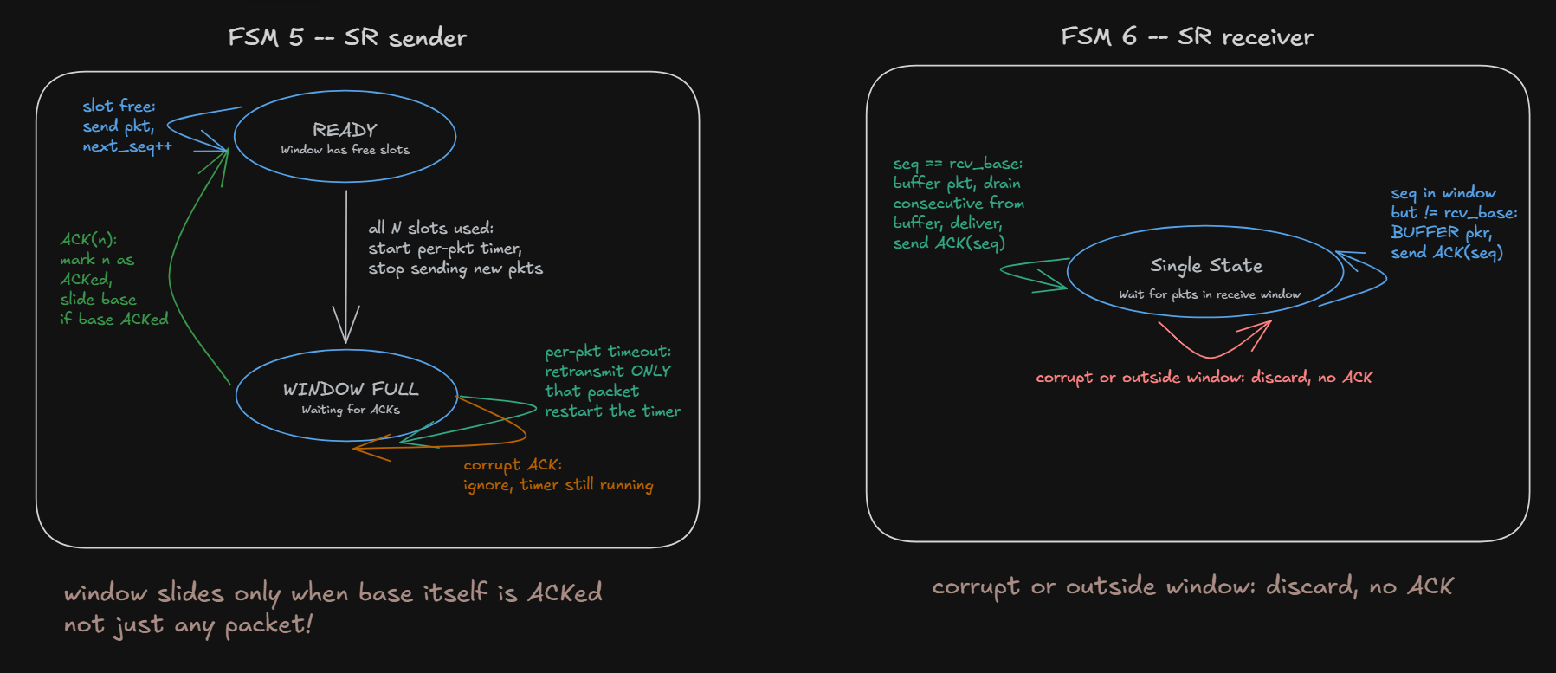

4. Testing Table
Scenario | Parameters | Expected behavior | Protocols Tested | Results
1 – Perfect conditions | loss = 0.0  corrupt = 0.0  delay = 0.0 | All pkts delivered on first attempt. Zero retransmissions. Sender ACKs every packet immediately. Data received in order matches data sent. | Rdt_3.0  GBN  SR | Success
2 – Loss only | loss = 0.4  corrupt = 0.0  delay = 0.0 | rdt 3.0: sender retransmits same packet on timeout. GBN: entire window retransmitted from base. SR: only the specific lost packet retransmitted. All data eventually delivered. | Rdt_3.0  GBN  SR | Success
3 – Corrupt only | loss = 0.0  corrupt = 0.4  delay = 0.0 | Receiver detects checksum mismatch and discards corrupted packet. Sends NAK (rdt 3.0) or no ACK (GBN/SR). Sender retransmits after timeout. Data integrity maintained. | Rdt_3.0  GBN  SR | Success
4 – all conditions | loss = 0.3  corrupt = 0.3  delay = 0.2 | Mix of lost, corrupted, and delayed packets. All three protocols recover through retransmission. Final delivered data matches sent data. Retransmission count is highest in this scenario. | Rdt_3.0  GBN  SR | Success

7. Sample Outputs

6. How to Run
Requirements: Python 3.6 or higher. No external libraries needed.
Setup: Place all five files in the same folder — packet.py, rdt30.py, gbn.py, sr.py, main.py.
Run: open terminal in that folder and run this command: `python main.py`
Choose option 1, 2, or 3 to test a specific protocol with a custom or preset scenario. Choose option 4 to automatically run all three protocols across all four test scenarios — this is the recommended option for the demo.

7. Conclusion
All three protocols were successfully implemented and tested against four scenarios: clean transmission, packet loss, corruption, and all conditions combined. In every case the data received matched the data sent, delivered in the correct order.
The three protocols represent a clear progression in efficiency. rdt 3.0 is the simplest but slowest — only one packet is ever in-flight. Go-Back-N improves throughput by pipelining N packets but wastes bandwidth retransmitting the entire window on any timeout. Selective Repeat is the most efficient, retransmitting only the lost packet, at the cost of more complex buffering logic on the receiver side.

