AHMADU BELLO UNIVESRSITY ZARIA

A TECHNICAL REPORT

ON

STUDENT INDUSTRIAL WORK EXPERIENCE SCHEME (SIWES)

HELD AT

DEPARTMENT OF COMPUTER ENGINEERING, AHMADU BELLO UNIVERSITY ZARIA

BY

ERASMUS E OBETH

U17CO1017

(cyber330d@gmaill.com)

SUPERVISED

BY

PROF E. ADEWALE ADEDOKUN

SUBMITTED TO THE DEPARTMENT OF COMPUTR ENGINEERING, FACULTY OF ENGINEERING, AHMADU BELLO UNIVERSITY, ZARIA IN PARTIAL FULFILMENT FOR THE REQUIRMENTS OF THE AWARD OF BACHELOR OF ENGINEERING (B.ENG) DEGREE IN COMPUTER ENGINEERING.

FEBRUARY, 2024

**DECLARATION**

I, ERASMUS E OBETH, hereby declare that this is a product and result of my own effort under the supervision of PROF E. ADEWALE ADEDOKUN and to the best of my knowledge, it has not been presented in any institution for the award of any certificate or degree of any kind. All the consulted materials have been dully referenced.

ERASMUS E OBETH Date

(U17CO1017)

**CERTIFICATION**

This is to certify that the technical report on student industrial work experience scheme, compiled by ERASMUS E OBETH (U17CO1017), was carried out in accordance with the requirements of the industrial training fund, and in partial fulfilment for the award Bachelor of Engineering (B.ENG) in Computer Engineering at Ahmadu Bello University Zaria.

PROF E. ADEWALE ADEDOKUN DATE

(SIWES SUPERVISOR)

__var_IT_coordinator DATE

(SIWES COORDINATOR)

__var_HOD DATE

(HEAD OF DEPARTMENT)

**DEDICATION**

This industrial work experience scheme (SIWES) technical report is dedicated to God Almighty for his mercy grace and the oppurtunity given to me to complete the this program. I also wish to dedicate this work to my family Rev(retired) Edward O Dangombe, Mrs Esther Edward and my siblings for their financial, moral , word of encouragement and prayer support throughout the period of my degree program.

**ACKNOWLEDGEMENT**

Firstly, my gratitude goes to God for giving me the privilege, directive, guidance and understanding so that I can have a focus and goal to achieve at the end of my training.

Thanks goes to __var_work_place_supervisor for being my guide throughout my training, and for taking his time to direct and advice me on what to do and how to go on doing it in spite of his tied schedules and constraints for an excellent completion of my training.

I would also like to thank my supervisor PROF E. ADEWALE ADEDOKUN and Mal A Kabiru and Mal. Aliyu Isa Elayo for providing provided me with the facilities being required and conductive conditions for my SIWES projects and training.

Special thank goes to my entire family for the prayer and endless support to me, you are all the pillars and the secret behind the successful completion of my training. Thanks you all and God bless you.

**ABSTRACT**

This report offers a detailed account of the sixmonth Student Industrial Work Experience Scheme (SIWES) conducted at the Department of Computer Engineering, Ahmadu Bello University Zaria. It encompasses a multiphase training program aimed at cultivating a comprehensive skill set.

The initial phase involves intensive training in various areas, including CompTIA A+, operating systems basics by Cisco NDG, Linux Unhatched by Cisco NDG, Linux Essentials, responsive web design, and server essentials. Additionally, participation as a web programming summer camp instructor provided practical experience. This phase laid the foundation for understanding computer systems, responsive web design, and the essentials of server management, including Linux proficiency.

Transitioning into the second phase, the acquired knowledge is applied to implement, configure, maintain, operate, and secure servers. The practical application extends to managing server roles, operating systems, hardware components, and serving as an instructor for a summer kids' web programming course. This phase underscores the translation of theoretical understanding into handson skills, emphasizing the practicality of the acquired knowledge.

In the concluding phase, the report showcases the culmination of knowledge and practical implementation in engineering a Home Media Server. Following the Software Development Life Cycle (SDLC) process, considerations from hardware to deployment constraints are meticulously addressed. This stage exemplifies the ability to synthesize learned concepts into a tangible and functional solution, reflecting a comprehensive understanding of computer engineering principles.

Overall, the report encapsulates the holistic training experience and practical applications gained during the SIWES program, demonstrating the evolution from foundational learning to advanced, realworld problemsolving in the field of computer engineering.

**TABLE OF CONTENTS**

DECLARATION

CERTIFICATION

DEDICATION

ACKNOWLEDGEMENT

ABSTRACT

LIST OF FIGURE

LIST OF TABLES

LIST OF ABREVIATION

CHAPTER ONE INTRODUCTION

1.1 BACKGROUND OF SIWES

1.2 AIMS AND OBJECTIVE OF SIWES

1.3 THE PLACE OF ATTACHMENT

1.4 MOTIVATION FOR SELECTION OF ATTACHMENT PLACE

1.5 THE TRAINING METHODOLOGY

1.6 REPORT ORGANISATION

CHAPTER FOUR

CONCLUSION, LIMITATION AND RECOMMENDATION

4.1 INTRODUCTION

4.2 CONCLUSION

4.3 LIMITATION

4.4 RECOMMENDATION

REFERENCES

**LIST OF FIGURES**

Figures page

Fig 2.1 fixed resistor and symbol…………………………………………………………. 6

Fig 2.2 variable resistor and symbol……………………………………………………… 6

Fig 2.3 resistor color table………………………………………………………………. 6

Fig 2.4 diode symbol………………………………………………………………………. 7

Fig 2.5 Transistor and symbol……………………………………………………………... 7

Fig 2.6 capacitor symbol…………………………………………………………………… 8

Fig 2.7 Relay structure……………………………………………………………………... 8

Fig 2.2.8 bench power supply……………………………………………………………… 9

Fig 2.9 digital oscilloscope………………………………………………………………… 10

Fig 2.10 soldering station…………………………………………………………………... 10

Fig 2.11 digital multimeter………………………………………………………………… 11

Fig 2.12 ISIS schematic capture window…………………………………………………... 11

**LIST OF TABLES**

Table 2.1 list of different Arduino board…………………………………………………... 16

Table 2.2 Comparism between Intel Galileo and raspberry features………………………. 21

**LIST OF ABREVIATION**

abrrev

**CHAPTER ONE: GENERAL INTROCTION**

1.1 INTRODUCTION OF SIWES

SIWES was established by ITF in 1973 to solve the problem of lack of adequate practical skills required for employment in industries by Nigerian graduates of tertiary institutions. The Scheme exposes students to industrybased skills necessary for a smooth transition from the classroom to the Industry. It affords students of tertiary institutions the opportunity of being familiarized and exposed to the needed experience in handling machinery and equipment which are usually not available in the educational institutions.

Participation in Industrial Training is a well known and worldwide educational strategy. Classroom studies are integrated with learning through handson work experiences in a field related to the student’s academic major and career goals. Successful internships foster an experiential learning process that not only promotes career preparation but provides opportunities for learners to develop skills necessary to become maestros in their chosen professions.

One of the primary goals of the SIWES is to help students integrate leadership development into the experiential learning process. Students are expected to learn and develop basic industrybased management skills.

By integrating leadership development activities into the industrial training experience, we hope to encourage students to actively engage in nonprofit management as a professional career objective. however, the effectiveness of the SIWES experience will have varying outcomes requirements. It is vital that each internship positions description includes specific, written learning objectives to ensure leadership skill development is incorporated.

Participation in SIWES has become a necessary precondition for the award of diploma and degree certificates in specific disciplines in most institutions of higher learning in the country, accordance with the education policy of government.

Operators the ITF, the coordinating agencies (NUC, NBTE), employers of labor and the institutions. Funding the federal government of Nigeria. Beneficiaries undergraduate students of the following: Agriculture, engineering, technology, environmental, science, education, medical science, and pure and Applied Science. Duration Four months for Polytechnics and Colleges of Education and six months for the Universities.

The Students Industrial Work Experience Scheme (SIWES) is a skills training programme designed to expose and prepare students of Universities, Polytechnics, Colleges of Technology, Colleges of Agriculture and Colleges of Education for the industrial work situation they are likely to meet after graduation. The scheme also affords students the opportunity of familiarizing and exposing themselves to the needed experience in handling equipment and machinery that are usually not available in their Institutions. Before the establishment of the scheme, there was a growing concern among our Industrialists that graduates of our Institutions of higher learning lacked adequate practical background studies preparatory for employment in Industries. Thus, the employers were of the opinion that the theoretical education going on in higher institutions was not responsive to the needs of the employers of labor.

1.2 SIWES AIMS AND OBJECTIVES

The aims of the SIWES is itemized as follows:

i. Provide students with an opportunity to apply their knowledge in real work situation thereby bridging the gap between theory and practice.

ii. Prepare students for the industrial work situation they are to meet after graduation.

iii. Expose students to work methods and techniques in handling equipment and machinery that may not be available in their institutions.

iv. To provide the student with firsthand experience of the implementation of theoretical concept.

v. Exposing student to the right and proper attitude and disciplinary measures to work.as well as encouraging group participation in decision making and project execution.

vi. Students will be able to provide tools to use in prioritizing tasks of an assigned project and create with staff a tentative schedule for completion based on these tasks.

a. Students will be able to develop a model policy that gives current frontline leaders the permission and expectation to work with other staff on conflict resolution and explain how this works to current frontline leaders.

b. Students will be able to outline at least five specific goals with several staff members by comparing performance with job duties and develop a draft plan with staff to accomplish performance needs, supervision plan and rewards.

c. Students will be prepared to enter into fullemployment in their area of specialization upon graduation.

1.3 MOTIVATION FOR SELECTION OF ATTACHMENT PLACE

I am enthusiastic about selecting the Department of Computer Engineering at Ahmadu Bello University for my Student Industrial Work Experience Scheme (SIWES), driven by a strong motivation rooted in my extensive background in systems administration and software web development. With the system administration and software (web) development group focused on journey which includes achievements such as completing certifications in CompTIA A+, CompTIA Server+, HCIA Datacom, HCIP Datacom Network Automation Developer, Responsive Web Design, Operating Systems Basics, Linux Unhatched and Essentials. I had the oppurtunity to also served as an instructor for children web programming summer camp. My enduring passion for computers has fueled my curiosity to explore the intricate workings of computer hardware, software, servers, and networking devices. I am particularly captivated by the seamless collaboration of these components to bring intelligence to devices and translate networking interfaces into computer instructions.

The Department of Computer Engineering at Ahmadu Bello University stands out for its exceptional academic reputation, commitment to nurturing future leaders, and cuttingedge facilities in computer engineering, network infrastructure service datacenter, and software development. Choosing this department for my SIWES aligns with my desire to immerse myself in a dynamic learning environment and leverage stateoftheart resources. I am confident that the experience gained during my SIWES at Ahmadu Bello University will be invaluable to my personal and professional growth. I look forward to broadening my horizons, deepening my knowledge in the field, and benefiting from the mentorship provided by the esteemed faculty. This opportunity will undoubtedly contribute significantly to shaping my future career in the everevolving field of computer engineering.

1.4 TRAINING METHODOLOGY IN SIWES PLACE OF ATTACHMENT

The training methodology undergone at my place of attachment is explained as follows:

I. The industrial base supervisor introduces the technology. tools and devices and gives the work and materials to use during the study and practicals. Thes topic, problems and objectives are then explained step by step, and the tools necessary for solving the problems are provided to the student to execute the task.

II. It is required that each student perform all given tasks given to him or her using the tools and knowledge obtained previously with relevant guidance and correction being given when necessary.

III. The industrial based supervisor ensures that each student complete task assigned to them both as a group and individual. This is done by encouraging group and individual contribution to ensure that everyone is carried along, hence taking the views of colleague into consideration in decision making.

1.5 SIWES REPORT OUTLINE

The technical report is structured systematically, encompassing chapters one through five.

Chapter One: GENERAL INTROCTION AND SIWES OVERVIEW

This chapter provides a comprehensive introduction to the Student Industrial Work Experience Scheme (SIWES), outlining its aims and objectives. It also delved into the motivation behind selecting my place of attachment, the chosen training methodology, and an overview outline of the report.

Chapter Two: THEORITICAL BACKGROUND OF THE SELECTED SIWES AREA

This section delved into the theoretical foundations of Systems Administration and software development, offering a background to the key concepts and principles relevant to the SIWES experience.

Chapter Three: DETAILS OF TRAINING UNDERGONE DURING THE SIWES

This chapter provides a detailed account of the training activities undertaken during the SIWES period. It highlights the practical aspects of systems administration and software development that were covered which includes comptia A+ , responsive web design, operating systems basics, linux unhatched, linux essentials, instructing childrens web programming summer camp, hauwei data communication associate engineer and network automation developer professional training, comptai server essentials and a media server software project .

Chapter Four: EXPERIENCE GAINED FROM THE TRAINING AND ITS APPLICATIONS IN FUTURE CARRIER

In this section, the focus is on presenting the experiences gained from the trainings undertaken in chapter three(3) and how they can be applied in future endeavors. It emphasizes the practical application of acquired knowledge.

Chapter Five: LIMITATIONS, DIFFICULTIES, CONCLUSION AND SUGGESTIONS TO FUTURE SIWES STUDENTS

This chapter addresses the difficulties, challenges, and limitations encountered during the SIWES program. It also offers suggestions and recommendations for future SIWES students. The conclusion of the technical report is included in this section.

The outlined structure ensures a coherent and organized presentation of the SIWES report, facilitating a clear understanding of each component of the experience and its implications for future learning and professional development.

CHAPTER TWO: THEORITICAL BACKGROUND OF THE SELECTED SIWES AREA

2.1 INTRODUCTION

This chapter seeks to establish a theoretical foundation for the SIWES experience undertaken area within the place of attachment Department of Computer Engineering at Ahmadu Bello University and group specialization. Each subsection Systems Administration, Servers, Operating Systems , Software Development (web) and Data Communication Engineer Training will delve into the relevant concepts, principles and technologies involved in those fields that form the basis of my practical exposure during the SIWES program.

2.2 PLACE OF ATTACHMENT

The department of computer engineering, Ahmadu Bello University was my place of industrial training. Ahmadu Bello University was established in 1962. The faculty of engineering started in 1965 with three departments namely; electrical, civil and mechanical engineering. Since then, the department has undergone reforms in academics and status. During the 2010/11 session the NUC, after a resource assessment exercise approved the change of name of department from electrical engineering, to electrical and computer engineering. They subsequently split the department into the Departments of: Electrical Engineering, Communication Engineering and Computer Engineering

These Departments were given full autonomy in November, 2017. The content of the Computer Engineering programme is based on the Benchmark Minimum Academic Standards (BMAS) of the NUC, international best practices and the need to acquaint the students with the appropriate knowledge, competencies and skills to face the challenges of the competition in the Computer Engineering ecosystem engendered by globalization. This is especially necessary in the everchanging world of ICT, computing and networking, applications development, intelligent systems, robotics and automation, etc. As such the Computer Engineering programme in ABU Zaria is focused on the following research areas:

a)AI, Robotics and Control Systems Group

b)Embedded Systems and Applications Development Group

c)Networks and Security Group

d) Image Processing and Computer Vision Group

Ahmadu Bello University has a wellstructured environment for the SIWES training program. I was placed under the **Systems Administration and Software Development Group**, department of computer engineering . The department has an effective academic and nonacademic staff, aimed at gearing the department in producing capable and fit engineers that can compete locally and internationally. The department has four (4) laboratory, namely Mamman kotongora, control, robotic, and concept and product laboratory. I worked in **Systems Administration and Sotware Web Development Group** in robotics lab of the department tasked with the responsibility of conducting practicals for student, research laboratory for staff and student providing them with tools, infrastructure and equipment needed for design, stimulation, construction, development and validation of project.

2.3 AREA OF SPECIALIZATION

In the realm of information technology, Systems Administration, Operating Systems, and Software/Web Development are essential for seamless computing innovation. Systems Administration ensures robustness and security through network management and system architecture. Operating Systems enable skillful operation, security, and maintenance, supporting effective computer functioning. Software/Web Development, rooted in programming and design, drives innovation and adapts to digital requirements, enhancing productivity and user experiences.

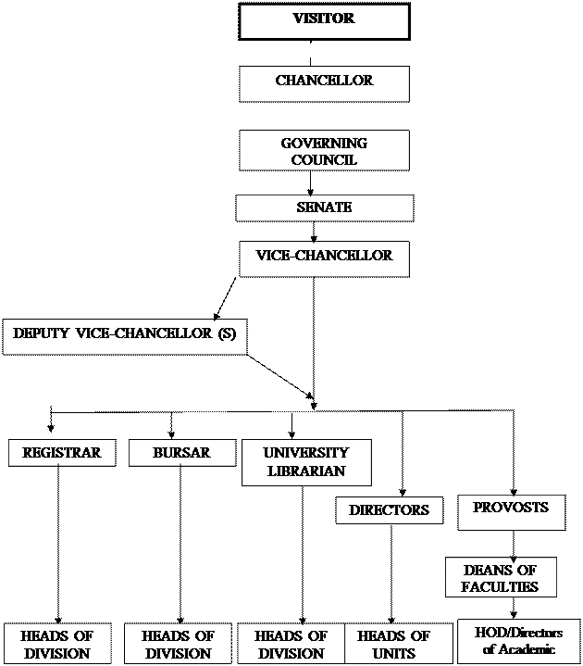

Fig 1.1 place of attachment organogram

2.4 SERVERS

Servers, rooted in the clientserver model, centralize resources for efficient data access. Virtualization and cloud computing enhance scalability and reliability. They are crucial for resource centralization, hosting critical services, ensuring security, scalability, and maintaining reliability, making them indispensable for modern computing environments.

2.5 SYSTEMS ADMINISTRATION

Systems Administration optimizes computer systems through hardware and software configuration, security protocols, and system optimization. Sysadmins play a vital role in configuring systems, managing security, troubleshooting issues, and implementing automation. Their importance lies in optimal system performance, security management, efficient troubleshooting, user management, and streamlined operations for smooth computing.

2.6 SOFTWARE AND WEB DEVELOPMENT

Software and web development, grounded in programming and engineering principles, drive technological innovation. They provide custom solutions, establish digital presence through websites, and enhance user experience. These fields adapt to changing requirements, integrating emerging technologies for continuous improvement.

2.7 OPERATING SYSTEMS

Operating systems form the foundation of computing environments, providing interfaces between hardware and software. They manage resources, provide a userfriendly interface, implement security measures, and ensure system stability. Operating systems are crucial for efficient, secure, and reliable computing, facilitating seamless user interaction and diverse application execution.

CHAPTER THREE: DETAILS OF TRAINING UNDERGONE DURING THE SIWES

3.1 INTRODUCTION

Embarking on the Student Industrial Work Experience Scheme (SIWES) at the Department of Computer Engineering, Ahmadu Bello University Zaria, this chapter delves into the multifaceted training undertaken. The participant engaged in diverse modules, acquiring a spectrum of skills. CompTIA A+ Training provided foundational expertise in troubleshooting and maintaining computer systems, while Cisco NDG's Operating Systems Basics offered comprehensive insights into essential operating system concepts. Hands-on experience in Linux usage, configuration, and administration was gained through Cisco NDG's Linux Unhatched and Linux Essentials. Proficiency in creating adaptive web solutions for various devices was honed through Responsive Web Design, and the role of a Web Programming Summer Camp Instructor involved guiding others in the intricacies of web development. Server Essentials provided in-depth knowledge of server configurations, networking, and security. Additionally, a media server project, serving as an integral component of the training, contributed to the real-world application of skills in the context of media server development.

This comprehensive training serves as the foundation for the subsequent chapters, where these acquired skills are applied and expanded upon in practical scenarios. The culmination of these experiences leads to the development and implementation of a Home Media Server solution.

3.2 COMPTIA A + TRAINING

3.2.1 INTRODUCTION

The CompTIA A+ training program serves as a foundational and comprehensive industryrecognized initiative that empowers IT professionals with the skills and knowledge needed to excel in entrylevel IT roles. The training covered a wide range of critical topics, From hardware and software fundamentals to networking, security, storage, disaster recovery and troubleshooting, ensuring that We are wellprepared for the dynamic and evolving landscape of IT.

One of the notable strengths of the CompTIA A+ training is its alignment with industry standards and current technology trends. The curriculum reflects the latest advancements in IT, ensuring that We are wellprepared to tackle contemporary challenges and technologies. Upon completion we are not only equipped with the theoretical knowledge but also gained practical handson experience through labs and simulations.

3.2.1 MOBILE DEVICES

This delved into essential topics related to mobile devices. We were guided through the installation and configuration of laptop hardware, emphasizing hardware/device replacement and incorporating physical privacy and security components. The curriculum explores the display components of mobile devices, covering OLED technology, WIFI antenna placement, cameras, microphones, touch screens, and inverters. Additionally, We learn to set up and configure accessories and ports, including connection methods, docking stations, port replicators, and trackpads. The objective of configuring basic mobiledevice network connectivity and application support is addressed, encompassing wireless/cellular data networks, Bluetooth, location services, and Mobile Device Management (MDM)/Mobile Application Management (MAM). This comprehensive approach equiped us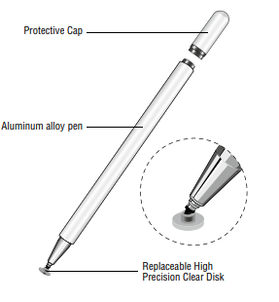 with the skills needed for efficient troubleshooting, connectivity, and application functionality in the dynamic landscape of mobile computing.

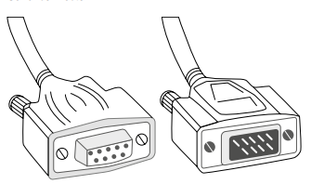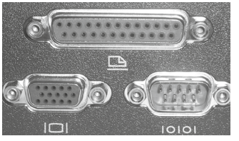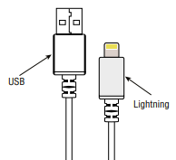

Lightning connector and USB DB-25, DB-15, and DB-9 ports Serial Connector touch pen(stylus) vr headset

3.2.2 NETWORKING

This part extensively covered crucial aspects of networking. We delved into the comparison of Transmission Control Protocol (TCP) and User Datagram Protocol (UDP) ports and protocols, exploring key ports such as FTP, SSH, Telnet, SMTP, DNS, DHCP, HTTP, POP3, IMAP, SNMP, LDAP, HTTPS, SMB, RDP, and more. The TCP vs. UDP distinction and the connectionoriented and connectionless nature of protocols like DHCP, HTTPS, and SSH are emphasized. Common networking hardware is thoroughly compared, including routers, switches (managed and unmanaged), access points, firewalls, and Power over Ethernet (PoE) components. Protocols for wireless networking, spanning frequencies, channels, regulations, and standards like Bluetooth, 802.11 a/b/g/n/ac/ax, are explored. The chapter also summarizes services provided by networked hosts, covering server roles, DNS, DHCP, file sharing, mail servers, and various network appliances. Installation and configuration of basic wired/wireless small office/home office (SOHO) networks, IP addressing (IPv4 and IPv6), and network configuration concepts like DNS, DHCP, VLANs, and VPNs are addressed. Additionally, Welearn to compare and contrast Internet connection types and network types, including LANs, WANs, PANs, MANs, and WLANs. The use of networking tools, such as crimpers, cable strippers, WIFI analyzers, toner probes, punchdown tools, cable testers, loopback plugs, and network taps, was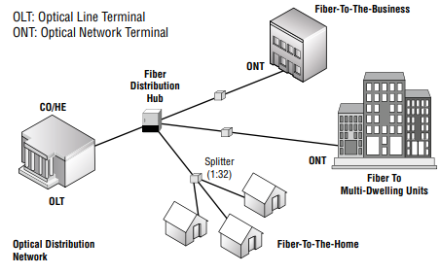 also covered to ensure a comprehensive understanding of networking fundamentals.

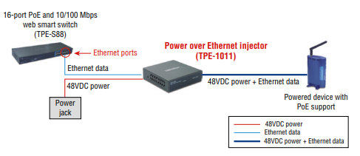

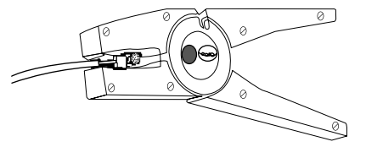

Power over Ethernet Optical Nertwork Terminal Cable stripper

Fig 1.1 networking device diagrams

3.2.3 HARDWARE

This delved into crucial hardware concepts to equip IT professionals with foundational skills. We explore basic cable types, connectors, and features, covering network cables such as copper, coaxial, and optical, as well as peripheral, video, and hard drive cables. The installation of appropriate RAM is addressed, considering virtual RAM, SODIMM, DDR3, DDR4, DDR5, ECC RAM, and various channel configurations. We learn to select and install storage devices, including hard drives, SSDs, and removable storage, with a focus on speeds, form factors, and drive configurations. Installation and configuration of motherboards, CPUs, and addon cards involve considerations of form factors, connector types, motherboard compatibility, BIOS/UEFI settings, CPU architecture, and expansion cards. Deploying and configuring multifunction devices/printers is explored, emphasizing proper unboxing, driver usage, connectivity options, and various configuration settings. Installing and replacing printer consumables for laser, inkjet, thermal, impact, and 3D printers is covered, including maintenance procedures for optimal printer functionality. The deployment and configuration of power supplies were discussed, addressing voltage, output, adapters, and modular options. The comprehensive hardware coverage ensures IT professionals are adept at handling a wide array of hardware components, from cables and connectors to RAM, storage devices, motherboards, printers, and power supplies.

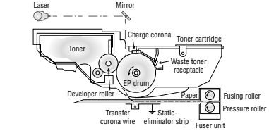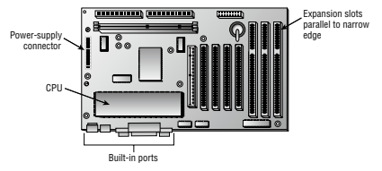

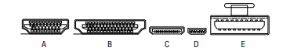

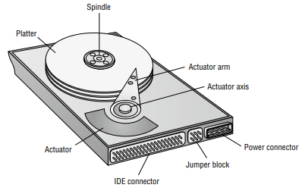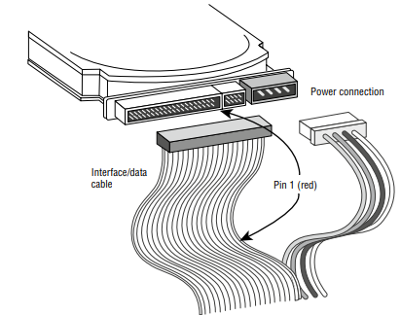

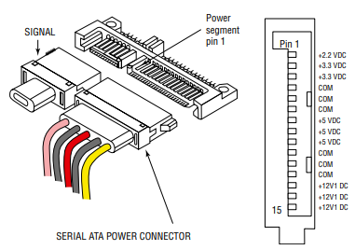

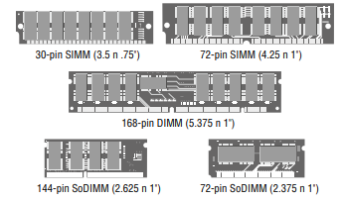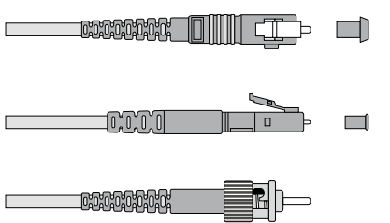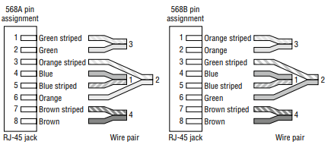

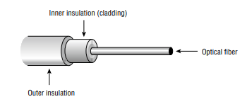

Fig 1.1 hardware diagrams

3.2.4 VIRTUALIZATIONAND CLOUD COMPUTING

This delved into the dynamic realm of virtualization and computing, providing us with essential knowledge and skills. Cloudcomputing concepts were summarized, covering common cloud models like private, public, hybrid, and community clouds. Infrastructure as a Service (IaaS), Software as a Service (SaaS), and Platform as a Service (PaaS) were explored, along with cloud characteristics such as shared resources, metered utilization, rapid elasticity, and high availability.It also addresses file synchronization and desktop virtualization, including Virtual Desktop Infrastructure (VDI) on premises and in the cloud. Clientside virtualization aspects were covered, emphasizing the purpose of virtual machines, sandboxing, test development, application virtualization, handling legacy software/OS, crossplatform virtualization, and considerations for resource and security requirements. The comprehensive coverage ensures that We are wellversed in the evolving landscape of virtualization and computing, enabling them to adapt to the demands of contemporary IT environments.

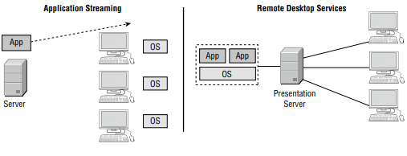

Fig 1.1 virtualization and cloud computing

3.2.5 HARDWARE AND NETWORK TROUBLESHOOTING

3.2.5.1 Hardware Troubleshooting

This equiped us with a systematic methodology to troubleshoot hardware issues effectively. Welearn to apply best practices by considering corporate policies, procedures, and impacts before implementing changes. The methodology involves identifying the problem, gathering user information, establishing a probable cause theory, testing the theory, and implementing a plan of action. Verification of full system functionality and documentation of findings are crucial steps. Troubleshooting covers common issues related to motherboards, RAM, CPU, and power, addressing symptoms like POST beeps, crashes, overheating, and more. Storage drive and RAID array problems are tackled, including LED indicators, noises, data loss, and S.M.A.R.T. failures. Video, projector, and display issues, along with common mobile device problems, are also explored. The troubleshooting methodology ensures IT professionals can efficiently diagnose and resolve hardware challenges.

3.2.5.2 Network Troubleshooting

Provided a comprehensive approach to troubleshooting wired and wireless networks. We learned to follow a systematic methodology that includes identifying common symptoms such as intermittent connectivity, slow speeds, and limited connectivity. Troubleshooting covers a range of issues including jitter, poor VoIP quality, port flapping, high latency, and external interference. The course emphasizes gathering information, establishing probable causes, testing theories, and implementing action plans. Troubleshooting extends to mobile devices, addressing problems like battery issues, connectivity problems, liquid damage, and malware. Printer issues, such as lines on printed pages, paper jams, and print quality problems, are also covered. The holistic network troubleshooting approach ensures IT professionals can efficiently address a wide array of networkrelated challenges in dynamic IT environments.

3.2.6 OPERATING SYSTEMS

This empowers IT professionals with indepth knowledge and troubleshooting skills for various operating systems. We learned to identify features of Microsoft Windows editions, addressing differences in editions, domain access, desktop styles, and key features like BitLocker and Remote Desktop Protocol (RDP). Practical use of Microsoft commandline tools, including ipconfig, ping, and chkdsk, is emphasized for efficient troubleshooting. Exploration of Windows 10 features and tools, such as Task Manager, Event Viewer, and Disk Management, enables us to diagnose and resolve OSrelated issues comprehensively. The course covered Control Panel utilities, Windows settings, and Microsoft Windows networking features, addressing tasks like shared resources, printers, and network configurations. Troubleshooting concepts extend to the application installation and configuration process, including system requirements, distribution methods, and impact considerations. The course concluded with an overview of common OS types, filesystems, and practical insights into OS installations and upgrades. This comprehensive approach ensures IT professionals are equipped to troubleshoot and optimize diverse operating systems efficiently.

3.2.7 SECURITY

Equiped us with comprehensive security measures and practices. The course covered physical security aspects like access control vestibules, badge readers, video surveillance, and biometrics. Logical security measures include the principle of least privilege, access control lists, multifactor authentication, and mobile device management. Wireless security protocols, encryption methods, and authentication techniques are explored, ensuring a robust understanding of securing network communications.

We learn to detect, remove, and prevent malware using tools such as recovery consoles, antivirus, and antimalware. Social engineering attacks, threats, and vulnerabilities are explained, addressing concepts like phishing, DDoS attacks, and structured query language (SQL) injections. The course delved into managing and configuring basic security settings in Microsoft Windows OS, covering Defender Antivirus, firewalls, and user authentication methods.

Best practices for securing workstations, including dataatrest encryption, password policies, and user account controls, are emphasized. Security configurations for small office/home office (SOHO) networks, mobile devices, and embedded devices are addressed, encompassing screen locks, remote wipes, and OS updates. Data destruction and disposal methods, as well as security settings for browsers, are detailed for comprehensive security awareness. The course ensured IT professionals are adept at implementing and maintaining robust security measures across diverse IT 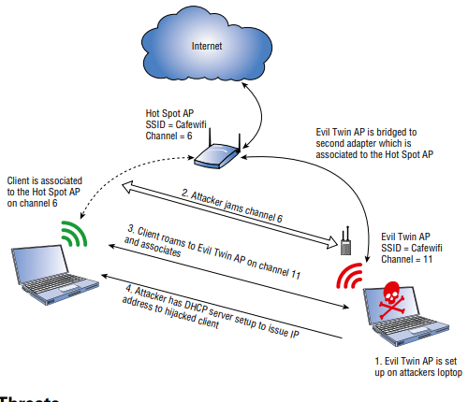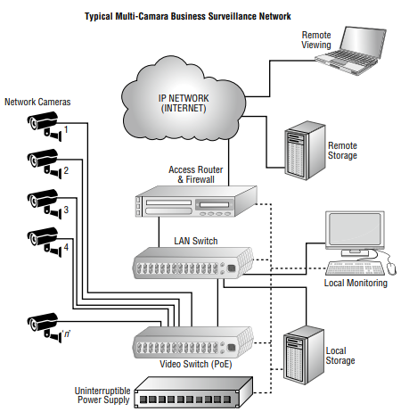environments.

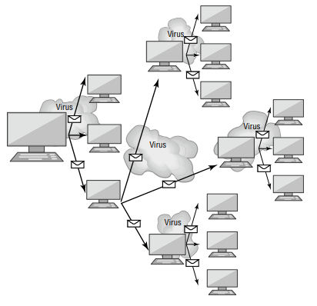

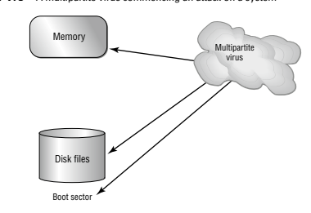

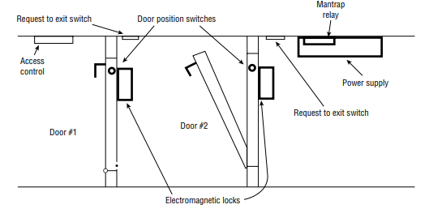

Fig 1.1 security

3.2.8 SOFTWARE TROUBLESHOOTING

Provided a comprehensive understanding of software troubleshooting, specifically focusing on Windows OS and common issues related to personal computers (PCs) and mobile devices.

It delved into troubleshooting common Windows OS problems, including symptoms like the Blue Screen of Death (BSOD), sluggish performance, and frequent shutdowns. It equips IT professionals with the ability to address issues such as applications crashing, USB controller resource warnings, and system instability. Troubleshooting steps cover rebooting, restarting services, uninstalling/reinstalling/updating applications, and performing system file checks.

We learned to troubleshoot common PC security issues, addressing symptoms like network inaccessibility, false antivirus alerts, and OS update failures. The course emphasizes best practice procedures for malware removal, covering investigation, system quarantine, disabling System Restore, remediation, updating antimalware software, and user education.

Mobile OS and application troubleshooting were also covered, encompassing issues like application launch failures, slow response times, and connectivity problems. We learned to troubleshoot security concerns such as APK source verification, developer mode, root access, and application spoofing. Common symptoms, including high network traffic, unexpected application behavior, and leaked personal files, are addressed with effective troubleshooting strategies.

The course ensured IT professionals are proficient in diagnosing and resolving a wide array of software related issues across various platforms, providing a robust skill set for maintaining software health in diverse IT environments.

3.2.9 OERATIONAL PROCEDURES

Covers operational procedures, focusing on best practices for documentation, support systems, change management, workstation backup and recovery, safety procedures, environmental controls, content/activity prohibition, privacy, licensing, and communication techniques.

The course equiped IT professionals to implement best practices associated with documentation and support systems information management. Topics include ticketing systems, asset management, acceptable use policies, network topology diagrams, and regulatory compliance requirements. We learned to manage incidents, create standard operating procedures, and develop a knowledge base.

Change management best practices are explored, emphasizing documented business processes, rollback plans, sandbox testing, responsible staff members, and change request forms. The course covers aspects such as change purpose, scope, date/time, affected systems, risk analysis, and approvals by change boards.

We gained insights into workstation backup and recovery methods, including full, incremental, differential, and synthetic backups. The course covers backup testing, frequency, rotation schemes, onsite vs. offsite storage, and the 321 backup rule.

Common safety procedures are discussed, including electrostatic discharge (ESD) precautions, proper power handling, equipment grounding, and personal safety. Environmental impacts and controls cover material safety data sheets (MSDS), battery disposal, toner disposal, temperature, humidity, and ventilation awareness, and power surge protection.

The course emphasizes the importance of prohibited content/activity and privacy, licensing, and policy concepts. Incident response, chain of custody, licensing, digital rights management (DRM), enduser license agreements (EULA), and data retention requirements are key components.

Proper communication techniques and professionalism are highlighted, covering attire, language, attitude, active listening, cultural sensitivity, and effective use of professional titles. We learned to handle difficult situations, set expectations, offer repair/replacement options, and provide documentation.

Basics of scripting was introduced, covering script file types (.bat, .ps1, .vbs, .sh, .js, .py), use cases for scripting (automation, backups, updates), and considerations when using scripts (avoiding malware introduction, system crashes).

Finally, the course covered remote access technologies, including methods/tools like RDP, VPN, VNC, SSH, and thirdparty tools. Wegain insights into security considerations for each access method, ensuring a comprehensive understanding of operational procedures in IT environments.

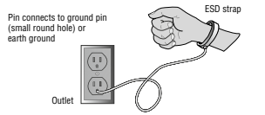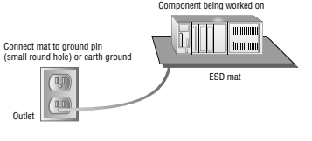

Fig 1.1 operational procedures

3.3 RESPONSIVE WEB DESIGN

The Responsive Web Design course on FreeCodeCamp is a comprehensive learning journey designed to empower individuals with the skills necessary to create visually engaging and functional websites across a multitude of devices. In this course, We delve into the fundamentals of HTML5 and CSS3, gaining proficiency in semantic markup and advanced styling techniques. The curriculum places a strong emphasis on responsive design principles, teaching learners how to create adaptable layouts through media queries, CSS Grid, and Flexbox.

As we progress, we were exposed to handson projects that simulate realworld scenarios, allowing us to apply theoretical concepts in practical settings. The course covered the mobilefirst approach, ensuring that students understand the importance of designing websites with a focus on mobile devices. Additionally, the integration of accessibility principles and the use of ARIA attributes contribute to creating websites that are inclusive and userfriendly for individuals with disabilities.

The skills acquired in this course go beyond the basics, delving into crossbrowser compatibility, web accessibility, and the nuances of creating responsive layouts for various screen sizes. By completing this program, We are not only equipped with the technical prowess to build responsive websites but are also prepared for diverse roles in web development, freelance opportunities, and potential contributions to opensource projects. The Responsive Web Design course on FreeCodeCamp serves as a foundational stepping stone for individuals aspiring to thrive in the dynamic and everevolving field of web development.

1. Tribute Page Project

Design a visually appealing tribute page for a historical figure, show casing proficiency in HTML and CSS basics.

2. Survey Form Project

Create an interactive and responsive survey form, mastering HTML form elements and CSS styling techniques.

3.Product Landing Page Project

Build a captivating product landing page using advanced CSS and responsive design principles for optimal user engagement.

4. Technical Documentation Page Project

Develop a clear and organized technical documentation page, highlighting skills in HTML5, CSS3, and responsive navigation.

5.Personal Portfolio Webpage Project

Design a personal portfolio webpage to exhibit completed projects, incorporating a navigation bar and gridbased layout for a professional online presence.

3.4 OPERATING SYSTEM BASIC

3.4.1 INTRODUCTION

Every smart device uses an operating system (OS), smart devices like personal computers, smartphones, game consoles, smart TVs, and the list continues. Whether the OS used is Windows, Linux, macOS, Android, or iOS, knowing how it works is a key digital skill you will need. The course builds your foundational knowledge for success in any IT career.

Operating Systems Basics teaches the fundamentals of operating systems. It covers basic concepts and skills needed to understand the purpose and characteristics of operating systems, the implementation of basic OS security, and how to configure mobile device network connectivity and email.

3.4.2 THE WINDOWS OPERATING SYSTEMS

3.4.2.1 Windows History

Explained Microsoft's evolution from MSDOS to modern Windows versions based on the NT operating system is marked by over 20 releases, of which the graphical user interface (GUI) has become integral, featuring a Desktop and Task Bar with Start menu, quick launch icons, and a notification area. Security recommendations include virus protection, strong passwords, firewall usage, and limited administrator account access.

3.4.2.2 Windows Architecture and Operations

Windows operates with a hardware abstraction layer (HAL), controlling communication between hardware and the kernel. Two modes, user and kernel, handle processes and direct hardware access. NTFS is the widely used file system, and the registry stores system information. Proper shutdown and understanding virtual address space in 32bit and 64bit systems are crucial.

3.4.2.3 Windows Configuration and Monitoring

For security, avoid logging in with the Administrator account, use Windows groups for user administration, and leverage lusrmgr.msc. Commands through CLI or PowerShell aid in automation, and Windows Management Instrumentation (WMI) manages remote computers. Task Manager, Resource Monitor, Network and Sharing Center, and protocols like SMB and UNC format are key aspects. Windows Server, focused on data centers, provides essential network, file, web, and management services.

3.4.2.4 Windows Security

Windows security involves monitoring communication ports with 'netstat,' utilizing Event Viewer, and keeping the OS updated with patches and service packs. Automatic updates, secure configurations, and scheduled restarts enhance security against evolving threats.

3.4.3 Linux Overview:

Linux, an opensource operating system, is widely recognized for its speed, reliability, and emphasis on network functionality. Tailored distributions such as Security Onion and Kali Linux specifically address cybersecurity needs. Interaction in the Linux environment takes place through either a graphical user interface (GUI) or commandline interface (CLI)/shell. This entails fundamental concepts like commands, treating various elements as files, and a comprehensive understanding of memory, disks, and directories as files.

In the realm of servers and clients, Linux servers play a pivotal role in providing services through ports, managing external services such as files, email, and web pages. Simultaneously, internal services handle critical tasks like log and memory management, with logfiles capturing system activities. Basic server administration in Linux involves intricate aspects like configuring files, implementing security measures, and ensuring regular updates to the operating system. Best practices include robust password management, secure remote login through SSH, and periodic adjustments to enhance overall device security.

Navigating the Linux file system reveals support for various file systems, each mounted on partitions with mounting points or directories. File permissions, displayed using 'ls l,' govern access, covering key concepts like the root file system, hard and symbolic links, and file system permissions. The graphical user interface in Linux, facilitated by the X Windows system, accommodates desktop environments such as Gnome and KDE. Understanding components like the Apps Menu and Ubuntu Dock in the Gnome 3 desktop is essential for efficient navigation.

Working on a Linux host involves the utilization of package managers for application installation, managed through commandline interfaces. Processes, forking, and addressing potential malware threats are fundamental considerations in the Linux environment. Regular updates, tools like chkrootkit, and efficient command chaining collectively contribute to an enhanced security posture.

3.4.4 MOBILE DEVICE CONNECTIVITY

3.4.4.1 Wireless and Cellular Data Network

Explored wireless and cellular data networks, providing an understanding of how mobile devices connect and communicate in various network environments.

3.4.4.2 Bluetooth

Detailed the functionality and applications of Bluetooth technology, showcasing its role in facilitating wireless communication between devices.

3.4.4.3 Email Configuration

Guided us on how to configure email on mobile devices, ensuring seamless communication and access to email services.

3.4.4.4 Mobile Device Synchronization

Explored synchronization processes, that allow users to keep their mobile devices updated and aligned with other connected devices.

3.4.4.5 Mobile Device Connectivity Summary

Summarizes the key aspects of mobile device connectivity, reinforcing the knowledge gained in establishing and managing connections.

3.4.5 MOBILE OPWERATIND SYSTEMS AND SECURITY

3.4.5.1 Android Versus iOS

Taught us how to compare Android and iOS, the two major mobile operating systems, and highlighting their features, differences, and market significance.

3.4.5.2 Mobile Touch Interface

Explored the touch interface of mobile devices, focusing on user interactions, gestures, and the design principles that enhance the user experience.

3.4.5.3 Common Mobile Device Features

Covered common features found in mobile devices, offering insights into functionalities that define the modern mobile experience.

3.4.5.4 Passcode Locks

Discussed the importance of passcode locks in securing mobile devices, addressing various methods and best practices for effective device protection.

3.4.5.5 CloudEnabled Services for Mobile Devices

Explored cloudbased services, detailing how they enhance mobile device functionality, storage, and collaboration.

3.4.5.6 Mobile Device Software Security

Focused on the security aspects of mobile device software, addressing vulnerabilities, encryption, and measures to protect against threats.

3.5 Linux Unhatched

3.5.1 Introduction to Linux

Linux is a fundamental opensource operating system with widespread usage in various IT domains. Mastery of Linux provides access to powerful tools, fostering a deeper understanding of computing principles. The importance of Linux extends to servers, cloud services, and embedded systems, making it a valuable skill for IT professionals.

3.5.2 Essential Commands and Syntax

We Understood the basic command syntax of Linux is crucial. Commands follow a structured format of command options and arguments. Mastery of command syntax is vital for effective commandline usage, automation, and efficient navigation within the filesystem.

3.5.3 Filesystem Navigation and Manipulation

Key commands like `pwd` for printing the working directory, `cd` for changing directories, and `ls` for listing files are essential for effective filesystem navigation were learned. These commands aid us in understanding their location within the filesystem and executing commands efficiently.

3.5.4 File and System Management

The module covered administrative access through the root user, file and directory permissions, changing file permissions and ownership, as well as viewing, copying, moving, and removing files. Understanding permissions, ownership, and file manipulation commands are essential for systemlevel configurations.

3.5.5 Advanced Topics and System Management

The final module delved into advanced topics such as filtering input with `grep`, working with regular expressions, network configuration, viewing processes, package management, updating user passwords, and advanced command operations like redirection. It also introduces text editors for configuration and scripting purposes. The module concludes by emphasizing the importance of continuous learning for mastering Linux and suggests exploring advanced topics like scripting, system administration, and security for broader expertise.

3.6 Linux Essentials

3.6.1 Linux Essentials Overview

In the first module, we delve into the rich history and architecture of Linux, unraveling its key components that make it a prominent opensource operating system. This exploration provides a comprehensive understanding of Linux's versatility, positioning it as a fundamental player in various IT domains. We take a closer look at its ubiquitous presence in servers, cloud services, and embedded systems, underlining its significance for IT professionals in today's diverse technological landscape.

3.6.2 Operating System Concepts and Command Line Proficiency

Moving forward, our focus shifts to a detailed examination of operating system concepts, types, and functionalities. We conduct a comparative study, highlighting Linux's strengths and use cases in comparison to other operating systems. Simultaneously, we embark on practical skill development, ensuring effective navigation and command line usage. This involves mastering file management techniques and the execution of basic commands, laying the foundation for proficiency in Linux commandline operations.

3.6.3 Open Source Software, Licensing, and Advanced Command Line Skills

This module encompasses an exploration of opensource software principles and licensing, shedding light on the legal aspects of software distribution and collaborative development. Concurrently, we elevate our command line expertise, delving into advanced usage for efficient navigation and task execution. The mastery of key commands becomes pivotal, contributing to an overall enhanced proficiency in harnessing the power of Linux.

3.6.4 Help Resources, Troubleshooting, and Filesystem Navigation

As we progress, we learn to leverage help resources effectively, tapping into manual pages and online forums for guidance. The development of troubleshooting skills takes center stage, empowering learners to resolve challenges with the support of the community. Simultaneously, we conduct an indepth examination of the Linux filesystem structure, unraveling its intricacies. Mastery of navigation commands becomes paramount, ensuring a deep understanding of directory organization.

3.6.5 File and Directory Management, Archiving, Compression, and Storage Optimization

In the final module, our focus sharpens on essential file and directory management skills. Learners delve into the intricacies of copying, moving, renaming, and deleting files, honing effective data organization techniques for heightened system efficiency. Simultaneously, methods for archiving and compressing files are explored, optimizing storage space and facilitating the seamless transfer of data. This module concludes our comprehensive exploration of Linux essentials, equipping learners with a robust skill set for realworld applications.

3.7 INSTRUCTING WEB PROGRAMMING KIDS SUMMER CAMP

3.7.1 Introduction to Web Technologies and HTML Fundamentals

Overview of Web Technologies: The children were introduced to web prgramming by my industry supervisor, Providing a holistic understanding of the web ecosystem, emphasizing the role of various technologies in creating dynamic and interactive content.

HTML Fundamentals: My co-SIWES student introduce the basics of Hypertext Markup Language, covering essential elements, document standards, and practical skills through the creation of an HTML Registration Form to the children.

Key Terminologies and Tools were explored with essential vocabulary and tools within the web development landscape, ensuring the children grasped the terminology commonly used in the field.

Installing a Text Editor: Practical guidance on setting up a text editor, a fundamental tool for web development, to create and edit code efficiently was taught to the wep programming class while some of us helped to assist the students whenever they run into problems.

3.7.2 Cascading Style Sheets (CSS)

Introduction to CSS : I introduced css initiating the students into Cascading Style Sheets, elucidating rulesets, and visual styling to enhance the presentation of HTML elements.

The Box Model:I took the students shallow dive into the Box Model, elucidating how elements are structured in CSS, influencing layout, and paving the way for effective design implementation.

CSS Syntax and Selectors: We Explored the syntax and various selectors in CSS, providing them with the skills to target and style specific elements within a webpage.

Using Developer Tools to Debug CSS: Taught the students practical insights into utilizing browser developer tools for debugging CSS, empowering Weto identify and resolve styling issues efficiently.

3.7.3 JavaScript and Advanced CSS

The students were initiated into the world of JavaScript, exploring its role in enhancing web interactivity and laying the foundation for dynamic content by my fellow SIWES student.

We guided students in Building a Photo Gallery using CSS, Applying advanced CSS techniques to create visually appealing and responsive photo galleries, providing handson experience in combining design aesthetics with functionality. And taught them how to Display and Positioning using CSS rules, Extending participants' knowledge of CSS to include advanced concepts of element display and positioning, crucial for creating complex layouts.

We also explored the use of colors in CSS for effective design, covering techniques such as color schemes, gradients, and transparency to enhance visual appeal, Style fonts and images Focusing on the styling of text and images, and how to enhance the visual presentation of content through font styles and image customization. And how to Create and Link a Stylesheet, instructing them on the creation and linking of external stylesheets, promoting a modular approach to styling for consistent and maintainable code.

3.7.4 Final Project

We finally supervised and guided them on how to build their Personal Web Page Project, Providing them with dedicated time to refine and complete their personal web page projects, ensuring a comprehensive showcase of their acquired skills. And awarded them with certification upon completion of the camp and project.

3.8 HAUWEI DATA COMMUNICATIONS ASSOCIATE ENGINEER TRAINING AND CERTIFICATION

3.8.1 INTRODUCTION

The Huawei Data Communications Associate Engineer Training and Certification program is a comprehensive initiative designed to equip individuals with the essential skills and knowledge required in the dynamic field of data communications. This program covers a wide range of topics, providing a solid foundation for aspiring professionals in the realm of network engineering and telecommunications.

3.8.2 Foundations of Data Communications and Networking

The Huawei Data Communications Associate Engineer Training and Certification program kickstarts with an exploration of fundamental principles in data communication and network structures. This module serves as the cornerstone for aspiring professionals, providing a comprehensive introduction to the dynamic field of network engineering and telecommunications.

3.8.3 IP Network Construction and Internetworking

Building upon the foundational knowledge, Module 2 delves into the intricacies of constructing IP networks. With a specialized focus on interconnection and internetworking, participants gain valuable insights into the seamless integration of IP networks, a crucial aspect in the evolving landscape of data communications.

3.8.4 Ethernet Switching Networks and Configuration

This is dedicated to the construction and configuration of Ethernet switching networks. Participants gain handson experience in setting up and optimizing Ethernet networks, fostering a deep understanding of the mechanisms behind efficient data transfer within interconnected systems.

3.8.5 Cybersecurity in Network Infrastructure

Understanding the critical relationship between cybersecurity and network infrastructure is the focus. Participants explore the nuances of establishing a secure network access environment, crucial in safeguarding sensitive data and ensuring the integrity of the overall network.

3.8.6 Network Services, Applications, and Wireless Technologies

The program's penultimate module, Module 5, shifts attention to the diverse range of network services and applications. Participants examine how these elements enhance connectivity and functionality. Additionally, an overview of Wireless Local Area Network (WLAN) fundamentals adds a layer of understanding of modern communication technologies.

3.8.7 WAN, Network Management, and Future Technologies

In the final module, Module 6, participants dive into the basics of Wide Area Networks (WAN) and their role in connecting geographically dispersed networks. The exploration extends to network management techniques and operational maintenance, ensuring optimal network performance. Furthermore, the module introduces futuristic concepts such as SoftwareDefined Networking (SDN) and automation, revolutionizing the landscape of network management. This comprehensive training and certification program thus equips individuals with the essential skills needed for success in the dynamic field of data communications.

3.9 Huawei Data Communications Network Automation Developer Professional Engineer Training

3.9.1 INTRODUCTION

Embarked on an innovative journey with the Huawei Data Communications Network Automation Developer Professional Engineer Training, designed to empower individuals with advanced skills in network programming and automation. As network automation engineers must be allrounders who master skils of network enginners, sytem engineers, and development engineers, This comprehensive program explores cuttingedge technologies and practices, providing a solid foundation for professionals aiming to excel in network programming and automation.

3.9.2 Introduction to Network Programming and Automation

Delved into the world of network programming and automation, unraveling the intricacies of automating network processes. Learned how to leverage programming languages like python, and source code management like Git and automation tools like ansible, chef, puppet etc to enhance efficiency, scalability, and agility in network management.

3.9.3 Device Openness and Programmability

Discovered the essence of device openness and programmability at the device layer. This module introduces key concepts such as SSH, SNMP, NETCONF, Telemetry, and OPS. Delve into Python programming basics, understand Git fundamentals, and grasped principles and practices of SSH, SNMP, NETCONF YANG, Telemetry, and OPS, equipping you with the skills to programmatically interact with network devices.

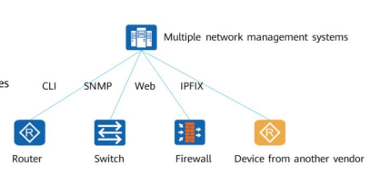

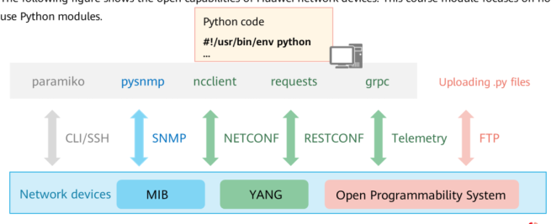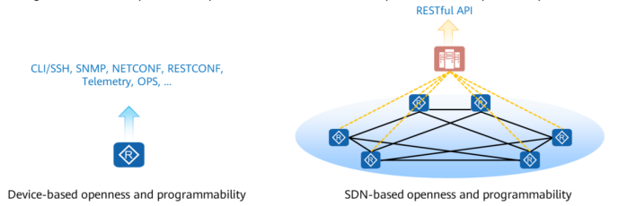

3.9.4 iMaster NCE Northbound Openness

Explored the northbound open APIs and practices of iMasterNCE, gaining insights into how to effectively utilize and integrate these APIs. Understand the principles of northbound openness, enabling seamless communication and integration with various network elements.

3.9.5 iMasterNCE Service Openness

Unlock the potential of iMasterNCE with this module, guiding you through the utilization of Specific Network Driver (SND) and Specific Service Plugin (SSP). Learn how to implement swift interconnection with new devices and construct new services efficiently. This module equips you with the skills to navigate the Specific NE Driver and Specific Service Plugin landscape, facilitating rapid development and deployment of tailored network services.

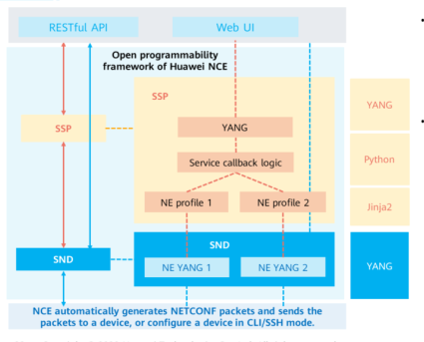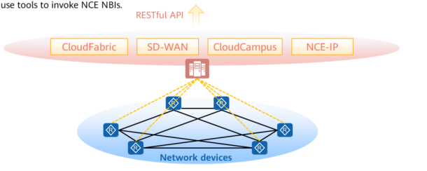

In summary, the Huawei Data Communications Network Automation Developer Professional Engineer Training offers a holistic approach to network automation, covering programming fundamentals, device openness, and the utilization of iMasterNCE for enhanced service creation and integration. This program is a gateway for professionals seeking to be at the forefront of network automation technologies.

Chapter 3.10: CompTIA Server+ Essentials

3.10.1 Introduction to CompTIA Server+ Essentials:

This training Provided an overview of the fundamental concepts covered in the CompTIA Server+ Essentials training and insights into the importance of server technologies, their role in modern IT infrastructure, and the skills needed to navigate the intricacies of server management. this sets the stage for a comprehensive exploration of server hardware, operating systems, storage, network concepts, security, troubleshooting, performance optimization, and disaster preparedness.

3.10.2 Server Hardware and Architecture:

This delved into the critical components that constitute server hardware. From processors and memory modules to storage devices and peripherals, We develop a deep understanding of the intricate details involved in configuring, maintaining, and optimizing server hardware. Practical insights and realworld examples will be provided to enhance the learner's ability to make informed decisions regarding server hardware selection and maintenance.

3.10.3 Server Operating Systems:

Focuses on server Operating Systems, exploring various platforms and their functionalities. We learn to install, configure, and manage server operating systems efficiently. The chapter covers topics such as user management, security features, and best practices for ensuring the stability and reliability of server operating systems.

3.10.4 Server Storage:

This revolves around server storage solutions, including different types of storage devices, RAID configurations, and storage management techniques. We gain the expertise to design and implement storage solutions that meet the specific needs of an organization, addressing issues related to data integrity, availability, and performance.

3.10.5 Server Network Concepts:

The importance of networking in server environments is the focal point of this training. we explored server networking concepts, including protocols, services, and technologies that facilitate seamless communication within and outside the IT infrastructure. Emphasis was placed on designing and implementing robust network architectures to support server functionalities.

3.10.6 Server Security:

Security is paramount in any IT infrastructure, and this focuses on server security principles and best practices. We learned about access controls, encryption, authentication mechanisms, and other security measures to safeguard servers and their data. It help equip us with the skills to identify and mitigate potential security threats effectively.

3.10.7 Server Troubleshooting and Performance Optimization:

Provided us with the tools and techniques necessary to diagnose and resolve serverrelated issues. We exploreed troubleshooting methodologies, performance optimization strategies, and preventive measures to ensure the continuous and efficient operation of server environments.

3.10.8 Server Preparing for the Worst:

In the final part, we learned about disaster preparedness for servers. This includes creating and implementing comprehensive backup strategies, developing disaster recovery plans, and understanding the importance of redundancy in minimizing downtime. We were equipped with the skills to mitigate the impact of unexpected events on server infrastructure, ensuring business continuity in challenging circumstances.

3.11 PROJECT CMEDIA HUB SERVER

3.11.1 INTRODUCTION

The CMEDIA HUB SERVER project represents the synthesis of knowledge and skills acquired through an extensive learning journey encompassing CompTIA A+, CompTIA Server Essentials, Responsive Web Design with FreeCodeCamp, and specialized training in operating systems and Linux.

Having navigated the diverse realms of hardware, server essentials, and web development, this project emerges as a cohesive embodiment of proficiency gained from various certification programs. The foundations laid in CompTIA A+ and CompTIA Server Essentials provide a solid understanding of hardware and server management, while the FreeCodeCamp training ensures expertise in responsive web design.

Furthermore, delving into the intricacies of operating systems and Linux adds a layer of sophistication to the CMEDIA HUB SERVER. The project stands as a testament to the seamless integration of skills acquired in system administration, network infrastructure, and Linux essentials.

Within the Software Development Life Cycle (SDLC), CMEDIA HUB SERVER reflects a comprehensive understanding of technolog from hardware components to responsive web design and the robust functionalities of Linuxbased systems. This project is not just an amalgamation of skills; it is a tangible outcome of a journey through diverse facets of IT, resulting in a sophisticated and usercentric home media server that seamlessly integrates innovation and expertise.

3.11.2 Planning Phase:

In the planning phase, the project's goals, scope, and requirements were defined. Key considerations included understanding the needs of the users, features required, and the overall architecture of the media hub server. Stakeholders collaborated to create a project plan, outlining timelines, resource allocation, and potential risks.

3.11.3 Feasibility Study:

A feasibility study was conducted to assess the technical, operational, and economic viability of the project. This included evaluating the chosen technology stack (Node.js, React, Express, Sequelize, SQLite), ensuring compatibility with the school's local network, and estimating development and maintenance costs.

3.11.4 Design Phase:

3.11.4.1 System Design:

Detailed system architecture was designed, covering both the backend and frontend components. The decision to use Node.js for backend development, React for frontend, and Express as the web application framework was made. The system's data flow, components, and their interactions were defined.

3.11.4.2. Database Design

The database schema using Sequelize ORM for SQL and SQLite implementation was designed. Entities such as media playlist, user and their interaction entities were identified, and relationships between them were established.

3.11.4.3 User Interface (UI) Design:

UI wireframes and design mockups for various pages and components were created to ensure a userfriendly and intuitive interface. This phase included the design of forms for login and signup.

3.11.6 Implementation Phase:

The implementation phase involved the actual coding of the project. The team followed best practices for Node.js and React development. The backend implemented features like file upload using Multer, thumbnail generation using Sharp, and duration retrieval for media files using Ffmpeg. Sequelize ORM was utilized for interacting with the SQL database.

3.11.7 Testing Phase:

Comprehensive testing was conducted to ensure the reliability and functionality of the CMEDIA HUB SERVER. This included unit testing for individual components, integration testing to verify the interaction between components, and system testing to evaluate the entire system's performance. Testing also involved validating user interfaces, input validation, and handling of various scenarios.

3.11.8 Deployment Phase:

The deployment phase involved deploying the application on the school's local network and Netlify. This included configuring servers, databases, and ensuring the security of the deployed system. Continuous integration and continuous deployment (CI/CD) practices were employed to automate the deployment process.

3.11.9 Maintenance and Updates:

Ongoing maintenance is crucial for the CMEDIA HUB SERVER to adapt to changing requirements, address any discovered bugs, and incorporate user feedback. Regular updates will be applied to enhance features, improve security, and ensure the application's continued relevance.

The SDLC for the CMEDIA HUB SERVER project followed a structured approach from planning through deployment and maintenance. This methodology ensures that the project meets its objectives, remains scalable, and can adapt to evolving needs over time on the server hardware,storage, networking, security, troubleshooting,software and disaster recovery. The iterative nature of the SDLC allows for continuous improvement and optimization of the media hub server.

CHAPTER FOUR: EXPERIENCE GAINED FROM THE TRAINING AND ITS APPLICATIONS IN FUTURE CARRIER

4.1 INTRODUCTION

This chapter encapsulates the invaluable insights and skills acquired during the training, offering a succinct exploration of their potential applications in shaping a successful future career.

4.2 COMPTIA A + TRAINING

4.2 IT Essentials Training Experience Summary and Future Applications

1. Mobile Devices:

Experience Gained: Handson experience in disassembling, assembling, and troubleshooting mobile devices.

Applications in Future Career: Roles as a mobile device support specialist, IT technician positions focusing on smartphones, and specialized roles in mobile device network support.

2. Networking:

Experience Gained: Configuration of routers, switches, and troubleshooting network connectivity.

Applications in Future Career: Network administrator roles, IT support specialist positions with a network troubleshooting focus, and opportunities in security analysis with a networking emphasis.

3. Hardware:

Experience Gained: Practical skills in building, upgrading, and troubleshooting computer systems.

Applications in Future Career: Hardware technician roles, IT support specialist positions with hardware troubleshooting expertise, and opportunities in system building or assembly.

4. Virtualization and Cloud Computing:

Experience Gained: Familiarity with cloud service models, handson virtualization experience, and troubleshooting virtualizationrelated issues.

Applications in Future Career: Roles in cloud administration or support, positions involving virtualization management, and IT roles with a focus on hybrid cloud environments.

5. Hardware and Network Troubleshooting:

Experience Gained: Identifying and resolving hardware and networkrelated issues, troubleshooting diverse systems.

Applications in Future Career: Hardware troubleshooting roles, network support specialist positions, and IT roles involving comprehensive system diagnostics.

6. Operating Systems:

Experience Gained: Handson experience with Windows OS features, troubleshooting OS problems, and performing installations/upgrades.

Applications in Future Career: IT roles involving Windows OS administration, support positions focusing on OS troubleshooting, and opportunities in system and software deployments.

7. Security:

Experience Gained: Implementing physical and logical security measures, configuring wireless security, and applying security settings on Windows OS.

Applications in Future Career: Roles in IT security administration, positions involving security implementation, and opportunities in security analysis and compliance.

8. Software Troubleshooting:

Experience Gained: Practical skills in diagnosing and resolving Windows OS problems, troubleshooting PC security, and malware removal.

Applications in Future Career: IT roles specializing in software troubleshooting, desktop support positions with a focus on resolving PC security issues, and opportunities in help desk support with malware removal expertise.

9. Operational Procedures:

Experience Gained: Practical experience in documenting and managing support systems, exposure to change management processes, and handson experience in implementing workstation backup and recovery methods.

Applications in Future Career: Roles in IT operations management, positions requiring expertise in change management, and opportunities in system administration with a focus on backup and recovery.

4.3 RESPONSIVE WEB DESIGN

Project Exposure, Experience Gained, and Future Career Applications in FreeCodeCamp's Responsive Web Design Course

1. Tribute Page Project

Exposure: Learners create a tribute page for a historical figure, applying HTML and CSS fundamentals.

Experience Gained: Proficiency in semantic HTML, CSS styling techniques, and structuring a webpage.

Future Career Application: Foundation for UI/UX design, critical for roles in frontend development.

2. Survey Form Project

Exposure: Crafting a responsive survey form using HTML forms and CSS styling.

Experience Gained: Understanding form elements, validation, and responsive design principles.

Future Career Application: Essential skills for web development positions, especially in creating interactive and userfriendly forms.

3. Product Landing Page Project

Exposure: Building a product landing page with advanced CSS techniques and responsive design.

Experience Gained: Mastery of CSS Flexbox, embedding multimedia, and creating visually appealing layouts.

Future Career Application:Demonstrates proficiency in designing engaging web interfaces, beneficial for frontend developer roles.

4. Technical Documentation Page Project

Exposure: Developing a technical documentation page using HTML5 and CSS3.

Experience Gained: Creating clear and organized documentation, implementing responsive navigation.

Future Career Application: Transferable skills for roles involving documentation, such as technical writing or content creation for software.

5. Personal Portfolio Webpage Project

Exposure: Designing a personal portfolio showcasing completed projects.

Experience Gained: Incorporating a navigation bar, responsive images, and a gridbased layout.

Future Career Application: Vital for job seekers in web development, presenting a professional portfolio is crucial for showcasing skills to potential employers.

Completing these projects not only provides exposure to different aspects of web development but also instills a practical understanding of responsive design principles, essential for creating websites accessible across various devices. The experience gained through these projects lays a solid foundation for pursuing roles in web development, UI/UX design, or even branching into areas like technical writing. The portfolio developed during the course serves as a tangible demonstration of skills and creativity, enhancing one's attractiveness to prospective employers or clients in the field of web development.

4.4 OPERATING SYSTEM BASICS

4.4.1 The Windows Operating System

Training Exposure:

1. Indepth exploration of Windows history, architecture, and operations.

2. Practical configuration and monitoring exercises for Windows systems.

3. Handson experience with Windows security protocols and best practices.

Experiences Gained:

1. A solid understanding of Windows OS evolution and functionality.

2. Proficiency in configuring and monitoring Windows systems.

3. Practical insights into implementing effective security measures on Windows platforms.

Future Career Application:

1. The knowledge gained is crucial for roles involving Windows system administration.

2. Enhanced troubleshooting skills applicable in IT support or helpdesk positions.

3. Foundation for advanced certifications in Microsoft technologies.

4.4.2 Linux Overview

Training Exposure:

1. Comprehensive introduction to Linux basics and serverclient interactions.

2. Handson experience with Linux shell commands and GUI navigation.

3. Basic server administration skills and understanding of the Linux file system.

Experiences Gained:

1. Proficiency in Linux commandline operations and server administration.

2. Practical insights into working with Linux graphical user interfaces.

3. Understanding Linux serverclient dynamics and filesystem management.

Future Career Application:

1. Valuable skills for roles involving Linux system administration.

2. Foundation for pursuing certifications in Linux, enhancing career prospects.

3. Ability to work effectively in environments that utilize Linuxbased systems.

4.4.3 Mobile Device Connectivity

Training Exposure:

1. Exploration of wireless and cellular data networks.

2. Indepth understanding of Bluetooth technology.

3. Practical configuration of email and mobile device synchronization.

Experiences Gained:

1. Handson experience in configuring wireless and cellular connections.

2. Proficiency in setting up Bluetoothenabled devices.

3. Practical insights into configuring email and synchronizing mobile devices.

Future Career Application:

1. Relevant skills for roles involving mobile device management.

2. Ability to troubleshoot and configure mobile connectivity in diverse settings.

3. Foundation for pursuing certifications related to mobile device technologies.

4.4.4 Mobile Operating Systems and Security

Training Exposure:

1. Comparative study of Android and iOS operating systems.

2. Practical insights into mobile touch interfaces and common features.

3. Understanding passcode locks, cloudenabled services, and mobile security.

Experiences Gained:

1. Proficiency in differentiating between Android and iOS functionalities.

2. Practical experience in securing mobile devices through various methods.

3. Insights into leveraging cloud services for enhanced mobile device functionality.

Future Career Application:

1. Relevance in roles involving mobile app development or support.

2. Enhanced security skills applicable to mobile device management.

3. Foundation for roles requiring expertise in the Android and iOS ecosystems.

4.5 LINUX UNHATCHED

Training Exposure, Experience, and Future Career Applications Summary

The Linux training curriculum provides Wewith a wellrounded exposure and handson experience, fostering skills applicable to diverse IT career paths. The key takeaways and future career applications can be summarized as follows:

1. Exposure and Experience:

Foundational Linux Knowledge: Wegain indepth knowledge of Linux, including its history, architecture, and opensource principles.

Practical Skills Development: Handson experience with commands, file management, and scripting enhances participants' proficiency in Linux environments.

Understanding System Administration: Exposure to administrative access, permissions, and network configuration lays the foundation for system administration roles.

ProblemSolving and Troubleshooting: Wedevelop strong problemsolving skills through troubleshooting exercises and utilizing help resources effectively.

2. Future Career Applications:

Linux Administration Roles: The acquired knowledge and practical skills directly apply to Linux administration roles, enabling Weto manage servers and systems proficiently.

DevOps and System Administration: Understanding Linux is crucial for roles in DevOps and system administration, where Linux is prevalent in infrastructure management and automation.

OpenSource Contributions: Wecan leverage their exposure to opensource principles to actively contribute to projects, showcasing collaborative and communitydriven approaches.

Enhanced Security Practices: Knowledge gained in permissions, file ownership, and system security is directly applicable to roles focused on enhancing and maintaining system security.

Transferable ProblemSolving Skills: The emphasis on troubleshooting and help resources equips Wewith transferable skills applicable across various IT roles.

Networking Proficiency: Skills acquired in network configuration make Weadept in setting up and troubleshooting network connections, valuable in networking and IT support roles.

In summary, the Linux training not only equips Wewith a deep understanding of Linux but also provides practical skills that are directly applicable to a range of IT roles. The combination of theoretical knowledge and handson experience positions Wefor success in Linux administration, DevOps, system administration, and other related fields, making them valuable assets in the evolving landscape of opensource technology.

4.6 LINUX ESSENTIALS

Training Exposure, Experience, and Future Career Application

Upon completion of this comprehensive Linux training curriculum, Wecan expect to gain a multifaceted exposure, valuable handson experience, and practical skills that directly apply to their future careers. Here's a breakdown of the training's impact:

1. Training Exposure:

Broad Understanding of Linux Ecosystem: Wewill acquire a deep understanding of the Linux operating system, from its historical development to its role as a versatile opensource platform.

InDepth Knowledge of Operating Systems: The training provides a thorough exploration of operating system concepts, allowing Weto compare Linux with other major operating systems and understand its applications across diverse environments.

CommandLine Proficiency: Practical experience in working with the Linux command line interface (CLI) equips Wewith essential skills for efficient system navigation, file management, and command execution.

OpenSource Software Principles: Wewill gain exposure to the principles of opensource software, collaborative development, and licensing, fostering a mindset conducive to communitydriven innovation.

2. HandsOn Experience:

Practical Skills in File Management: Wewill develop handson expertise in managing files and directories, including essential operations like copying, moving, renaming, and deleting.

Scripting and Automation: The training includes an introduction to basic scripting, empowering Weto automate routine tasks and enhance productivity.

Network Configuration and Security: Practical exercises in network configuration and system/user security provide Wewith realworld scenarios for securing Linux environments.

Troubleshooting and Help Resources: Exposure to troubleshooting techniques and utilization of help resources ensures Weare wellequipped to address issues independently.

3. Application in Future Career:

Linux Administration Roles: The acquired knowledge and skills are directly applicable to roles in Linux administration, enabling Weto efficiently manage Linux servers and systems.

DevOps and System Administration: Understanding the Linux ecosystem is crucial for roles in DevOps and system administration, where Linux is prevalent in infrastructure management.

OpenSource Contributions: Wecan leverage their exposure to opensource principles to actively contribute to projects, showcasing their collaborative and communitydriven approach.

Enhanced ProblemSolving Skills: The training's emphasis on troubleshooting and help resources equips Wewith strong problemsolving skills applicable across various IT roles.

In summary, this training program not only imparts theoretical knowledge but also provides a practical foundation for Weto excel in Linuxrelated roles, contributing effectively to the evolving landscape of opensource technology. The skills acquired are transferable, making Wevaluable assets in diverse IT environments, from Linux administration to DevOps and beyond.

4.7 INSTRUCTING WEB PROGRAMMING KIDS SUMMER CAMP

The exposure experience as an instructor involved a handson approach to teaching, reinforcing my own understanding of web technologies while facilitating a dynamic learning environment. Navigating through the intricacies of HTML, CSS, and JavaScript, I provided realworld examples and practical insights, enhancing my ability to communicate complex technical concepts effectively.

Application in Future Career:

1. Communication and ProblemSolving Skills: The instructive role sharpened my ability to break down intricate technical topics into digestible components, a vital skill applicable to instructional or mentoring positions.

2. Adaptability and Tailoring Instruction: Tailoring the teaching approach to diverse learning styles showcased my adaptability. This is a valuable trait applicable in various professional settings where flexibility in communication is essential.

3. Leadership Skills: Guiding a group through a structured learning journey highlighted my leadership skills. This experience demonstrated my capacity to lead and facilitate learning, a skill crucial in roles involving mentorship or instructional leadership.

4. Transferable Skills Development: The camp solidified not only technical expertise but also transferable skills essential for future career endeavors. These include effective communication, problemsolving, and leadership skills.

4.8 HAUWEI DATA COMMUNICATIONS ASSOCIATE ENGINEER TRAINING AND CERTIFICATION

Participating in the Huawei Data Communications Associate Engineer Training and Certification program provides individuals with valuable training exposure, allowing them to acquire a diverse skill set and knowledge base. The experienced gained through this program has several key aspects that contribute to future career applications:

1. Comprehensive Skill Development: The program covers a wide range of topics, from basic network concepts to advanced technologies like SDN and automation. Wegain handson experience in building and managing networks, configuring devices, implementing security measures, and understanding emerging technologies. This comprehensive skill development prepares individuals for a variety of roles within the field of data communications.

2. IndustryRelevant Certification: Successfully completing the program results in Huawei certification, which is recognized globally in the IT and telecommunications industry. This certification enhances the credibility of individuals in the job market, making them more competitive candidates for roles related to data communications and network engineering.

3. Practical Application in Future Roles: The training program emphasizes practical applications, enabling Weto directly apply their knowledge and skills in realworld scenarios. This handson experience is crucial for individuals looking to excel in roles such as network administrators, engineers, or cybersecurity specialists.

4. Adaptability to Evolving Technologies: As the program covers a wide range of topics, Wegain exposure to both foundational and cuttingedge technologies. This adaptability to evolving technologies is particularly valuable in the fastpaced IT industry, where staying current with the latest advancements is essential for career growth.

5. Networking Opportunities: Wein the training program may have the opportunity to connect with industry professionals, experts, and fellow participants. Networking is crucial for career advancement, as it opens doors to potential job opportunities, collaborations, and the exchange of ideas within the broader professional community.

6. Global Recognition and Mobility: Huawei certifications are globally recognized, providing individuals with the flexibility to pursue career opportunities on an international scale. The acquired skills and certification can make individuals more attractive to employers worldwide who value Huawei's standards in the field of data communications.

3.9 Huawei Network Automation Engineer Training Experience Summary with Future Career Application

Embark on an innovative journey with Huawei's Data Communications Network Automation Developer Professional Engineer Training, designed to empower individuals with advanced skills in network programming and automation. Here's a summary of the experiences gained and their applications in a future career:

1. Introduction to Network Programming and Automation:

Experience Gained: Unraveled the intricacies of automating network processes.

Key Learnings: Leveraged Python, Git, and automation tools for enhanced efficiency and scalability in network management.

Application in Future Career: Equipped with skills crucial for roles demanding efficient network management and automation, ensuring streamlined operations.

2. Device Openness and Programmability:

Experience Gained: Discovered the essence of device openness and programmability at the device layer.

Key Learnings: Explored SSH, SNMP, NETCONF, Telemetry, OPS, Python programming basics, and Git fundamentals.

Application in Future Career: Prepared to interact programmatically with network devices, essential for roles involving network configuration, monitoring, and troubleshooting.

3. iMaster NCE Northbound Openness:

Experience Gained: Explored northbound open APIs and practices of iMasterNCE.

Key Learnings: Understood principles of northbound openness for seamless communication and integration with various network elements.

Application in Future Career: Equipped with the skills needed for roles in network management and orchestration, ensuring effective communication across diverse network elements.

4. iMasterNCE Service Openness:

Experience Gained: Unlocked the potential of iMasterNCE for efficient service creation and integration.

Key Learnings: Guided through Specific Network Driver (SND) and Specific Service Plugin (SSP) usage.

Application in Future Career: Prepared for roles focused on developing and deploying customized network services, providing a competitive edge in the dynamic field of network engineering.

In summary, the Huawei Data Communications Network Automation Developer Professional Engineer Training not only provides a holistic approach to network automation but also equips individuals with skills applicable to various future career paths, ranging from efficient network management to specialized roles in network configuration and service development.

4.10 COMPTIA SERVER +

4.10.1: Introduction to CompTIA Server+ Essentials:

Training Exposure: Understanding the foundational concepts of server technologies and their role in IT infrastructure.

Experience Gained: Familiarity with key terms, server functions, and the significance of server management.

Application in Future Career Path: Provides a broad understanding of server technologies, laying the groundwork for specialized knowledge in subsequent chapters.

4.10.2: Server Hardware:

Training Exposure: Indepth exploration of server hardware components, configurations, and maintenance.

Experience Gained: Handson experience in configuring and optimizing server hardware.

Application in Future Career Path: Enables the ability to make informed decisions regarding server hardware selection, maintenance, and troubleshooting.

4.10.3: Server Operating Systems:

Training Exposure: Installation, configuration, and management of server operating systems.

Experience Gained: Practical skills in user management, security implementation, and optimizing server OS.

Application in Future Career Path: Essential for roles involving server administration, ensuring stable and secure server environments.

4.10.4: Server Storage:

Training Exposure: Understanding different storage devices, RAID configurations, and storage management.

Experience Gained: Proficiency in designing and implementing storage solutions for data integrity and performance.

Application in Future Career Path: Crucial for roles involving storage management and planning, ensuring data availability and reliability.

4.10.5: Server Network Concepts:

Training Exposure: Exploring server networking concepts, protocols, and technologies.

Experience Gained: Designing and implementing robust network architectures supporting server functionalities.

Application in Future Career Path: Essential for roles involving server networking, ensuring seamless communication within and outside the IT infrastructure.

4.10.6: Server Security:

Training Exposure: Principles and best practices for server security, including access controls and encryption.

Experience Gained: Identifying and mitigating potential security threats effectively.

Application in Future Career Path: Critical for roles involving server security, safeguarding servers and data from unauthorized access and cyber threats.

4.10.7: Server Troubleshooting and Performance Optimization:

Training Exposure: Tools and techniques for diagnosing and resolving serverrelated issues.

Experience Gained: Expertise in troubleshooting methodologies and performance optimization strategies.

Application in Future Career Path: Valuable for roles involving server administration and support, ensuring continuous and efficient server operation.

4.10.8: Server Preparing for the Worst:

Training Exposure: Disaster preparedness, backup strategies, and creating recovery plans.

Experience Gained: Skills to mitigate the impact of unexpected events on server infrastructure.

Application in Future Career Path: Essential for roles involving IT continuity planning, minimizing downtime, and ensuring business continuity in challenging circumstances.

4.11 PROJECT CMEDIA HUB SERVER

Project Exposure and Experienced Gained:

1. Technical Skills Enhancement:

The CMEDIA HUB SERVER project has provided exposure and handson experience in a variety of technologies and tools. The development of a fullstack application using Node.js, React, Express, and Sequelize has enhanced proficiency in backend and frontend development. Additionally, the integration of specialized libraries such as Multer, Sharp, and Ffmpeg for media file handling has expanded expertise in multimedia processing.

2. Database Management:

Working with Sequelize ORM and implementing SQL with SQLite for local file storage has deepened knowledge in database management. Designing and implementing a robust database schema for media and user entities has honed skills in data modeling and interaction with relational databases.

3. API Development:

The project involved designing and implementing APIs for various functionalities, such as media and user operations. This experience has improved understanding and competence in API development, including creating routes, controllers, and middleware for efficient request handling.

4. Deployment and Hosting:

Deploying the CMEDIA HUB SERVER on both a local school network and Netlify has provided exposure to deployment practices. Managing servers, configuring environments, and understanding the intricacies of hosting platforms contribute to a wellrounded skill set.

5. Media Processing Technologies:

The integration of Multer, Sharp, and Ffmpeg for file upload, thumbnail generation, and duration retrieval has provided exposure to multimedia processing. This knowledge is valuable in scenarios requiring specialized handling of media content.

Future Career Applications:

1. FullStack Development:

The project's fullstack development experience positions the individual for roles involving endtoend application development. This includes backend logic, API design, and frontend implementation.

2. Multimedia Processing:

Expertise gained in handling media files using libraries like Sharp and Ffmpeg opens opportunities in multimediafocused development roles. Industries such as entertainment, streaming, and content management systems value such skills.

3. Database Management:

Proficiency in database management, particularly with Sequelize ORM and SQL, prepares the individual for roles emphasizing data modeling, database optimization, and maintaining data integrity.

4. API Design and Integration:

Having designed and implemented APIs for various functionalities enhances suitability for roles emphasizing API development and integration, common in microservices architectures.

5. Deployment and DevOps

Experience in deploying applications on diverse platforms, including local networks and cloud services like Netlify, is advantageous for roles involving deployment and DevOps practices. Skills in continuous integration and continuous deployment (CI/CD) are particularly valuable.

6 ProblemSolving and Critical Thinking

The challenges encountered and solved during the project contribute to improved problemsolving skills and critical thinking, valuable attributes in any software development or IT role.

CHAPTER FIVE: LIMITATIONS, DIFFICULTIES, SUGGESTIONS TO FUTURE SIWES STUDENTS AND CONCLUSION

5.1 INTRODUCTION

This chapter aims at bringing the limitations of the training, difficulties faced during the training and its conclusion. It finally gives a suggestion to student who will be aspiring to run their industrial training anywhere.

5.2 LIMITATIONS OF THE SIWES TRAINING

While the attachment was extremely exciting and educative, there were a few limitations faced that hindered the rapid and total assimilation of knowledge obtained.some even led to the shrinking of duties by students undergoing the training program. Some of these limitations are outline here:

I. Lack of regular stipends to help sustain students basic life needs especially in foriegn environments which will have been a great source of motivation and relief to students to focus purely on learning and gaining experience not on survival.

II. Most of the activities went smoothly without hitches, but a few could not be carried out as a result of insufficient equipment and in some cases, not even available, hence making implementation of training difficult.

III. Training programme should also be organized for all trainees in all companies, industries or set up which accommodate students for SIWES so as to give them a review of what is expected of them to make the programme much more successive.

IV. Lack of frequent supervision throughout the SIWES program a new method of assignments should be look into to solve the transportation issue faced by supervisors.

V. Not eneough collaboration between ITF and tertiary institustions to provide basic industrail tools and technologies to enable research and proper training of students under full supervisions of their lecturers because the supervision provided by the ITF and school based industrial supervisors is inadequate this make some students to be careless about the whole exercise.

5.3 DIFFICULTIES FACED DURING THE SIWES/TRAINING

While the attachment was extremely exciting and educative, there were a few difficulties faced that hindered the rapid and total assimilation of knowledge obtained or toeven focus on the industry training. Some of the difficulties we encountered that led to one or more challenges to immerse ourselve in the industry training provided are outlined here.

I. Lack of funds or stipends to cover the cost incured during the training and basic needs

II. Lack of proper explanation of the area of interest and specialiazation

III. Disregard of student opinion of specialization area during industry assignment

IV. Lack of proper equipments and technologies to implement what we learned during the training.

V. Slow assimilation of the knowledge aquired due to not enough practice and supervised guidiance

5.4 SUGGESTIONS TO FUTURE STUDENTS

I. Please go to where you can get stipends to support you basic needs unless you are confident of going on without any help.

II. Make sure to choose a place of attachment where your opinion of specialization will be considered and offered advice on and not disregarded by indusstry supervisorson theirown personal opinion.

III. Don’t select an Industry that has poor work ethics or disregard to safety and concern for their personal.

IV. Take the most of the training oppurnity to learn and experience something new and immerse yourself in the experience of working in a industry

V. Dedicateyour time and effort to the trining programme and used that period to pave your way to the market industry after graduation.

5.5 CONCLUSION

As a tool for bridging the gap between the theoretical and practical world, the essence of SIWES cannot be over exaggerated. It helped me get exposed to the practical world of computer usage as well as maintaining it. This motivated me in different perspectives. Not only that, SIWES has exposed me to administrative experience/work which would be of great benefit to me.

The completion of my SIWES program marks a successful beginning of a prosperous career as I have gathered practical experiences that will greatly help me in my field of study.

I now have a better knowledge of the work force and the industrial market. It is quite evident that the essence of the SIWES program has been achieved even though more should’ve been done.

With the increasing unemployment rate in Nigeria today, mostly amidst Nigerian graduate. There is need for one to be practically oriented in facing life’s harsh reality. This report is just a brief summary of the skills, knowledge and experience gained during the six (6) month period of the SIWES. The activities and tasks undergone is in concurrent with what is been taught in classroom. The configuration, maintenance, operation, troubleshooting and programing skills of servers, operating systems and computer systems in general, data communications and sytems administration will give me an edge in both the employment and entreprenuerial sector markets after i graduate.

Finally, it has helped me appreciate my course of study (computer engineering) and will surely be of great help to me in the practical application of my field of study.

REFERENCES

Make sure that the list of references cited and used in the SIWES report are listed at the last page of the report in the APA format accepted by ABU and the Department.