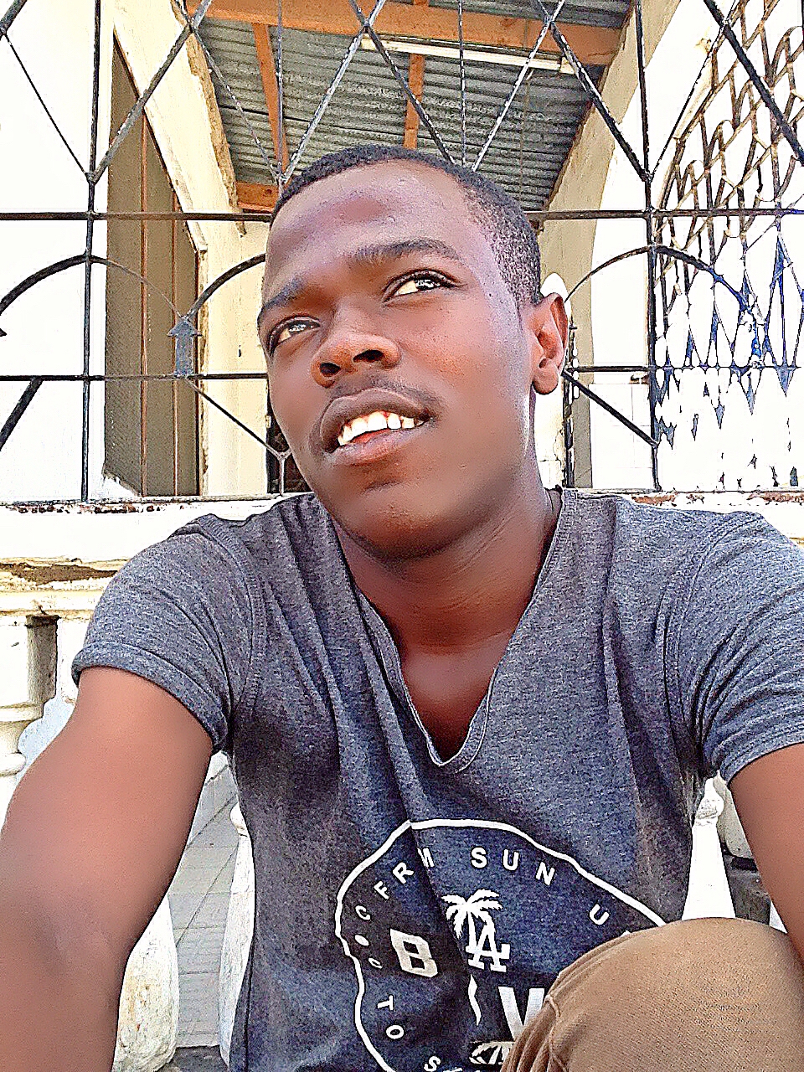
Ramadhan Khamis

Date of birth: 28.4.1993. hospital Ocean Road
Address: Tabata baraccuda-Dar Es Salaam, Tanzania
Mobile number: +255 655-272092
E-mail: rhamisi43@hotmail.com
Website: http://Tzcode.co.tz or tzcode.com
CEO: TzCode

Title: | Portfolio:  http://www.tzcode.com  Yoteyote community – Web developer:
Portfolio | My 1st website:  -Basic HTML / CSS  Yoteyote website:  - HTML5 / CSS3 / MSQL / PHP  Yoteyote works:  - C# / C / HTML5 /, JavaScript, MSQL / PHP / BOOTSRAP  Other :  - CMS: Joomla, Wordpress, Udk gamming. PC Gaming.  - Adobe paket: Photoshop, Flash , Adobe after Effect .
 | NEW YOTEYOTE COMMUNITY AVAILABLE NOW ON:

