_{ScPlayer}
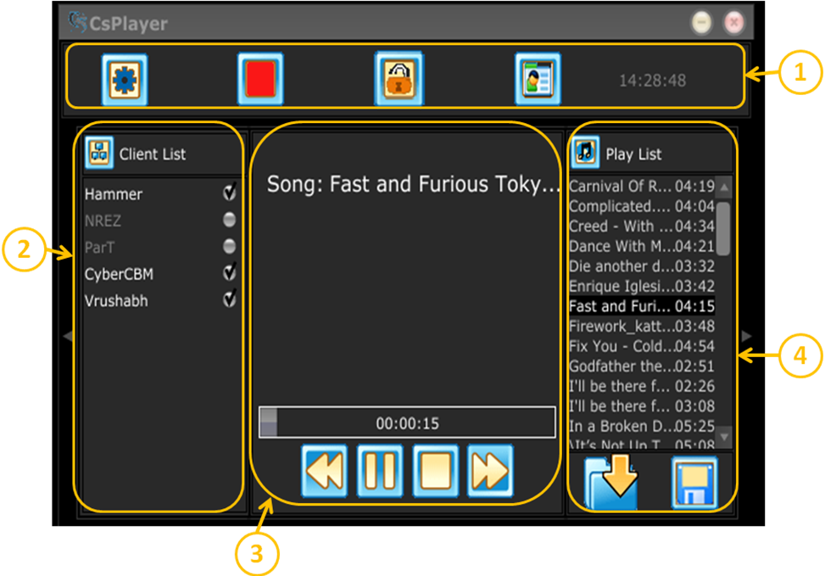
The ScPlayer is developed to play the songs on the network connected with LAN. There is only one audio output device availabe and that device is connected to the server only. So, the clients can connect to the server and ask for the rights and can play their desired songs. Basically, this player is used to play the songs on the network.
- Control Bar Component:
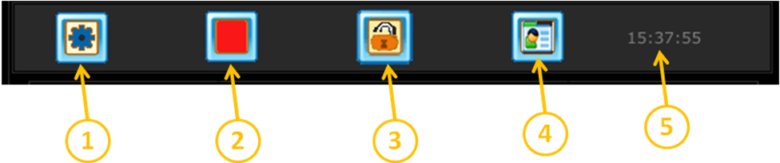
The top component of the player is the Control Bar Component. There are 4 buttons and a clock for display.
- AudioSettings Button: The audio settings includes audio device type, output, input, active output channels, active input channels, sample rate, audio buffer size and active midi inputs. The above parameters can be changed and the desired configuration can be set.
- Start/Stop Server Button: This button is used to start and stop the server. The red colour indicates that the server is currently stopped and the green colour indicates that the server is currently running.
- Allow/Release Lock Button: When any connected client applies lock to the server, the server is locked and this lock is indicated by this button. The server can release the acquired lock by clicking on this button.
- About ScPlayer: The basic description of the ScPlayer is displayed while clicking on this button.
- ClientList Component:
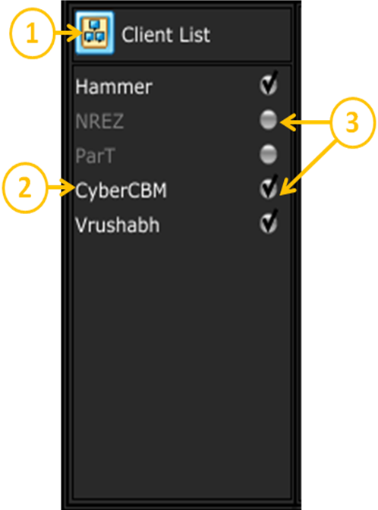
The ClientList Component shows the name/ip address of the clients connected to the server.
- Client List: Theclient list shows the name of the client and its connection status. If you right click on this label, you may display the ip addresses of the clients instead of their names.
- Client List Item: The client item has the name of the client and its connection status.
- Check Box: The tick indicates that the client is connected to the server. If the checkbox is not clicked then that client is not connected to the server. The colour of the text shall become green If the client is connected and shall become red if the lock is acquired.

- Player Component:
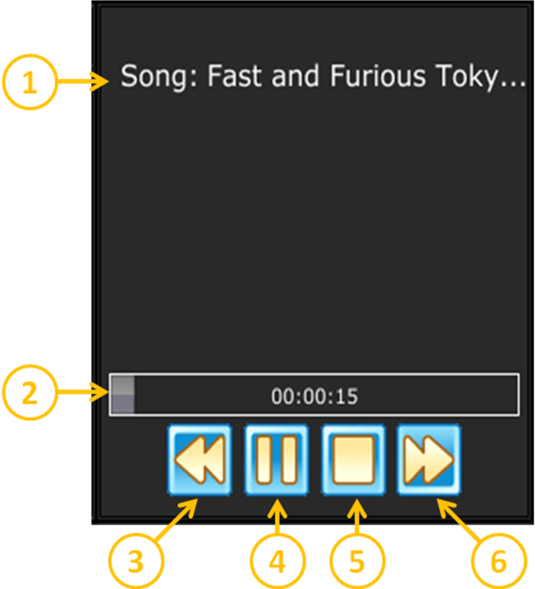
The player component shows the current song playing and the buttons to control the audio.
- Currently Playing Song Display: The name of the current playing or paused song is displayed.
- Seek Bar: The seek bar shows the progress of the song currently being played.
- Previous Button: When the previous button is clicked, the previous song of the currently playing song is played. If the previous button is pressed for more than half a second, then the song is reversed backward.
- Play/Pause Button: The current playing song can be played and paused by clicking on this button.
- Stop Button: The currently playing song is stopped when the stop button is clicked.
- Next Button: When the next button is clicked, the next song of the currently playing song is played. If the next button is pressed for more than half a second, then the song is forwarded.

- PlayList Component:
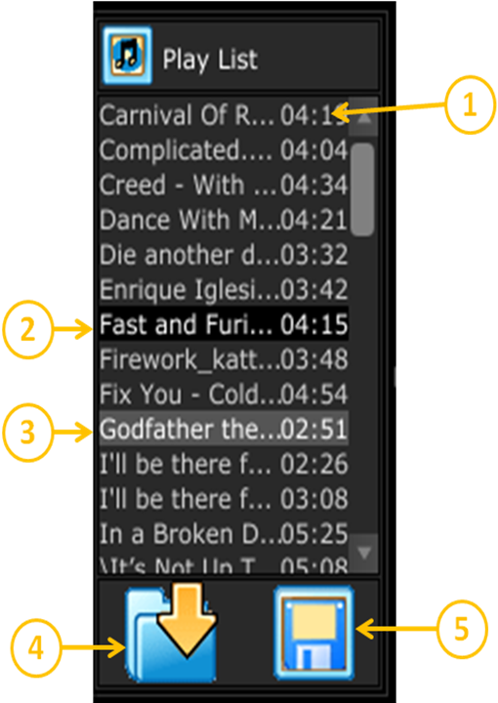
The PlayList Component contains the playlist of the songs added to the player. It contains a list containing songs and two buttons.
- Songs in the PlayList: The name and the duration of the songs added in the playList are displayed.
- Currently Playing Song: The currently playing song is highlighted as the black background as shown in above figure.
- Selected Song: The selected song is highlighted in the above way.
- Browse Button: If you want to add a song in the playlist from your hard drive, you may click this browse button and select the desired songs.
- Save PlayList Button: You can save the playlist at the desired location by clicking on this button.

