## Planning

Parts required:

* LCD for UI display
* Buttons for moving between LCD menus
* Two float switches (one for drip tray and one for water reservoir)
* Motor driver and peristaltic pump
* 12v supply for motor
* One-way values and water tubing
* Water moisture sensor

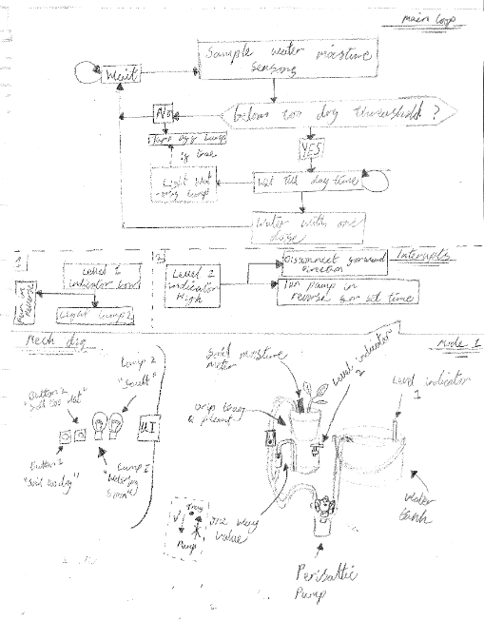

Figure

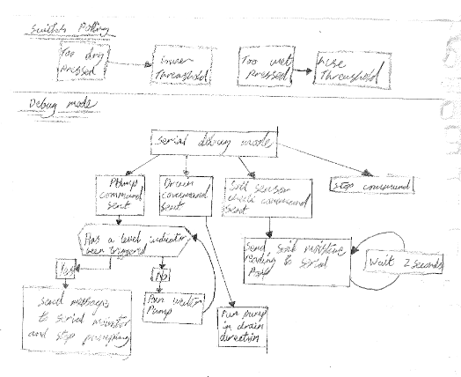

Figure 3

Figure 2

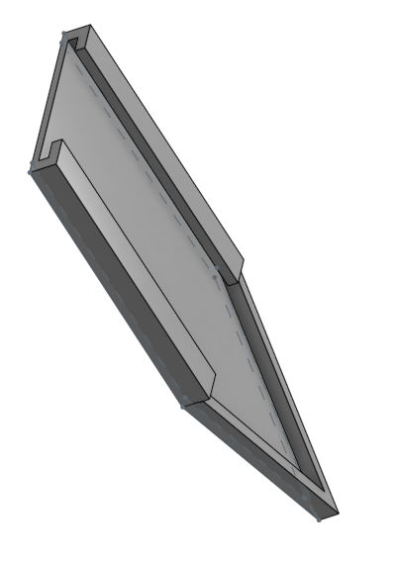

Figure 4

## Functionality

The functions are split into 3 main areas:

* The LCD UI
* Pumping/draining water depending on moisture/water levels
* Serial communication

## Techniques used

### Serial communication

Serial communication was used to test all features (sensors, motor) of the system before the LCD was implemented. Furthermore, as pins 0 and 1 are intentionally left unused this functionality would be used for testing/ quality control if the system was hypothetically manufactured. This facility is also used for outside devices to log the data from the moisture sensor to assist in calibrating it

### Motor (H bridge) control

The H bridge is used to control the 12V pump either pumping water to water the plant or to drain the drip tray of water

### LCD

Used as the user interface of the system and allows the user to test and calibrate the system as different soils and plants have different water requirements. The LCD has 3 main menus (Welcome screen, calibrate screen and test screen). Then sub menus to select the function (for calibrate add/reduce threshold or water amount and for testing menu they can test the pump/drain and check current readings)

### Buttons

There are two buttons used in this project for navigation of the LCD menus. This is done by adding values to a menu integer (main menus being represented as thousands, submenus as hundreds and selections as ones) this allows extra options to be easily added by just adding extra cases into the switch statement

### Interrupts

The system has two interrupts, one automatically drains the drip tray if it gets too full to avoid overflowing and the other interrupt alerts the user of a low/empty water reservoir

### ADC

The ADC takes readings from the moisture sensor and outputs it as an integer that can be used to determine when the soil needs watered. The depth of the sensor is important hence the sensor holder (Figure 4)