**SOFTWARE REQUIREMENTS SPECIFICATION**

**FOR**

**CUSTOMER SUPPORT DATA ANALYSI PROJECT**

**Prepared by: BSE GROUP 19**

**Organization: NSSF Uganda**

**Created on: 26TH /07/2017**

**Version 1.0**

Table Of Contents

**1.0 INTRODUCTION** 5

**1.1 Purpose** 5

**1.2 Document Conventions** 5

**1.3 Intended Audience and Reading Suggestions** 5

***Table 1.3.1: Overall Descriptions*** 5

**1.4 Product Scope** 6

**1.5 References** 6

**2.0** **OVERALL DESCRIPTION** 7

**2.1 Product Perspective** 7

**2.2 Product Functions** 7

***Figure 2.2.1 top level diagram of the NSSF Customer Support Data Analysis System.*** 8

**2.3 User Classes and Characteristics** 8

***Figure 2.3.1 use case diagram of the NSSF Customer Support Data Analysis System.*** 9

**2.4 Operating Environment** 9

**2.5 Design and Implementation Constraints** 9

**2.6 User Documentation** 9

**2.7 Assumptions and Dependencies** 10

**3.0** **EXTERNAL INTERFACE REQUIREMENTS** 11

**3.1 User Interfaces** 11

**3.2 Hardware Interfaces** 11

**3.3 Software Interfaces** 11

**3.4 Communication Interfaces** 11

**4.0 SYSTEM FEATURES** 12

**4.1 Data visualization** 12

**4.1.1 Description and Priority** 12

**4.1.2 Stimulus or Response Sequences** 12

**4.1.3 Functional Requirements** 12

**4.2 The Predict Feature** 12

**4.2.1 Description and Priority** 12

**4.2.2 Stimulus or Response Sequences** 12

**4.2.3 Functional Requirements** 13

**4.3 The search feature** 13

**4.3.1 Description and Priority** 13

**4.3.2 Stimulus or Response Sequences** 13

**4.2.3 Functional Requirements** 13

**4.4 The download feature** 13

**4.4.1 Description and Priority** 13

**4.4.2 Stimulus or Response Sequences** 13

**4.2.3 Functional Requirements** 14

**5.0 OTHER NON FUNCTIONAL REQUIREMENTS** 15

**5.1 Performance Requirements** 15

**5.2 Safety Requirements** 15

**5.3 Security Requirements** 15

**5.4 Software Quality Attributes** 15

**APPENDIX: GLOSSARY** 16

**LIST OF TABLES**

***Table 1.3.1: Overall Descriptions*** 5

**LIST OF FIGURES**

***Figure 2.2.1 top level diagram of the NSSF Customer Support Data Analysis System.*** 8

***Figure 2.3.1 use case diagram of the NSSF Customer Support Data Analysis System.*** 9

# **1.0 INTRODUCTION**

## **1.1 Purpose**

The purpose of this System Requirements Specification is to provide a full description of the requirements of the NSSF Customer Support Data Analysis Project. The system software requirements include both functional and non-functional requirements.

Functional requirements are functions that the system should do and non-functional requirements are requirements that can be used to judge the operation of the system such as performance etc.

## **1.2 Document Conventions**

When writing this System Requirements Specification for the NSSF Customer Support Data Analysis System different conventions were followed.

- A Times New Roman Font was used. Main headings were given a font size of 14, and bold faced and the normal text was given a font size of 12.

## **1.3 Intended Audience and Reading Suggestions**

This document is intended for project managers, systems administrators and the decision making team at NSSF Uganda to initiate an open discussion to look into the current Customer Support System. This document will guide them into making correct decisions to improve the Customer Support System.

## ***Table 1.3.1: Overall Descriptions***

|  |  |
| --- | --- |
| **Section** | **Description** |
| Overall Description | This section mainly gives information about the overall description of the NSSF Customer Support Data Analysis system such as its perspective, user classes and characteristics, its main functions, operating environment and many more others. |
| External Interface Requirements | Describes all the interfaces of the NSSF Customer Support Data Analysis System such as the hardware interfaces, software interfaces, communication interfaces and the user interfaces. |
| System Features | This section highlights the functional requirements that is, the major services that will be provided by the NSSF Customer Support Data Analysis System. |
| References | This section describes a list of references on which this document is based. |
| Glossary | This describes briefly all the general terms used in this software requirements specification. |

## **1.4 Product Scope**

1. **NSSF project manager:** The NSSF systems administrator is going to use this analysis report to find flaws in the customer support system and forward it to the top level administrators for decision making on how to improve it.
2. **NSSF systems Administrator:** The NSSF systems administrator is mainly meant to maintain the proposed system once it is in operation.
3. **System Scope:** The results of this analysis is going to provide a report on how the system users (NSSF customers) and the NSSF workers (operators) interact with the current customer support system.

## **1.5 References**

Please consult the project scope document of the NSSF Customer Support Data Analysis System if you need more information regarding the project scope.

# **2.0** **OVERALL DESCRIPTION**

## **2.1 Product Perspective**

* The NSSF customer support data analysis system will require the NSSF intranet for it to operate, it uses a CSV file containing data from the NSSF Customer Support System to fetch and display results such as the graphs, analyzed data, charts and others.
* All the graphical representations are displayed on a user interface of this system installed on a local computer.
* The product (the system) is not a replacement of any existing system but it uses the data from the NSSF Customer Support System to provide full analysis of the data.

## **2.2 Product Functions**

* To provide an analysis of the most commonly asked questions and how to answer them as quickly as possible.
* To guide NSSF staff on how to improve the way operators respond to the various questions asked by the clients.
* To determine the time when there are many incoming requests and provide advice on how to handle those requests by the correct number of operators.
* To provide an analysis of the average number of clients to the online customer support system per day and give suggestions on how to provide better services to them.
* To find out if the customers get the exact help they need from the NSSF online operators.

**Provided below is a top level diagram of the NSSF Customer Support Data Analysis System.**

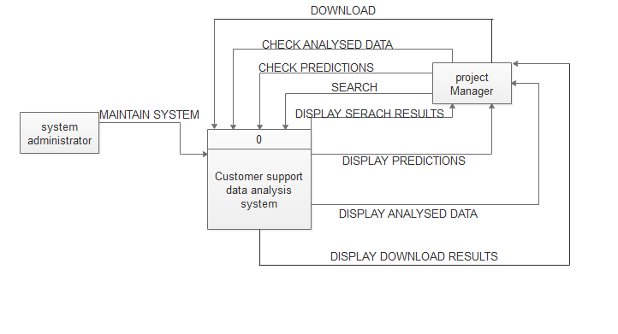

## ***Figure 2.2.1 top level diagram of the NSSF Customer Support Data Analysis System.***

## **2.3 User Classes and Characteristics**

* **User class 1-System administrator**

1. Uploads the data files
2. Checks whether there are errors with the data
3. Maintains the system

* **User class 1- Project Manager**

1. Uploads the data files
2. Checks the analyzed data
3. Presents analyzed data to the top executives for decision making.

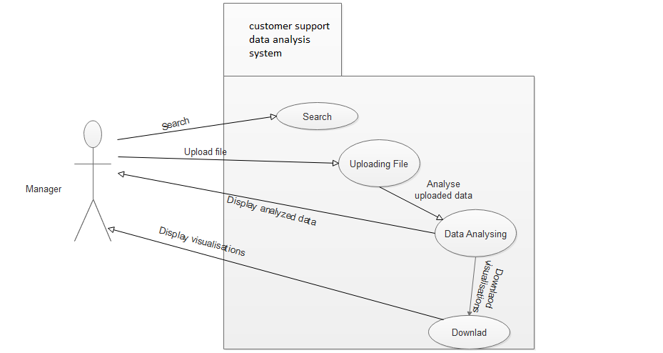

## ***Figure 2.3.1 use case diagram of the NSSF Customer Support Data Analysis System.***

## **2.4 Operating Environment**

* The system will require intranet of the organization for it to operate. The system is expected to operate on every hardware of a computer.
* It can also operate on all windows versions, Linux and Ubuntu. The system will run using any browser.

## **2.5 Design and Implementation Constraints**

* Programming standards: The organization will be responsible for maintaining the system because it is a long term project that has to be used with changing data throughout the years NSSF will be in operation.
* Unreliable internet since some of the resources have to be got from internet.
* Poor funding of the project.

## **2.6 User Documentation**

User documentations such as the project scope so far have been given in handy.

The users of this system shall refer to these documents for any further information about the Customer Support Data Analysis System.

The system is under development stage and requires a complete implemented prototype to explain the user documentation. Once the prototype is designed and implemented online manuals, user manuals shall be provided.

## **2.7 Assumptions and Dependencies**

**Assumptions**

* Effort: The project will need fulltime commitment, hard work, research and team work.
* Schedule: The system will take 2 to 4 weeks including implementation.
* Resources: The project will be done by 3 to 4 members each with a computer connected to internet working for at least 5-6 hours every day.
* Budget: The project may cost a minimum of 3 million Uganda Shillings for all the events and tasks.
* Software: The existing software will be used such as R studio.

**Dependencies**

* The system will depend on a CSV file which contains all the data that will be used to display the charts and graphs showing the data analysis.
* The existing software will be used such as R studio.

# **3.0** **EXTERNAL INTERFACE REQUIREMENTS**

## **3.1 User Interfaces**

There will be designed interfaces to show the carried out analysis. Below is a sample of the main interface which is still under development in RStudio.

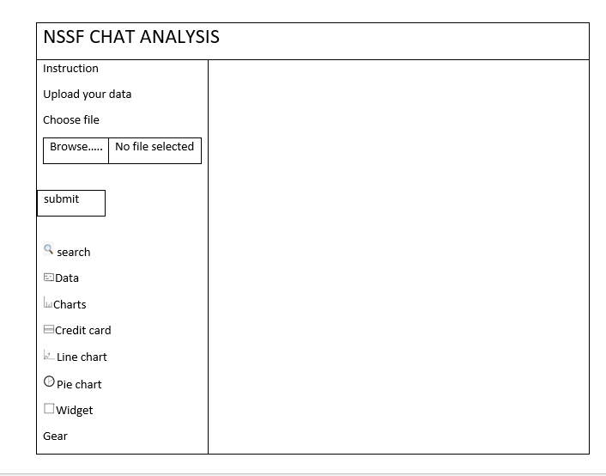

**Figure 3.1.1 User Interface**

## **3.2 Hardware Interfaces**

* This system will not require any special hardware designed in advance. The minimum requirement is a computer system with at least 2 GB of RAM, 500 GB of storage space.

## **3.3 Software Interfaces**

* This System requires special packages like the shiny and dashboard packages which will all be downloaded to help in the designing of the user interfaces.
* R-studio is used to edit and compile the source code. For Browser support, R-Studio contains a special browser to display the content.

## **3.4 Communication Interfaces**

* The Customer Support Data Analysis System shall use the HTTP protocol for communication over the localhost since no internet connection shall be required.

# **4.0 SYSTEM FEATURES**

## **4.1 Data visualization**

### **4.1.1 Description and Priority**

This is a collection of various visualization techniques that shall be used to analyze the customer support data. Such visualization techniques include bar graphs, scatter plots, a word cloud to display most appearing n-grams and any others as will be required.

### **4.1.2 Stimulus or Response Sequences**

Stimulus: The user uploads a comma separated value file to be analyzed.

Response: A confirmation message is displayed showing successful upload

Stimulus: The user has to click on a button depending on the visualization technique they want to use.

Response: A visualization diagram such as a bar graph, scatter plot etc shall be displayed depending on the choice made by the user.

### **4.1.3 Functional Requirements**

* Browser support on every machine running this system
* RStudio and R (version 3.4 and above) installed on every machine
* CSV file containing the data to be analyzed.

## **4.2 The Predict Feature**

### **4.2.1 Description and Priority**

This feature will help give a future prediction of what will happen in the future such as an increase or decrease in the number of customers accessing the NSSF Customer Support System.

This is a high priority feature because it will help the NSSF executives to make better decisions in order to improve services they offer to their customers.

### **4.2.2 Stimulus or Response Sequences**

Stimulus: The user clicks on a line graph.

Response: A line graph (uses data from the uploaded CSV file) is displayed on the dashboard.

Stimulus: The user clicks the predict button

Response: An improved line graph is displayed showing prediction of what will happen over a specified amount of time in the future.

### **4.2.3 Functional Requirements**

* Browser support on every machine running this system
* RStudio and R (version 3.4 and above) installed on a computer system running this system.
* CSV file containing the data to be analyzed.

## **4.3 The search feature**

### **4.3.1 Description and Priority**

This feature shall allow users of the NSSF Customer Support Data Analysis System to search for certain clients, pages depending on what they need.

This is a high priority feature because during analysis users might want to know what is going on with the clients and operators and in this case they have to search through the uploaded CSV file.

### **4.3.2 Stimulus or Response Sequences**

Stimulus: The user types a keyword in the search box.

Response: A list of search results are displayed to the user.

### **4.2.3 Functional Requirements**

* Browser support on every machine running this system
* RStudio and R (version 3.4 and above) installed on a computer system running this system.
* CSV file containing the data to be analyzed.

## **4.4 The download feature**

### **4.4.1 Description and Priority**

The download feature shall allow users of the NSSF Customer Support Data Analysis System to download search for certain clients, pages depending on what they need.

This is a medium priority feature as users may not need to download the graphic visualizations every time. It depends on the needs of the users anyway.

### **4.4.2 Stimulus or Response Sequences**

Stimulus: The user clicks the download.

Response: An image of format png is downloaded to their computer.

### **4.2.3 Functional Requirements**

* Browser support on every machine running this system
* RStudio and R (version 3.4 and above) installed on a computer system running this system.
* CSV file containing the data to be analyzed.

# **5.0 OTHER NON FUNCTIONAL REQUIREMENTS**

## **5.1 Performance Requirements**

The NSSF Customer Support Data Analysis System shall not be hosted and has to be run from a local web server (Apache web server) on a local computer system.

It will also take an initial load time depending on the capabilities of the computer system and the size of the file.

## **5.2 Safety Requirements**

1. To prevent failure of the software, the user should make sure that the file to be uploaded is a CSV file.

## **5.3 Security Requirements**

The NSSF Customer Support Data Analysis System will only be disclosed to the NSSF executives who are responsible for decision making in the organization.

## **5.4 Software Quality Attributes**

**Reusability**

The system will be rebuilt, and enhanced to meet the new needs of the user. Therefore newer versions of the systems will be released based on the demands of users.

**Usability**

The system has a good graphical interface which is easy to handle, use and navigate even for people with little knowledge about complex systems.

# **APPENDIX: GLOSSARY**

Browsers: A software application for retrieving, presenting, and traversing information resources on the wide world web.

Prototype: a first, typical model of something from which other forms are developed or copied.

Developers: These are people concerned with facets of the software development process, including research, design, programming, and testing of computer software.

Functional requirements: These are the features that describe what exactly the system is going to do.

Shiny: This is a package in R that has tools that are to be used in developing the user interface.

CSV: Comma Separated Values

**HTTP:** Hypertext transfer protocol, the set of rules for exchanging files such as texts, graphics, sound and other multimedia files on the web.