**Personal Portfolio Website**



# **Department of Computer Science and Engineering**

## ****Pundra University of Science and Technology, Gokul, Bogura.****

### ****Project Title****: Personal Portfolio Website

### ****Author****: Arafat Rahman

### ****Student ID****: 0322310105101052

### ****Semester****: 4th Semester

### ****Session****: Summer-2024

### ****Batch****: 22nd

### ****Submitted To****:

**Nahid Hasan  
Lecturer  
Department of Computer Science and Engineering, PUB.**

**Abstract**

This project is a personal portfolio website developed to highlight my skills, academic background, and projects. The website offers an interactive and user-friendly interface to present dynamic content about my professional work. It is developed using **HTML**, **CSS**, **JavaScript** and **PHP**, providing a modern approach to showcasing personal and technical achievements. The backend is integrated with the contact form to store and manage data in an admin panel. This demonstrates my ability to combine frontend and backend technologies into a functional application. The website is designed to provide potential employers or clients with detailed insights into my skills, projects, and contact information.

**Live Website URL**: <https://arafat-portfolio-ar.netlify.app/>

**Table of Contents**

1. **Introduction**  
   1.1. Purpose  
   1.2. Scope
2. **Objectives**  
   2.1. Usability  
   2.2. Functionality  
   2.3. Reliability  
   2.4. Scalability
3. **Technologies Used**  
   3.1. HTML  
   3.2. CSS  
   3.3. JS  
   3.4. MySQL
4. **Project Architecture**  
   4.1. Model-View-Controller (MVC) Architecture
5. **Features and Functionality**  
   5.1. Home Page  
   5.2. About Page  
   5.3. Portfolio Page 5.4.Skills Page  
   5.5. Services Page  
   5.6. Contact Page 5.7.Admin Page
6. **Implementation Details**  
   6.1. Contact Form Integration  
   6.2. Admin Panel for Data Storage  
   6.3. User Interface Design  
   6.4. Implementation Code
7. **Testing and Evaluation**  
   7.1. Unit Testing  
   7.2. Integration Testing  
   7.3. User Acceptance Testing (UAT) Insights
8. **Challenges Faced**  
   8.1. Managing Boundary and Edge Cases  
   8.2. Ensuring Cross-Platform Compatibility
9. **Future Enhancements**  
   9.1. Incorporating Additional Features  
   9.2. Implementing a Blog Management System  
   9.3. Offering Extensive UI Customization  
   9.4. Introducing Keyboard Shortcuts for Efficiency
10. **Conclusion**
11. **References**

**1. Introduction**

**1.1 Purpose**

The purpose of this project is to create an engaging personal portfolio website that serves as an online resume for professional opportunities. This portfolio will highlight my skills, technical expertise, academic background, and completed projects. The website also provides a point of contact for potential employers or clients through a functional contact form.

**1.2 Scope**

The scope of this project involves the development of a fully functional portfolio website. The website includes several sections: Home, About, Projects, Services, and Contact. The primary focus of the backend is to handle the **contact form**, with the data being stored in an **admin panel** for future reference and management. The project will use modern web technologies to ensure the website is dynamic, responsive, and user-friendly.

**2. Objectives**

**2.1 Usability**

The website must provide an easy-to-navigate interface with a clear layout. Users should be able to quickly access information about my skills, projects, and background. Additionally, the contact form should be intuitive and easy to use.

**2.2 Functionality**

The website should be functional, with interactive elements such as the contact form. The contact form will store user input in the database and allow the admin (me) to view and respond to messages. Other sections, like Projects and Blogs, should dynamically display content fetched from the backend.

**2.3 Reliability**

The portfolio should function seamlessly without errors. The backend should handle contact form submissions reliably, and the website should display all data accurately. There should be no disruptions to the user experience.

**2.4 Scalability**

The project should be scalable to add more features in the future, such as an online portfolio for selling services or a detailed blog management system.

**3. Technologies Used**

**3.1 HTML**

HTML is the backbone of the website, organizing its structure with semantic tags for better readability and SEO optimization. It includes essential components like navigation menus, headers, sections, and forms, forming the layout of pages such as Home, About, Portfolio, Services and Contact. HTML5 introduces advanced features like multimedia support, ensuring a modern and interactive user experience.

**3.2 CSS**

CSS defines the aesthetic appeal and responsive design of the website. It uses styling properties to create visually consistent themes, including color palettes, typography, and spacing. Media queries ensure adaptability across devices, while advanced techniques like CSS animations and transitions add life to the design.

**3.3 JavaScript**

JavaScript enriches the user experience by enabling dynamic functionality. It powers interactive elements such as dropdown menus, modals, and real-time content updates without reloading pages. JavaScript frameworks like React can manage component-based designs, enhancing scalability and efficiency. AJAX and API integration allow smooth backend communication for features like dynamic project listings or blog updates.

**3.4 MySQL**

MySQL handles backend data management with its structured, relational database model, making it ideal for managing user inputs like contact form submissions. Its integration with Node.js enables efficient CRUD (Create, Read, Update, Delete) operations. MySQL’s scalability ensures smooth performance even with increased data volume, while robust indexing and advanced query optimization improve data retrieval efficiency. The admin panel connects seamlessly to MySQL, allowing intuitive and secure management of stored data.

**4. Project Architecture**

**4.1 Model-View-Controller (MVC) Architecture**

* **Model**:  
  MySQL serves as the model, storing user-submitted data such as contact form inputs. It provides a relational database structure for efficient data management and ensures that stored information is easily retrievable, modifiable, and well-organized using tables, rows, and columns.
* **View**:  
  The user interface, created with HTML, CSS, and JavaScript, represents the view.
  + **HTML**: Structures the content and layout of the web pages, defining essential sections such as forms, navigation menus, and project details.
  + **CSS**: Styles the interface to make it visually appealing, applying layouts, colors, typography, and responsive designs for different devices.
  + **JavaScript**: Adds interactivity and dynamic behaviors, such as handling form validation, updating content without page reloads, and enabling animations.
* **Controller**:  
  JavaScript in the browser acts as the controller, managing user interactions and connecting the view to the model. It handles tasks like sending form data to the backend, fetching content from MongoDB, and dynamically updating the UI based on data or user actions.

This MVC approach ensures that the application is modular, with clear separation of concerns, making it easy to update or expand the website.

**5. Features and Functionality**

**5.1 Home Page**

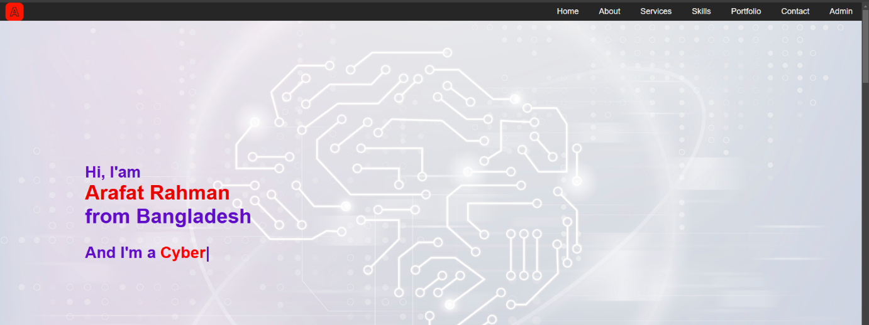

**Description:**  
The Home page serves as the introduction to the portfolio, with an overview of who I am, my skills, and a brief introduction.

**Functionality:**

* The Home page provides navigation to all other sections of the site.
* Displays dynamic content like skills and highlights from the projects section.

**5.2 About Page**

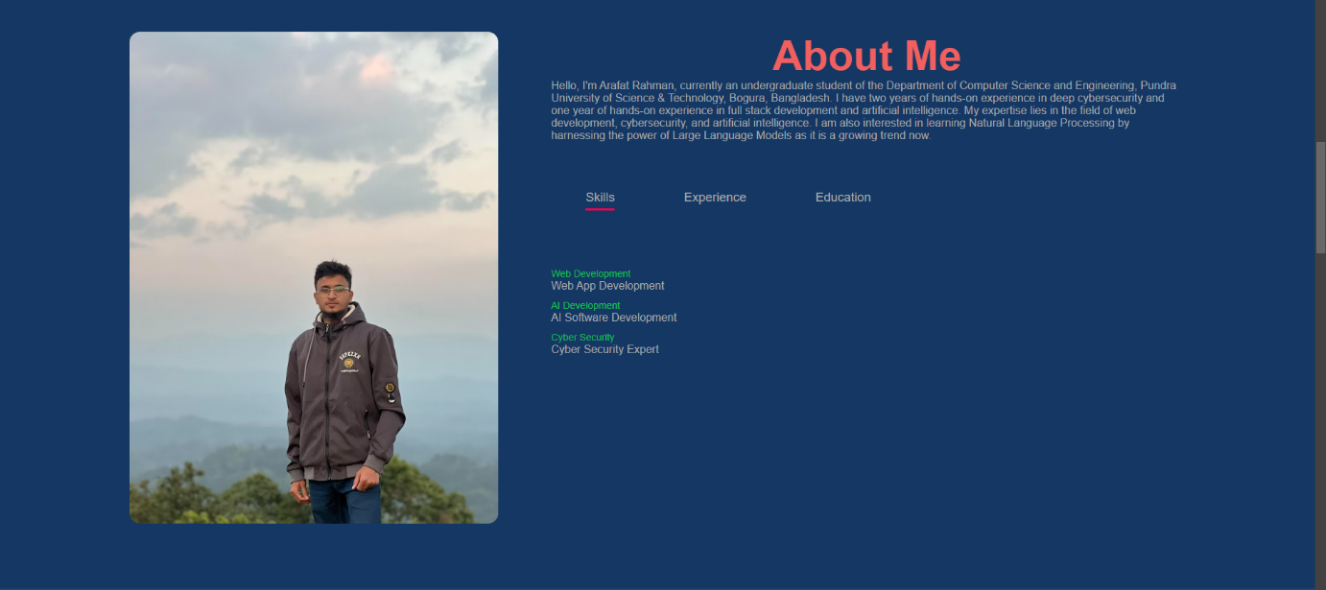

**Description:**  
The About page provides in-depth information about my skills, education, achievements.

**Functionality:**

* Displays text and images dynamically loaded from the backend (if needed).
* Clear sections that describe each aspect of my professional journey.

**5.3 Portfolio Page**



**Description:**  
The Portfolio page lists my completed projects, showcasing the skills and technologies used in each one

**Functionality:**

* Each project is displayed as a card with a description and a link to the live demo or repository.

**5.4 Skills Page**

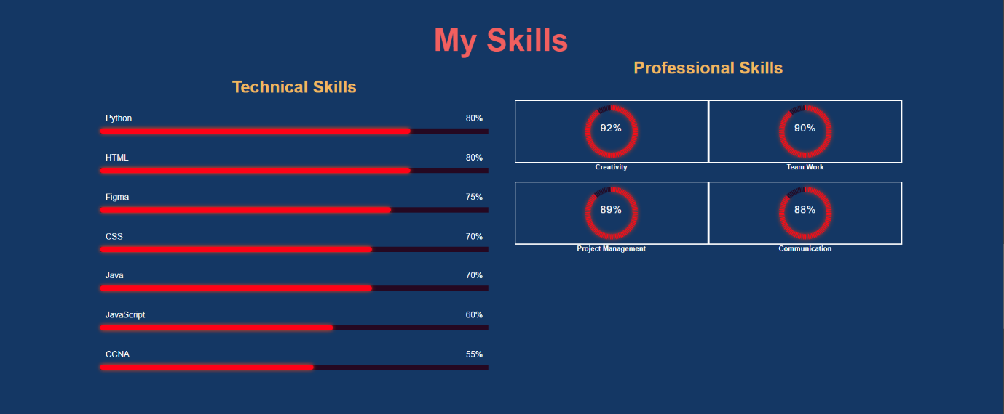

**Description:**

The updated Skills section highlights your capabilities with distinct **Technical Skills** and **Professional Skills**:

* **Technical Skills:** Illustrated with horizontal progress bars showcasing the proficiency levels in key areas such as Python, HTML, Figma, Java, and CCNA.
* **Professional Skills:** Displayed as circular progress indicators emphasizing soft skills like Creativity (92%), Teamwork (90%), Project Management (89%), and Communication (88%).

**Functionality:**

* The design uses a clean blue background with contrasting red progress bars and circular indicators.
* The layout categorizes the skills effectively, allowing for an intuitive user experience.
* The percentages visually emphasize the level of expertise in each skill, providing clarity to viewers.

**5.5 Services Page**

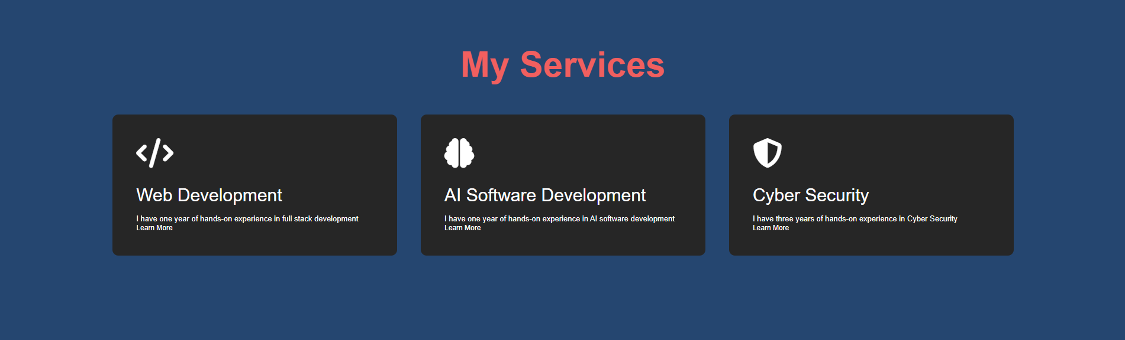

**Description:**  
The Services page lists my Services such as Web Devlopment,AI Devlopment,Cyber Security.

**Functionality:**

* Each project is displayed as a card with a description and a link to the live demo or repository.

**5.6 Contact Page**

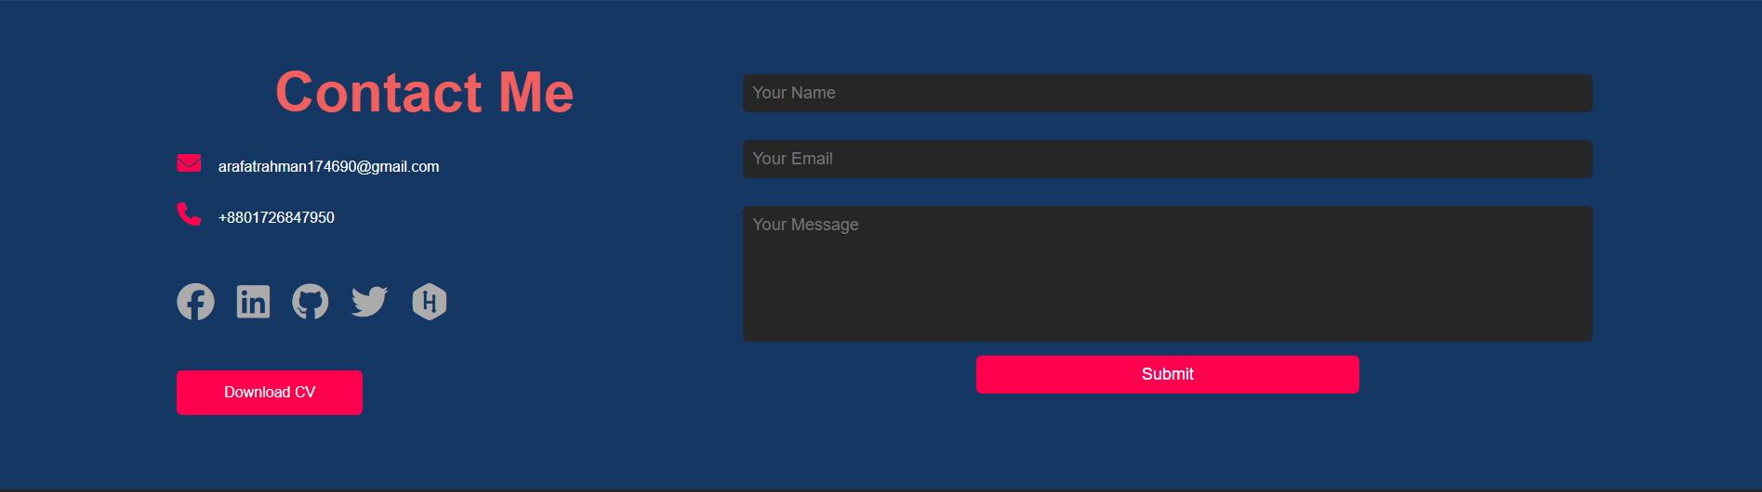

**Description:**  
The Contact page allows users to reach out to me by filling out a form with their details and message.

**Functionality:**

* When the form is submitted, the data is sent to the backend and stored in MySql.

**5.7 Admin Page**

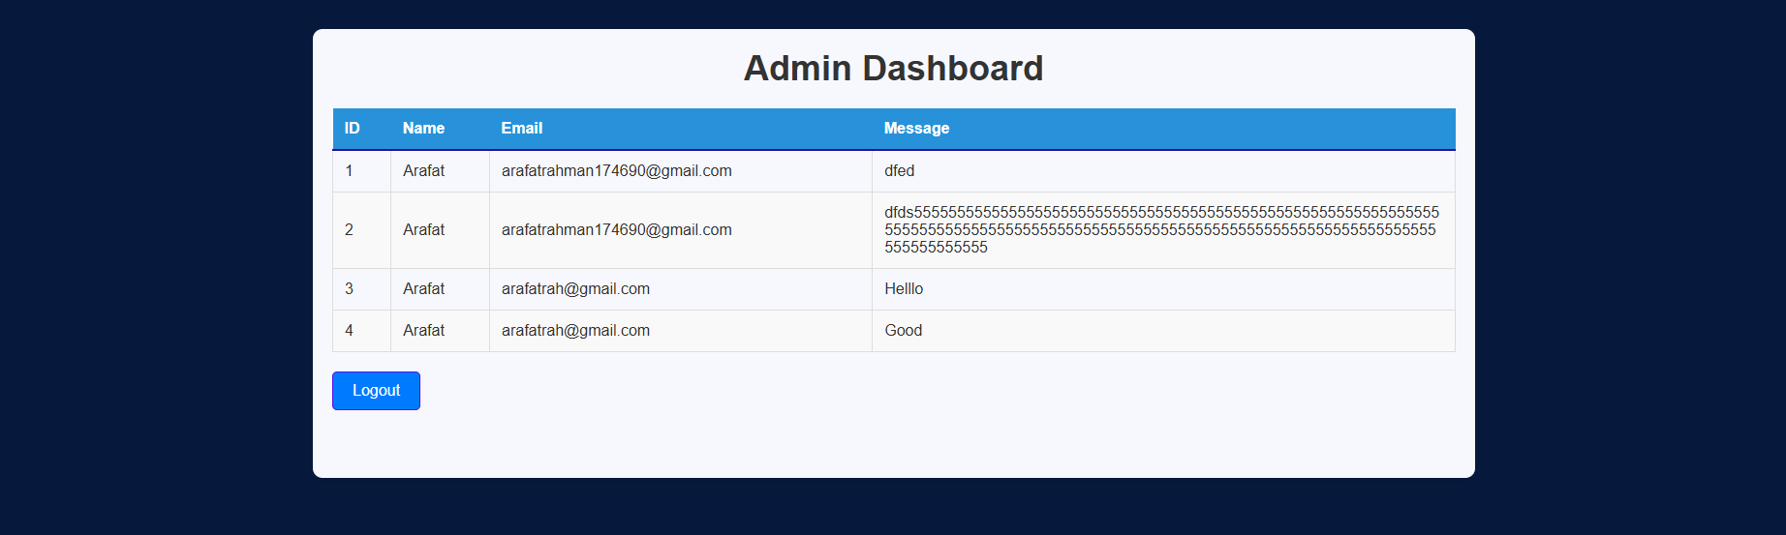

**Description:**  
The Admin page allows users to reach out to me by filling out a form with their details and message

**Functionality:**

* The admin panel allows me to view and respond to messages submitted via the form.

**6. Implementation Details**

**6.1 Contact Form Integration**

The contact form was integrated with Node.js, allowing form data to be submitted to the backend and stored in MongoDB. Form submission includes validations to ensure all required fields are filled correctly.

**6.2 Admin Panel for Data Storage**

The contact form data is stored in MySQL, and an admin panel allows me to view the submitted messages. This setup enables efficient management and timely responses to inquiries received via the contact form.

**6.3 User Interface Design**

CSS was used for designing the user interface, ensuring that it is responsive and adaptable to different screen sizes. Key design principles include simplicity, readability, and user-friendly navigation.

**6.4 Implementation Code**

• **Frontend**:  
The frontend is created using **HTML**, **CSS**, and **JavaScript** to ensure a responsive, interactive, and user-friendly interface:

* **HTML**: Provides the structural foundation of the website, organizing content into sections such as Home, About, Services, and Contact.
* **CSS**: Enhances visual presentation with styling for layouts, colors, fonts, and responsiveness. Advanced CSS features like media queries ensure the website adapts to various screen sizes.
* **JavaScript**: Powers interactivity by enabling dynamic behaviors such as form validation, smooth scrolling, content updates without reloading, and animations for an engaging user experience.

• **Backend**:

• **PHP**: Handles data submissions and interactions between the frontend and the MySQL database.  
• **JavaScript**: Facilitates fetching and storing user inputs, such as form submissions, ensuring efficient communication with the MySQL database through AJAX or API endpoints.

**7. Testing and Evaluation**

**7.1 Unit Testing**

Unit tests were performed on individual components, ensuring they functioned as expected.

**7.2 Integration Testing**

Integration tests confirmed that the frontend and backend systems communicate properly, ensuring smooth data transfer between the two.

**7.3 User Acceptance Testing (UAT) Insights**

Feedback from users helped refine the website’s user interface, ensuring that the portfolio met user expectations in terms of usability and functionality.

**8. Challenges Faced**

**8.1 Managing Boundary and Edge Cases**

During the development, one of the challenges was managing boundary and edge cases, especially when handling form submissions. Ensuring that all fields were validated properly before submission and handling unexpected inputs or errors gracefully were crucial to maintaining the reliability of the contact form.

**8.2 Ensuring Cross-Platform Compatibility**

Ensuring that the website functions seamlessly across various platforms (different browsers, mobile devices, and desktops) was a challenge. Using responsive design principles in combination with CSS helped address this issue. However, testing across multiple browsers and devices was necessary to guarantee the best experience for all users.

**9. Future Enhancements**

**9.1 Incorporating Additional Features**

In the future, I plan to expand the functionality of the website by adding new features such as an online portfolio for selling services, allowing clients to reach out for specific web development tasks or projects.

**9.2 Implementing a Blog Management System**

Currently, the blogs page is static, but a blog management system could be added, allowing me to write, edit, and delete blog posts from the admin panel.

**9.3 Offering Extensive UI Customization**

I plan to provide users with an option to customize the website’s appearance, such as switching between light and dark themes, adjusting the layout, or choosing color schemes.

**9.4 Introducing Keyboard Shortcuts for Efficiency**

Incorporating keyboard shortcuts to improve the efficiency of user navigation and interaction with the website will be beneficial. For example, users could press "Ctrl + 1" to navigate directly to the Home page or use other shortcuts for faster access to sections.

**10. Conclusion**

In conclusion, this project demonstrates my proficiency in web development by combining frontend technologies (HTML, CSS) with a backend (JavaScript, MongoDB) to create a fully functional personal portfolio website. The website serves as an interactive and user-friendly platform for showcasing my skills, projects, and achievements. The inclusion of the contact form with a functional backend also demonstrates my ability to work with databases and handle form data.

The project met its objectives of usability, functionality, and reliability, and provided a solid foundation for future improvements. As I continue to develop my skills, I plan to incorporate additional features and functionality to further enhance the portfolio’s value.

**11. References**

1. **HTML Documentation:** <https://developer.mozilla.org/en-US/docs/Web/HTML>
2. **CSS Documentation:** <https://developer.mozilla.org/en-US/docs/Web/CSS>
3. **JavaScript Documentation:** <https://developer.mozilla.org/en-US/docs/Web/JavaScript>
4. **MySql Documentation:**  [https://dev.mysql.com/doc/](%20https://dev.mysql.com/doc/)