Step 1：download XAMPP server

Download Link：<https://we.tl/t-euDNywHw1Y>

Step 2：installed xampp，use default path

Step 3：try to start xampp server

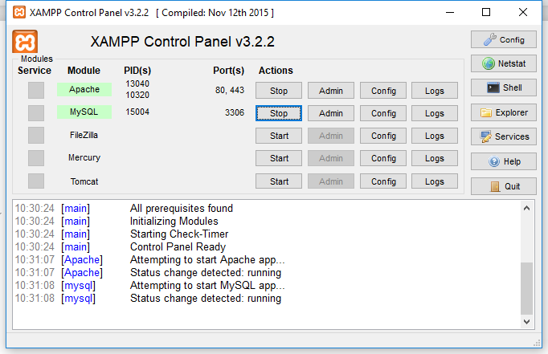

It happened port occupation problem，search some approach from Google，change the mysql port or Apache port

Step 4：start php_socket

C:\xampp\php\php.ini, find extension=php_sockets.dll Release notes

Coppy C:\xampp\php\php5ts.dl into c:\windows\system32

[decompression](https://www.baidu.com/link?url=3Cs6Ys0ZiMhIGcs_wjv5ybgnVMo8hiy1DFR5h3rVLVGJZ0NgNEnv2sesoxuGiv9YLZnxt-M2v3D4e5cCS_AKjDTbjV74LY_I4-iEKr-7u_W&wd=&eqid=9793e09400052dd6000000065d0af850" \t "https://www.baidu.com/_blank) code into C:\xampp\htdocs

Then update code ,’Realtime_Mysql\main\db\config.php’Update the ip address and your db name

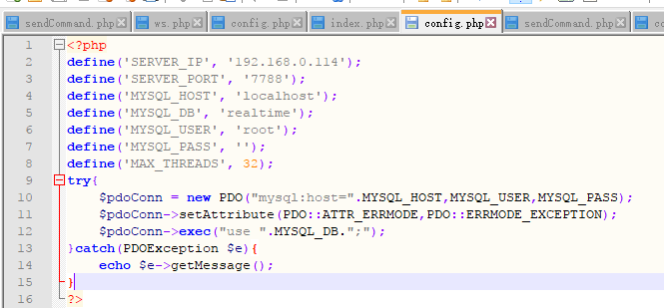

Search <http://localhost/phpmyadmin/sql.php> to create your db

Step 5：restart xampp server

Step 6：Search <http://localhost/Realtime_Mysql/ws.php>

Step 7：Search [http://localhost/Realtime_Mysql](http://localhost/Realtime_Mysql/ws.php)

(some detail referenced vedio )