BlockTix: Decentralized Ticketing Platform – Comprehensive Technical & Operational Report
Author: Muhammad Atif
Date: October 26, 2024
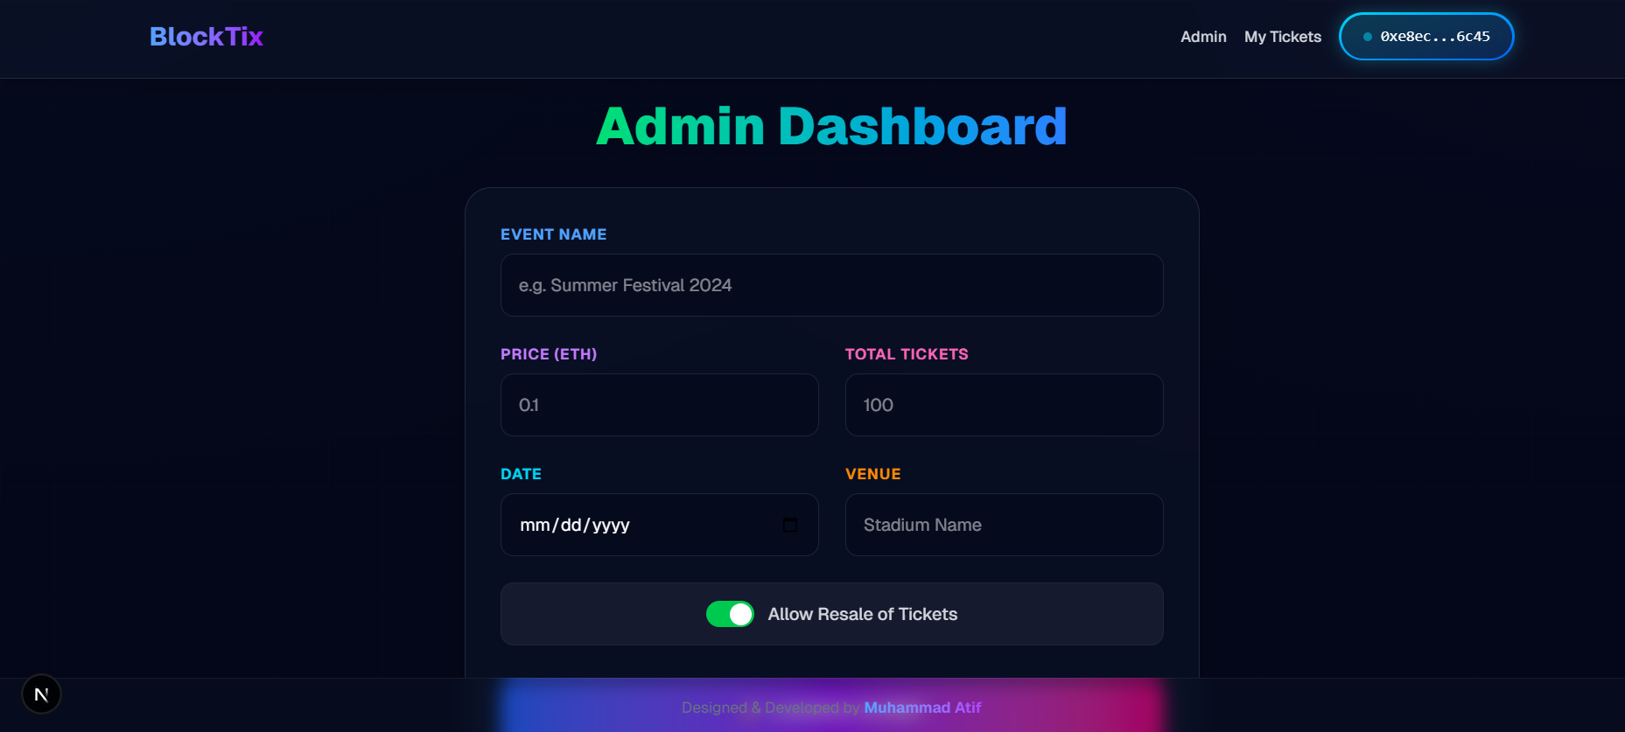

Table of Contents
- Executive Summary
- Development Lifecycle & Technology Stack
- Architectural Overview
- Smart Contract Engineering
- Deployment & Network Configuration
- Operational Workflows
- Troubleshooting & System Maintenance
- Conclusion
- Appendices

1. Executive Summary
BlockTix is a decentralized ticketing platform built on Ethereum blockchain technology, designed to address pervasive issues in the traditional ticketing industry such as fraud, lack of transparency, and intermediary dependency. By leveraging Non-Fungible Tokens (NFTs) for ticket representation, BlockTix ensures each ticket is unique, verifiable, and owned securely by the purchaser.
This report provides a comprehensive overview of the platform’s development lifecycle, technical architecture, deployment methodology, and user workflows. It is intended for multiple stakeholders: developers maintaining the system, administrators managing events, and end-users purchasing and reselling tickets.
Key innovations include:
- Zero-gas local testing environment
- Automated contract deployment and synchronization
- Integrated wallet auto-funding for seamless user onboarding
- Configurable resale controls to combat scalping
The platform is fully functional in a local development environment and demonstrates a scalable, secure model for decentralized event management.

2. Development Lifecycle & Technology Stack
The development of BlockTix followed an iterative, security-first approach, emphasizing modularity, reusability, and adherence to industry best practices.
2.1 Technology Stack
Layer | Technology | Purpose
Blockchain | Solidity (v0.8.20) | Smart contract development
 | Hardhat | Local Ethereum network, testing, deployment
 | OpenZeppelin Contracts | ERC721 implementation and access control
Frontend | Next.js | Server-rendered React application
 | TypeScript | Type-safe frontend development
 | Tailwind CSS | Utility-first styling with dark mode support
 | Ethers.js (v6) | Blockchain interaction and wallet integration
Tooling | MetaMask | User wallet and transaction signing
 | Node.js | Runtime environment
2.2 Development Philosophy
- Security: Use of audited OpenZeppelin libraries and explicit access controls.
- Usability: Frictionless onboarding with auto-funding and zero-gas mode.
- Decentralization: Direct peer-to-peer transactions without intermediaries.
- Maintainability: Modular code structure with clear separation of concerns.

3. Architectural Overview
The BlockTix platform is structured as a monorepo with two primary components: the smart contract backend and the Next.js frontend.
3.1 System Architecture Diagram
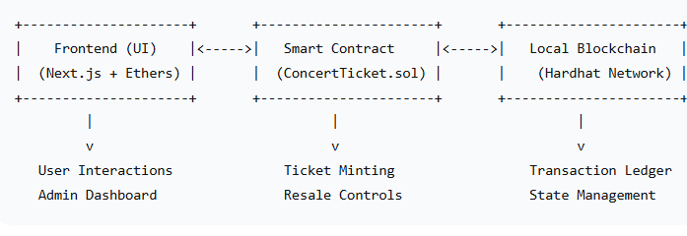
3.2 Directory Structure
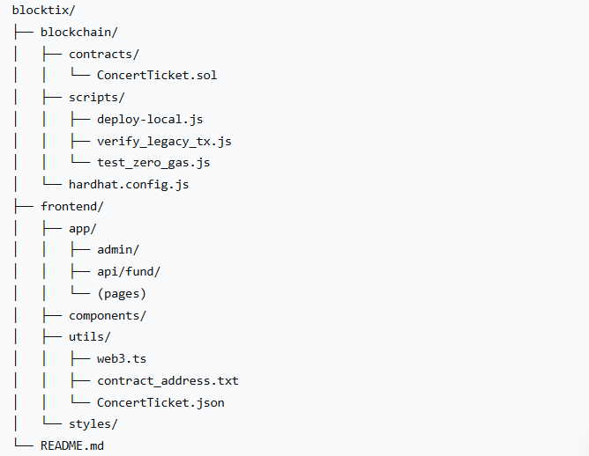

4. Smart Contract Engineering
4.1 Core Contract: ConcertTicket.sol
This contract governs all ticket-related operations and adheres to the ERC721 NFT standard.
Key Features:
- Ticket Minting: Each ticket is a unique NFT minted to the buyer’s address.
- Direct Payment: ETH is transferred directly to the event organizer upon purchase.
- Resale Control: Organizers can enable/disable secondary sales via resellAllowed.
- Ownership Controls: Uses OpenZeppelin’s Ownable for administrative functions.
Contract Interface Summary:
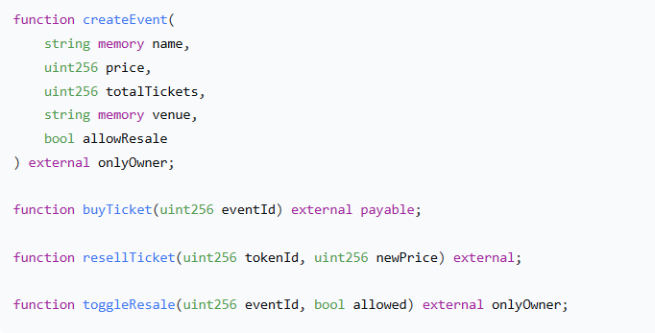
5. Deployment & Network Configuration
5.1 Zero-Gas Mode Configuration
To eliminate transaction cost barriers during testing, BlockTix uses a custom Hardhat network configuration:
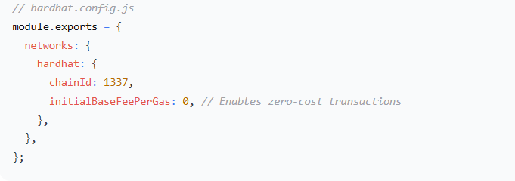
5.2 Automated Deployment Pipeline
The deployment is scripted for consistency and repeatability:
Deployment Steps:
- Compile Solidity contracts
- Deploy to local Hardhat network
- Update frontend configuration files (contract_address.txt, ConcertTicket.json)

6. Operational Workflows
6.1 Admin: Event Creation
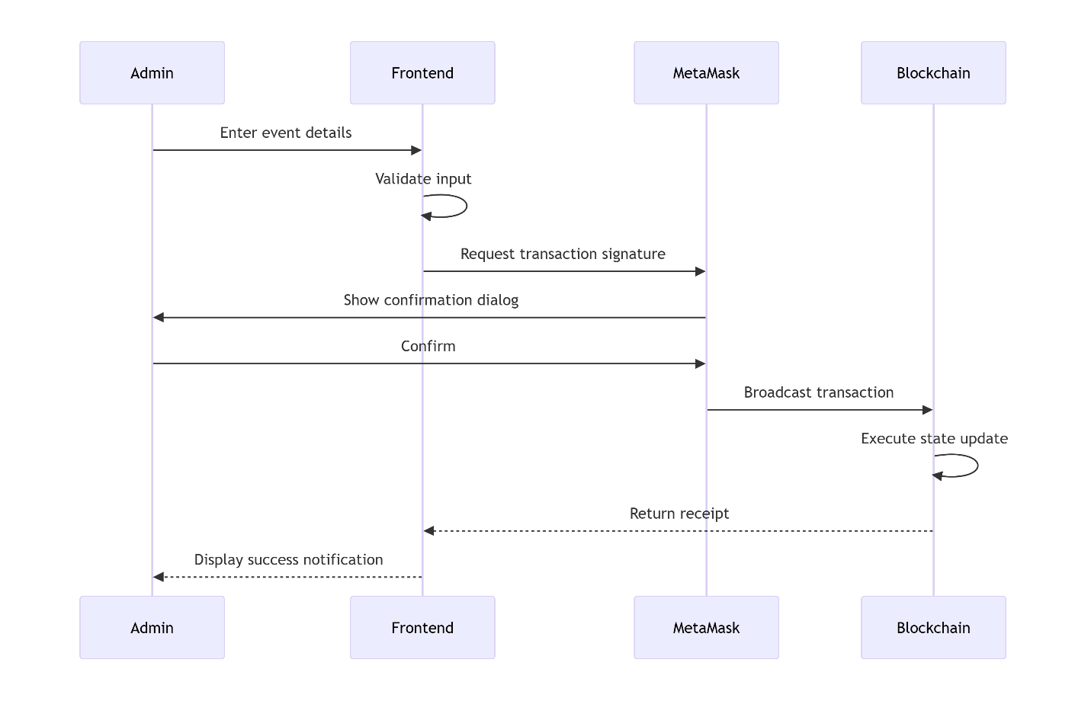
Steps:
- Navigate to /admin
- Connect wallet (must be contract owner)
- Fill event form (name, price, tickets, venue, resale toggle)
- Submit and confirm in MetaMask
- 6.2 User: Ticket Purchase

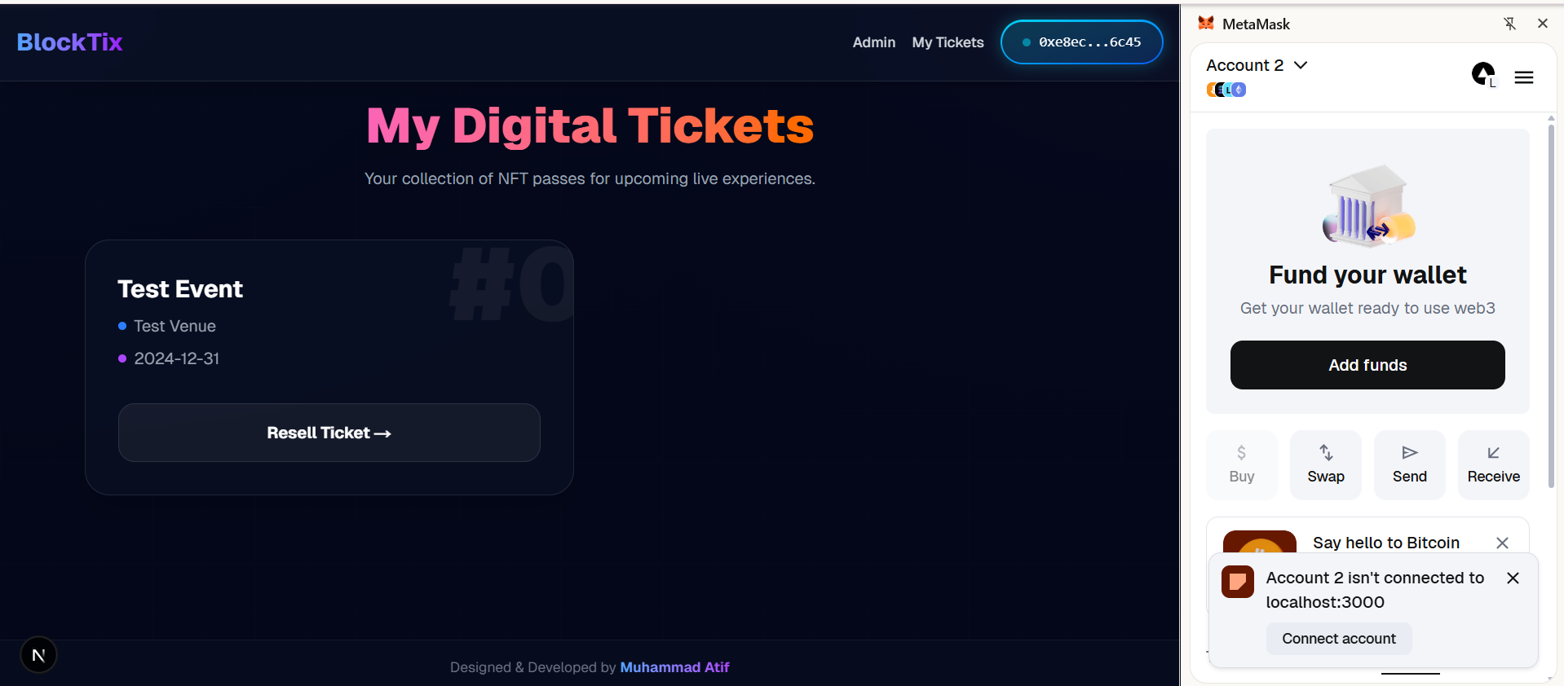

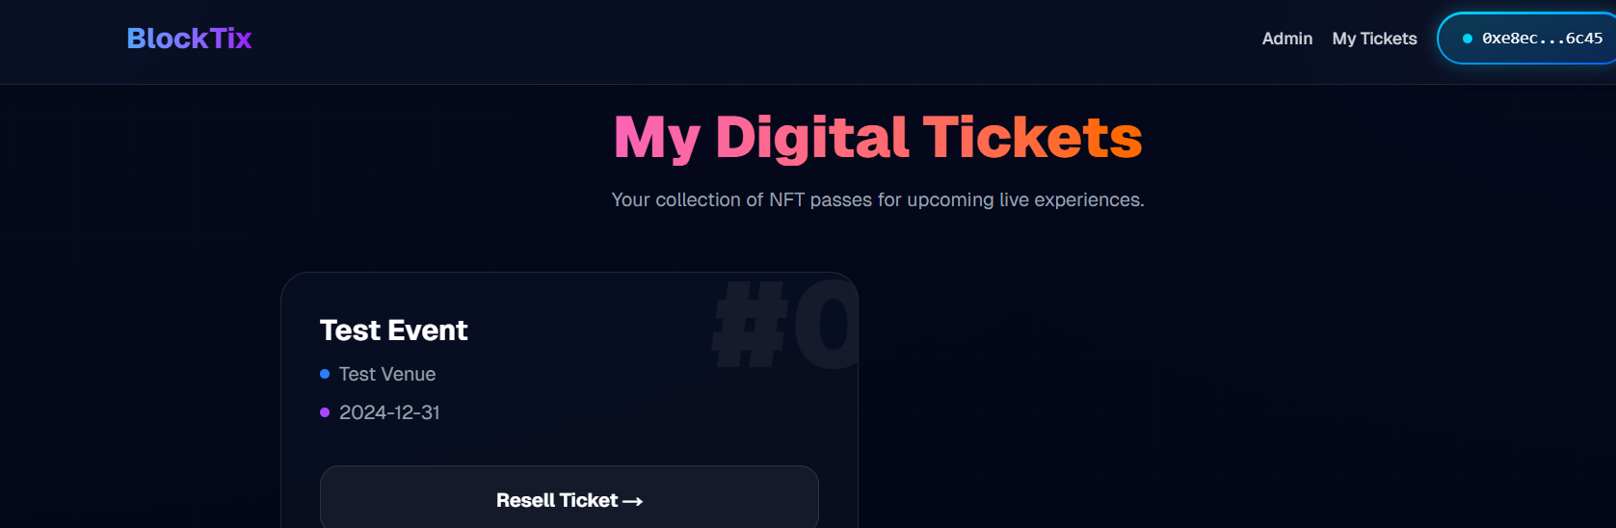
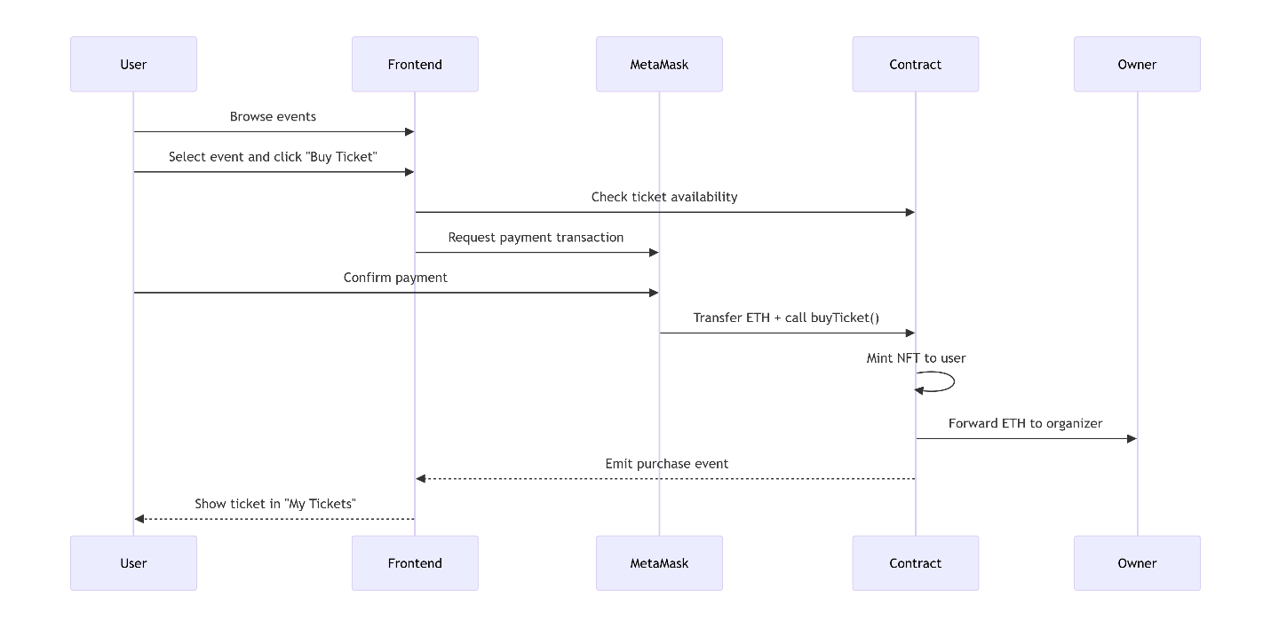
6.3 Auto-Funding Service
To support testing, an API endpoint (/api/fund) detects zero-balance wallets and automatically sends 10 test ETH from a developer-controlled account.

7. Troubleshooting & System Maintenance
7.1 Common Issues & Resolutions
Issue | Cause | Resolution
Nonce Too High | MetaMask/blockchain state mismatch after node restart | Clear MetaMask activity history or reset account
Insufficient Funds | New wallet with zero ETH | Use auto-funding endpoint or manually send ETH in local network
Transaction Stuck | Low gas or network congestion | Enforce gas limits in frontend; use hardhat_reset to clear local chain
Contract Not Found | Frontend ABI/address out of sync | Re-run deployment script to update config files
7.2 Maintenance Protocols
- Regularly update dependencies (Hardhat, Ethers.js, OpenZeppelin)
- Monitor gas strategy compatibility with Ethereum mainnet updates
- Maintain backup of contract ABIs and deployment addresses
- Document all configuration changes in version-controlled files

8. Conclusion
BlockTix successfully demonstrates a functional, secure, and user-friendly decentralized ticketing system. Through innovative local development strategies—such as zero-gas transactions and automated wallet funding—the platform offers a frictionless testing experience while maintaining production-grade security and structure.
The system is ready for demonstration, extended testing, and serves as a foundational model for real-world deployment on Ethereum testnets or mainnet following appropriate audits and scalability enhancements.

9. Appendices
A. Glossary
- dApp: Decentralized Application
- NFT: Non-Fungible Token
- ERC721: Token standard for unique assets on Ethereum
- Gas: Transaction fee unit on Ethereum
- Nonce: Number used once, a transaction counter per account
B. References
- Ethereum Official Documentation
- OpenZeppelin Contracts Library
- Hardhat Documentation
- ERC721 Standard Specification
C. Contact & Support
For technical inquiries or contribution opportunities, refer to the project repository or contact the development team.

End of Report
Prepared by Muhammad Atif – Blockchain Developer & System Architect

