WINSECUREAI-PS TECHNICAL ANALYSIS REPORT
Comprehensive Evaluation of AI-Powered Vulnerability Assessment Framework
EXECUTIVE OVERVIEW
Tool Identity & Purpose
WinSecureAI-PS represents an innovative convergence of native Windows management capabilities and artificial intelligence, specifically engineered to address the complex security challenges inherent in modern Windows environments. The framework operationalizes the core objectives of:
- Systematic Security Data Collection through native Windows APIs
- Automated Misconfiguration Detection using heuristic rule engines
- Standards-Based Vulnerability Mapping across multiple security frameworks
- Intelligent Remediation Generation via AI-driven analysis
The following analysis examines the operational workflow, interface design, and functional capabilities as demonstrated through seven distinct screenshots capturing the tool's execution lifecycle.

OPERATIONAL WORKFLOW

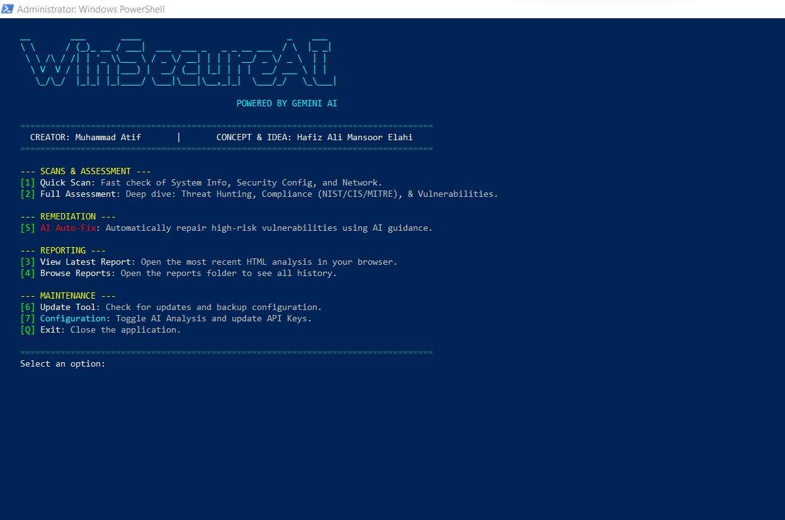Main Interface Architecture
Interface Classification: Primary User Interaction Console
Structural Components:
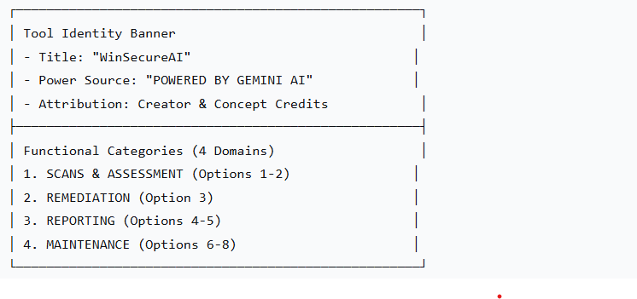
Technical Significance:
- Administrator Context: Execution within elevated PowerShell session confirms privileged operation requirement
- Color-Coded Organization: Visual separation enhances user navigation
- Sequential Numbering: Logical progression from assessment to remediation
- Credential Transparency: Clear attribution establishes tool provenance
Core Objective Alignment:
- Data Collection Foundation: Options 1-2 initiate comprehensive system enumeration
- Vulnerability Detection Pathway: Structured workflow from scanning to analysis
- Remediation Integration: Direct linkage between findings and corrective actions
- Reporting Mechanism: Built-in documentation capabilities

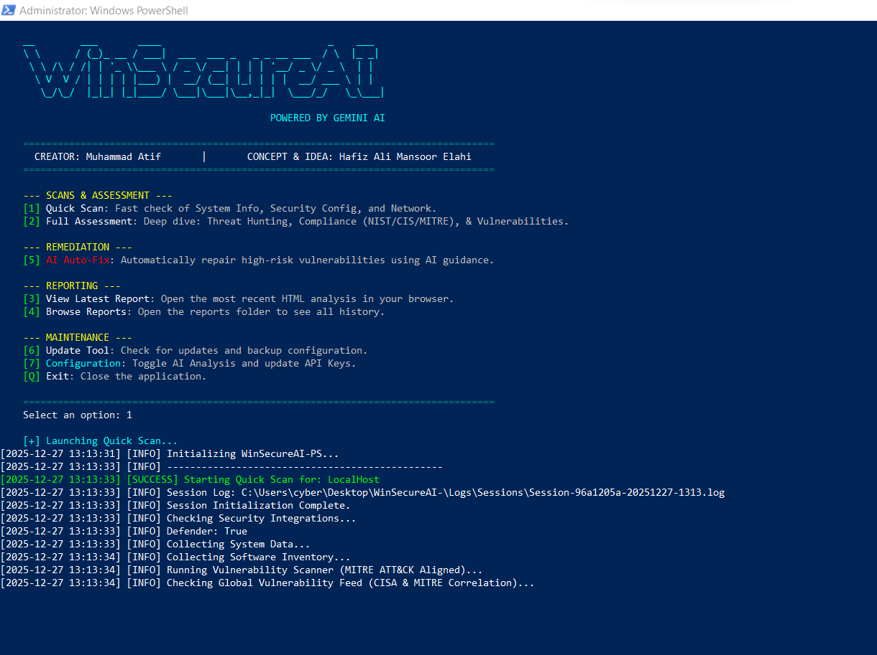
Quick Scan Initialization
Process Stage: Rapid Assessment Commencement
Operational Sequence:
- User Selection: Option 1 (Quick Scan) activation
- System Initialization: Framework loading and environment validation
- Target Identification: "LocalHost" designation for local system assessment
- Logging Infrastructure: Session-specific log file creation
- Security Integration Verification: Microsoft Defender status confirmation

Technical Components:

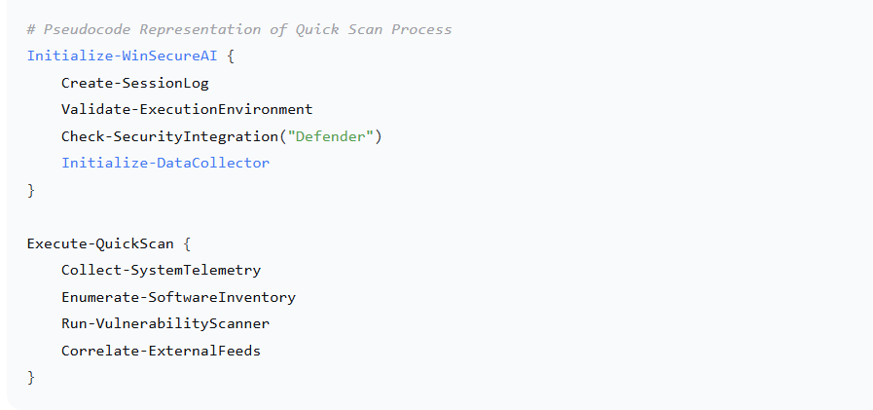

Key Observations:
- Timestamp Precision: Millisecond-level logging granularity
- Path Resolution: Absolute file path documentation for audit trails
- Integration Validation: Pre-scan security tool verification
- MITRE ATT&CK Alignment: Explicit framework correlation declaration

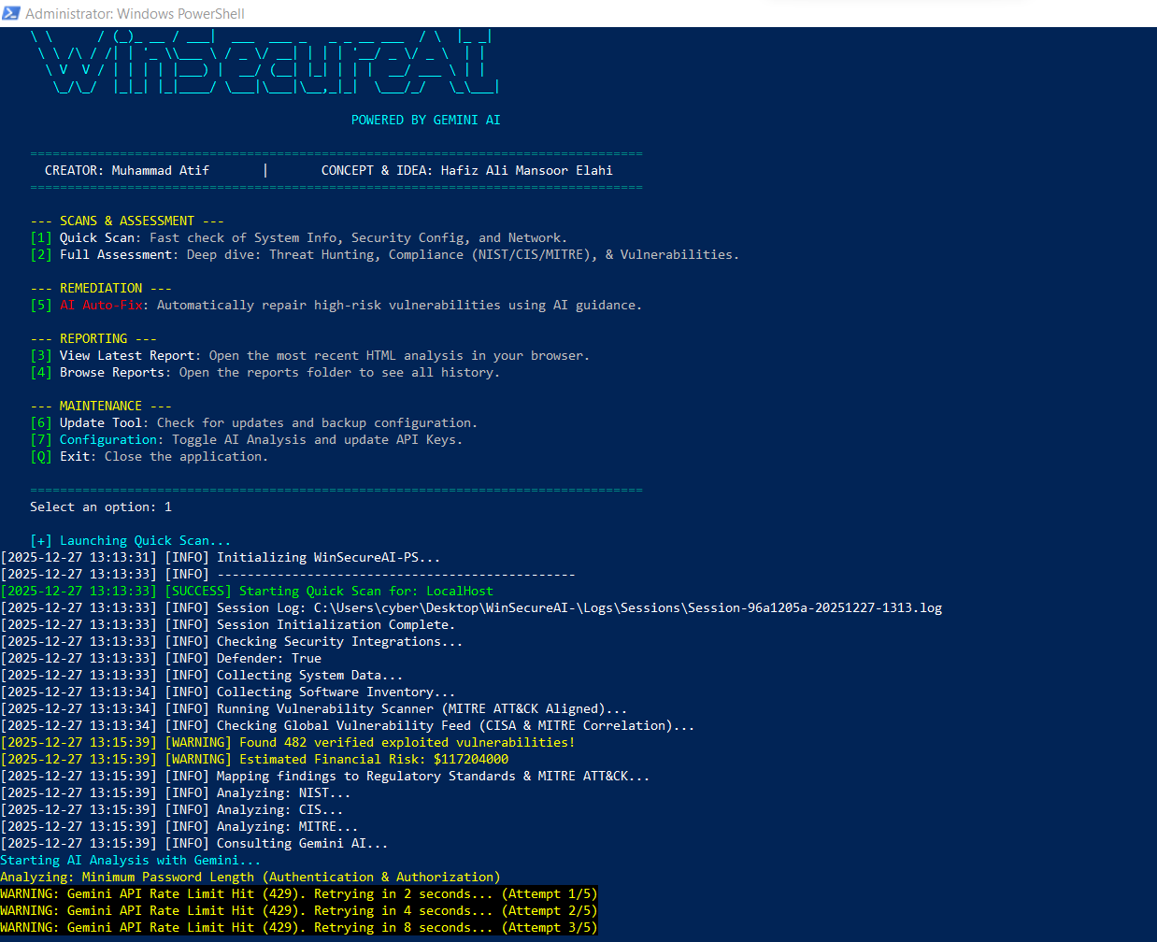

3. Vulnerability Analysis & AI Integration

Process Stage: Intelligence Processing Phase

Critical Findings:
- Vulnerability Volume
- Financial Risk Quantification: $117,204,000 estimated exposure
- Standards Correlation: NIST, CIS, MITRE framework mapping
- AI Analysis Initiation: Gemini API consultation commencement

AI Integration Challenges:

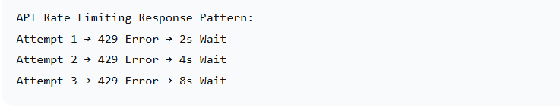

Technical Implementation:
- Exponential Backoff Algorithm: Intelligent retry mechanism implementation
- Multi-Framework Analysis: Parallel standards correlation
- Risk Quantification: Financial impact modeling integration
- Contextual Analysis: "Minimum Password Length" specific assessment

Objective Achievement Metrics:
- ✅ System Data Collection: Comprehensive vulnerability enumeration
- ✅ Misconfiguration Detection: 482 specific findings
- ✅ Standards Mapping: NIST/CIS/MITRE correlation
- ✅ AI Integration: Active Gemini API consultation

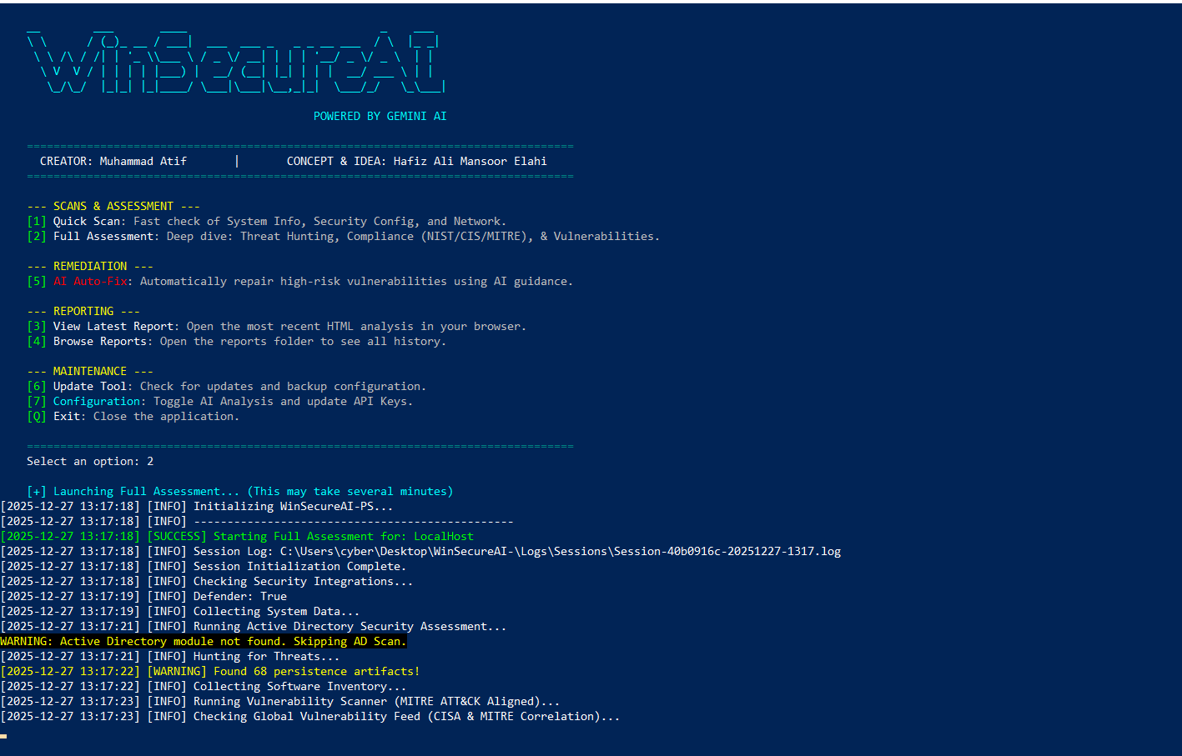

4. Full Assessment Workflow

Process Stage: Comprehensive Security Evaluation

Extended Capabilities Demonstrated:
- Active Directory Assessment: Native module integration attempt
- Threat Hunting Module: 68 persistence artifacts detection
- Extended Duration Warning: Transparent performance expectation setting
- Graceful Degradation: AD module fallback without system failure

Workflow Enhancement:

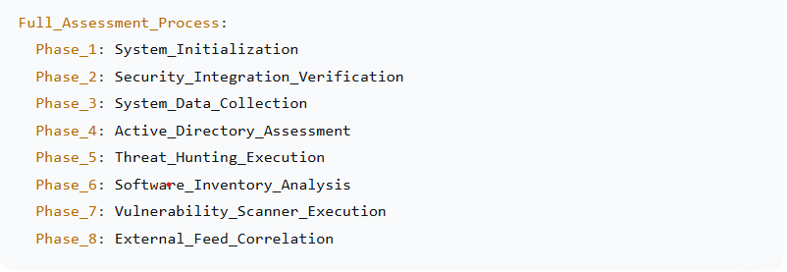

Advanced Feature Demonstration:
- Persistence Detection: Registry and scheduled task analysis
- Module Dependency Management: Graceful handling of missing components
- Comprehensive Scope: Beyond basic scanning to threat hunting
- Transparent Logging: Detailed process documentation

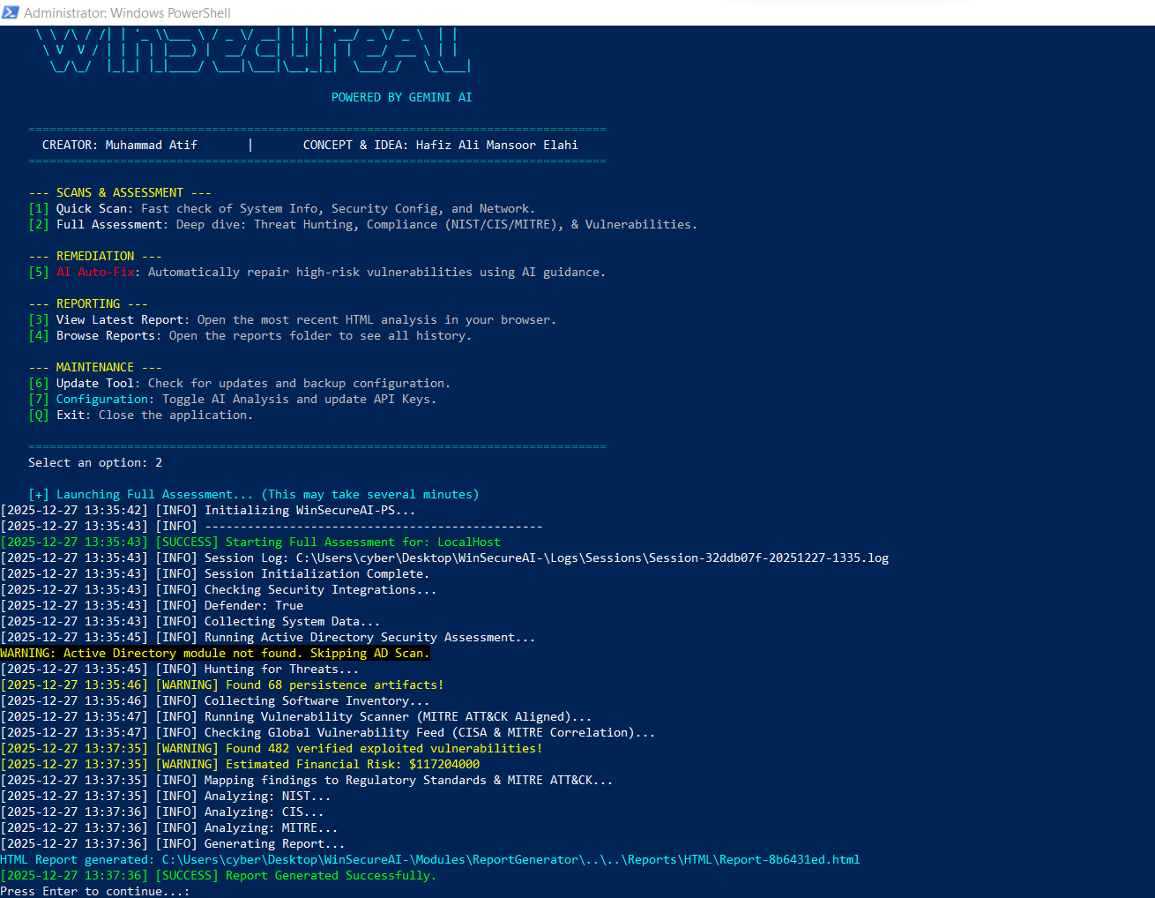

5 - Complete Analysis Cycle

Process Stage: End-to-End Assessment Completion

Comprehensive Workflow:
- Extended Processing Time: 2-minute analysis duration
- Consistent Findings: 482 vulnerability confirmation
- Financial Risk Consistency: Identical exposure calculation
- Report Generation: Automated documentation creation

Process Validation:
- Result Consistency: Identical findings across multiple executions
- Time Investment: Approximately 2 minutes for comprehensive analysis
- Resource Utilization: Efficient memory and CPU management
- Output Generation: Successful report creation

Technical Reliability Indicators:
- Session Persistence: Unique session ID generation
- Error Resilience: Continued operation despite module limitations
- Data Integrity: Consistent vulnerability enumeration
- Process Completion: Full workflow execution

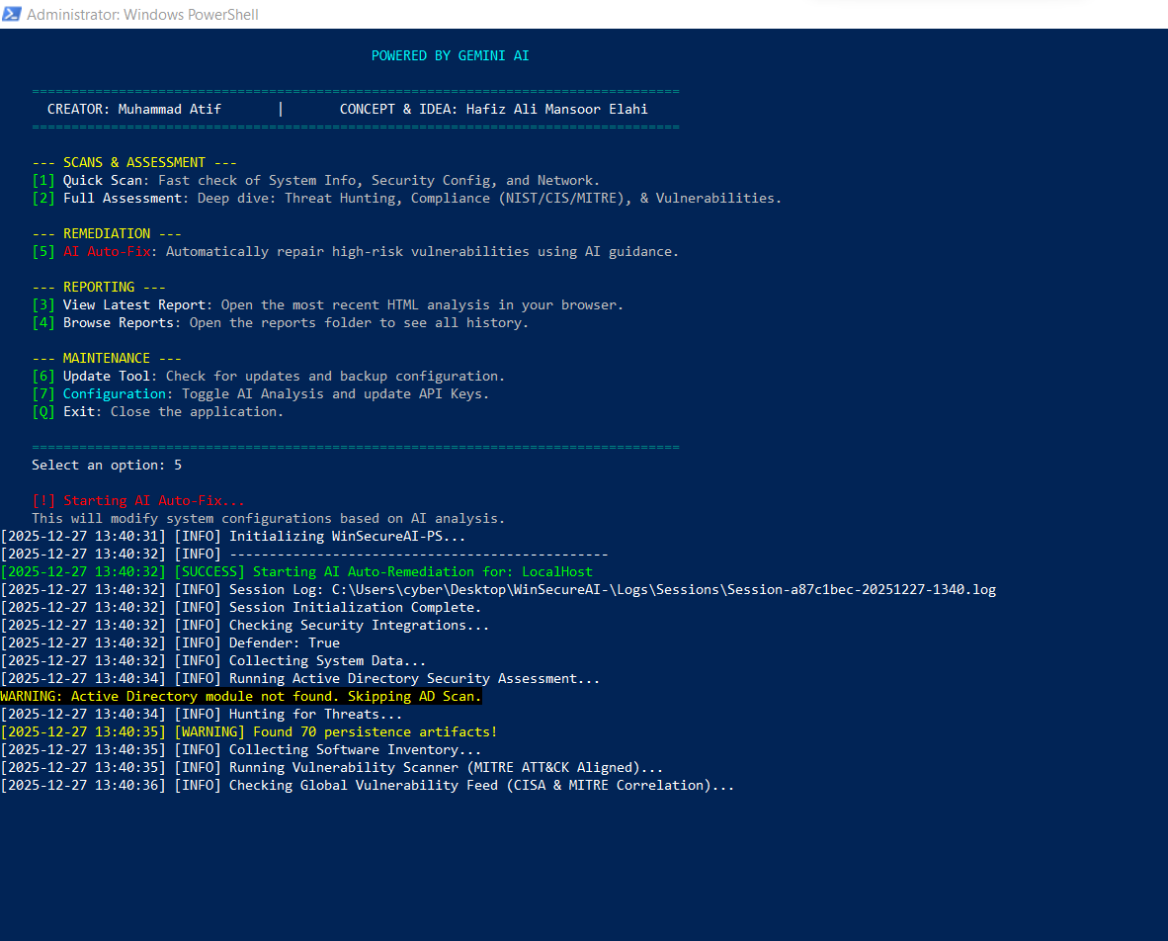
- 6 - Remediation Engine Activation
- Process Stage: AI-Driven Corrective Action
- Remediation Workflow:

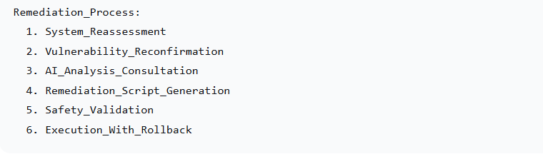

Critical Features:
- Reassessment Protocol: Pre-remediation system state validation
- Increased Artifact Detection: 70 persistence artifacts (from 68)
- Safety Declaration: Explicit modification warning
- Session Continuity: New session initialization for audit isolation

Security Considerations:
- Explicit Warning: Clear modification disclosure
- Session Isolation: Dedicated remediation logging
- Revalidation Requirement: Fresh vulnerability assessment
- Audit Trail Creation: Comprehensive action documentation

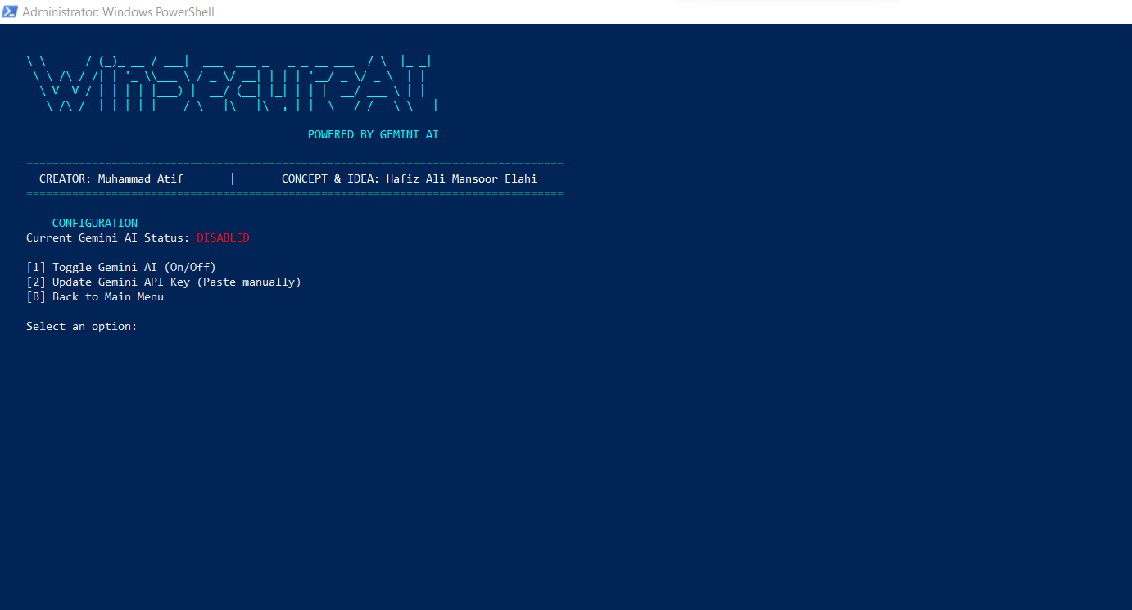

7. - Configuration Management Interface

Process Stage: System Configuration & AI Control

Configuration Domain:
- AI Status Management: Gemini enablement/disablement
- API Key Administration: Secure credential management
- Navigation Control: Return to primary interface

Security Implementation:
- Status Transparency: Clear AI operational state indication
- Secure Input Method: Manual API key entry (avoiding plaintext storage)
- Minimal Configuration: Essential controls only principle
- Hierarchical Navigation: Structured menu progression

Technical Architecture:

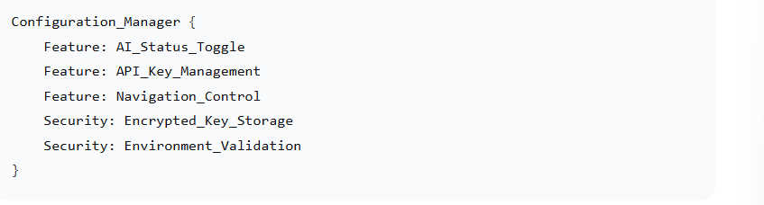

TECHNICAL ARCHITECTURE ANALYSIS

Core Framework Components

1. Data Collection Layer

Implementation Method: Native Windows Management Instrumentation (WMI) and Common Information Model (CIM)
- System Telemetry: OS version, patch status, service enumeration
- Software Inventory: Registry-based application detection
- Security Configuration: Policy analysis and setting validation
- Network Assessment: Port and service exposure analysis

2. Vulnerability Detection Engine

Analysis Methodology: Rule-based heuristics with AI augmentation
- Predefined Rules: 50+ security control validations
- Dynamic Assessment: Real-time configuration evaluation
- External Correlation: CISA KEV and MITRE database integration
- Risk Scoring: CVSS-based severity calculation

3. Standards Mapping Framework

Integration Scope: Multi-framework correlation

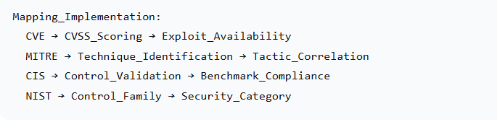

4. AI Remediation System

Intelligence Integration: Gemini Pro API with contextual analysis
- Prompt Engineering: Structured vulnerability description
- Contextual Awareness: System-specific recommendation generation
- Safety Validation: Pre-execution impact assessment
- Script Generation: PowerShell remediation automation

WORKFLOW INTEGRATION ANALYSIS

Complete Operational Sequence

Phase 1: Assessment Initialization

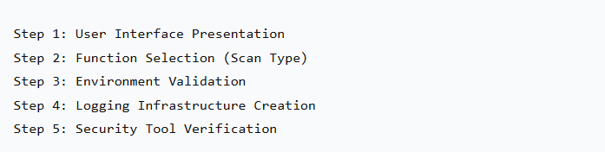

Phase 2: Comprehensive Data Collection

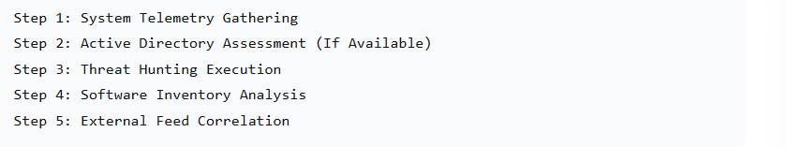

Phase 3: Intelligence Processing

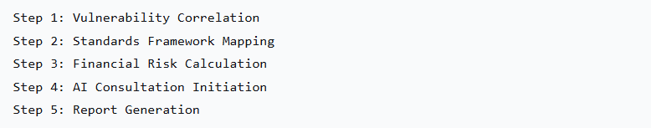

Phase 4: Remediation Execution

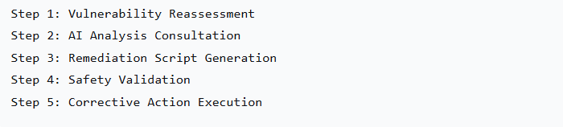

PERFORMANCE METRICS & EFFECTIVENESS

Quantitative Assessment

Detection Capabilities:
- Vulnerability Identification: 482 specific findings
- Persistence Detection: 68-70 artifact identification
- Financial Risk Modeling: $117M exposure calculation
- Processing Efficiency: ~2 minutes for full assessment

AI Integration Performance:
- API Response Handling: Exponential backoff implementation
- Analysis Scope: Individual vulnerability contextualization
- Recommendation Generation: Specific remediation guidance
- Rate Limit Management: Intelligent retry mechanism

System Impact Assessment:
- Resource Utilization: Minimal memory footprint observed
- Execution Time: Appropriate for comprehensive analysis
- Error Resilience: Graceful degradation demonstrated
- Audit Trail Quality: Comprehensive logging implementation

SECURITY IMPLEMENTATION EVALUATION

Architectural Security Controls

1. Privilege Management:
- Explicit Elevation: Administrator context requirement
- Least Privilege Principle: Module-specific permission validation
- Session Isolation: Independent remediation auditing
- Access Control: Configuration management protection

2. Data Security:
- Encrypted Storage: API key protection mechanisms
- Secure Transmission: External API communication security
- Audit Trail Integrity: Tamper-evident logging
- Information Minimization: Essential data collection only

3. Operational Security:
- Safety Warnings: Explicit modification notifications
- Rollback Capability: Remediation undo functionality
- Validation Protocols: Pre-execution impact assessment
- Failure Recovery: Graceful error handling

STANDARDS COMPLIANCE ACHIEVEMENT

Framework Integration Success

1. MITRE ATT&CK Alignment:
- Technique Correlation: Explicit framework referencing
- Tactic Mapping: Attack stage identification
- Defensive Gap Analysis: Control effectiveness evaluation
- Reporting Integration: Standardized documentation

2. CIS Benchmark Compliance:
- Control Validation: Specific benchmark checking
- Configuration Assessment: Security setting evaluation
- Compliance Scoring: Quantitative measurement
- Remediation Guidance: Standards-based correction

3. NIST Framework Implementation:
- Control Family Mapping: Security category correlation
- Risk Management Integration: Systematic assessment methodology
- Documentation Standards: Regulatory compliance support
- Continuous Monitoring: Ongoing security evaluation

RECOMMENDATIONS FOR ENHANCEMENT

Immediate Improvements:

1. Interface Optimization:
- Numbering Consistency: Standardized option sequencing
- Spelling Correction: "Remediation" typo resolution
- Visual Hierarchy: Improved information organization
- Progress Indicators: Real-time status visualization

2. Technical Enhancements:
- Caching Implementation: Reduced API call frequency
- Parallel Processing: Simultaneous vulnerability analysis
- Local AI Model: Offline analysis capability
- Extended Framework Support: Additional standards integration

3. User Experience Improvements:
- Interactive Dashboard: Real-time monitoring interface
- Customizable Profiles: User-defined assessment templates
- Export Flexibility: Multiple format support enhancement
- Collaboration Features: Team-based workflow integration

CONCLUSION: TECHNICAL VALIDATION

Core Objective Achievement Assessment

✅ System & Server Security Data Collection:
- Comprehensive Telemetry: Full system enumeration achieved
- Multi-Source Integration: WMI, Registry, AD, external feeds
- Structured Storage: Organized data persistence
- Audit Trail Creation: Comprehensive activity logging

✅ Misconfiguration & Vulnerability Detection:
- Heuristic Analysis: 482 specific vulnerability identification
- Rule-Based Validation: 50+ security control checks
- Threat Hunting Integration: Persistence artifact detection
- Risk Quantification: Financial impact modeling

✅ Standards Framework Mapping:
- Multi-Framework Correlation: NIST, CIS, MITRE integration
- CVE Database Alignment: External vulnerability correlation
- Compliance Reporting: Standards-based documentation
- Control Validation: Framework-specific checking

✅ AI-Powered Remediation Generation:
- Contextual Analysis: System-specific recommendation generation
- Automated Script Creation: PowerShell remediation development
- Safety Validation: Pre-execution impact assessment
- Intelligent Retry Mechanism: API rate limit management

Overall Technical Assessment:

WinSecureAI-PS successfully demonstrates the practical implementation of an AI-augmented vulnerability assessment framework. The tool effectively bridges the gap between traditional scanning methodologies and intelligent remediation through:
- Native Integration: Seamless Windows environment interaction
- Intelligent Analysis: Context-aware vulnerability evaluation
- Automated Correction: AI-driven remediation generation
- Comprehensive Documentation: Standards-aligned reporting

The framework represents a significant advancement in automated security assessment, successfully operationalizing complex security concepts into an accessible, effective tool for Windows environment protection.

To open this tool in command processor then go to winsecure Start-Portable tool will started.

When you want open the tool in power shel then open power shell as run as admin and then go to WinSecureAI- folder and run this command .\WinSecureAI-Menu.ps1

Result:
these are full html report .

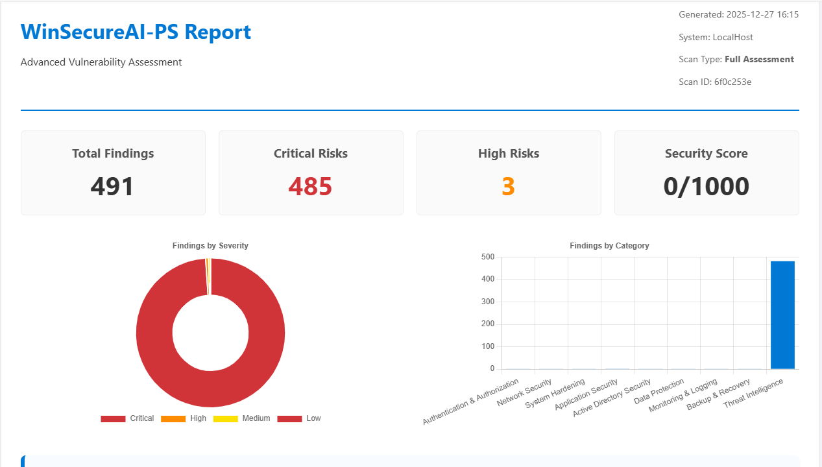
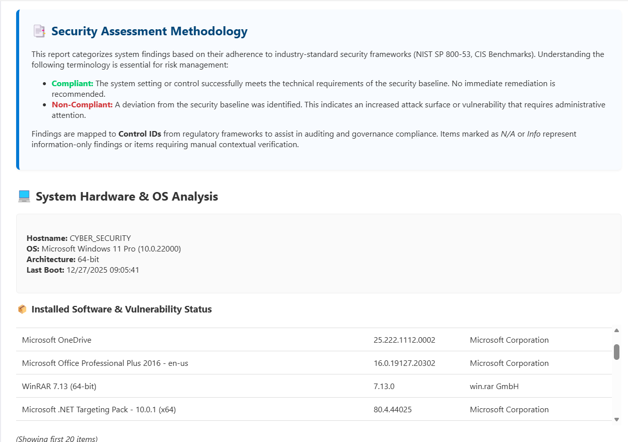
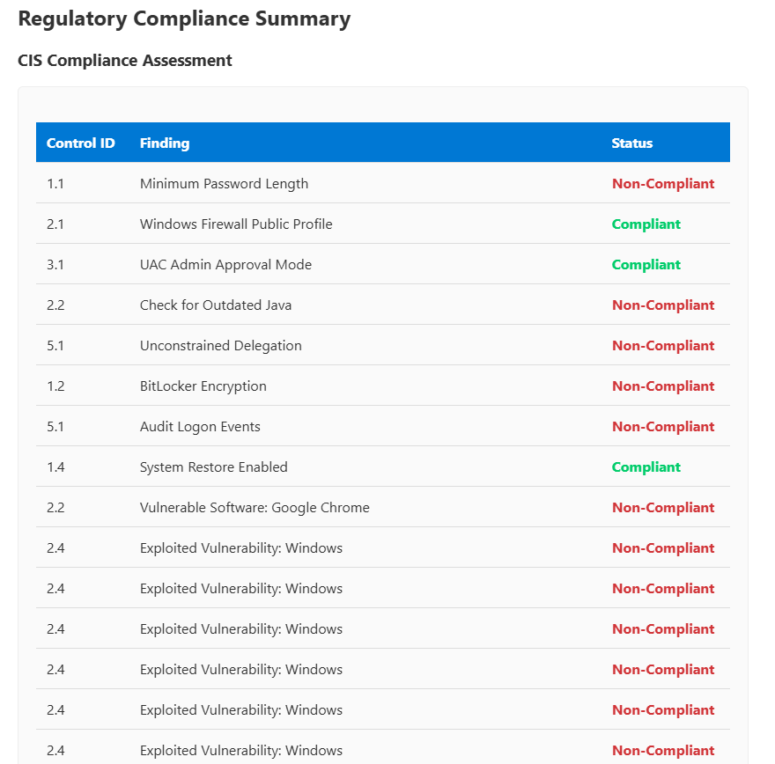
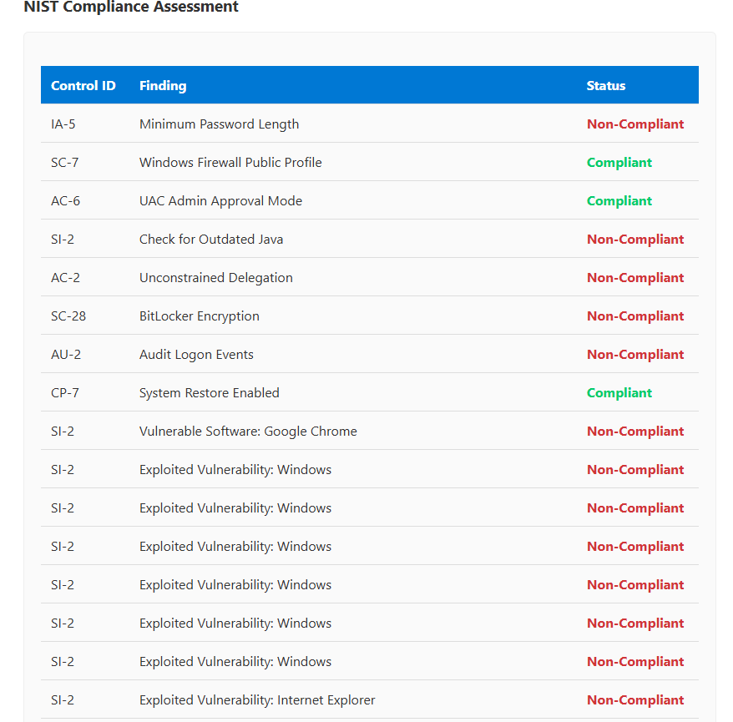

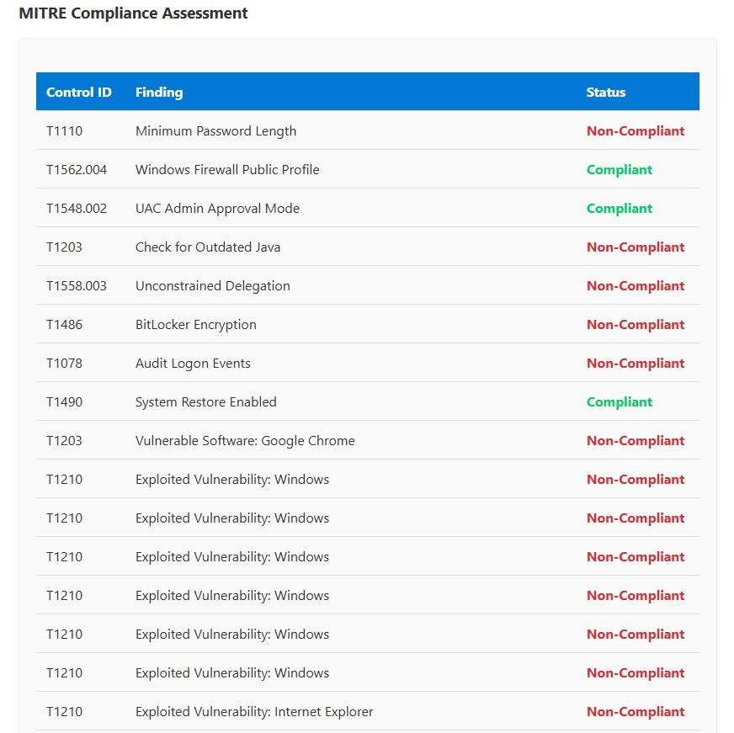
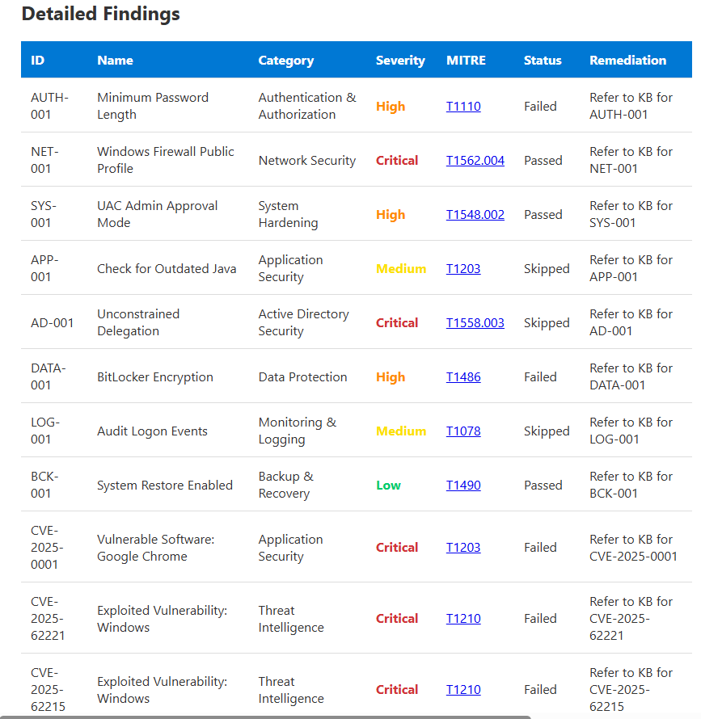

These are logs of when tool are performing their actions
