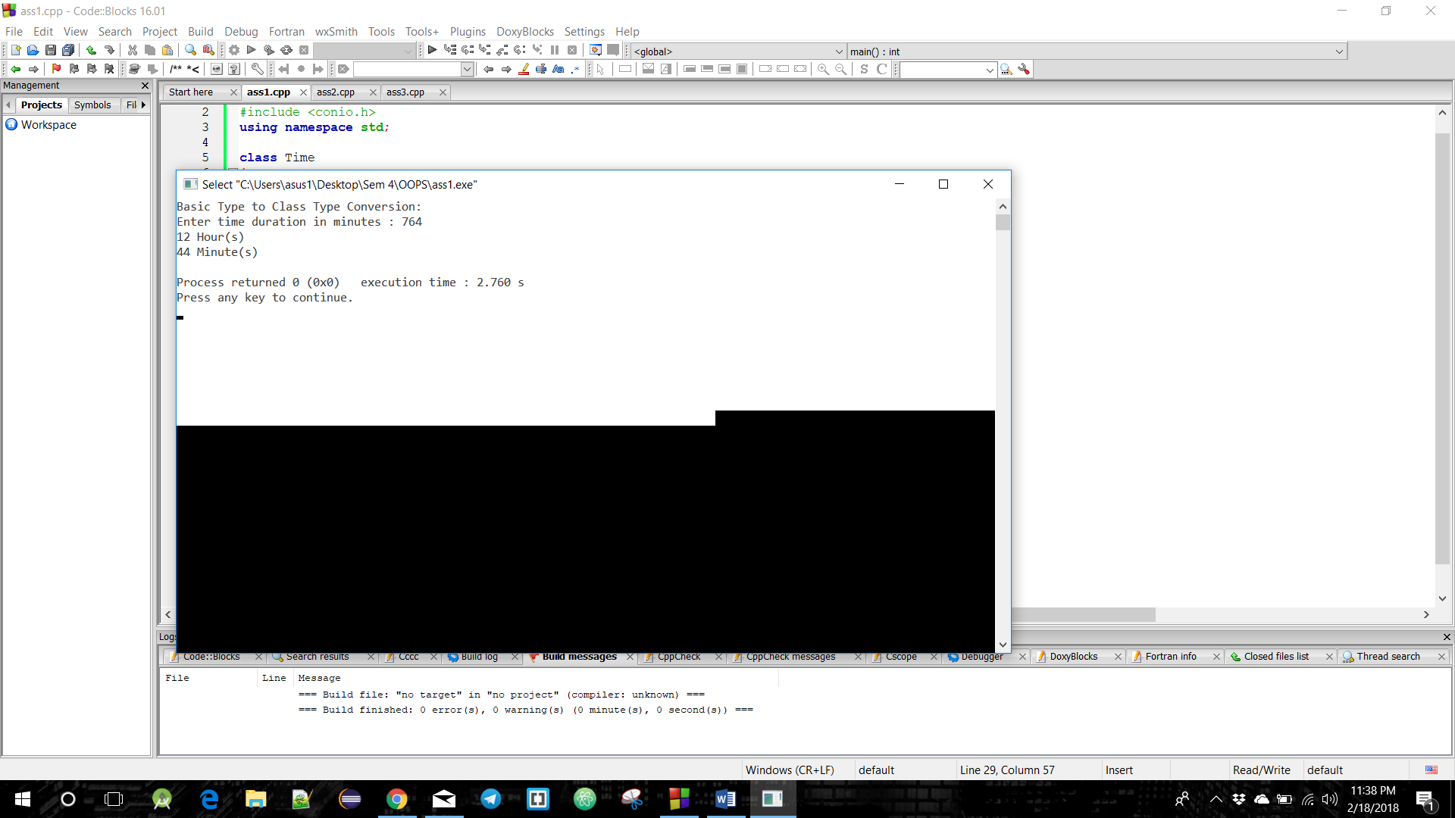

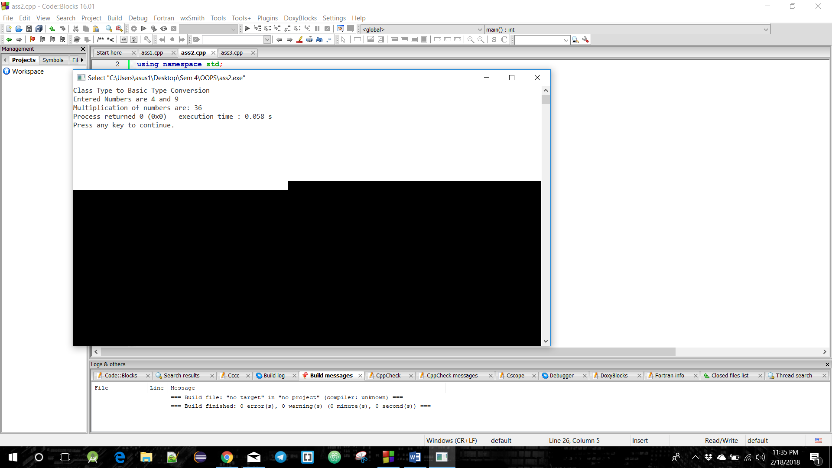

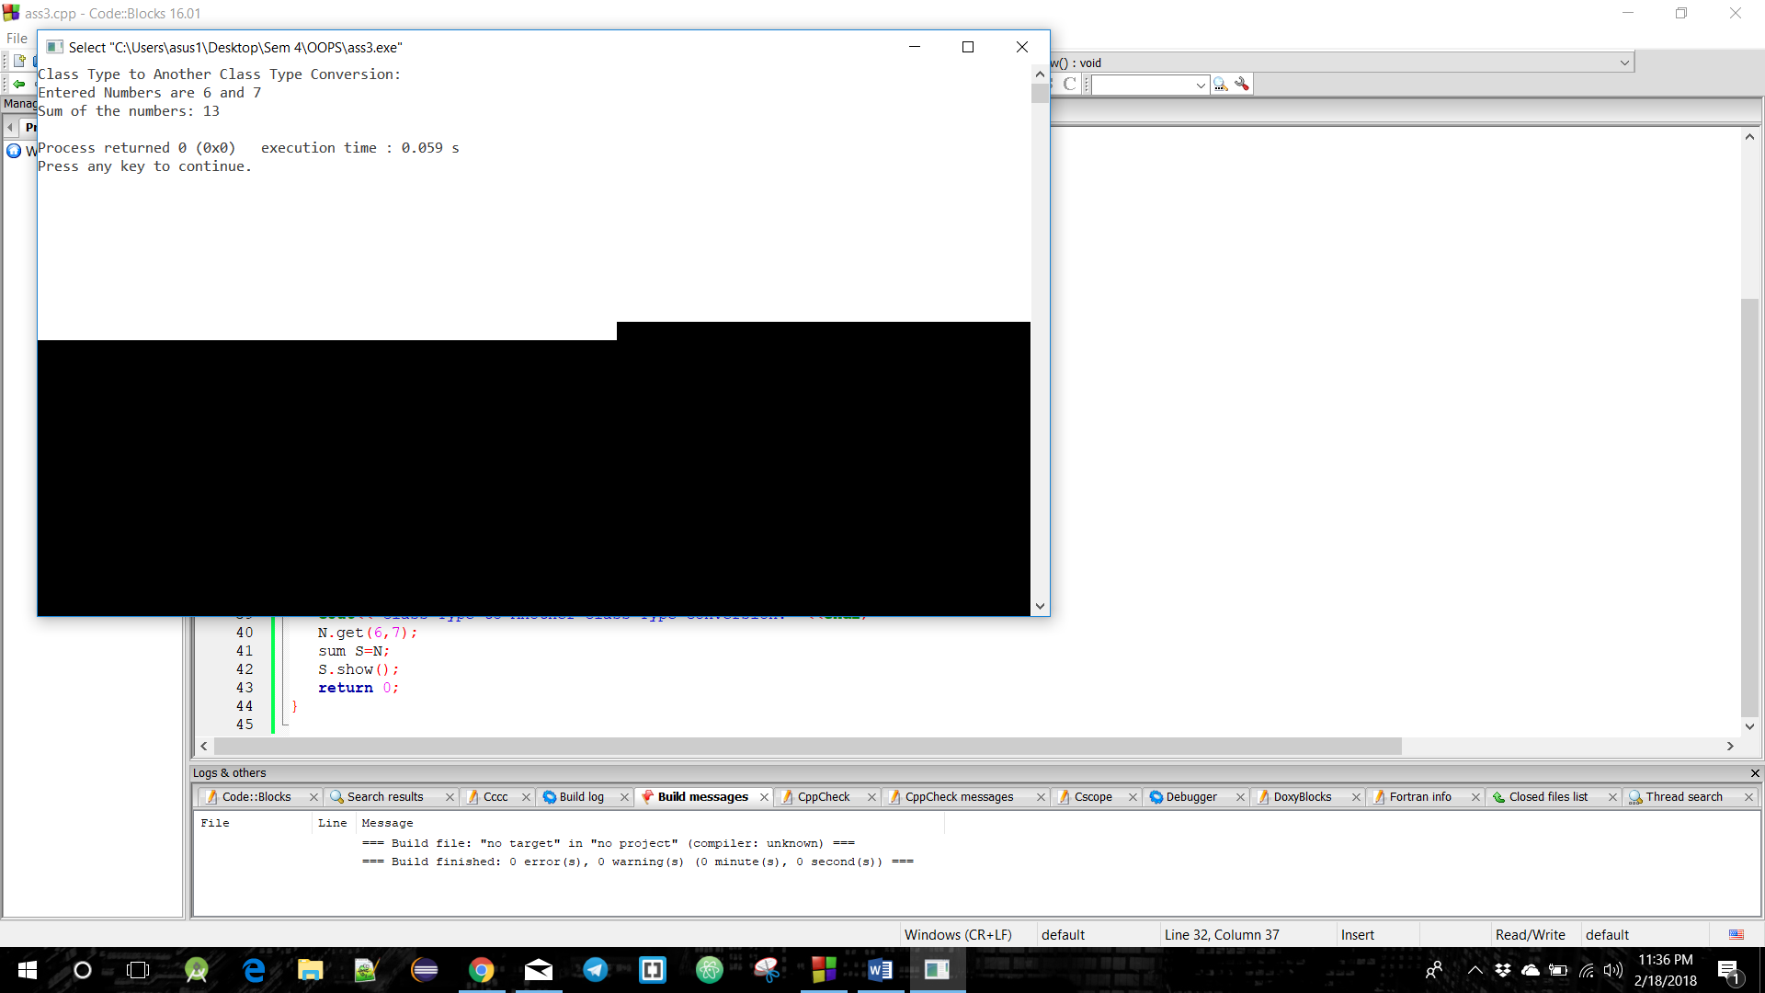

A screenshot of a cell phone

Description generated with high confidence



A screenshot of a cell phone

Description generated with very high confidence