## **Creating a New Repository on GitHub**

A screenshot of a computer

Description generated with very high confidence

**Adding a Local file to GitHub using Command Line**

These set of commands are used to push a local file to Git:

echo "# test" >> README.md

git init

git add README.md

git commit -m "first commit"

git remote add origin https://github.com/cyberboysumanjay/test.git

git push origin master

A screenshot of a computer

Description generated with very high confidence

**Cloning a Repository**

A screenshot of a computer

Description generated with very high confidence

**Forking a Repository**

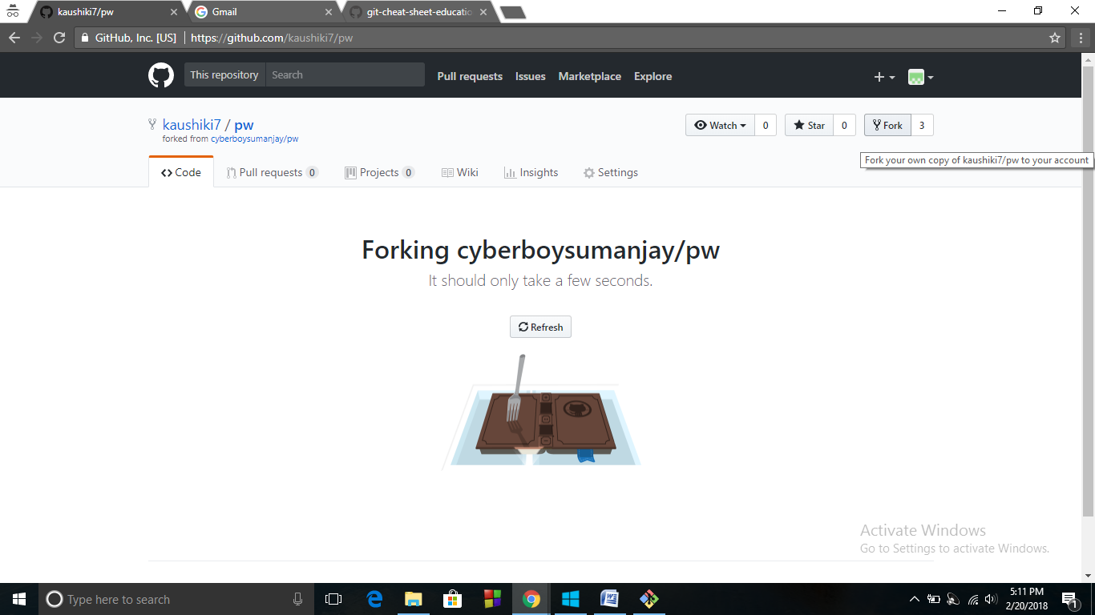

**Comparing and Opening a Pull Request**

A screenshot of a computer

Description generated with very high confidence

A screenshot of a computer

Description generated with very high confidence

A screenshot of a computer

Description generated with very high confidence