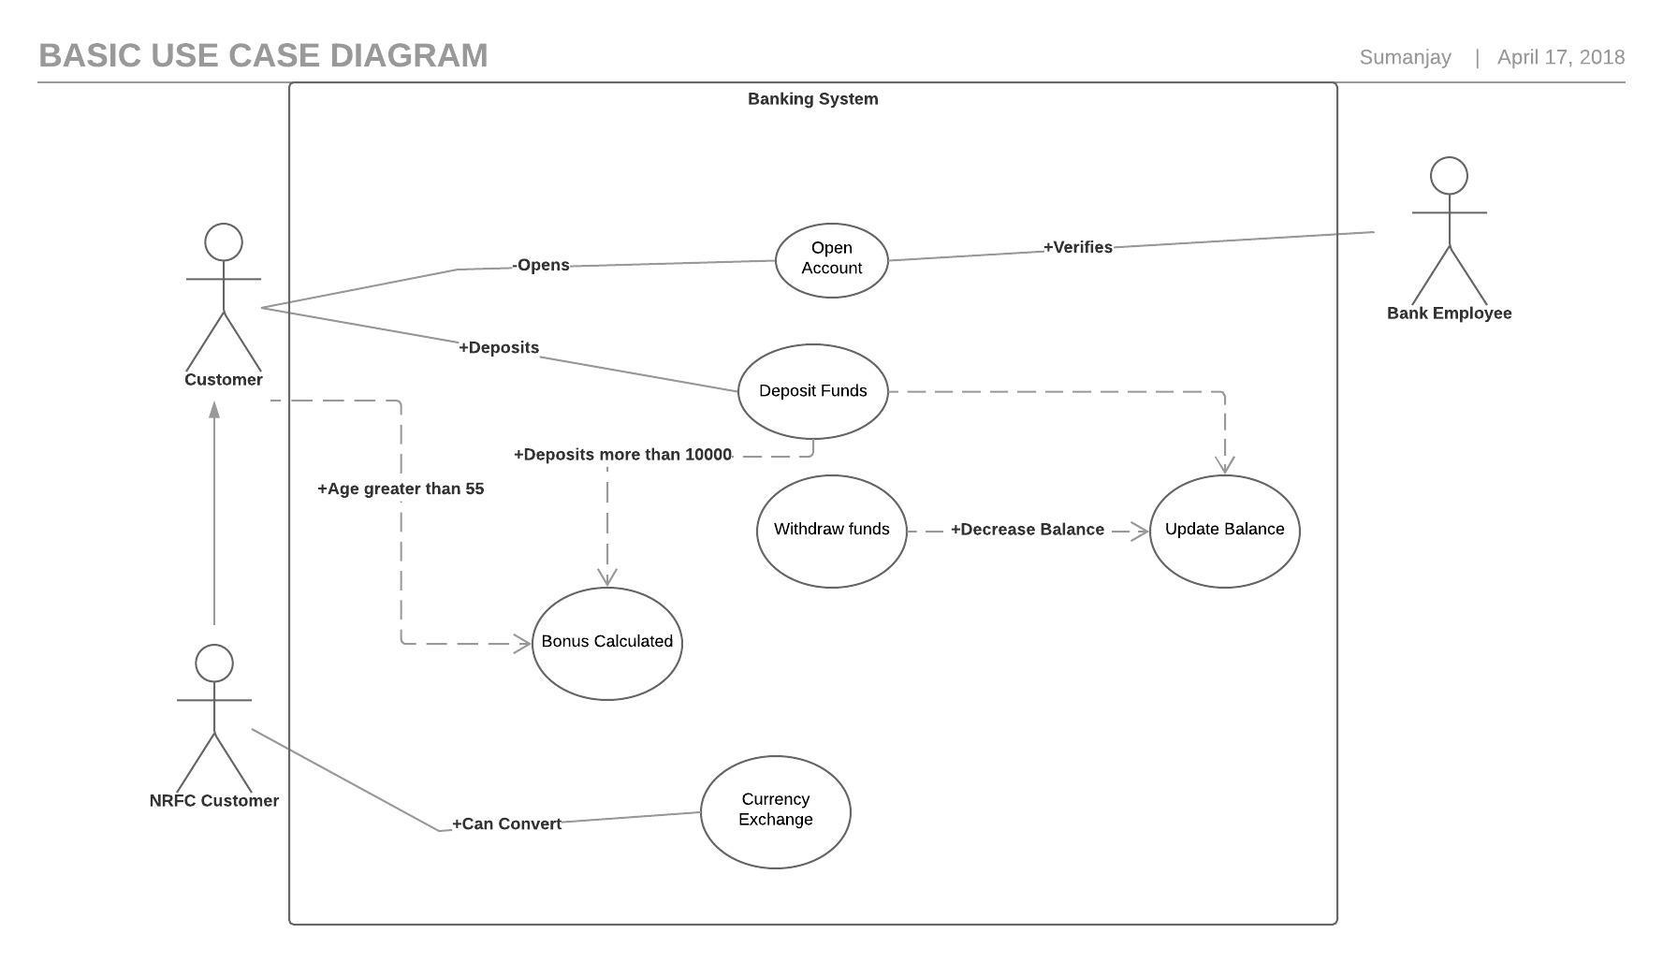

**BASIC USE CASE DIAGRAM**

1. Customer Case:

-Open Account verified by Bank Employee.

-Deposit Funds.

-Withdraw Funds.

**Deposit and Withdraw funds include the functionality at update balance.**

1. NRFC Customer Case:

**These customers can avail all the above functionality + Currency Exchange functionality.**

**A close up of a map

Description generated with high confidence**

**DATA FLOW DIAGRAM**

SuperMarket Prize Scheme

1. Input Address, Mobile Number, Driving License Number and Generate Unique Customer ID.
2. Select Products and Update Total Value and Checkout.
3. If Total Value > 10000 then Customer gets 22 Caret Gold Coin.
4. For top 10 customers, the customer gets Surprise Gift.

A screenshot of a cell phone

Description generated with high confidence

**Sequence Diagram**

1. Associate logs into application.
2. Application performs authentication at its end and grant access to associate.
3. Associate selects category of the problem:
4. Submit problem with IEF filters.
5. View/Edits the problem.
6. Provides Suggestion.
7. Application send notification to associate.
8. Manager resolves problem:
9. Performs discussion with other managers through forums.