Preventive Maintenance Document - {product_short} {customer_short}
{product} for {customer} in {environment}

Prepared By:
{author_name}

PT MULTIPOLAR TECHNOLOGY
{date_short}

Version
{version}


COPYRIGHT NOTICE

Copyright ©2026 by PT. Multipolar Technology Tbk

All rights reserved. This material is confidential and proprietary to PT. Multipolar Technology Tbk. and no part of this material should be reproduced, published in any form by any means, electronic or mechanical including photocopy or any information storage or retrieval system nor should the material be disclosed to third parties without the express written authorization of PT. Multipolar Technology Tbk.

Contact Details

No | Name | Position | Email
{#contacts}{no} | {name} | {position} | {email}{/contacts}

Document Control
Document Title
Customer | {customer}
Title | {doc_title}
Author | {author_name}
File Name | {file_name}
Release History
Release | Author | Date | Description
{#releases}{version} | {author} | {date} | {description}{/releases}
Distribution List
Name | Organization | Note
{#distribution}{name} | {org} | {note}{/distribution}

Table of Contents

Contact Details 3
Document Control 4
I. Introduction 6
II. Architecture 7
III. Servers 8
IV. Services List 9
V. Capacity and Performance 12
VI. Topology / Architecture 13
VII. Cassandra 15
VIII. SSL Certificates (Only Show Expired or Expiring in 3 Months) 16
1. QRCB (40xx) 16
2. RTSIST (60xx) 16
3. RINTIS (70xx) 17
4. DSP_RINTIS (80xx) 17
5. DSP (90xx) 17
IX. Available Patches 19
X. Backup 21
XI. Transactions 22
XII. Summary 23

Introduction
Sebagai bagian dari proses pemeliharaan untuk PT Rintis Sejahtera, Multipolar melakukan aktivitas Preventive Maintenance (PM) yang dilakukan secara berkala. Kegiatan yang dilakukan meliputi pemeriksaan lingkungan server/data center, utilisasi sumber daya server baik CPU, memori maupun hard disk di environment production serta melakukan diskusi dengan IT Staff PT Rintis Sejahtera mengenai berbagai hal terkait layanan pemeliharaan yang dilakukan.

Lingkup perawatan meliputi:
- Memeriksa konfigurasi server
- Memeriksa penggunaan sumber daya hardware pada server
- Memeriksa aplikasi yang diinstall pada server

Lingkup yang tidak termasuk dalam perawatan:
- Memeriksa kondisi fisik terkait semua bagian server

Architecture

{#has_arch}
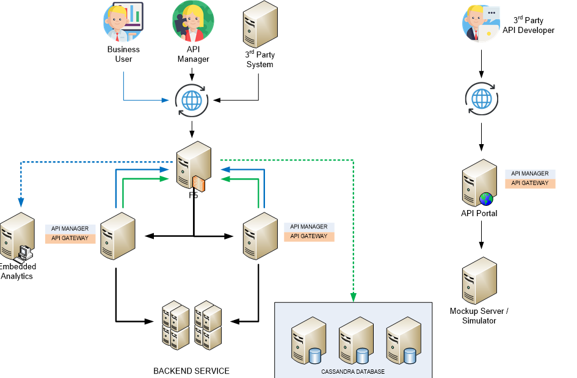
{/has_arch}
Gambar 1. Arsitektur Axway API Management Rintis di Environment Production

Servers
{#environments}
{#has_name}
{#new_page}
{name}
{/new_page}
{^new_page}
{name}
{/new_page}
{/has_name}
No | Hostname | Env | Function | CPU | Memory |  | Disk | OS | IP Address
 |  |  |  |  | RAM | Swap | Disk | OS | IP Address
{#servers}{no} | {hostname} | {env} | {function} | {cpu} | {ram} | {swap} | {disk} | {os} | {ip}{/servers}

{/environments}

Services List
{#env_blocks}
{#has_name}
{name}
{/has_name}
No | Service Name | IP Address | Server Name | Zone | Port | Active
{#services}{no} | {name} | {ip} | {server} | {zone} | {port} | {active}{/services}
{/env_blocks}

Capacity and Performance
{#env_blocks}
{#has_name}
{name}
{/has_name}
Berdasarkan pemeriksaan, berikut ini adalah informasi memori dan CPU yang terinstall pada setiap server Rintis:
{#has_iowait}
No | Server | Env | Memory |  |  |  | CPU Load Average (15-min) | iowait (%)
No | Server | Env | Total Size (MB) | Available |  | Swap Used (MB) | CPU Load Average (15-min) | iowait (%)
 |  |  |  | (MB) |  | Swap Used (MB) | CPU Load Average (15-min) | iowait (%)
{#mem}{no} | {server} | {env} | {mem_total} | {mem_avail} | {mem_avail_pct} | {swap_used} | {cpu_load} | {iowait}{/mem}
{/has_iowait}
{#no_iowait}
No | Server | Env | Memory |  |  |  | CPU Load Average  (15-min)
No | Server | Env | Total Size (MB) | Available |  | Swap Used (MB) | CPU Load Average  (15-min)
 |  |  |  | (MB) | % | Swap Used (MB) | CPU Load Average  (15-min)
{#mem}{no} | {server} | {env} | {mem_total} | {mem_avail} | {mem_avail_pct} | {swap_used} | {cpu_load}{/mem}
{/no_iowait}

Berikut ini adalah informasi kapasitas HDD yang terinstall pada setiap server Rintis:
No | Server | Env | Mount | Total Size (MB) | Used (MB) | Available
 |  |  |  |  |  | MB | %
{#disk}{no} | {server} | {env} | {mount} | {total} | {used} | {avail} | {avail_pct}{/disk}

{/env_blocks}

Topology / Architecture
{#env_blocks}
{#has_name}
{name}
{/has_name}
{#topologies}
{label}
Version: {version}
Last updated: {updated}
Domain ID: {domain}

Hosts
No | Host
{#hosts}{no} | {host}{/hosts}
Admin Node Managers
No | Admin Node Managers
{#admins}{no} | {item}{/admins}
{#has_nms}
Node Managers
No | Node Managers
{#nms}{no} | {item}{/nms}
{/has_nms}
Groups
No | Group | Instance
{#groups}{no} | {group} | {instances}{/groups}
{/topologies}
{/env_blocks}

Cassandra
{#env_blocks}
{#has_name}
{name}
{/has_name}
{#cassandra}
{label}
No | IP Address | Load | Tokens | Owns | Host ID | Rack | State | Last Repair
{#nodes}{no} | {ip} | {load} | {tokens} | {owns} | {host_id} | {rack} | {state} | {last_repair}{/nodes}
{/cassandra}
{/env_blocks}

SSL Certificates (Only Show Expired or Expiring in 3 Months)
Label
No | Color | Explanation
1 | Yellow | Expiring in 3 Months
2 | Red | Expired

{#ssl_groups}

{title}
{#empty}
No expired non-CA certificates
{/empty}
{#has_keyed}
Certificates with Keys
No | Alias | Expiry | Status
{#keyed}{no} | {alias} | {expiry} | {status}{/keyed}
{/has_keyed}
{#has_plain}
Certificates
No | Alias | Expiry | Status
{#plain}{no} | {alias} | {expiry} | {status}{/plain}
{/has_plain}

{/ssl_groups}

Available Patches
Axway Supported API Gateway List
No | Release | Status | End of Maintenance Date | End of Support Date
{#support}{no} | {release} | {status} | {eom} | {eos}{/support}

API Gateway and API Manager
No | Patch Name | Reference URL
{#gw_patches}{no} | {name} | {url}{/gw_patches}

API Portal
No | Patch Name | Reference URL
{#portal_patches}{no} | {name} | {url}{/portal_patches}

Backup
{#env_blocks}
{#has_name}
{name}
{/has_name}
{#has_backup}
{@backup_table}
{/has_backup}
{/env_blocks}

Transactions
{#tx_items}
Berikut ini adalah analisis API dari {tx_from} 00:00 sampai dengan {tx_to} 00:00 di environment {tx_env}.
Successes | Blocked | Exceptions | Total

{/tx_items}

Summary
{#env_blocks}
{#has_name}
{name}
{/has_name}
Berikut adalah ringkasan data berdasarkan prosedur system health checking yang telah dijalankan:
No | Server | Env | Report
No | Server | Env | Memory | HDD | CPU
{#summary}{no} | {server} | {env} | {mem_status} | {hdd_status} | {cpu_status}{/summary}
Notes:
- Memory Utilization (0-70%=OK, 70-90%=Warning, >90%=Critical)
- HDD Utilization (0-70%=OK, 70-90%=Warning, >90%=Critical)
- CPU Utilization (0-60%=OK, 60-80%=Warning, >80%=Critical)
{/env_blocks}
Beberapa hal yang menjadi catatan:
No | Item | Server | Impact | Proposed Solution
{#notes}{no} | {item} | {server} | {impact} | {solution}{/notes}

