## **Project “RPG_Core_Combat_Creator” 1-Page GDD**

*Diablo meets GTA Vice City*

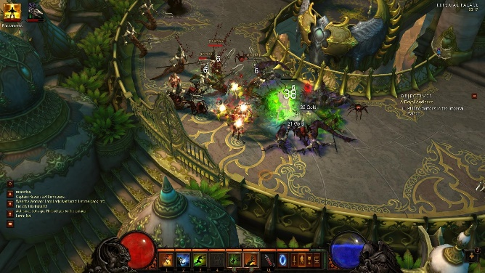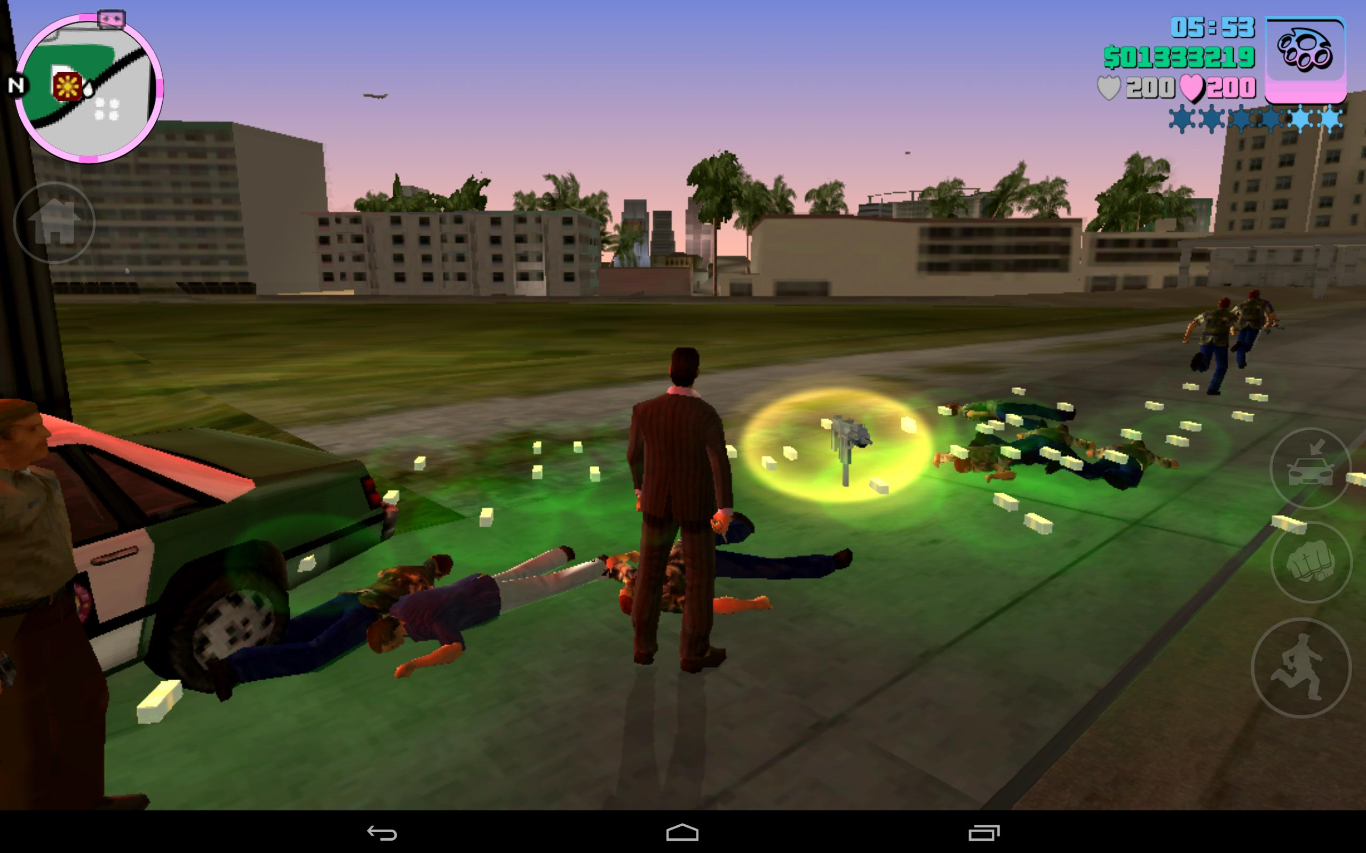

**Genre:** RPG, 3rd person fixed camera RPG.  
**Target Audience:** R for 18 rated

**Controls:** Mouse and Keyboard, and Controller.

**Thematic Setting:** Seedy contemporary – fists, vandals, hookers

**Tech Stack:** Unity 5+, Blender, Photoshop, Audacity

**Platform(s):** Steam

**Game Moment:** 2 minutes of simple flow, basic combat (hitting and taking damage) with multiple enemy types.

**Game Summary:**

**Core Player Experience:**

**Central Theme:**

**Design Pillar:**

**Anticipated Remarkability:**

**Anticipated Steam Early Access Launch date:**

**Feature Development Priorities:**

**Comparative Products:**