Logical paradigm of computing



*Project Title:AI Based Dictionary*

*Submitted To:*

Sir Tayyab awan

Logical paradigm of computing

Superior Group of Colleges

**Project Team:**

* Husnain Sarwar(Project Leader)
* Zohaib rafique
* Faisal Khalid
* Muhammad Irfan
* Muhammad Faiq

**Table of Contents:**

* Introduction
* Requirements
* Functional Requirements
* Non-Functional Requirements
* System Requirments
* Screenshots

**Introduction**

**Dictionary** in Python is an unordered collection of data values, used to store data values like a map, which unlike other Data Types that hold only single value as an element, Dictionary holds key: value pair. Key value is provided in the dictionary to make it more optimized. Each key-value pair in a Dictionary is separated by a colon (:), whereas each key is separated by a ‘comma’.

A Dictionary in Python works similar to the Dictionary in a real world. Keys of a Dictionary must be unique and of immutable data type such as Strings, Integers, and tuples, but the key-values can be repeated and be of any type.

**Requirements**

**Functional Requirements:**

This Application Find meaning of the word in two ways.

1. By Writing a word (Using Keyboard)
2. By Voice

We also use Voice to Text (Speech Recognition) Functionality in our project. By this functionality our user is able to find meaning of the word with his/her voice

**For this Purpose,** We Use Following Libraries….

1. **Speech Recognition**
2. **PyAudio**

When the user writes or speak a word for finding it’s meaning, this dictionary show suitable meaning of the word but if user write wrong spellings of a specific word then 4 to 5 suggestions given to him, user will select one of them and easily find’s a meaning.

**Non-Functional Requirements:**

* Accuracy
* Precision
* Performance
* Capacity
* Scalability
* Reliability
* The system should be user friendly in all manners.
* It should take less time for users to get login.

**Modules needed:**

**json:** It comes built-in with python, so there is no need to install it externally.

**difflib**: This module provides classes and functions for comparing sequences. It also comes built-in with python so there is no need to install it externally.

**Speech Recognition:** Library for performing speech recognition, with support for several engines and APIs, online and offline.

**Tkinter :** is **Python's** de-facto standard GUI (Graphical User Interface) package. It is a thin object-oriented layer on top of Tcl/Tk. **Tkinter** is not the only GuiProgramming toolkit for **Python**.

**Tools:**

* Visual studio Code
* Pycharm
* Jupitor Notebook

**Model:**

**WATERFALL MODEL**

**The waterfall model is a breakdown of project activities into linear sequential phases,** where each phase depends on the deliverables of the previous one and corresponds to a specialization of tasks. The approach is typical for certain areas of engineering design. In software development, it tends to be among the less iterative and flexible approaches, as progress flows in largely one direction ("downwards" like a waterfall) through the phases of conception, initiation, analysis, design, construction, testing, deployment and maintenance.

In our project we first focus on requirements. Our user is able to find correct meaning of specific word and also able to find correct spelling of that word. Our system is proper user friendly that's why we integrate speech to text functionality in this system.

After that we design the project in proper way and follow the specific paradigm to complete the project.

We start construction of the project to follow the sequence of waterfall model and follow the paradigm which we design at the startup of project.

After completeness of project we test the system with the help of different users. Users tell us some problems of our project. Then we resolve the problems and again test from the user. This cycle help us to complete our project properly.

We also introduce some features in our project through which we easily maintain our project when needed.

**Screen shots**

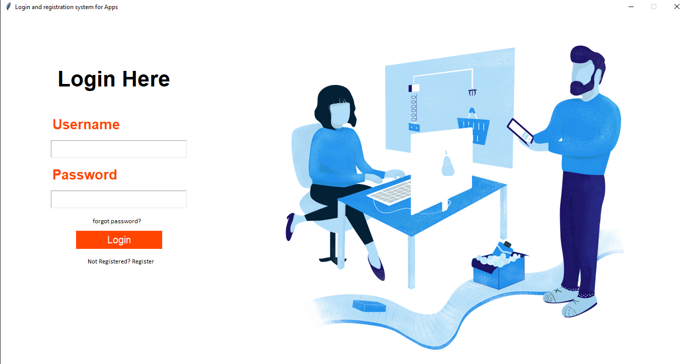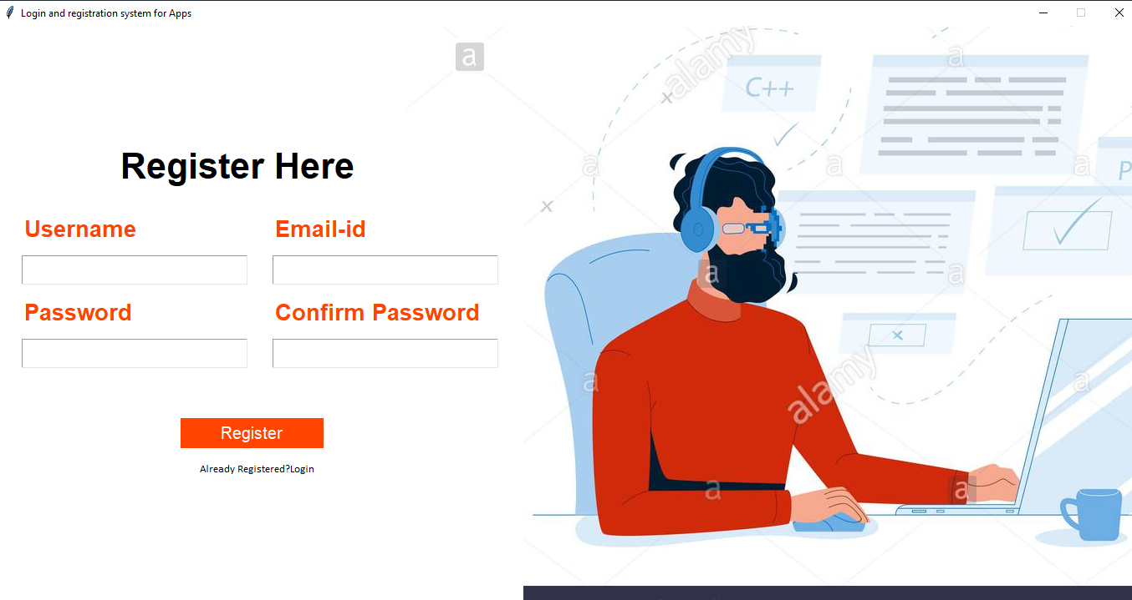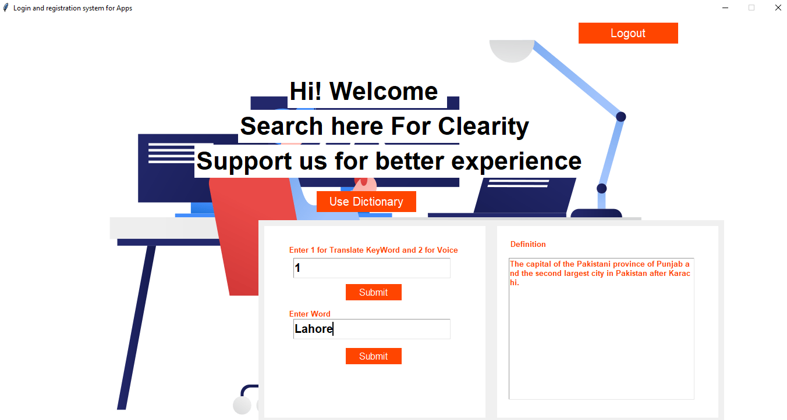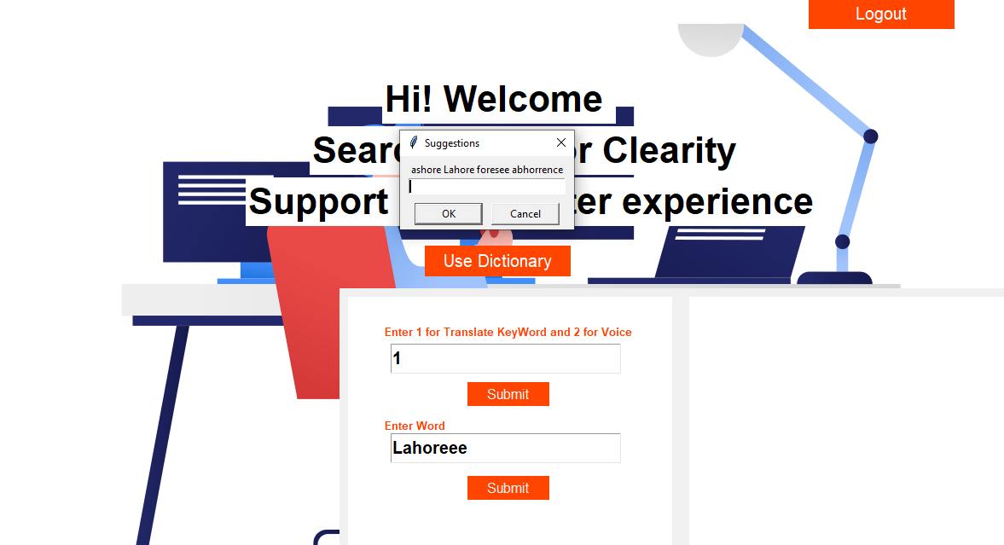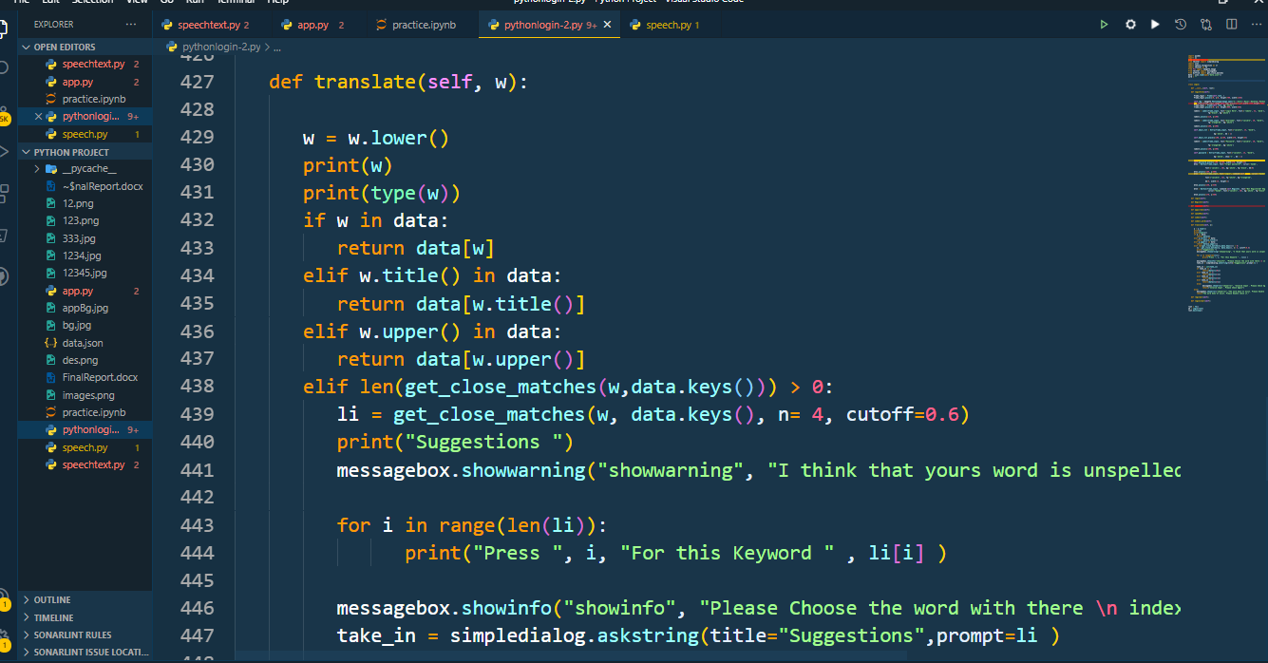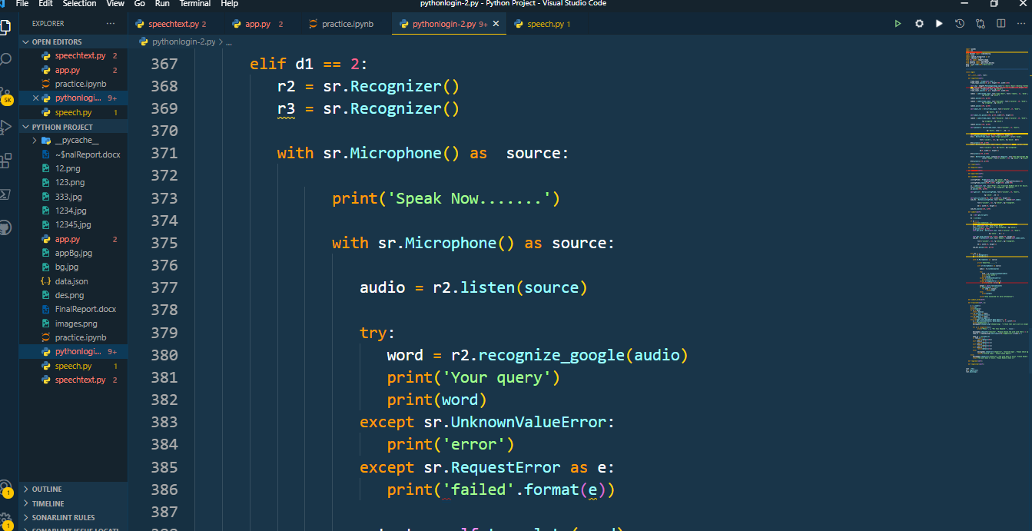

Suggestions

If Spell Mistakes

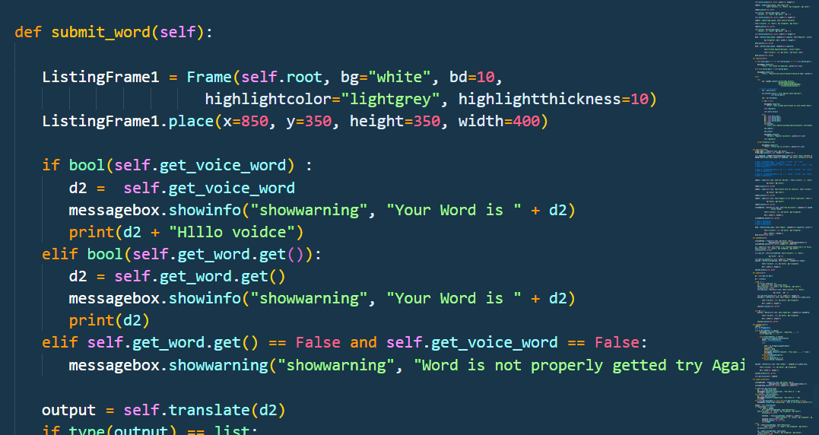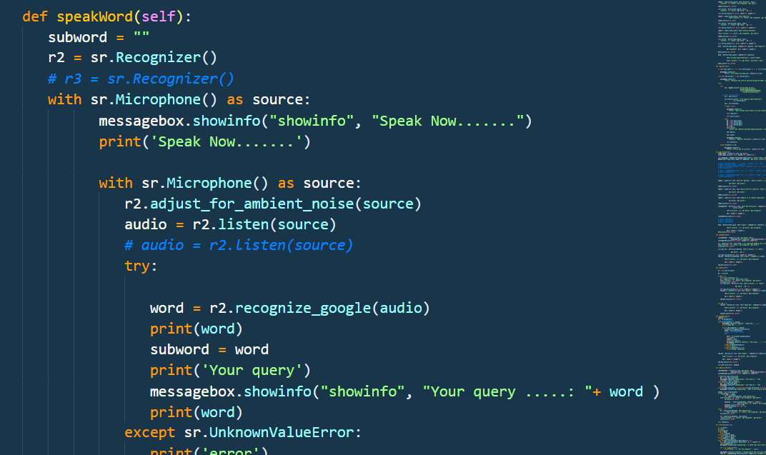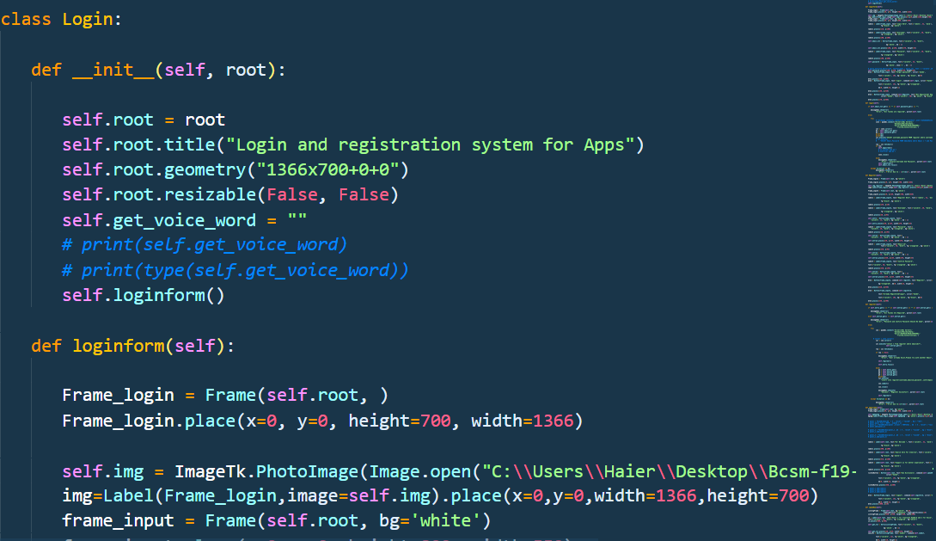

**Conclusion:**

Here I explain the most important part of code that I mention the important snap shots and how it works. When we run the main.py file than it works. Also this project report is prepared by Muhammad Husnain Sarwar and Zohaib Rafique and this project is very helpful in order to understand the Speech Recognition and how the AI works with python. Python is very helpful in order to understand the AI concepts and here we can do anything that we think .