Business Proposal

# FKLDL Motor Shop

## I. Business Name

FKLDL Motor Shop

## II. Logo

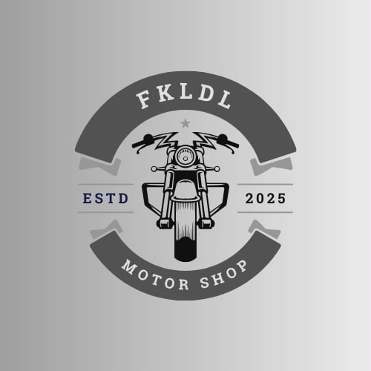

## III. Objective

To provide affordable, reliable, and quality motorcycle parts, accessories, and services for riders in Pasig and nearby areas.

## IV. Mission

To serve every rider with trusted products and excellent services that ensure safety, performance, and satisfaction.

## V. Vision

To become one of the most trusted and innovative motor shops in Metro Manila, offering complete motorcycle solutions.

## VI. Introduction

FKLDL Motor Shop is a startup business created by a team of passionate individuals dedicated to motorcycles.  
The shop provides essential parts, stylish accessories, and expert services for all types of riders.  
Whether for daily commuting or long rides, FKLDL Motor Shop aims to be the go-to destination for quality motorcycle needs.

## VII. Products and Services

* Motorcycle Parts – brakes, tires, engine components, and other essential replacements.
* Accessories – helmets, gloves, lights, decals, and style-enhancing items.
* Maintenance Services – oil changes, tune-ups, tire replacement, and minor repairs.
* Customization – basic upgrades and aesthetic modifications for riders who want a personalized touch.

## VIII. Scope and Limitation

Scope:

* Serves motorcycle owners primarily in Pasig City and surrounding areas.
* Focused on small to mid-range motorcycles, including popular commuter models.

Limitation:

* Currently limited to a single physical store.
* Expansion to larger motorcycle types and a wider product line will depend on market growth and future investment.

## IX. Market Target

Motorcycle owners and riders in Pasig and nearby areas (Cainta, Mandaluyong, Marikina, etc.).  
Delivery riders, commuters, and motorcycle enthusiasts looking for quality yet affordable products.

## X. Competitive Advantage

* Affordable but high-quality products.
* Friendly and expert staff with passion for motorcycles.
* Convenient Pasig location for easy access
* Focus on customer trust and long-term relationships.

## XI. Financial Projection (Sample/Estimated)

|  |  |
| --- | --- |
| Category | Amount (₱) |
| Initial Capital Requirement | 300,000 – 500,000 |
| Expected Monthly Operating Cost | 50,000 – 80,000 |
| Estimated Monthly Revenue (Year 1) | 80,000 – 120,000 |

## XII. Future Plans

* Develop an online ordering and delivery service.
* Expand to a second branch in neighboring cities.
* Offer premium motorcycle brands and exclusive accessories.
* Partner with delivery companies for bulk parts and maintenance services.

## XIII. Digital Presence and Website Integration

To strengthen customer reach and modernize operations, FKLDL Motor Shop will establish a strong online presence through a professionally designed website. The website will feature:

* Homepage – Introduction of shop, mission, and featured services.
* Product Catalog – Motorcycle parts and accessories with prices and images.
* Online Ordering & Delivery – Customers can place orders for delivery or pick-up.
* Service Booking – Online appointment system for repairs and customization.
* Customer Support – Live chat or inquiry form.
* Testimonials & Reviews – Showcase customer feedback
* Blog Section – Motorcycle tips, safety guides, and product updates.

## XIV. Online Marketing Strategy

* Search Engine Optimization (SEO): Rank higher on Google searches (e.g., “motorcycle shop in Pasig”).
* Social Media Marketing: Active engagement on Facebook, Instagram, and TikTok.
* Email Marketing: Send promos, newsletters, and service reminders.
* Paid Ads: Use Facebook Ads and Google Ads to target riders in Metro Manila.

## XV. Website Benefits for FKLDL Motor Shop

* Wider Reach – Attract customers nationwide
* Convenience – Easy ordering and booking.
* Branding – Professional online presence.
* Data Analytics – Track customer behavior and improve sales strategy.

## XVI. Technical Requirements for Website

* Domain & Hosting: Secure domain name (e.g., fkdldmotorshop.com).
* CMS Platform: WordPress, Shopify, or custom-built site.
* Responsive Design: Mobile-friendly layout.
* Security: SSL certificate and secure payment methods.
* Integration: Connect with social media and delivery apps.

## XVII. Future Digital Expansion

* Launch a Mobile App for easier access to products and services.
* Introduce a Digital Loyalty Program with points and rewards.
* Add AI Chatbots for 24/7 customer service.
* Partner with Lazada, Shopee, or GrabMart for e-commerce expansion.

Prepared by:

Dale Serceña

Francia Lyn Elpa

Liezl Develuz

Christopher Soriano

Lyn Tila-on