Updated site tree

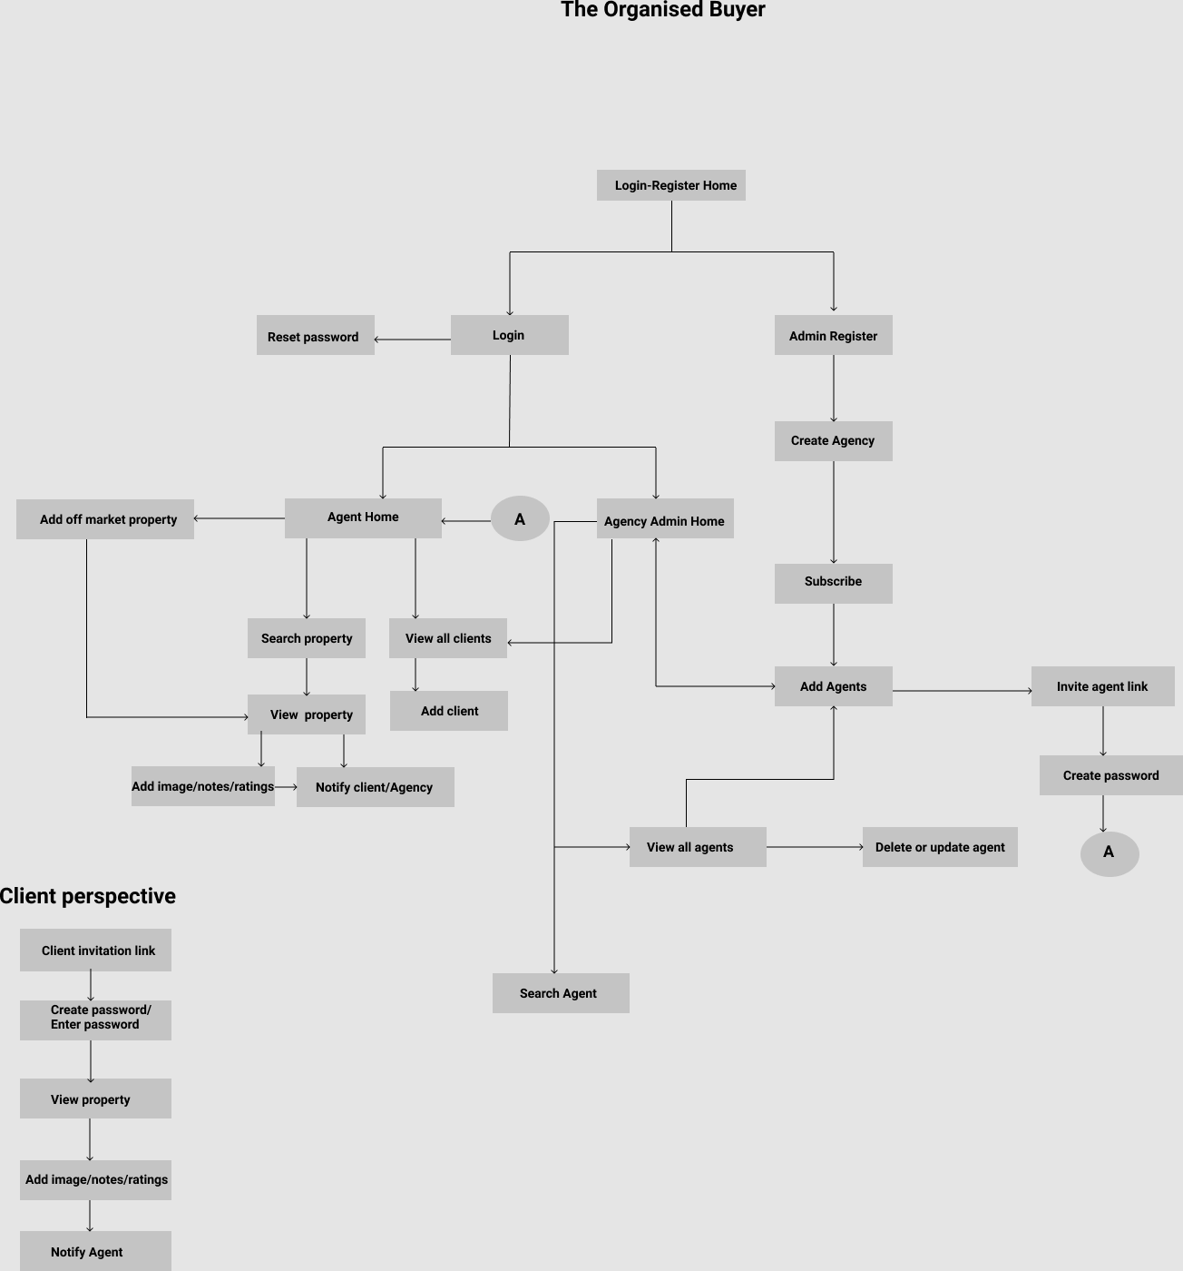

We need some more inputs for the below points:

* *At the moment there is no site tree from a client’s perspective at all, which will be added.*
* *The client must be able to view a list of properties suggested by their agent, and be able to click on each one to go to a ‘property view’ page.*
* *They should be able to view a list of upcoming inspections for the properties in their list.*
* *They should also have a notifications page for changes from the agent.*

Queries

* In the “View property” screen, when an agent sends the property to a client, should one email be sent for every property share?

Yes.

* Should it be one email per agent or one email containing all properties shared by all agents for a client?

Not sure what one email per agent means. A client should be emailed when their agent adds properties for them to view.

* For viewing the list of upcoming inspections, should we include a separate screen?

Yes.

* What kind of changes would be made by the agent in the property details? We assume, agents would be able to modify the details of only the properties that they added themselves, as “Off market properties”. Please confirm.

Yes they can change details of ‘off market properties’. For other properties they can add their own notes and images to be shared with their agency and clients.

* Kindly provide an example where client uploads images to a property for his own organizational purposes.

If a client goes and inspects a property in person, they may take pictures, and wish to upload them to the app, so that when they look at the property in the app they can see their picture there.