1st Year: Beginner Cyber Security
Task 1: CTF Challenge Walkthroughs (TryHackMe)

WHAT IS NETWORKING
-NETWORK:
basically, things being connected together
can be formed between two to billions of devices
-INTERNET is a giant network, consisting of many small networks
1989 tim berners lee created WWW (world wide web)-this was a very crucial development of internet
It is used for storing and showing information

DEVICES ON A NETWORK
Must be identifying and identifiable
Just like humans have name and fingerprint, computers have IP (internet protocol) Address and MAC (media access control) Address
-IP ADDRESS
Identifies host device on network for a period of time
It is divided into 4 octets
Ip address can change for different devices but can’t be active simultaneously within same network
Ip address follows some protocols and forces many devices to communicate in same language

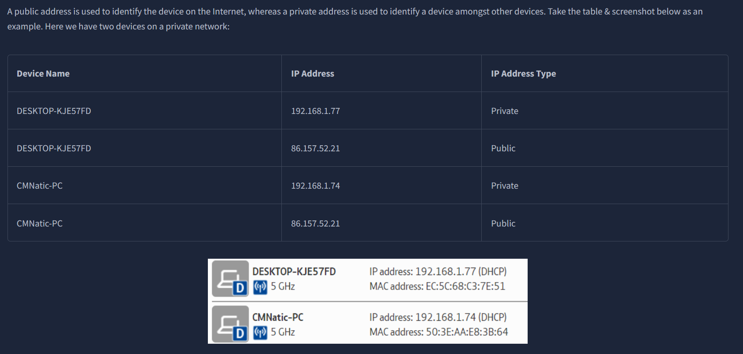
2 devices can use their PRIVATE Ip to communicate with each other
WHERAS
Any data sent from the internet to either device will have same PUBLIC IP address

Eg: 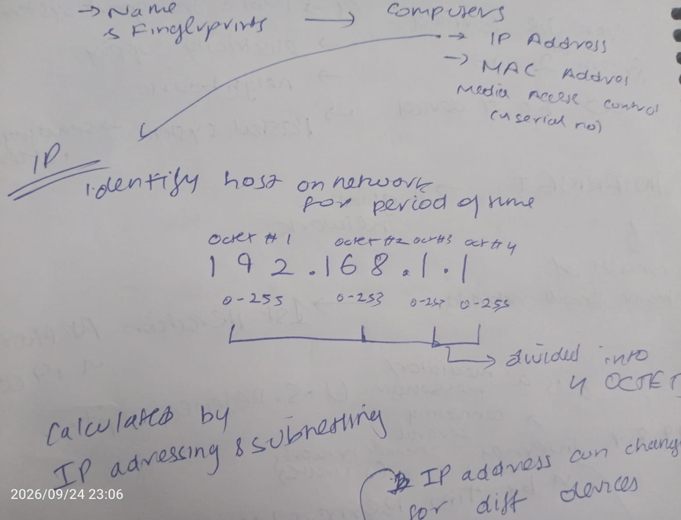

-IPv4
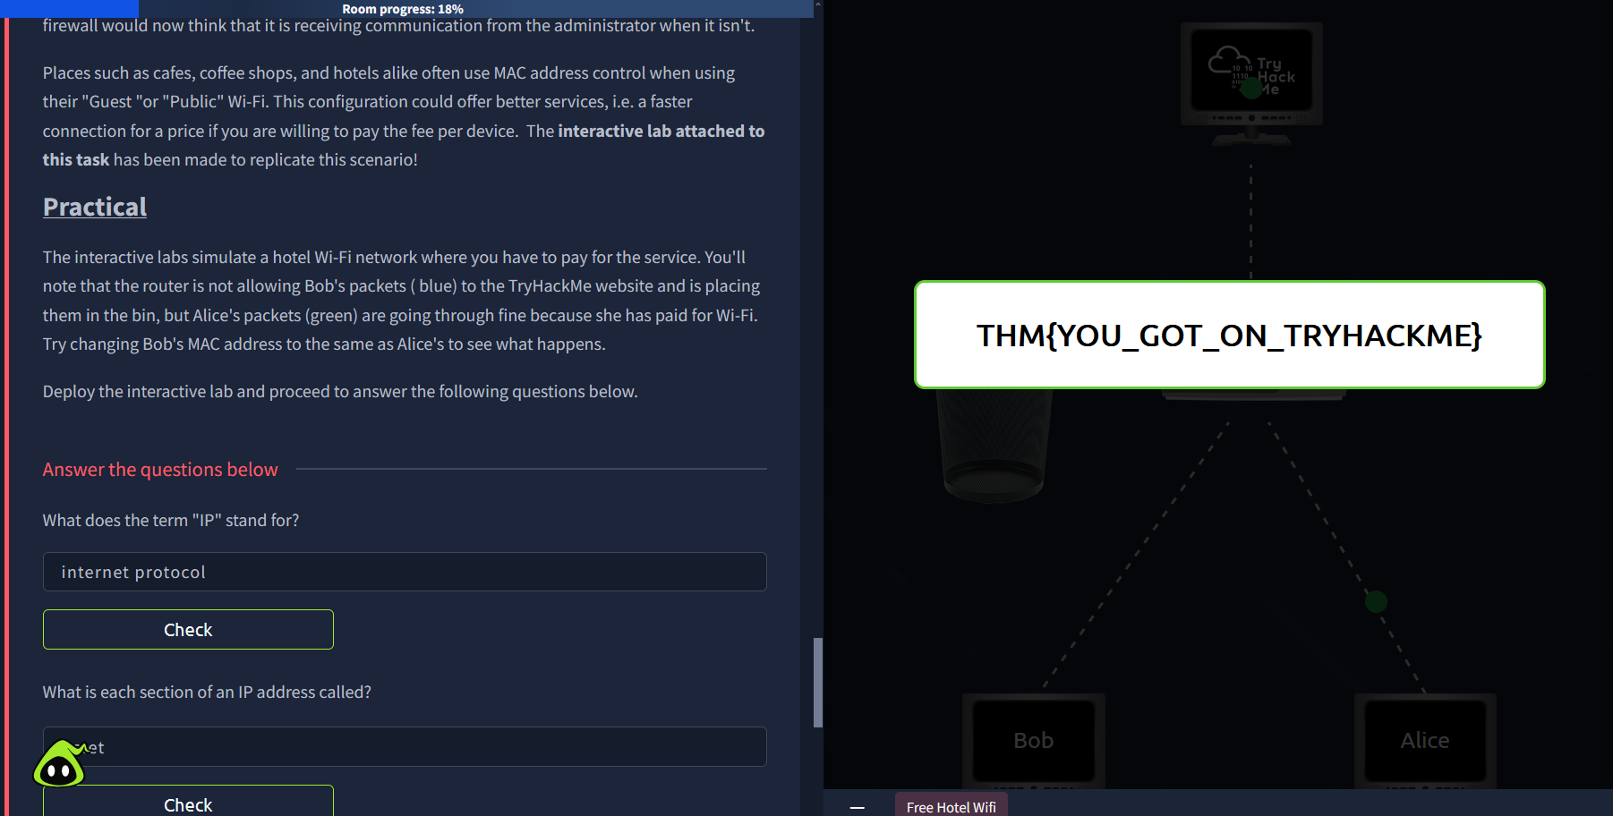
A version of IP addressing scheme
Uses 4.29 billion IP addresses (numbering system)
BUT SINCE THE NUMBER OF DEVICES IS ESTIMATED TO BE ABOVE 50 BILLION
ITS BECOME HARD TO GET AN IP ADDRESS WHICH IS NOT IN USE
-IPv6
THIS IS A SOLUTION TO THE ABOVE ISSUE IN IPv4
Since it supports around 340 trillion IP addresses

-MAC ADDRESS
All devices have a PHYSICAL NETWORK INTERFACE: Which is a microchip board on the device’s motherboard. It has a unique address at the factory it was made in
It is a 12-character hexadecimal number split into two parts, separated by a colon.
The 1st 6 characters represent the company where it was manufactured
The last 6 are unique numbers
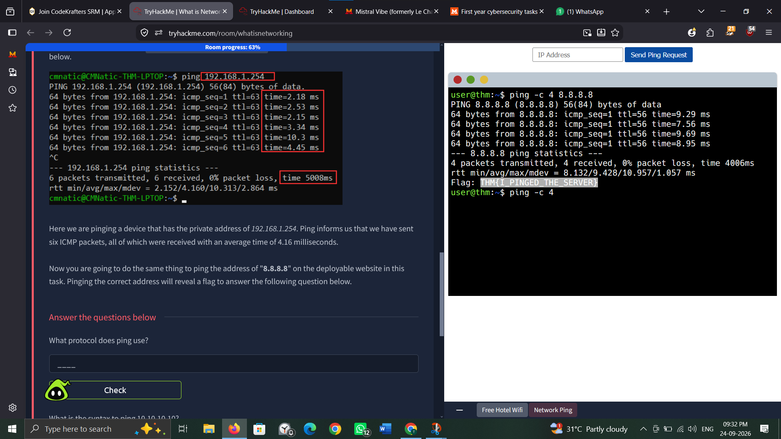

NOTE:
MAC Addresses can be faked or SPOOFED
-SPOOFING is when a networked device pretends to be another one using its mac address
This sometimes fools poorly designed security measures

-PING(ICMP)
It is the most fundamental network tool which uses ICMP (internet control message protocol) packets
ICMP determines performances of a connection between devices
The time taken for ICMP packets to travel between devices is measured by PING using ICMP’S echo packet and echo reply from target devices
IN SHORT: it informs you of the no of ICMP packets sent and received, and the time taken
SYNTAX:
Ping IP Address or Website URL
