**1.What is lift machine_id that Modula set ,the current default is 1;**

Machine ID would be 1 that’s correct. Bay ID for the exit would be also 1. That means you have to use the Prefix 11.

See page 4 in document à Command structure à Prefix

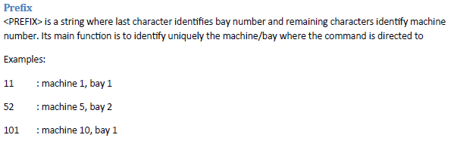

**2. Test command: 1|1|CALL|1|1, whether the lift can place the corresponding tray, bay, position;**

The Call-Command should be like that:

See page 8.

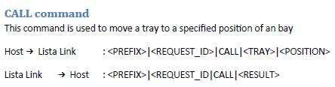

So we have totally 3 trays where the AGV has to pick or drop his goods.

Call command for the 3 trays would be:

Tray 1: 11|1234|CALL|1001|1

Tray 2: 11|5678|CALL|1001|1

Tray 3: 11|9012|CALL|1001|1

**3. Test command: 1|2|RETURN|1, whether the Lift can take back the tray from outside.**

The Return-Command should be like that: (be sure that you send this command only if the AGV is finished with pick or drop and drove away from lift)

See page 14.

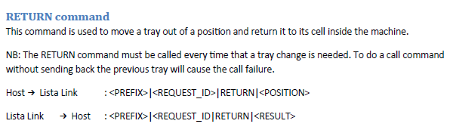

So therefore the examples for the 3 trays:

Tray 1: 11|6789|RETURN|1001|1

Tray 2: 11|0123|RETURN|1001|1

Tray 3: 11|4567|RETURN|1001|1

**4. Test command for Status to check if the Tray Is ready for the AGV to pick or drop:**

After you did the Call-Command from point 3 above. You have to check if the tray is ready for the AGV.

This you can do with the STATUS Command:

See page 5 & 6.

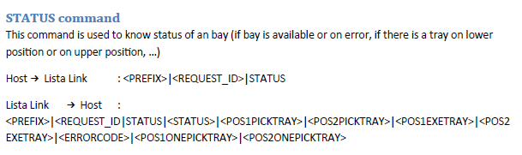

Examples:

Call-Command for Tray 1 à 11|1234|CALL|1001|1

REX à Lista Link:         11|1357|STATUS

Lista Link à REX:         11|1357|STATUS|0|1001|0|0|0|0|0  à Tray is in movement. So we have to wait some seconds and try again.

REX à Lista Link:         11|1357|STATUS

Lista Link à REX:         11|1357|STATUS|0|1001|0|1001|0|0|0 à Tray is ready.

I recommend you to set a wait time between CALL and STATUS about 15 to 20 seconds.

If you have any additional question just let me know. Next week I will install the WMS Link on An’s computer and

Then I can show you with a simulation tool how these all command works. But start with the development.