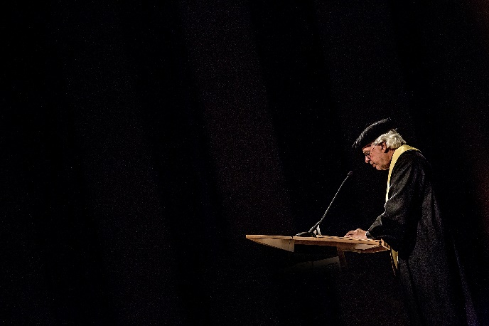

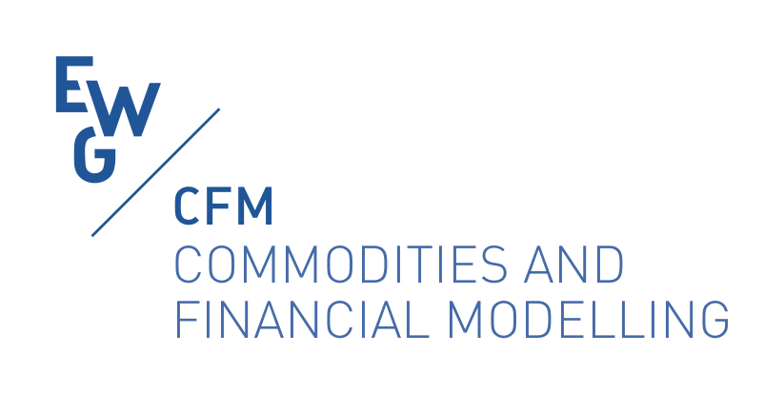

**Jaap Spronk Memorial Award**

***Bridging the gap Between Theory and Practice in Finance and Financial Management***

**2024**

|  |  |
| --- | --- |
| We are proud to introduce the Jaap Spronk Memorial Award. This prestigious award recognizes outstanding contributions that successfully bridge the gap between academic theory and practical application in the fields of finance and financial management, both nationally and internationally. **About the Award** Professor Jaap Spronk was a visionary in the field of finance, known for his relentless pursuit of excellence in both theoretical research and its practical implications. His work has inspired countless professionals and academics worldwide. The Jaap Spronk Memorial Award continues his legacy by honoring innovative work that makes a significant impact on the financial industry. **Award Criteria**  We invite nominations and submissions that demonstrate:   * **Innovative Research:** Original studies that offer new insights into financial theory and its practical applications. * **Practical Solutions:** Real-world applications that solve complex financial problems using theoretical frameworks. * **Impactful Contributions:** Work that has significantly influenced national and international financial management practices.  **Who Can Apply?**  * Young Scholars (up to 35 years old) in finance and related fields. * Collaborative teams that include both young academics and practitioners. * Participants of the 69th and 70th EWGCFM Meetings.  **Submission Guidelines** To apply or nominate someone for the award, please submit your complete research to [rita.decclesia@uniroma1.it](mailto:rita.decclesia@uniroma1.it) with the subject line "**Jaap Spronk Memorial Award Submission**". The evaluation committee is composed of the GEMFM Global Network Advisory Board and the Chair of the 70th EWGCFM Meeting. For any inquiries, contact Rita Laura D’Ecclesia. **Important dates**  * **June 1st 2024**: Opening of the submission procedure * **September 30th 2024**: Submission deadline (Full papers only) * **October 24Th 2024**: Assignment of the Award during the 70th EWGCFM Meeting in Prague  **Award Ceremony** The winner(s) of the Jaap Spronk Memorial Award will be announced by his wife Yvonne Spronk at a special ceremony during the 70th EWGCFM held in Prague next October 2024. The ceremony will include a keynote speech on the importance of bridging the gap between theory and practice in finance, as well as presentations by the award recipients. The Award of €500 will be assigned twice year for the next five years. **Join Us in Honoring Jaap Spronk's Legacy** We encourage all young finance professionals, academics, and researchers to participate in this award. By doing so, you contribute to the ongoing dialogue between theory and practice, fostering innovations that can drive the financial industry forward.  For more information, please visit  [**http://www.ewgfm.eu/**](http://www.ewgfm.eu/)  Let's continue to inspire and be inspired by the legacy of Jaap Spronk. |  |