**Intrusion, Detection, and Response**

## Cloud Environment

## Installation Process

Access root

sudo su –

## Allow traffic rules in your system

ufw allow 22

ufw allow 443

ufw allow 7736

## Initiate Setup

sosetup

After Reboot:

sudo su –

nano /etc/hosts

sosetup

Now go to [www.ifconfig.me](http://www.ifconfig.me)

In your terminal provide access to your ip address

so-allow

Select option [a]

Type your ip address.

How would you add UIW’s address space?

<https://host.io/uiw.edu>

<https://whois.ipip.net/AS33683>

<https://ipinfo.io/AS33683/198.49.125.0/24>

Allow UIW’s address space:

208.91.16.0/22

198.49.125.0/24

You can later check the same information with:

*ufw status*

Before starting activity in your browser allow port 80 in UFW:

*ufw allow from 75.1.50.210 proto tcp to any port 80*

Allow UIW’s address space:

208.91.16.0/22

198.49.125.0/24

You will need to install zip and unzip to decompress this file.

Make a directory named pcap and unzip the file in the newsly generated directory.

The industry standard password is : infected

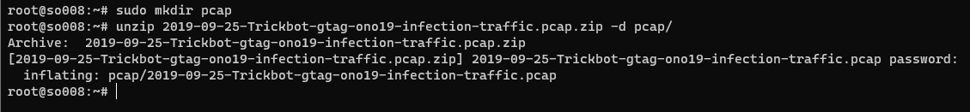

Validate that your pcap is in this file:

Now it is time to load the new PCAP into security onion.

What commands do you have available?

Type *so*, hit the tab key twice, and select *y*

Import the pcap into security onion. You have two options:

1. so-replay-pcap
2. so-import-pcap

There is a big difference between the two. The so-replay-pcap command will have the timestamps of the original files, and the so-import-pcap command will have the timestamp of the day/time you imported the file.

so-import-pcap pcap/2019-09-25-Trickbot-gtag-ono19-infection-traffic.pcap

Time to analyze our data!