## Health Stage Project Document

Tasks List

1. Build AirPI and integrate with Dweet
2. Build Node Red with MQTT broker
3. Build health Stage website
4. Design Website
5. Integrate dashboard or put on other box
6. Mod rom to have branding
7. Build android cyanogenmod clone
8. Build android web app to display data

### AirPi Schemtic

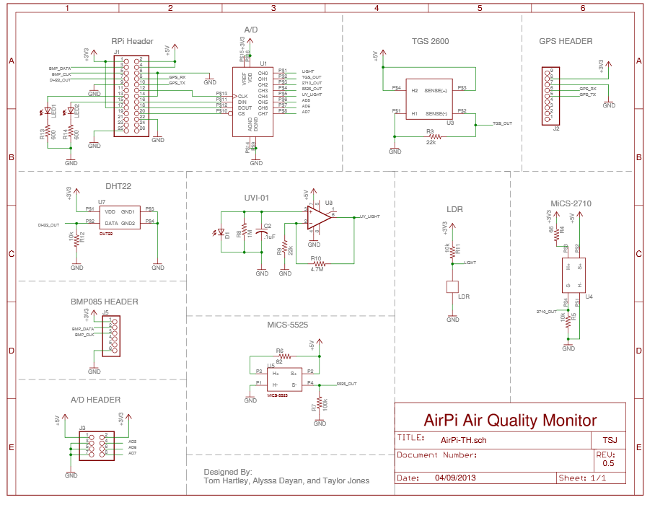

## Installation Instructions

### Installing software

To install the AirPi software, first set up your Raspberry Pi with Raspbian. The easiest way to do this is to follow the Quick-Start guide here:

http://www.raspberrypi.org/wp-content/uploads/2012/04/quick-start-guide-v2_1.pdf

Once you have connected your Raspberry Pi to the internet, enter the following commands at the command line (note the capitalisation

cd ~

git clone https://github.com/tomhartley/AirPi.git

Note the capitalisation. This downloads the AirPi code from the GitHub repository. The advantage of this is that it is easy to update when the code is changed.

sudo apt-get install python-smbus i2c-tools python-setuptools

Press Y when prompted to continue with installation. The final piece of software to be installed is a

python module called requests, for making web requests (used for uploading to Xively).

sudo easy_install requests

### I2C setup

The final stage in setting up your Raspberry Pi to work with the AirPi code is to enable I2C. This is used for communicating with the BMP085 sensor. First begin by entering the following command:

sudo nano /etc/modules

Then add the following two lines to the end of the file:

i2c-bcm2708

i2c-dev

Exit by pressing

ctrl-x , followed by y to confirm you want to save, and

⏎

to confirm the

filename.

Finally, unblacklist i2c by running the following command:

sudo nano /etc/modprobe.d/raspi-blacklist.conf

Add a

#

at the beginning of the line “blacklist i2c-bcm2708”. Then exit in the same way as last time.

Restart your Raspberry Pi with the following command:

sudo reboot

### Software setup

First, go to

Xively

and create a new account. Once you've done that, add a device, and set the

privacy to Public. You should then be taken to a page with your feed ID (a 10 digit number) and API key (a very long string of numbers and letters)

Back on the Pi, enter the following two commands:

cd AirPi

sudo nano outputs.cfg

Enter your Xively API key and Feed ID in this file, then exit with ctrl-x.

If you have a 256MB Raspberry Pi (the first Model B version released), you will need to change the

two instances of “i2cbus = 1” in

sensors.cfg

to “i2cbus = 0”.

If you’re using a standard AirPi V1.2 kit, this should be all the configuration required to let it upload to the internet. To start it uploading, type the following command:

sudo python airpi.py

To stop uploading and quit python, you can press

ctrl-c

### AirPI Links

Haydn Williams

<https://github.com/haydnw/AirPi>

<http://www.haydnwilliams.com/blog/airpi-a-tentative-v1-0-release>

AirPI Forums

<http://airpi.freeforums.net/thread/133/airpi-1-4>

<https://pi.gate.ac.uk/posts/2014/02/07/airpi1/>

Fred Sonnenwaldf

<http://www.sheffield.ac.uk/civil/staff/research/sonnenwaldf>

<https://github.com/guruthree/AirPi>

AirPi Forums2

<http://airpi.freeforums.net/thread/147/revised-airpi-software-features-averaging>

Airpies

<https://airpies.wordpress.com/>

<http://airpi.freeforums.net/thread/154/airpi-bare-pcb-version-available>

Lots of Airpi Stuff Archived – schematics etc

<http://www.gysenbergs.info/data/airpi/>

<http://www.raspberrypaul.co.uk/category/airpi/>

AirPi Node Red

<http://logic.sysbiol.cam.ac.uk/?p=1423>

Xively JSON put sample

|  |
| --- |
| [ { "id" : "e2fc8af4.1d0378",  "label" : "Sheet 1",  "type" : "tab"  },  { "broker" : "api.xively.com",  "id" : "d1387e04.2ec78",  "port" : "1883",  "type" : "mqtt-broker"  },  { "base64" : false,  "datamode" : "single",  "datatype" : "utf8",  "host" : "",  "id" : "7cc0d61c.833f28",  "name" : "fromAirPi",  "newline" : "",  "port" : "1888",  "server" : "server",  "topic" : "",  "type" : "tcp in",  "wires" : [ [ "452f7417.bad08c",  "31813151.ce7ece"  ] ],  "x" : 70,  "y" : 54,  "z" : "e2fc8af4.1d0378"  },  { "func" : "// The received message is stored in 'msg'\n// breaks it at the \":\" to separate the value\n\nvar res = msg.payload.split(\":\");\nmsg.topic = res[0];\nmsg.payload = res[1];\nreturn msg;",  "id" : "452f7417.bad08c",  "name" : "splitMessage",  "outputs" : 1,  "type" : "function",  "wires" : [ [ "ef1909bd.10e6f8" ] ],  "x" : 236,  "y" : 54,  "z" : "e2fc8af4.1d0378"  },  { "broker" : "d1387e04.2ec78",  "id" : "c383315c.3c7cd",  "name" : "Xively",  "topic" : "",  "type" : "mqtt out",  "wires" : [ ],  "x" : 570,  "y" : 54,  "z" : "e2fc8af4.1d0378"  },  { "func" : "// The received message is stored in 'msg'\n// reformats to topic to contain login details\n\nmsg.topic = \"yourAPIKEYgoeshere/v2/feeds/yourFEEDIDgoeshere/datastreams/\"+msg.topic+\".csv\"\nreturn msg;",  "id" : "ef1909bd.10e6f8",  "name" : "addXivelyPath",  "outputs" : 1,  "type" : "function",  "wires" : [ [ "c383315c.3c7cd" ] ],  "x" : 403,  "y" : 54,  "z" : "e2fc8af4.1d0378"  }  ] |

|  |
| --- |
| Partlist  Exported from AirPi_1-2.brd at 10/06/14 20:25  EAGLE Version 6.5.0 Copyright (c) 1988-2013 CadSoft  Assembly variant:  Part Value Package Library Position (inch) Orientation  C1 100nF C2.5-4 capacitor-wima (0.11725 1.036) R270  C2 470uF E5-10,5 rcl (0.2635 0.52325) R90  IC1 MCP6283 DIL08 linear (0.72775 0.51725) R0  J1 2X13 pinhead (0.676 2.05) R0  J2 1X09-BIG adafruit (2.8 0.9) R0  J3 2X04 adafruit (2.0455 0.185) R0  J5 1X06 adafruit (1.9 1.4) R180  LDR1 LDR LED5MM tjones (1.20275 0.512) R180  LED1 LED3MM adafruit (0.583 0.18825) R270  LED2 LED3MM adafruit (0.30025 0.191) R270  M1 MIC WM-62PC/62PK microphon (1.105 0.26) R270 WM-64MN  R1 22k 0207/10 adafruit (0.65 1) R90  R2 10k 0207/10 adafruit (0.8 1) R90  R3 22k 0207/10 adafruit (2.08175 0.456) R180  R4 68 0207/10 adafruit (1.1 1) R270  R5 10k 0207/10 adafruit (2.08725 0.6165) R0  R6 82 0207/10 adafruit (2.98175 0.2895) R270  R7 100k 0207/10 adafruit (2.674 0.7) R180  R8 330 0207/10 adafruit (0.5 1) R90  R9 390k 0207/10 adafruit (0.35 1) R90  R11 10k 0207/10 adafruit (1.25 1) R270  R12 10k 0207/10 adafruit (0.95 1) R270  R13 100 0207/10 adafruit (1.3415 1.56325) R270  R14 100 0207/10 adafruit (1.516 1.55825) R270  U1 MCP3008 DIL16 tjones (1.75 1.05) R0  U3 TGS2600 TGS2600 tjones (1.4685 0.21) R270  U4 MICS-2710 MICS-2710 tjones (1.63725 0.5935) R0  U5 MICS-5525 MICS-5525 tjones (2.603 0.28) R180  U7 DHT22 DHT22 tjones (0.227 1.725) R270 |