[1] Bomber-Friends [Online] <https://www.spielaffe.de/Spiel/Bomber-Friends> (visited on 03.05.2022)

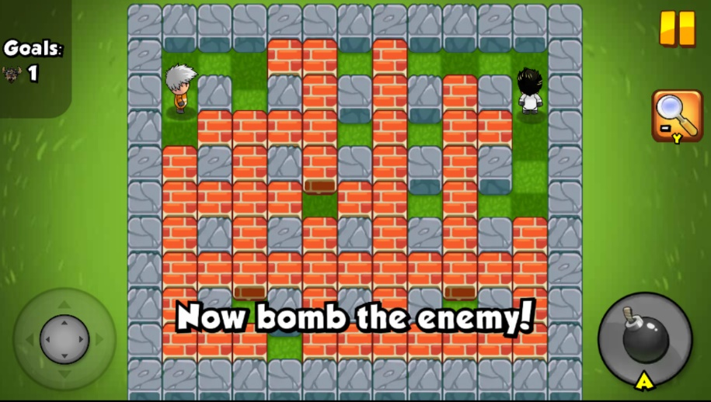

Figure Bomber-Friends Screenshot [1]

[2] Bomber-Mouse [Online] <https://de.y8.com/games/bomber_mouse> [visited in 03.05.2022]

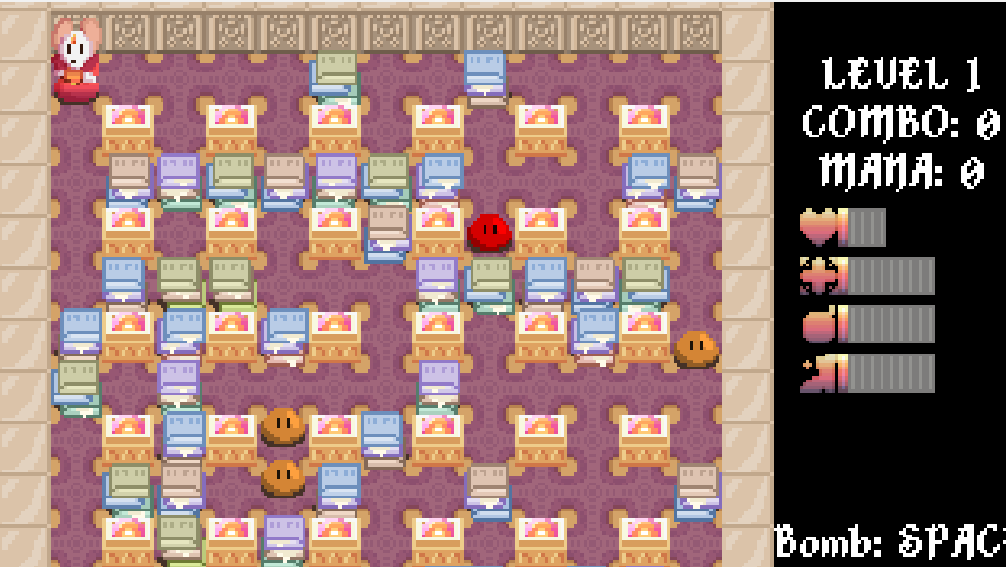

Figure 2 Bomber-Mouse Screenshot

[3] Playing with Fire [Online] https://www.kibagames.com/Game/Playing-with-Fire-2 (visited on 03.05.2022)

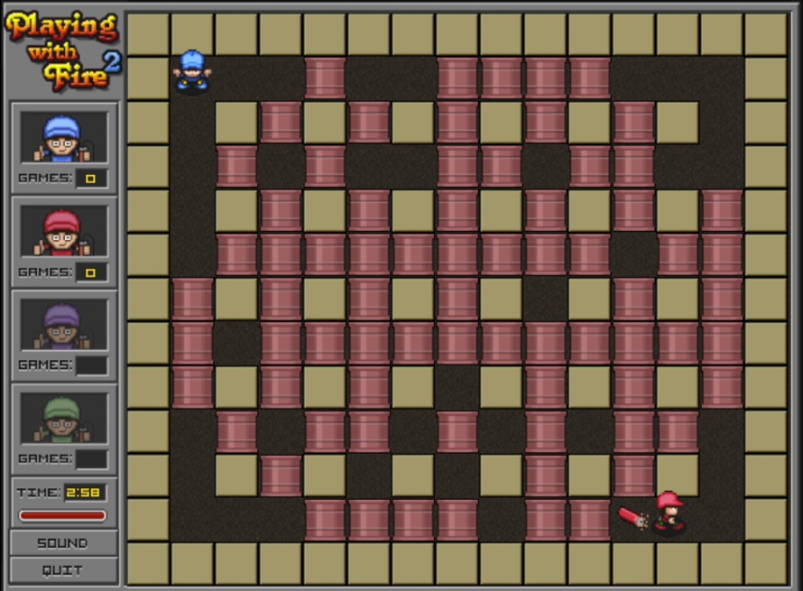

Figure 3 Playing with Fire 2 Screenshot

[4] Allstar-Blast [Online] <https://www.kibagames.com/Game/All-Star-Blast> (visited on 03. 05.2022)

Ein Bild, das Verkauf enthält.

Figure [4] Allstar-Blast Screenshot