**SUBJECT NAME: Web Design**

**SUBJECT CODE: WEDE5020**

**FULL NAMES: MOGOMANE MOSA TSHEBESEBE**

**STUDENT NUMBER: ST10485614**

**GROUP 1**

**PART 2**

**Index Page :**

* A[dded colors to navigation](https://github.com/cybermosaa/Part_2/commit/202d38c7b16b84290eabe522690358854f18f707) tag
* C[onsistency in a tags](https://github.com/cybermosaa/Part_2/commit/e3f236056fcd94f9ad6b18ddd3e24b0f7c769aa4)
* A[dded more information for care](https://github.com/cybermosaa/Part_2/commit/38a5f8f108e85a6366f93627063593a51c721695)
* S[pace between button and the image](https://github.com/cybermosaa/Part_2/commit/4f53ef0c81e66b278b8f0a62d86ee4c33efad671)
* A[dded heading class](https://github.com/cybermosaa/Part_2/commit/f2339fe3e01a8991879b84d414fbbfdf5094bf62)
* A[dded the brand name on top](https://github.com/cybermosaa/Part_2/commit/a0fa5a1acb28570694b178a0fe9aaca61672bb92)
* A[dded heading class](https://github.com/cybermosaa/Part_2/commit/f2339fe3e01a8991879b84d414fbbfdf5094bf62)
* Added button styles to enhance the button
* A[dded heading class](https://github.com/cybermosaa/Part_2/commit/f2339fe3e01a8991879b84d414fbbfdf5094bf62)
* A[dded button class](https://github.com/cybermosaa/Part_2/commit/88e7c05854b66ecdd2f3b2f888d77155aa2aa366)
* Shop Now button added
* Added hover to the button

**Lookbook Page :**

* A[dded colors to navigation](https://github.com/cybermosaa/Part_2/commit/202d38c7b16b84290eabe522690358854f18f707) tag
* Consistency in the a tags links
* In[itial commit](https://github.com/cybermosaa/Part_2/commit/6b3fd482d23fc2b11125860dbe75cbe0cf97cd59)
* A[dded the brand name to every page](https://github.com/cybermosaa/Part_2/commit/587b2aca564f3b2a119cc2f0c2ca17f1d2989dad)
* A[dded looks class](https://github.com/cybermosaa/Part_2/commit/e43afcc163103d6045d92010ad131669387a641e)
* A[dded navigation class](https://github.com/cybermosaa/Part_2/commit/86d0a9a0cba8230515c035b05c693d99be74a0c4)
* Added captions class
* Added hover to images
* Added a back to top button

**ContactUs Page :**

* A[dded colors to navigation](https://github.com/cybermosaa/Part_2/commit/202d38c7b16b84290eabe522690358854f18f707) tag
* Consistency in a tag links
* A[dded the brand name on top](https://github.com/cybermosaa/Part_2/commit/a0fa5a1acb28570694b178a0fe9aaca61672bb92)
* C[hanged naming](https://github.com/cybermosaa/Part_2/commit/03d13c259cb630c47648a559c642c03e1e9120ef)
* A[dded the brand name on top](https://github.com/cybermosaa/Part_2/commit/a0fa5a1acb28570694b178a0fe9aaca61672bb92)
* A[dded the brand name to every page](https://github.com/cybermosaa/Part_2/commit/587b2aca564f3b2a119cc2f0c2ca17f1d2989dad)
* A[dded the brand name on top](https://github.com/cybermosaa/Part_2/commit/a0fa5a1acb28570694b178a0fe9aaca61672bb92)

**Collection Page:**

* A[dded colors to navigation](https://github.com/cybermosaa/Part_2/commit/202d38c7b16b84290eabe522690358854f18f707) tag
* Consistency in a tag links
* A[dded colors to navigation](https://github.com/cybermosaa/Part_2/commit/202d38c7b16b84290eabe522690358854f18f707)
* C[onsistency inn tags](https://github.com/cybermosaa/Part_2/commit/e3f236056fcd94f9ad6b18ddd3e24b0f7c769aa4)
* A[dded info for care](https://github.com/cybermosaa/Part_2/commit/38a5f8f108e85a6366f93627063593a51c721695)
* A[dded the brand name on top](https://github.com/cybermosaa/Part_2/commit/a0fa5a1acb28570694b178a0fe9aaca61672bb92)
* Added a hover effect to the images
* Added back to top button

**Checkout Page :**

* I[nitial commit](https://github.com/cybermosaa/Part_2/commit/6b3fd482d23fc2b11125860dbe75cbe0cf97cd59)
* A[dded colors to navigation](https://github.com/cybermosaa/Part_2/commit/202d38c7b16b84290eabe522690358854f18f707) tag
* Consistency in a tag links
* Created a form
* Added button
* C[onsistency in a tags](https://github.com/cybermosaa/Part_2/commit/e3f236056fcd94f9ad6b18ddd3e24b0f7c769aa4)
* A[dded the brand name to every page](https://github.com/cybermosaa/Part_2/commit/587b2aca564f3b2a119cc2f0c2ca17f1d2989dad)
* Added form for sign up
* Added button
* Added hover to button
* A[dded checkout class](https://github.com/cybermosaa/Part_2/commit/3c2f9fd270ffe0ea6984e43c23e4747e27dc080f)

**Care Page:**

* A[dded colors to navigation](https://github.com/cybermosaa/Part_2/commit/202d38c7b16b84290eabe522690358854f18f707) tag
* Consistency in a tag links
* A[dded colors to nav](https://github.com/cybermosaa/Part_2/commit/202d38c7b16b84290eabe522690358854f18f707)
* R[emoved a tag](https://github.com/cybermosaa/Part_2/commit/2a28b0dc72d54bacb303289876406e91c0e21cf4)
* A[dded class grid](https://github.com/cybermosaa/Part_2/commit/c402062089dfe3487e141ae803f673586e442afb)
* A[dded the brand name to every page](https://github.com/cybermosaa/Part_2/commit/587b2aca564f3b2a119cc2f0c2ca17f1d2989dad)
* A[dded h1 styles](https://github.com/cybermosaa/Part_2/commit/2e78f1928800720221cd5000c8d3899b9ab577df)
* A[dded grid styling](https://github.com/cybermosaa/Part_2/commit/9ed74cfcef41f5aee1585923cab15873e908cadd)
* A[dded class grid](https://github.com/cybermosaa/Part_2/commit/c402062089dfe3487e141ae803f673586e442afb)
* Added information for [care](https://github.com/cybermosaa/Part_2/commit/38a5f8f108e85a6366f93627063593a51c721695)
* A[dded h1 style](https://github.com/cybermosaa/Part_2/commit/2e78f1928800720221cd5000c8d3899b9ab577df)
* A[dded p tag](https://github.com/cybermosaa/Part_2/commit/dd55579c9b91820ac08d025292bc2a3ec0386d2f)
* A[dded sections for care](https://github.com/cybermosaa/Part_2/commit/62accc83e45f18d0c89df6380f27b26b639a7e0f)
* A[dded back to top](https://github.com/cybermosaa/Part_2/commit/bf62d9f6cda707975079377c7034dbc2bd94b79d) button
* A[dded button class](https://github.com/cybermosaa/Part_2/commit/88e7c05854b66ecdd2f3b2f888d77155aa2aa366)

**About Us Page :**

* A[dded care guide](https://github.com/cybermosaa/Part_2/commit/b625d21434c269235eff5e25dd4ba09c75f3e28d) page a tag link
* A[dded colors to navigation](https://github.com/cybermosaa/Part_2/commit/202d38c7b16b84290eabe522690358854f18f707) tag
* Consistency in a tag links
* A[dded the brand name to every page](https://github.com/cybermosaa/Part_2/commit/587b2aca564f3b2a119cc2f0c2ca17f1d2989dad)
* A[dded mobile media quiry](https://github.com/cybermosaa/Part_2/commit/db01721eedc1f03284e27e17e0d8953c5b2a584f)
* R[epladed h5 with p tag](https://github.com/cybermosaa/Part_2/commit/70522310503af47795702a9688f0839c513781f3)
* A[dded h2 styling](https://github.com/cybermosaa/Part_2/commit/452ea1b377588adba87409510ff1e4faab29b740)
* R[epladed h5 w p tag](https://github.com/cybermosaa/Part_2/commit/70522310503af47795702a9688f0839c513781f3)
* A[dded back to top](https://github.com/cybermosaa/Part_2/commit/bf62d9f6cda707975079377c7034dbc2bd94b79d) button

**MEDIA QUIRIES FOR MOBILE DEVICE & TABLET SCREENS**

MOBILE DEVICE

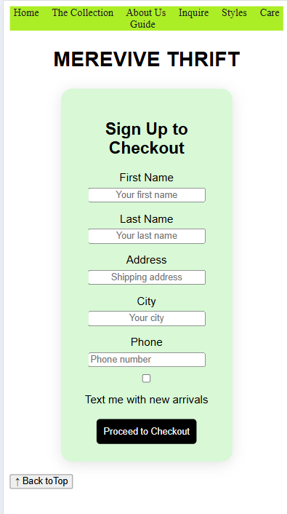

Tablet Screen

