Important links -

<https://kafka.apache.org/quickstart>

Kafka Installation -

1. Download kafka from <https://www.apache.org/dyn/closer.cgi?path=/kafka/2.2.0/kafka_2.12-2.2.0.tgz>
2. Open terminal in that directory where you have downloaded Kafka.
3. > tar -xzf kafka_2.12-2.2.0.tgz
4. > cd kafka_2.12-2.2.0

Start Kafka Server -

1. Kafka uses [ZooKeeper](https://zookeeper.apache.org/) so you need to first start a ZooKeeper server.You can use the convenience script packaged with kafka to get a quick-and-dirty single-node ZooKeeper instance.

Command to start ZooKeeper -

**E:\nmbsystemWorkspace\cybernetiz\kafka_2.12-2.2.0\bin\windows**>*zookeeper-server-start.bat E:\nmbsystemWorkspace\cybernetiz\kafka_2.12-2.2.0\config\zookeeper.properties*

*zooKeeper will run on port 2181.*



2. Now start the Kafka server:

**E:\nmbsystemWorkspace\cybernetiz\kafka_2.12-2.2.0\bin\windows>**kafka-server-start.bat E:\nmbsystemWorkspace\cybernetiz\kafka_2.12-2.2.0\config\server.properties

Kafka will run on port 9200.

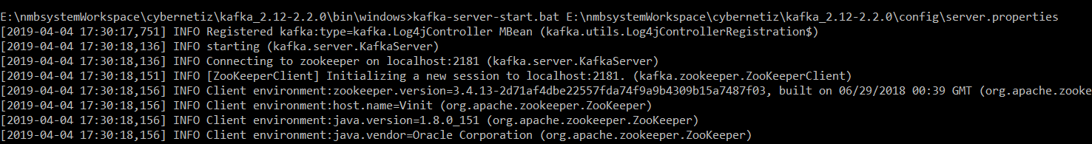

3. Create a Topic -

**E:\nmbsystemWorkspace\cybernetiz\kafka_2.12-2.2.0\bin\windows>**kafka-topics.bat --create --zookeeper localhost:2181 --replication-factor 1 --partitions 1 --topic userEventTopic

4. List all the topics -

kafka-topics.sh --list --bootstrap-server localhost:9092



4. Send Messages -

Kafka comes with a command line client that will take input from a file or from standard input and send it out as messages to the Kafka cluster. By default, each line will be sent as a separate message.

Start a producer -

**E:\nmbsystemWorkspace\cybernetiz\kafka_2.12-2.2.0\bin\windows>**kafka-console-producer.bat --broker-list localhost:9092 --topic freshTopic

Start a Consumer -

**E:\nmbsystemWorkspace\cybernetiz\kafka_2.12-2.2.0\bin\windows>**kafka-console-consumer.bat --bootstrap-server localhost:9092 --topic enrichEventTopic --from-beginning

Now you can send the message through producer and can listen those at consumer side.

5. Producer reading data from a FIle -

**E:\nmbsystemWorkspace\cybernetiz\kafka_2.12-2.2.0\bin\windows>**kafka-console-producer.bat --broker-list localhost:9092 --topic freshTopic < E:\nmbsystemWorkspace\cybernetiz\sample.txt