Partial Encryption, Full Signature – Invention Disclosure
This invention is
herby placed in
the Public Domain
ABSTRACT
This document outlines a scheme where a Payee-originated Authorization Request is triggering a corresponding Authorization Response object, created by a Payment Wallet under the Payer’s supervision. The Authorization Response object contains both the original Authorization Request object as well as data associated with a by the Payer selected Payment Credential (aka virtual card). All data is signed by a single signature associated with the selected Payment Credential. For privacy reasons (with respect the Payee), Payer-specific data is encrypted, while the Authorization Request as well as non-personal data related to the Payment Network associated with the selected Payment Credential, is provided in clear to enable forwarding and processing. The described scheme depends on the secure cutting and pasting of message elements facilitated by Deterministically Encoded CBOR.
- Sequence Diagram
A Merchant is an entity requesting a payment from a Payer. Merchant entities include on-line (Web) shops, local shops, and automated facilities like gas stations. Users are equipped with mobile devices hosting digital Wallets containing Virtual (payment) Cards issued by one or more User Banks. The following sequence diagram was taken from Wallet Core [CORE] but the specification herein is only targeting the Authorization Request and Authorization Response pair.

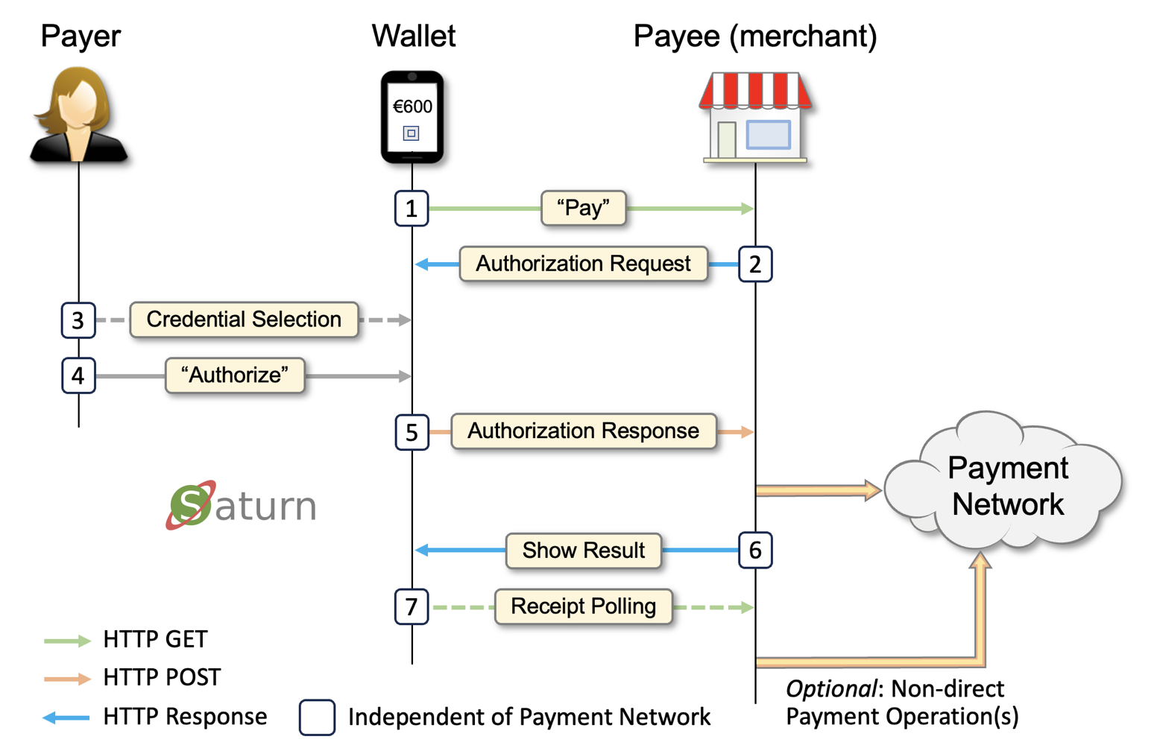

Throughout this specification messages are expressed in the human-readable format of CBOR [CBOR] known as “Diagnostic Notation”. In an actual implementation, the normal (binary) format would always be used.
Note that the described concept depends on that the CBOR serializer and parser supports Deterministic Encoding [CDE], including maintaining proper representation when adding and removing CBOR map keys.
- Authorization Request
The following CBOR message represents a possible Authorization Request object to be sent to the wallet:
Core request
{
"paymentRequest": {
"id": "20241207.00079",
"amount": "600.00",
"currency": "EUR",
"commonName": "Space Shop"
},
"supportedNetworks": ["https://banknet2.org", "https://visa.com"]
}
Note: the supportedNetworks attribute is not core to this specification but adds the possibility supporting multiple Payment Networks through a single wallet and authorization concept.
The PaymentRequest part of the Authorization Request object would then typically be rendered in the wallet like:
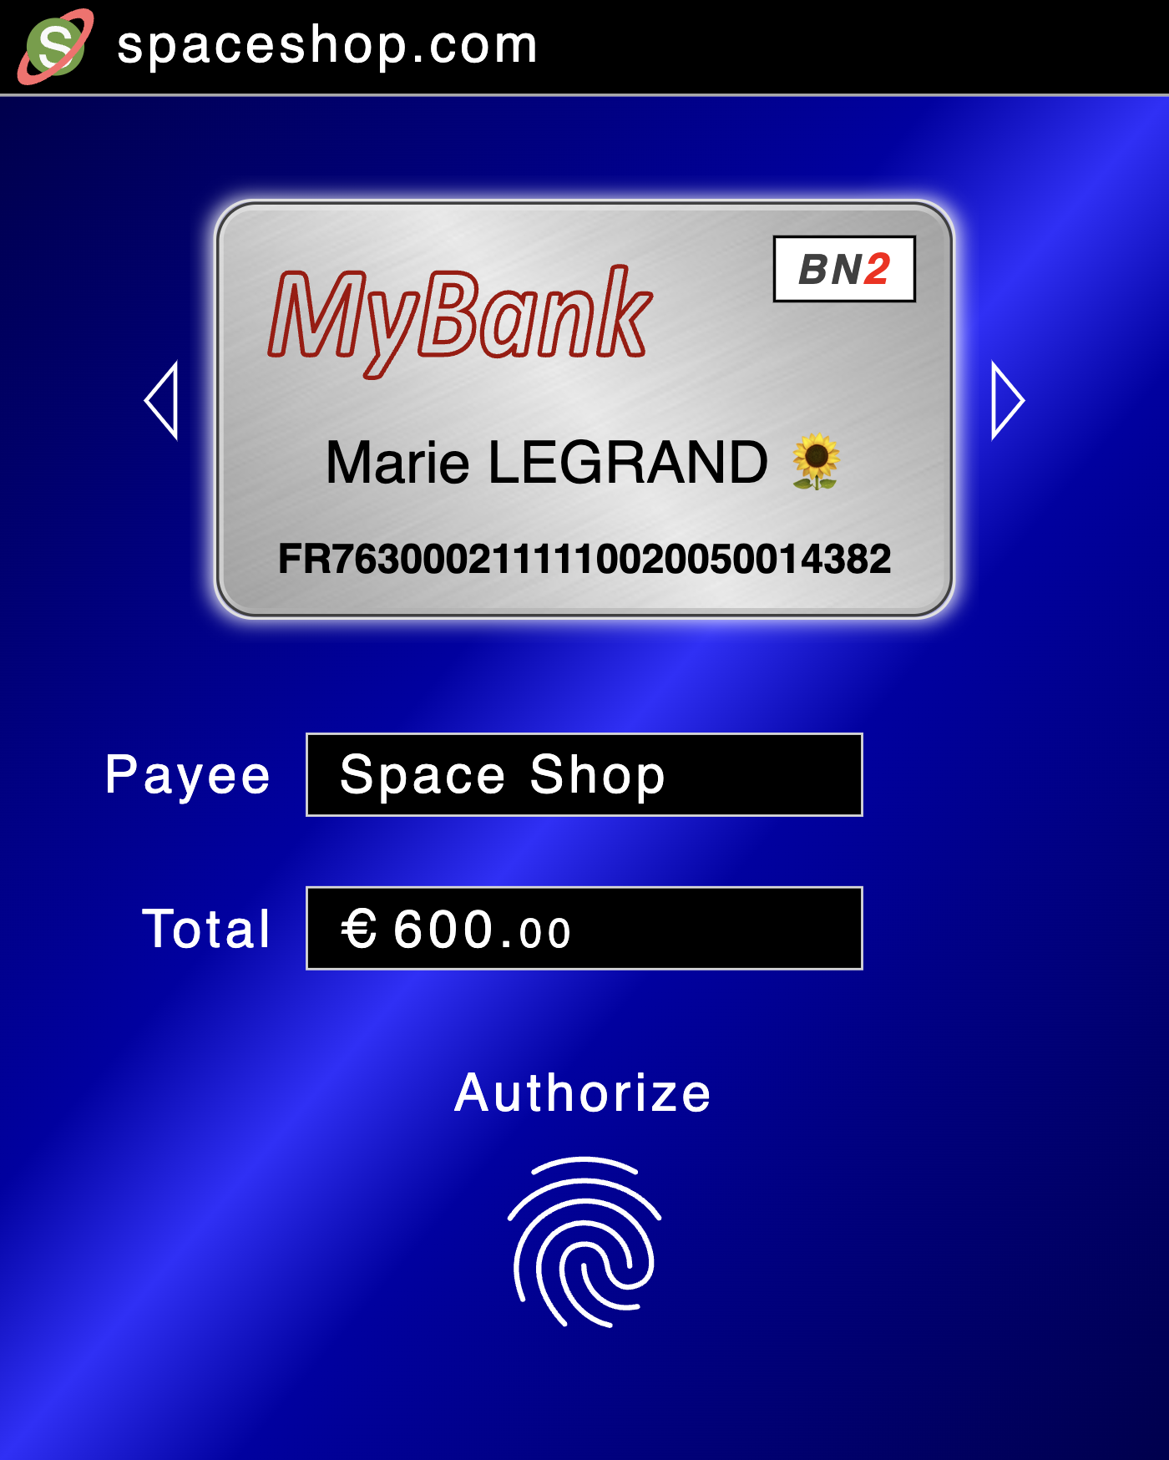

After the Payer have authorized the PaymentRequest using a PIN or biometric operation, the corresponding Authorization Response object is created and sent back to the Payee.

- Authorization Response
The Authorization Response object is created through a number of discrete steps which constitute the core of this invention disclosure.
  - Unsigned Authorization Response
The following CBOR code shows a possible unsigned Authorization Response object:
{
"accountId": "FR7630002111110020050014382",
"timeStamp": "2024-09-01T13:28:02-02:00",
"unencryptedData": {
"providerInfo": {
"networkId": "https://banknet2.org",
"serviceLocator": "mybank.com"
},
"paymentRequest": {
"amount": "600.00",
"currency": "EUR",
"commonName": "Space Shop",
"referenceId": "20241207.00079"
}
}
}
The attributes networkId and serviceLocator represent payment network/method respectively an indicator used for accessing the Issuer. In the sample, serviceLocator is expressed as a host-name meaning that the actual service end-point is to be retrieved through a /.well-known/ URL [RFC8615].
The networkId, serviceLocator, and the accountId attributes are derived from the selected Payment Credential.

  - Signed Authorization Response
Adding an enveloped CBOR signature [CSF], to the unsigned Authorization Response object will result in the following CBOR code:
{
"accountId": "FR7630002111110020050014382",
"timeStamp": "2024-09-01T13:28:02-02:00",
"unencryptedData": {
"providerInfo": {
"networkId": "https://banknet2.org",
"serviceLocator": "mybank.com"
},
"paymentRequest": {
"amount": "600.00",
"currency": "EUR",
"commonName": "Space Shop",
"referenceId": "20241207.00079"
}
},
"authorizationSignature": {
1: -50,
4: {
1: 1,
-1: 6,
-2: h'fe49acf5b92b6e923594f2e83368f680ac924be93cf533aecaf802e37757f8c9'
},
6: h'a4ff37cc4b1db1a760ea930f274c59d71a7e7edef5b2e4a07eff764bb01590a7...'
}
}
Notes:
The enveloped signature encompasses the entire CBOR object except for signature value itself (label 6).
The signature value was truncated for readability reasons.
The sample uses an Ed25519 signature algorithm (1: -50).
The signature keys are derived from the selected Payment Credential.
The public part of the signature keys is specified by label -2.
Algorithms and key containers are compatible with COSE [RFC9052].

  - Encrypted Authorization Response
To build the final Authorization Response object, the signed authorization object is first split into two:
- One part holding data that must remain in clear to facilitate further processing.
- Another part that contains privacy-sensitive data like account numbers and public keys. This part must be encrypted.
Data to be supplied in clear:
{
"providerInfo": {
"networkId": "https://banknet2.org",
"serviceLocator": "mybank.com"
},
"paymentRequest": {
"amount": "600.00",
"currency": "EUR",
"commonName": "Space Shop",
"referenceId": "20241207.00079"
}
}
By keeping paymentRequest in clear, this information does not require duplication in other message layers.

Data to be encrypted:
{
"accountId": "FR7630002111110020050014382",
"timeStamp": "2024-09-01T13:28:02-02:00",
"authorizationSignature": {
1: -50,
4: {
1: 1,
-1: 6,
-2: h'fe49acf5b92b6e923594f2e83368f680ac924be93cf533aecaf802e37757f8c9'
},
6: h'a4ff37cc4b1db1a760ea930f274c59d71a7e7edef5b2e4a07eff764bb01590a7...'
}
}
In this specification the accountId and the associated credential public key (label -2) define Personally Identifiable Information (PII). Merchants should not have such information; therefore, this part of the Authorization Response object is encrypted.

Continued…

The encryption uses a CBOR container object called CEF [CEF]. This represents the completed (final) Authorization Response object:
{
0: {
"providerInfo": {
"networkId": "https://banknet2.org",
"serviceLocator": "mybank.com"
},
"paymentRequest": {
"amount": "600.00",
"currency": "EUR",
"commonName": "Space Shop",
"referenceId": "20241207.00079"
}
},
1: 3,
2: {
1: -29,
4: {
1: 2,
-1: 1,
-2: h'e812b1a6dcbc708f9ec43cc2921fa0a14e9d5eadcc6dc63471dd4b680c6236b5',
-3: h'9826dcbd4ce6e388f72edd9be413f2425a10f75b5fd83d95fa0cde53159a51d8'
},
7: {
1: 2,
-1: 1,
-2: h'ce264b040ad50970935438f7588202b633e99587ebf43b8b6f6433cddfd0af79',
-3: h'8a156afabaccb3143525f83511ca108601c5e12c21d0cec5737e900a7b56f7c1'
},
10: h'c25237ed702f9479f247ee95b5cb8465faaa6c096ccb026fb0068d87597661....'
},
8: h'33b239edee76332761d9cd041ce82d6f',
9: h'ab1d2e84b6f48f03cba0ba67',
10: h'f48bb11ca94bc94e47bfc0d0f31a36de2a1ef2162c3765c576a4d7b6a042d7dc....'
}
Notes:
In a CEF object, label 0 holds data that should pass unencrypted.
The encryption uses a key usually hold by the Credential Issuer. To not transcend the encryption public key (label 4) into PII, encryption keys must be shared among multiple clients.
The key encryption algorithm (1: -29) is ECDH-ES+A128KW using a P256 curve (-1: 1).
The content encryption algorithm (1: 3) is A256GCM.
The Additional Authentication Data (AAD) encompasses the entire CBOR object.
Algorithms and key containers are compatible with COSE [RFC9052].

4. Payment Credentials

Continued on the next page…

Invention Summary
This invention disclosure describes the following sub inventions:
- How virtual payment cards equipped with static encryption keys can be used for simplifying the communication between a digital wallet holding such cards and the outer world by encrypting sensitive user authorization data so that it can safely pass through untrusted parties like merchants. There appears to be potential reducing security certifications (with respect to payments) for merchants to almost nothing including the need for specific payment terminals.
- How decentralized operation can be achieved by URLs stored in a virtual cards which point to the issuing bank, in contrast to deploying central registries where card numbers are mapped to banks. Also see Authority Objects.
- How the encryption scheme referred to in claim #1 can also be used to securely transport an encryption key generated by the wallet to the user’s bank in order to create a means for the bank sending private messages and/or perform risk based authentication through the payment channel rather than through a specific ditto.
- How counter signing and message embedding can simplify processing, auditing, and debugging by eliminating external references to previous steps in a transaction.
- How a secure authorization object can be created and at a later stage be activated by a counter signature.
- How non-direct payments can be dealt with both at the messaging and UI level.

References
Name | Description | URL
CORE | Wallet Core
CBOR | CBOR
CDE | Deterministically Encoded CBOR
RFC8615 | /.well-known/ URL
CSF | CBOR Signature Format | https://cyberphone.github.io/doc/security/jcs.html
CEF | CBOR Encryption Format | https://cyberphone.github.io/doc/security/jef.html
RFC9052 | COSE

Permanent document URL: https://cyberphone.github.io/doc/defensive-publications/partial-encryption-full-signature.pdf

Authored by: anders.rundgren.net@gmail.com

