

Goodbye Mobile Wallet, Hello Personal Payment Terminal

Since the terminology in this space is somewhat fluid, I take the liberty defining mobile Wallets as EMV-derivates like the current versions of Apple Pay, Android Pay, etc.

These schemes haven't in spite of compatibility with existing payment systems gotten wide-spread adoption while systems created from scratch using proprietary (and mostly secret) protocols have become a huge success in countries as different as China and Sweden.

Why is that?  An obvious reason is that a mobile Wallet (*using the definition above NB*), doesn't offer any new functionality, only a new form factor.  In addition, none of these systems *currently* support on-line (Web) payments which mean that *you still need traditional payment cards*.  The "challengers" OTOH, typically provide services *outside* of what cards can do, like P2P payments.

So what we will see are *fundamentally revised systems* that unlike the first generation of "card emulators", take a much bigger chunk of the transaction flow, which among many things *eliminate payment terminals* (a common characteristic of most proprietary app-based schemes).

Standardization of ***Personal Payment Terminals*** (tentative name...) will be a *major challenge* for the payment industry since these are not simple add-ons to payment systems, they rather interact with the whole chain of payment actors in order to provide a *better user-experience*, *higher functionality*, and (of course), full *end-to-end security*!

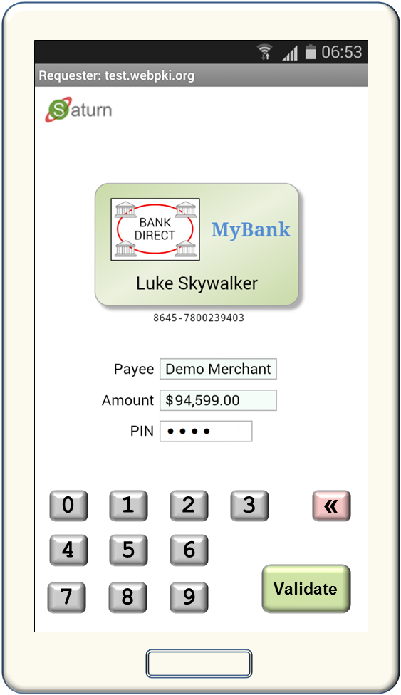

Non-normative Sample

V0.1 A.R. 2016-05-21