This invention is hereby placed in
the Public Domain

Efficient Provisioning of Complex Structures over Unsecured Channels

Background to the Invention

This invention is an intrinsic part of a scheme called SKS/KeyGen2 where SKS represent a comparatively simple (but secure) electronic device that can hold cryptographic keys (e.g. “smart card”) which can be use for authentication etc. KeyGen2 is a matching high-level protocol for provisioning an SKS device with such keys.

Since the provisioning may take place over the Internet an issuer of keys like a bank, government agency, employer etc., do not have a particularly good control over the security in the computer to which the SKS is connected to or embedded in.

To make this process more trustworthy the SKS has been equipped with a built-in key which can be used for vouching the brand and even the individual serial number of the SKS to the issuer.

However, this is not enough because a provisioning session consists of multiple steps and an adversary (“man-in-the-middle”) could modify and/or redirect the information flow after the initial authentication. Although TLS (Transport Level Security) could be used to address this problem, TLS would greatly complicate both the design and administration of an SKS. In addition, the use of TLS would effectively disable the ability letting a user define a PIN-code associated with a key to be provisioned unless the SKS also have a built-in user-interface.

Due to this, many existing key-provisioning systems rather rely on adding MAC (Message Authentication Code) checksums and to each message interchange. Sensitive data is usually encrypted using a key derived from the same key that is used for MACs.

This document describes how you by combining MACs with a virtual name-space can create complex structures in an SKS not only in a secure manner but efficiently as well

SKS/KeyGen2 Architecture

The figure below shows the components involved in this description. The parts of SKS that deal with the actual usage of cryptographic keys (in the upper left corner of the picture) are not elaborated on here because they are more or less “standard”.
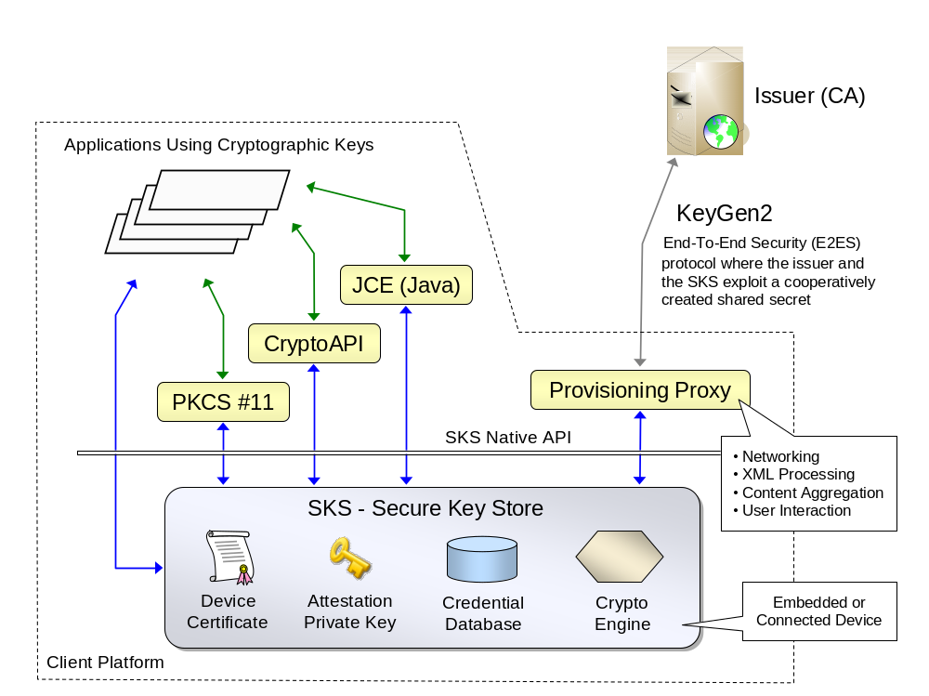

The Device Certificate and Attestation Private Key are built-in objects having a single task: vouching for the authenticity of the SKS device during provisioning sessions. The Credential Database stores keys and associated data while the Crypto Engine performs the cryptographic operations needed.

The SKS native API is by design primitive to keep the device cost down, while the KeyGen2 protocol is comparatively high-level. A proxy is therefore necessary as a “translator” between the two worlds. The proxy essentially does all the “heavy lifting”. It also provides user interaction support during the provisioning process. However, this scheme does not presume that the proxy is entirely “honest”, otherwise it wouldn’t be an end-to-end security solution. The true end-points still constitute of the Issuer and the SKS.

The rest of this document shows how the Issuer, Provisioning Proxy and SKS interact in order to maintain security and efficiency.
Step #1: Creating a SessionKey

In order to perform multiple interactions using light-weight symmetric-key cryptography, the Issuer and the SKS need a shared key. Shared keys can be established in many ways. The scheme used in SKS/KeyGen2 is simply provided as a reference. The SKS/KeyGen2 concept builds on a specific trust model which is as follows.

The Issuer trusts/recognizes a set of SKS devices based on their Device Certificates. The SKS however, does not have any opinion about issuers and accepts provisioning requests from anybody. The actual granting of an Issuer is supposed to be done by the user through a GUI which is a part of the Provisioning Proxy:
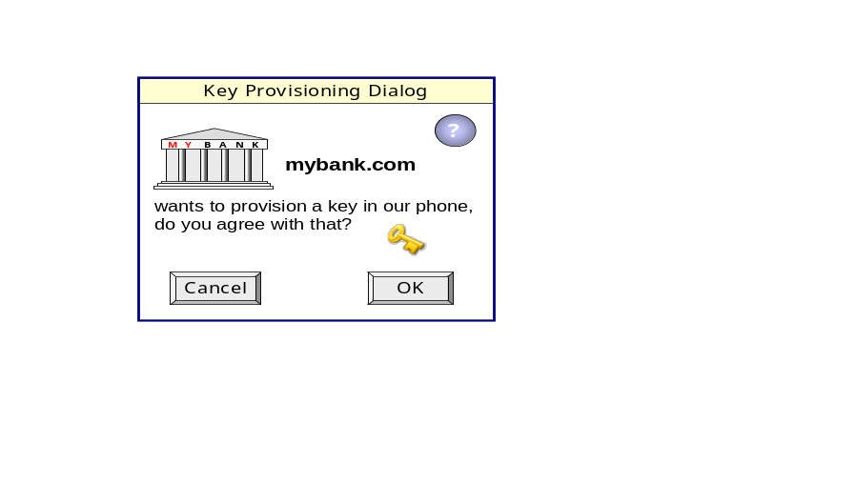
Not until the user hits OK, the actual provisioning process can start. When this happen the Provisioning Proxy sends an (not shown) acknowledge message to the Issuer which then responds with a set of Issuer-Proxy-SKS message exchanges where the first one establishes a mutual SessionKey. This process is described on the next page.
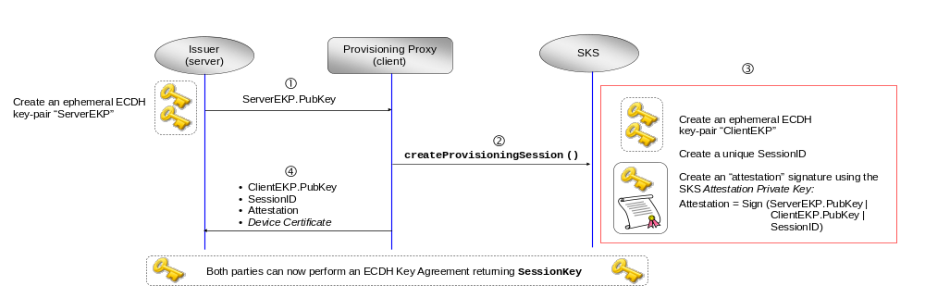
The Issuer begins by creating an ephemeral ECDH (Elliptic Curve Diffie-Hellman) key-pair and sending it down to the Provisioning Proxy which in turn translates the request to the SKS API format and invokes a method called createProvisioningSession. This method creates a number of data objects in an “atomic” fashion:
ProvisioningSession session = createProvisioningSession (ServerEKP.PubKey)

The ProvisioningSession object contains the following elements:

PublicKey ClientEphemeralKey; // ClientEKP.PubKey. Public part of the ephemeral ECDH key-pair created by the SKS
String SessionID; // SKS-created SessionID which is used externally for identifying a particular session
byte[] Attestation; // Asymmetric signature created by the SKS Private Attestation Key
int handle; // Low-level “handle” to the created session which is only used locally by the Provisioning Proxy

After the method call has returned, the Provisioning Proxy sends back the data shown in the figure. By running the attestation signature over both the server and client public keys, the Issuer (server) is assured that both ECDH keys where participating in the DH operation which is necessary for securing the SessionKey. The SKS Device Certificate is acquired by the Provisioning Proxy through another method since it is static. Each created SessionKey lives inside of the SKS until the session is explicitly closed or an error occurs. As can be seen in the diagram the Provisioning Proxy does neither handle private keys nor perform cryptographic operations. The exact format of the message exchange above between the Issuer and the Provisioning Proxy is not important but is included in the appendix of this document for completeness.

For brevity the above is a slightly simplified version; the actual implementation adds a set of security-enhancing elements including a Client time-stamp, Server-side SessionID, Provisioning algorithm ID, Session expiration time, Invoking URL, Session usage-limit, and an ECDH KDF but these are not central for this specification
Sample Object Structure

Although the scheme presented in this document may have multiple applications, KeyGen2 is a dedicated protocol for provisioning cryptographic keys and associated PIN and PUK codes. The following shows sample structure that is used throughout this document. It consists of two keys with certificates that are controlled by a single PIN code which in turn is controlled a PUK.

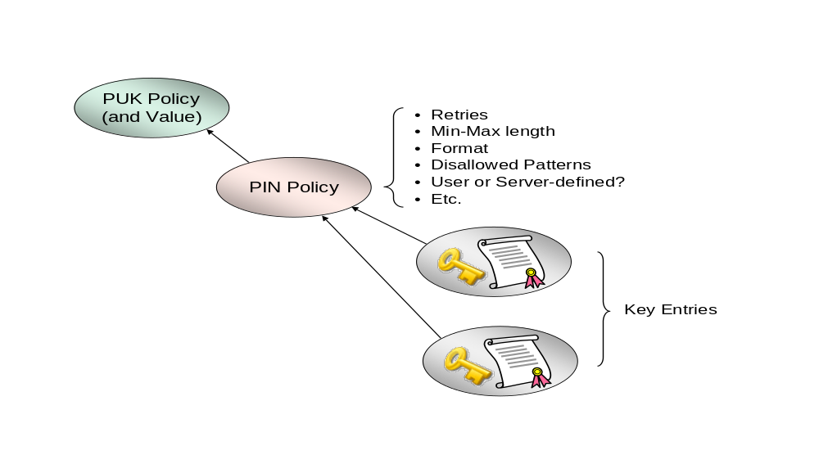

Now the actual provisioning can finally start! See next page.
Step #2: Creating the Sample Object Structure in a End-to-End Secured Fashion
KeyGen2 Request Sent by the Issuer | Corresponding SKS Operations Issued by the Provisioning Proxy
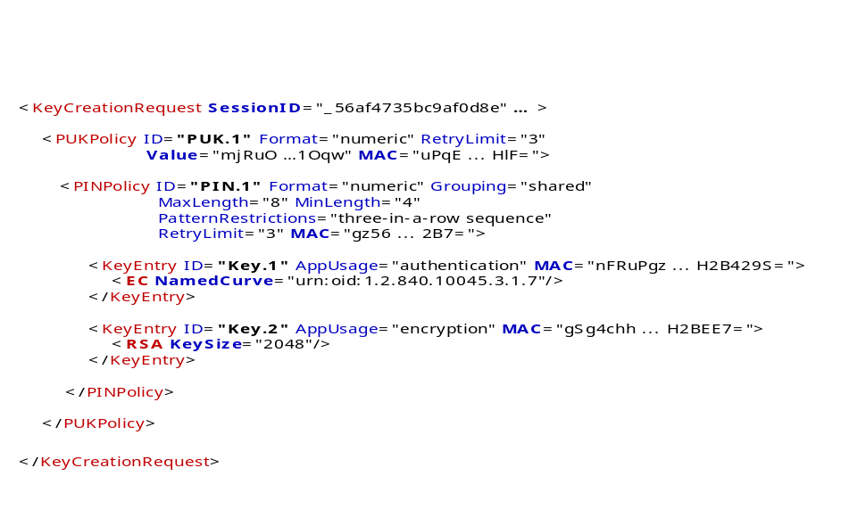 | int puk_handle = createPUKPolicy (session.handle, ″PUK.1″, OtherArguments, MAC);  int pin_handle = createPINPolicy (session.handle, ″PIN.1″, puk_handle, OtherArguments, MAC);  KeyData key_1 = createKeyEntry (session.handle, ″Key.1″, pin_handle, OtherArguments, MAC);  KeyData key_2 = createKeyEntry (session.handle, ″Key.2″, pin_handle, OtherArguments, MAC);
Explanation: The object structure is in KeyGen2 level expressed through embedding: The PUKPolicy object embeds a PINPolicy object which in turn embeds two KeyEntry objects. However, SKS does not deal with XML or object embedding, it only understands simple stuff like object handles. In addition an SKS can only deal with one object at a time. Due to this the Provisioning Proxy rearranges the request so that it becomes a set of low-level SKS calls. Since this could be done in an incorrect way (deliberately or not), the Issuer assigns a MAC to each XML construct. This MAC is read and verified by the SKS. The MACs used for the KeyCreationRequest all follow the pattern:
MAC = HMACSHA256 (SessionKey | MethodName | MACSessionCount, Data)
- MethodName holds the name of the expected SKS method like “createPUKPolicy”. This binds the method with the Data.
- MACSessionCount holds a session-internal counter which is incremented for each call. This thwarts call sequence changes or exclusions.
- Data holds a concatenated byte-array consisting of the input arguments where the arguments have been converted to simple types like 1-,2-, and 4-byte integers and byte-arrays preceded by 2-byte length indicators. An Issuer must (of course) use exactly the same conventions as specified by the SKS when creating KeyGen2 objects.

Note: The locally created object handles puk_handle and pin_handle are not included in the MAC calculations because the Issuer can have no idea what these values could be. This is where the virtual name-space comes in. The following shows the actual MAC for the createPINPolicy call:
HMACSHA256 (SessionKey | “createPINPolicy” | MACSessionCount, “PIN.1” | “PUK.1” | OtherArguments)
That is, the createPINPolicy method uses the puk_handle argument to locate an object that must be of the type PUKPolicy. When the local MAC is created by the SKS the identity of the located PUKPolicy object is included which this case is “PUK.1”. Any deviation from what the Issuer “ordered” will thus be detected by the SKS. A MAC or other argument error should in a proper SKS implementation result in a terminated provisioning session and full “rollback” of created data.

Because object names like “PIN.1” are meant to be entirely local to the provisioning session (“virtual”), issuers do never have to bother about local object handles or worry about possible name collisions with existing objects
Summary

Compared to the standard approach (making a separate networked call for each object and using the returned object handle as argument to the next call), the object aggregation and linking scheme described on the previous page reduces the number of network “roundtrips” from 4 to 1. This is a core feature of this invention.

User-defined PINs

Although not shown here, user-defined PIN-codes are also inputted during the key request phase, supervised by the Provisioning Proxy. The proxy interprets the PIN policy and only returns when it is fulfilled. The actual value is supplied as an argument to createKeyEntry. The SKS also checks PIN syntax and aborts the session on invalid PIN data. User-defined PIN-codes are excluded from the MAC operations; their values are replaced by the literal string “N/A”.

Encrypted Data from the Issuer to the SKS

PUK-codes (see “Value” attribute in the XML fragment) as well as Issuer-defined PINs are encrypted using a key derived from SessionKey. When featured in MAC operations the encrypted value is used. Note that the Provisioning Proxy (unlike the SKS) cannot decipher Issuer-encrypted data since the proxy does neither have direct nor indirect access to SessionKey. The encryption method used in the SKS/KeyGen2 scheme is as follows:

EncryptedData = AES256-CBC (HMACSHA256 (SessionKey, “Encryption Key”), UnencryptedData)

Srep #3: Returning Generated Data to the Issuer

After processing the KeyCreationRequest the Provisioning Proxy is supposed to return the public keys associated with the created key entries. The public keys are supplied in the KeyData objects created by the calls to createKeyEntry. A KeyData object contains the following:

PublicKey GeneratedPublicKey; // Generated public key in X.509 encoding
byte[] Attestation; // Symmetric signature (MAC) created by the SessionKey
int handle; // Low-level “handle” to the created key entry which is only used locally by the Provisioning Proxy

The PublicKey and Attestation elements are XML-encoded before sent to the Issuer:

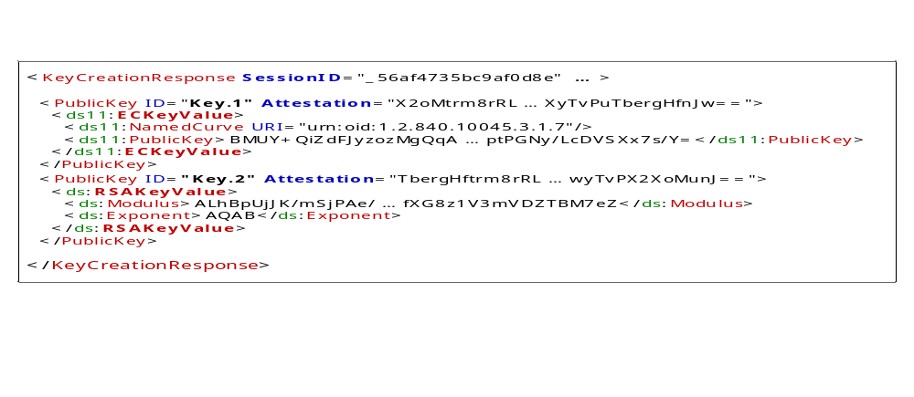

The Attestation element is an SKS-created MAC using the formula:
Attestation = HMACSHA256 (SessionKey | “Device Attestation” | MACSessionCount, ID | GeneratedPublicKey)
ID is the virtual name assigned to the actual key entry like “Key.1”.

After receival the Issuer should verify that the number of keys matches that of the request, that keys are of the requested type, and that the Attestation signatures match.

The Attestation signature scheme effectively replaces the PoP (Proof of Possession) method commonly featured in PKI enrollment schemes. In fact, an Attestation is considerably stronger security-wise since it binds a generated public key to a specific container. This scheme can also be used for secure automated renewals. As a contrast, the currently established methods provide no cryptographic assurance regarding the origin of the new key-pair!
Step #4: Adding the Certificates and Session Termination

After the Issuer has verified the authenticity of the received public keys, it creates matching certificates and sends them back to the Provisioning Proxy,

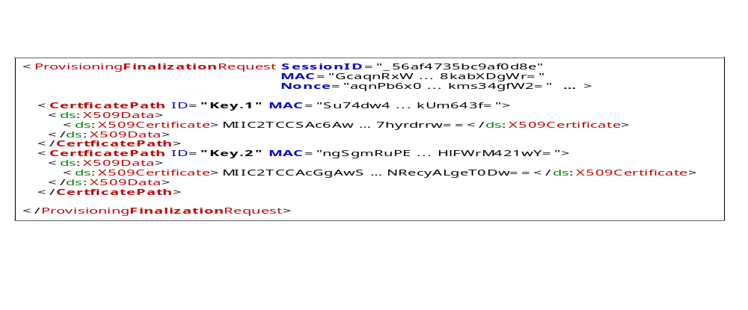

This request is secured by MACs in the same way as for the KeyCreationRequest. The exact MAC operation is as follows:
MAC = HMACSHA256 (SessionKey | “setCertificatePath” | MACSessionCount, ID | GeneratedPublicKey | CertificatePath)
ID is the virtual key name like “Key.1”. GeneratedPublicKey is the generated public key associated with the key entry. X509Certificate[] CertificatePath holds the issued end-entity certificate plus optional upper certificates belonging to the same certificate path. Each KeyGen2 CertificatePath element corresponds to a call like:

setCertificatePath (KeyData.handle, CertificatePath, MAC)

KeyData.handle holds the matching handle created during the KeyCreationRequest.

Due to the fact that the SKS has no predefined idea of when a session is ready, the Issuer must as a final measure send a session termination request. To avoid unnecessary network roundtrips, the MAC and Nonce attributes in the request header hold the input arguments to the following call which is executed immediately after the body of the request has been processed:

byte[] Attestation = closeProvisioningSession (session.handle, Nonce, MAC)

This method “commits” all operations to the SKS container after first verifying the consistency of the provisioned data. The MAC is calculated as follows:
MAC = HMACSHA256 (SessionKey | “closeProvisioningSession” | MACSessionCount, SessionID | Nonce)
If closeProvisioningSession succeeds a result in the form of “receipt” is created by:
HMACSHA256 (SessionKey | “Device Attestation” | MACSessionCount, Nonce)
Only if the Issuer receives a valid receipt it can be assured that the provisioning process has been carried out as planned. The receipt also serves as a way to gather information about the quality of the Issuer operations. The actual message sent to the Issuer holding the receipt only contains the SessionID and the Attestation:

<ProvisioningFinalizationResponse SessionID="_56af4735bc9af0d8e" Attestation="gEWzCCD ... 0w81L/ls2W0UYNE="/>
Extensions through “Piggybacking”

The KeyGen2/SKS scheme allows you to securely “piggyback” other data to a key entry in step #4 by object embedding on the XML level and binding with MACs including the associated end-entity certificate on the SKS level. Each object type has its own SKS method. SymmetricKey is a key import-method where the value is encrypted as described for PUK and PIN codes.
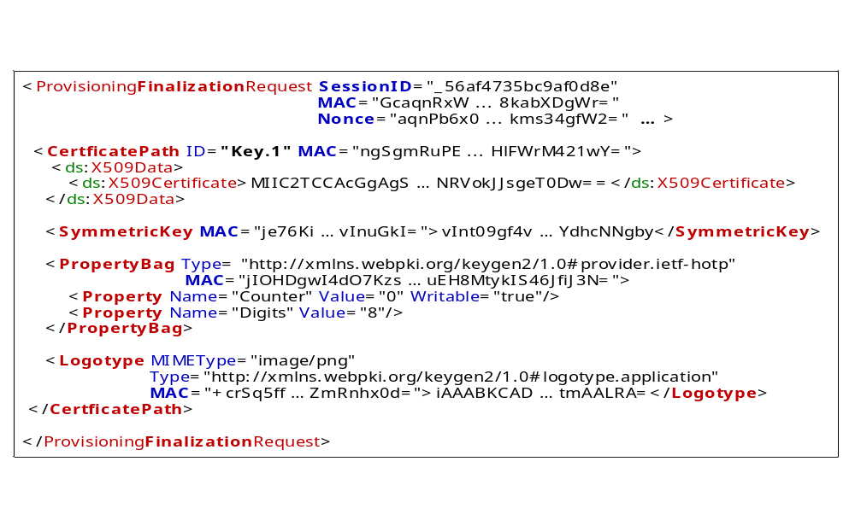

Appendix

The following are the two messages in XML format exchanged between the Issuer and the Provisioning Proxy detailed on page 4. The circled number represents the message’s place is the timing diagram.
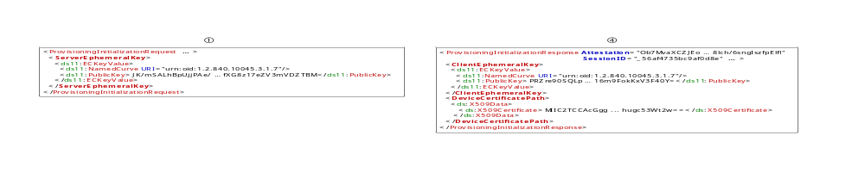V0.5, 2012-02-22
Anders Rundgren, Storbolsäng 50, 740 10 Almunge, SWEDEN

