A USB-token Proof-of-Concept Project – IDplus

Currently hundreds of millions (maybe a billion) USB memory sticks are used for everything from storing and transporting music files to running entire operating systems. The idea of reusing such a popular item as a container for some kind of authentication credential is thus quite logical since USB connectors are everywhere while for example traditional smart card interfaces are rather uncommon as well as quite expensive.

Why not just put an authentication key in the existing USB flash memory? This is of course a possibility. The drawback is that such keys (files) can be stolen (copied) etc without the user’s knowledge. A regular smart card stores keys in the chip itself and only allows indirect operations and therefore requires that you steal the physical device in order to steal someone’s electronic identity. In the case of device theft, the original owner will presumably sooner or later find out that he or she has lost the unit, giving the owner a possibility to revoke the key so the identity thief cannot continue to impersonate him or her.

Therefore this proposal proposes a modified USB memory stick, where keys are only directly accessible by the unit itself.
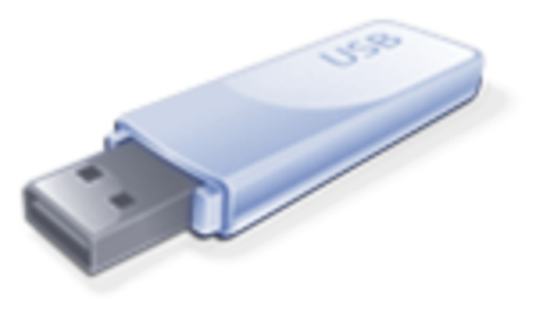
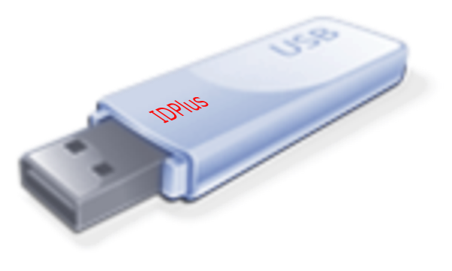

⇨

Benefits

- Does not interfere with the ordinary usage of a USB memory stick
- Based on a high-volume product keeps costs low
- Considerably more secure than passwords or file-based certificates
- Can with ease keep multiple keys by reserving a megabyte from the flash memory
- USB is a ubiquitous system
- Can with proper local software run on any personal computer

This proof-of-concept project is designed to verify the viability of such a “combo”, both from a technical and from a marketing perspective.

Success technical criterions

PCB (Printed Circuit Board) redesign requirements.

If there is a need to create new Electronics, the inertia among vendors will most likely kill the idea unless they get full external funding. Note though that if an USB stick is based on a publicly available microcontroller (in contrast to a custom-made circuit), it may be necessary to use a higher-order chip family member with more memory in order to host the additional code and data required by the dual function. This is something that must be discussed with USB stick vendors and most likely under NDAs (Non Disclosure Agreements) since this market is quite competitive.

Cryptographic capability

Verify that a non-crypto processor actually is able to execute cryptographic operations. Based on some recent studies it seems that this is quite possible both for symmetric-key operations as well as asymmetric-key operations based on ECC.
http://code.google.com/p/opencryptotoken

Middleware issues

One of the difficulties with smart cards which is also valid for IDplus, is that you need local software to use it. The project must be able to reuse existing middleware in the form of open source PKCS #11 drivers in order to work with existing applications such as browsers and desktop login.

Prototype

In order to be able to show different parties how the concept is working, a prototype based on a readily available USB token kit should be created. Using open source it will function as a reference design. A suitable starting point is:
http://www.atmel.com/dyn/products/tools_card.asp?tool_id=3879

Timetable

A working prototype should be possible to create with about 3 months of work using the suggested kit. Fully useful middleware may take another 3 months.

Success market criterions

Multiple sourcing

If such devices are only available from one party there is a great risk that the critical mass is not reached.

USB vendor support

The more the better!

Working business model

This has to date been a stumbling block. If this is going to run its own without government subsidizing or similar, there must be an advantage to have such a device compared to not having it. The additional cost for an IDplus ready USB stick must not be more than $2

