Silicon Lab Shortwave Radio Notes
References:
https://pu2clr.github.io/SI4735/
https://pu2clr.github.io/SI4735/#schematic
https://pu2clr.github.io/SI4735/extras/schematic/

Functional Block Diagram
The image below shows the SI473X-D60 block diagram. It was extracted from Silicon Labs Si4730/31/34/35-D60 / BROADCAST AM/FM/SW/LW RADIO RECEIVER (page 21). Note that the author of this Library highlights in red the pin operating voltages that can be connected to the Arduino. Be aware of the operating voltage of the Arduino pins you will use in your project. Preferably use an Arduino with 3.3V operating voltage. If you are not using a 3.3V version of Arduino, you must use a kind of 5V to 3.3V converter on RST, SCLK, SDIO and SEN (depending on your project).
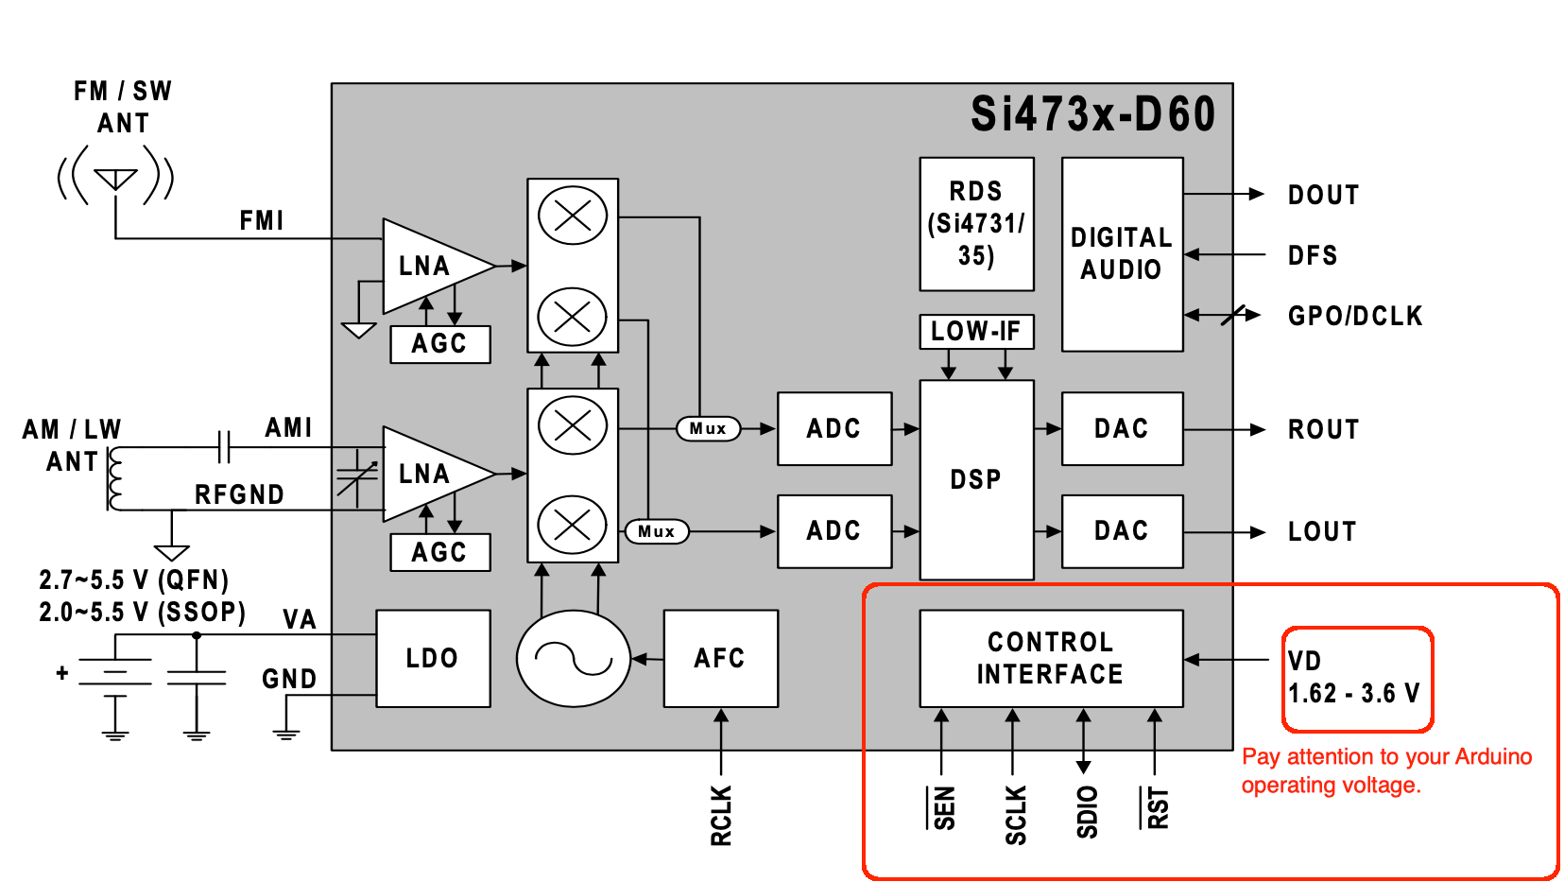

According to the Si47XX PROGRAMMING GUIDE/AN332, the Si4732-A10 has the same firmware FMRX component and AM_SW_LW RX component as that of Si4735-D60. It is considered as the most recent revision as D60. So, all descriptions related to the SI4735-D60 also apply to Si4732-A10. Including SSB patch support. See the Si4732-A10 block diagram below.
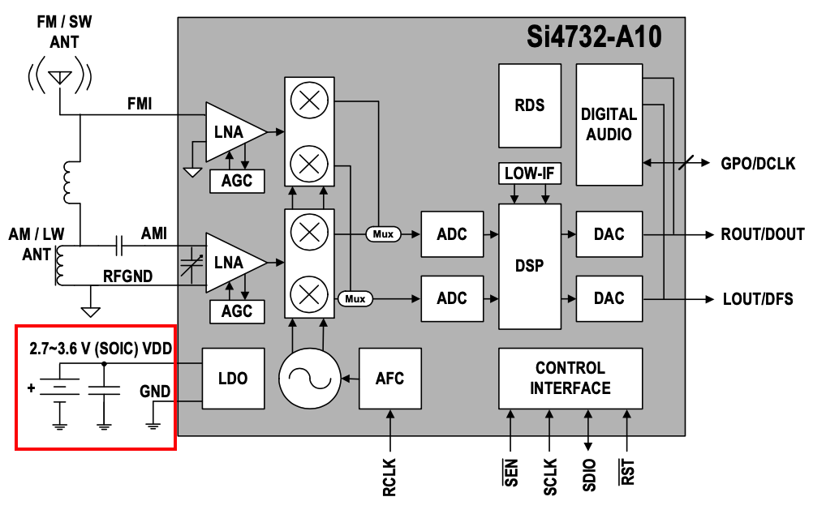
SI4735-D60 and SI4732-A10 I²C bus address
While the Si4735-D60 provides the 0x11 I²C bus address when the SEN pin is connected to the ground, the SI4732-A10 provides the same address when the SEN pin is connected to the +VCC. Also, this library provides the function getDeviceI2CAddress to detect the I²C bus address automatically. This way, you don’t need to worry about this setup if you use this function
THE SI4735 IS A 3.3V PART. IF YOU ARE NOT USING A 3.3V VERSION OF ARDUINO or another board, YOU HAVE TO USE A KIND OF 5V-3.3V BIDIRECTIONAL CONVERTER. Also pay attention to the appropriated pinout of your board to select the correct interrupt (IRQ- if you are using), RST, SDIO and SCLK pins. The table below shows some Arduino board pinout
My plan is to use an ESP32 which is a 3V3 device

SI4735-D60 PIN | SI4732-A10 PIN | Note
#3 (GP03/[DCLK]) | #2 (GP03/[DCLK])
#8 (FMI) | #6 (FMI)
#9 (RFGND) | #7 (RFGND) | Depending on your design, you can use this pin connected to GND
#10 and #11 (NC) | Not applicable | Connected to GND if you have the SI4735
#12 (AMI) | #8 (AMI)
#13 and #14 (GND) | #15 (GND)
#15 (RST) | #9 (RST)
#16 (SEN) | #10 (SENB) | While the Si4735 device provides the 0x11 I²C bus address when the SEN pin is connected to ground, the SI4732-A10 provides the same address when the SENB pin is connected to +VCC. The SI4735 Arduino Library provides the function getDeviceI2CAddress to detect the I²C bus address automatically. The library will detect and use the correct address if you use this function. See getDeviceI2CAddress(). By default, connect SEN/SENB pin to the GND.
#17 (SCLK) | #11 (SCLK)
#18 (SDIO) | #12 (SDIO)
#19 (RCLK) | #13 (RCLK)
#20 and #21 (VD VA) | #14 (VDD) | Connected to +VCC (between 2.8V and 3.7V)
#22 (DBYP) | Not applicable
#23 (ROUT/DOUT) | #16 (ROUT/DOUT)
#24 (LOUT/DFS) | #1 (LOUT/DFS)

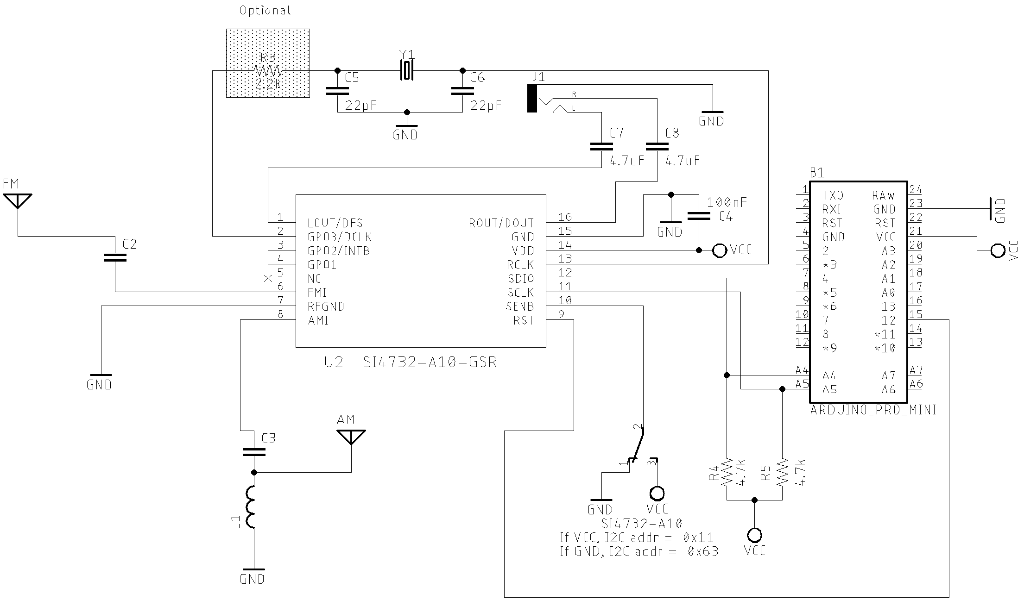
Figure 1 SI4732
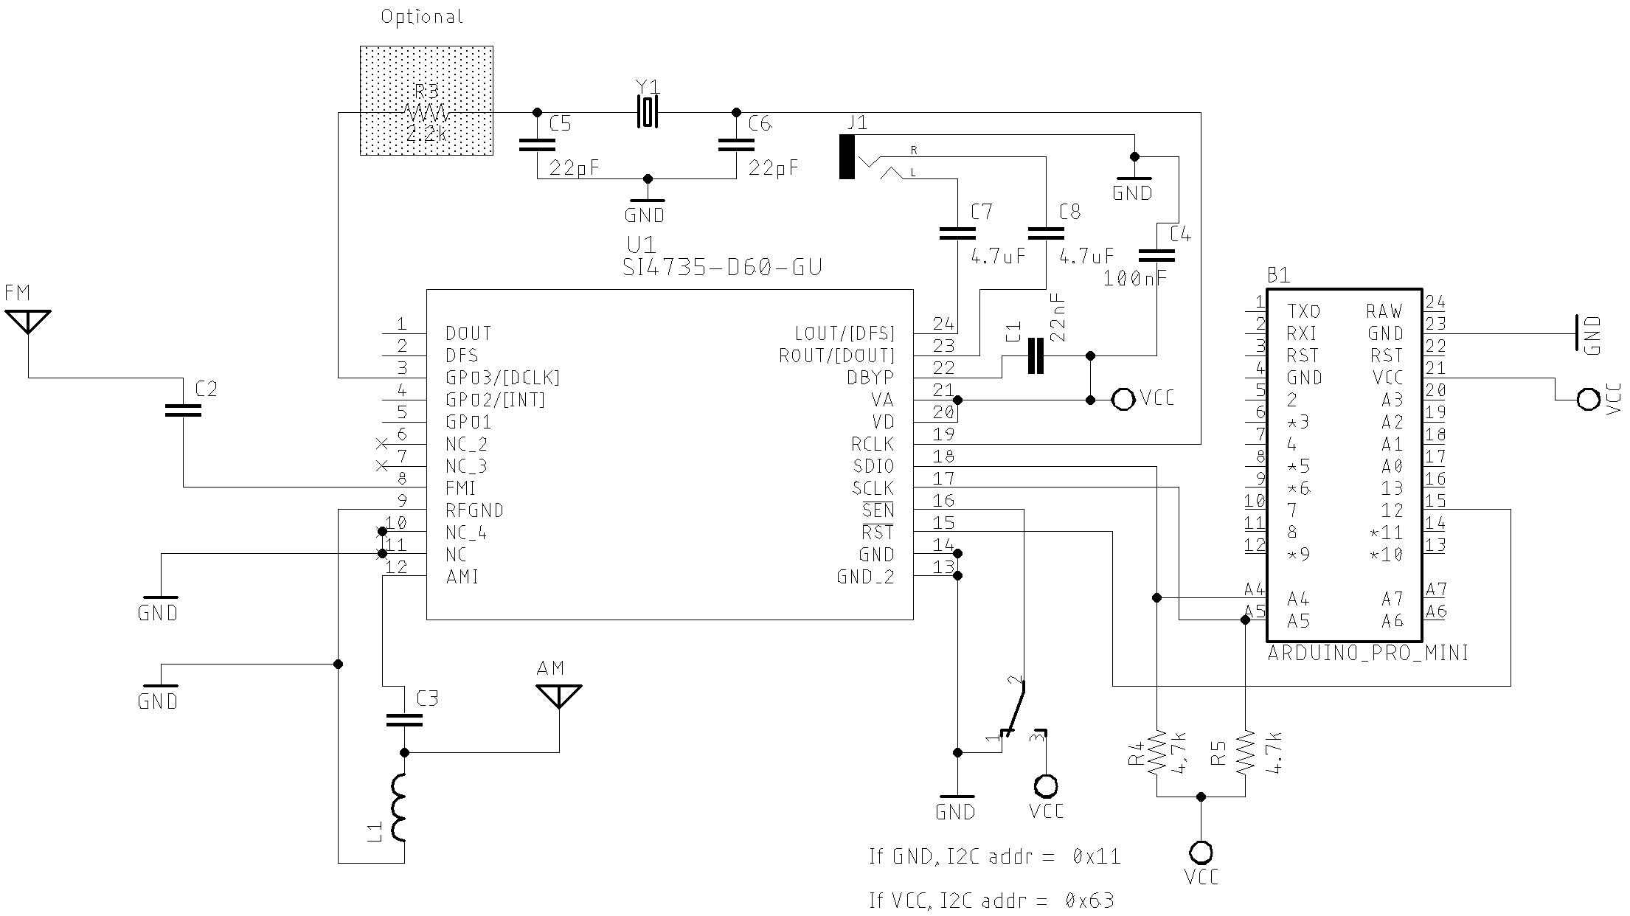
Figure 2 SI4735
Part | Description
C1 | 22nF Monolithic Multilayer Chip Ceramic non polarized capacitor (Place it close to VA pin)
C2 | 1nF Monolithic Multilayer Chip Ceramic non polarized capacitor
C3 | 470nF Monolithic Multilayer Chip Ceramic non polarized capacitor
C4 | 100nF Monolithic Multilayer Chip Ceramic non polarized capacitor (Place it close to VD pin)
C5 and C6 | 22pF (Crystal load capacitors)
C7 and C8 *1 | 4.7uF Monolithic Multilayer Chip Ceramic non polarized capacitor
R3 | 2.2K
(R4 and R5) *2 | 2.2K to 10K (pull-up resistors)
L1 | Ferrite loop stick (about 500 μH)
X1 | 32.768 kHz crystal
SI4735 | digital CMOS AM(LW, MW and SW)/FM radio receiver IC

Example with ESP32
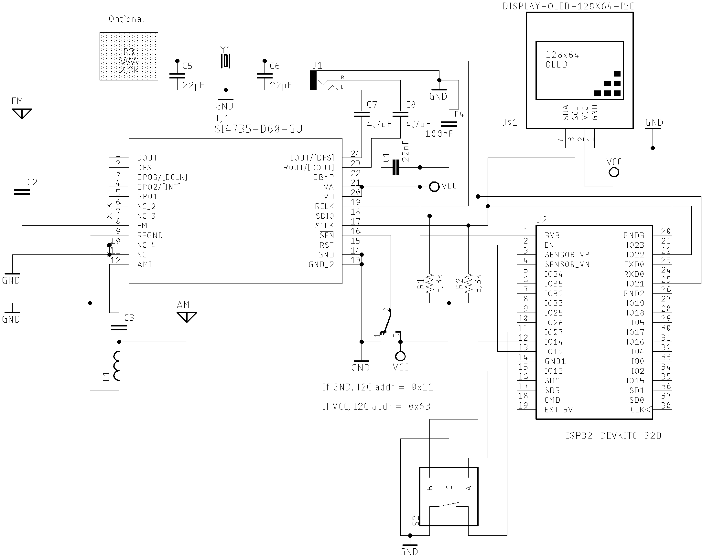
Figure 3 basic example using ESP32

