The user sends a request through the controller, where each endpoint maps to a service method. The service interacts with the repository to create, fetch, update, or delete employee data. If something goes wrong, the custom exception is thrown and handled by the global exception handler. The response is then returned to the user in the form of success data or a clear error message.

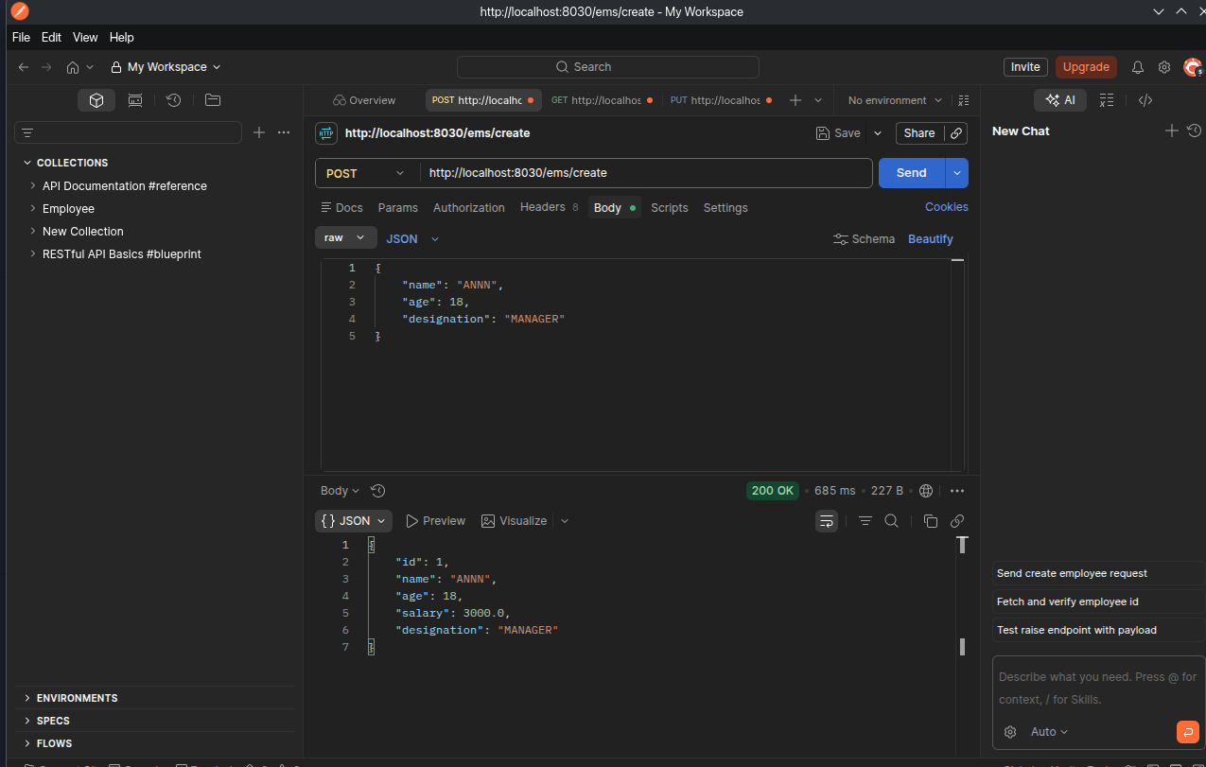
create
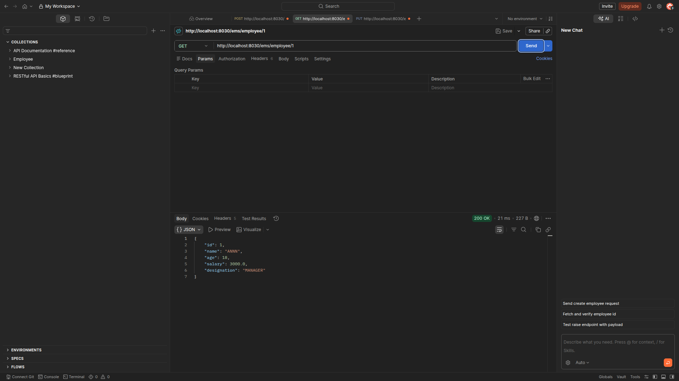
Get method

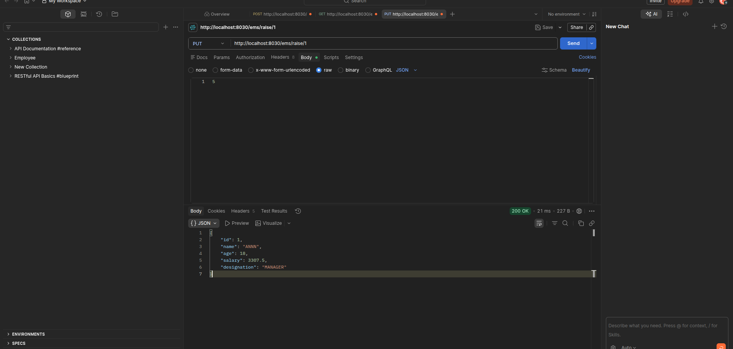
PUT method to update the salary

