PROJECT REPORT
TEXT ENCRYPTION
& DECRYPTION TOOL
A Python-based application for protecting text using cryptography
Submitted by: Rahul Kumar
Roll No.: ___________________________________
Course / Class: Cyber Security
Submitted to: _______________________________
Institution: __________________________________
Academic Session: 2026–2027
Project focus: This individual Cyber Security project demonstrates how a text message can be protected through encryption and restored through decryption. The practical work uses Python and includes both a classical learning cipher and a modern library-based method.

PRELIMINARY PAGES

Certificate
This is to certify that the project report entitled “TEXT ENCRYPTION & DECRYPTION TOOL” is a record of project work prepared by the student named below as part of the academic requirements of the relevant course.
The project demonstrates a Python command-line program that encrypts and decrypts text using a basic Caesar Cipher and Fernet authenticated encryption.
Student Name: Rahul Kumar
Roll Number: ___________________________________________
Course / Class: Cyber Security___________
This certificate page identifies the work being presented and its academic context. The project is a practical demonstration rather than a claim of a production-ready security system. Its purpose is to show that the student can set up a Python environment, use a cryptographic package, run a command-line program and explain the results. The certificate wording can be retained as a personal project record; no guide, department or institutional approval fields are required for this personal submission.

PRELIMINARY PAGES

Student Declaration
I hereby declare that this project report titled “TEXT ENCRYPTION & DECRYPTION TOOL” has been prepared by me for academic purposes. The program and explanations included in this report are intended to demonstrate introductory concepts of text encryption, decryption, key handling and Python file operations.
I understand that the Caesar Cipher is a learning example and is not suitable for protecting real confidential information. The Fernet option depends on keeping its secret key secure.
Student Name: Rahul Kumar
Signature: _______________________ Date: ______________
The declaration clarifies authorship and the educational purpose of the work. It is important to distinguish between demonstrating a cryptographic concept and deploying a secure product. The Caesar Cipher is deliberately simple and should never be used for passwords, banking details or private communication. Fernet is the stronger option in this application, but its protection depends on keeping the key file confidential and preventing unauthorised access to the computer.

PRELIMINARY PAGES

Acknowledgement
I would like to express my gratitude to my project guide and teachers for their guidance and support during the preparation of this project. I am also thankful to my institution for providing the opportunity to learn practical programming and introductory information-security concepts.
I acknowledge the Python community and the developers of the cryptography library for providing tools and documentation that make it possible to demonstrate authenticated encryption in a small educational application.
This project also provided an opportunity to practise independent learning. Reading package instructions, understanding error messages and correcting an installation problem are important parts of software development. The successful terminal runs show the value of testing after each change. Acknowledgement is given to the maintainers of Python and the cryptography package because the application relies on their documented interfaces rather than attempting to create its own low-level encryption algorithm.

PROJECT OVERVIEW

Abstract
The Text Encryption & Decryption Tool is a small Python application designed to demonstrate how readable text can be transformed into ciphertext and later restored to its original form. It offers two methods: Caesar Cipher for basic learning and Fernet for authenticated symmetric encryption.
The program accepts text through a command-line interface. For Caesar Cipher, the user supplies a shift value. For Fernet, the application loads a secret key from a local file, creating the key if it does not already exist. The encrypted Fernet output can be saved in encrypted.txt.
The project illustrates cryptography fundamentals, conditional logic, functions, file handling, library installation and the importance of key management. It is an educational demonstration and is not a complete secure messaging product.
The application is intentionally kept small so that its operation can be understood from beginning to end. A user enters a message, selects an encryption method and views the result in the terminal. With Fernet, the application reuses a locally stored key so that text encrypted in one run can be decrypted in a later run, provided that the same key remains available. The saved ciphertext file contains the encrypted token, not the original readable message. This makes the project useful as a first practical exercise in confidentiality, reversible transformations and safe key handling.

PROJECT OVERVIEW

Table of Contents
Section | Topic
1 | Introduction
2 | Problem Statement and Motivation
3 | Aim and Objectives
4 | Scope and Limitations
5 | Cryptography Background
6 | Caesar Cipher Method
7 | Fernet Encryption Method
8 | Technology Stack and Requirements
9 | System Design
10 | Algorithm and Pseudocode
11 | Flow of Execution
12 | Program Modules
13 | Source Code – Part I
14 | Source Code – Part II
15 | Installation and Execution
16 | Testing Strategy
17 | Test Cases and Results
18 | Output Screenshot – Caesar Cipher
19 | Output Screenshot – Fernet
20 | File Handling and Key Management
21 | Security Analysis
22 | Use Cases and Applications
23 | Learning Outcomes and Future Enhancements
24 | Conclusion and References

The report is arranged in a sequence that moves from the security problem to the design, implementation and evaluation of the program. Early chapters introduce the concepts and objectives. The middle chapters explain the two encryption methods, the software requirements and the program logic. The final chapters describe installation, testing, terminal evidence, security considerations and possible improvements. Readers can use the table to locate a topic quickly or read the report from beginning to end as a complete project explanation.

CHAPTER 1

Introduction
Digital communication frequently involves sending or storing information in text form. If readable information is exposed to an unauthorised person, it may be understood immediately. Encryption helps reduce this risk by transforming plaintext into ciphertext using a cryptographic method and, where applicable, a secret key.
This project builds a simple command-line tool to show the encryption and decryption process. It combines a classical substitution technique with a modern library-based encryption method so that the difference between a learning cipher and a practical cryptographic construction can be discussed.
- Plaintext: the original readable message.
- Ciphertext: the transformed encrypted message.
- Encryption: converting plaintext into ciphertext.
- Decryption: recovering plaintext using the appropriate method and key.
Encryption is especially relevant when information is stored on a shared device, copied into files or sent through a communication channel. It does not make information invulnerable, but it can make intercepted or copied data unreadable without the required key. Decryption is the authorised reverse operation. In this project, the same input is encrypted and then decrypted so that the user can directly compare the original and recovered messages. This visible result makes the relationship between plaintext, ciphertext and key easier to understand.

CHAPTER 2

Problem Statement and Motivation
Plain text can be read by anyone who gains access to it. When messages or files are transmitted or stored without protection, accidental disclosure or unauthorised access can expose their contents. This project addresses the educational need to understand how encryption changes the appearance and accessibility of text.

Motivation
- Demonstrate why sensitive text should not be left unprotected.
- Show that encryption and decryption are paired operations.
- Compare a simple classical cipher with a library-based authenticated encryption method.
- Introduce secure key storage as an essential part of encryption.
The project does not claim to prevent all network attacks. Secure communication also requires secure protocols, endpoint protection, identity verification and correct deployment.
The problem becomes clearer when considering a message such as a password reminder or a private note. If it is stored as ordinary text, anyone who can open the file can read it. Encryption changes the stored representation so that the content is not immediately understandable. In real systems, protection must be applied at the right points and supported by secure transport, authentication, device security and access control. This project focuses on the encryption operation itself and introduces the user to one part of a broader cyber security strategy.

CHAPTER 3

Aim and Objectives
Aim: To develop a simple Python tool that demonstrates text encryption and decryption through a command-line interface.

Objectives
- Accept a text message from the user.
- Provide a Caesar Cipher option with a user-defined shift.
- Provide a Fernet encryption option using a stored secret key.
- Decrypt ciphertext using the corresponding method and key.
- Save Fernet ciphertext to a text file.
- Demonstrate basic Python functions, conditions and file handling.
- Explain the importance of keeping encryption keys secure.
Each objective can be checked through a practical action. Text input is verified by entering a sample message. Caesar Cipher is checked by confirming that a known shift changes letters and that the reverse shift restores them. Fernet is checked by encrypting a message and decrypting the returned token with the same key. File handling is checked by confirming that encrypted.txt is created and contains the token. These measurable objectives keep the project focused and make the final demonstration easy to evaluate.

CHAPTER 4

Scope and Limitations

Scope
- Local command-line execution on a computer with Python installed.
- Text-only input and output.
- Caesar Cipher encryption/decryption for educational experimentation.
- Fernet encryption/decryption through the Python cryptography package.
- Saving encrypted Fernet output to encrypted.txt.

Limitations
- No graphical user interface in the current version.
- No network communication or multi-user account system.
- No password-based key derivation or key recovery feature.
- The Caesar Cipher is not secure against modern cryptanalysis.
- The local key file must be protected; anyone who obtains it may decrypt matching ciphertext.
The scope is limited deliberately to keep the project manageable and understandable for a beginner. It does not include a server, database, user registration, network protocol or mobile application. The tool also does not manage multiple users or rotate keys automatically. These omissions are not defects in the learning objective; they identify areas that would need additional design in a larger product. A future version could add a graphical interface and a separate decrypt workflow while preserving the same core cryptographic functions.

CHAPTER 5

Cryptography Background
Cryptography is the study and practice of techniques that protect information. Encryption is one important tool. In symmetric encryption, the same secret key is used to encrypt and decrypt data. The key must be available to authorised users and protected from unauthorised access.

Important terms
Term | Meaning
Plaintext | Original readable information.
Ciphertext | Encrypted representation of the information.
Key | Secret value used by a cryptographic algorithm.
Encryption | Transformation from plaintext to ciphertext.
Decryption | Recovery of plaintext from ciphertext.
Authentication | Checking that protected data has not been altered and is valid under the key.

Modern secure systems generally use vetted cryptographic libraries rather than designing encryption algorithms from scratch.
Encryption alone is not the same as complete information security. Confidentiality means that unauthorised people should not be able to read the content. Integrity means that unauthorised changes can be detected. Authentication helps establish that protected data is valid and was created by someone possessing the correct key. Fernet combines encryption and authentication in a convenient token format. The user should still protect the endpoint and key because cryptography cannot compensate for a compromised computer or a secret key that has been shared publicly.

CHAPTER 6

Caesar Cipher Method
The Caesar Cipher is a classical substitution cipher. Each alphabetic character is shifted by a fixed number of positions in the alphabet. For example, with a shift of 3, A becomes D and X becomes A. The project preserves spaces, digits and punctuation.

Formula
For uppercase letters: E(x) = (x + k) mod 26. Decryption uses D(x) = (x − k) mod 26. The same idea is applied separately to lowercase letters.

Example
Input | Shift | Encrypted | Decrypted
HELLO | 3 | KHOOR | HELLO
Rahul | 15 | Gpwja | Rahul

Security note: the Caesar Cipher has only 26 possible shifts and is easy to break. It is included only to explain the basic idea of substitution.
For example, a shift of 1 changes A to B, B to C and Z to A. The modulo operation makes the alphabet wrap around after Z. The code checks whether a character is uppercase or lowercase and applies the corresponding alphabet starting point. Characters such as spaces, numbers and punctuation are copied unchanged, which is why the sample punctuation remains visible in the output. Since every possible shift can be tested quickly, this method offers no meaningful protection against an attacker.

CHAPTER 7

Fernet Encryption Method
Fernet is a high-level symmetric authenticated encryption interface provided by the Python cryptography package. It combines encryption with authentication so that modified or invalid tokens are rejected during decryption.
- A Fernet key is generated using Fernet.generate_key().
- The key is stored in key.key so it can be reused on later runs.
- Text is encoded to bytes before encryption.
- The encrypted token is converted to text for display and file storage.
- Decryption requires the same key and a valid token.
Fernet uses AES-128 in CBC mode with PKCS7 padding and HMAC-SHA256 for authentication. Users should rely on the library rather than implementing these primitives themselves.
Fernet is suitable for this project because it provides a simple API and handles important cryptographic details internally. The program does not need to choose an AES mode, padding scheme or authentication algorithm manually. A valid token can be decrypted only with the matching key; if the token has been altered or the wrong key is used, decryption fails. The key is not included inside the encrypted token, so it must be stored separately and protected. Anyone who obtains both the token and its key can recover the message.

CHAPTER 8

Technology Stack and Requirements
Component | Requirement / Use
Programming language | Python 3
Cryptography package | Provides Fernet encryption and decryption
Operating system | Windows, Linux or macOS
Editor | Visual Studio Code, PyCharm or another text editor
Interface | Command-line interface (CLI)
File handling | key.key and encrypted.txt

Installation command
python -m pip install cryptography

Run command
python encryption.py
The Python interpreter used to install the package should be the same interpreter used to run the program. If the import fails, install the package through that interpreter using: python -m pip install cryptography.
Python is used because its syntax is readable and it supports a large ecosystem of libraries. Visual Studio Code provides an editor and integrated terminal, while the cryptography package supplies the Fernet implementation. The package must be installed into the same Python interpreter that runs the script. If multiple Python versions are installed, using `python -m pip` or the full interpreter path helps avoid installing a package into a different environment. The successful test output confirms that the dependency was available when the program ran.

CHAPTER 9

System Design
The application follows a simple input–process–output model. The user selects a method, enters a message and receives the encrypted or decrypted result.
Stage | Description
Input | User selects Caesar or Fernet and enters text.
Processing | Selected function performs encryption or decryption.
Key handling | Fernet mode loads or creates key.key.
Output | Result is printed in the terminal.
Storage | Fernet ciphertext may be written to encrypted.txt.

Main components
- User interface: menu and input prompts.
- Caesar module: character shifting.
- Fernet module: library-based encryption and decryption.
- File module: persistent key and ciphertext files.
The input–process–output design separates what the user provides from what the program does and displays. The menu choice determines which method is used. The Caesar function processes each character in a loop. The Fernet object accepts bytes, so the input string is encoded before encryption and decoded after decryption. The output stage prints the result and optionally writes the encrypted token to a file. Keeping these responsibilities clear makes the code easier to read, test and extend.

CHAPTER 10

Algorithm and Pseudocode

Encryption flow
- Start the program.
- Display the encryption/decryption menu.
- Read the selected method and input text.
- If Caesar is selected, read the shift and apply the shifting formula.
- If Fernet is selected, load the key and encrypt the UTF-8 encoded text.
- Display the result and, for Fernet, optionally save ciphertext to a file.

Decryption flow
- Read ciphertext and selected method.
- For Caesar, apply the reverse shift.
- For Fernet, load the same key and decrypt the token.
- Display the recovered plaintext.
- End or return to the menu.
The algorithm describes the sequence of operations without tying the explanation to a particular programming language. Pseudocode is useful because it makes decisions and data flow visible before implementation. One important condition is that encryption and decryption must use matching methods and parameters. For Caesar, the same shift is reversed. For Fernet, the same secret key is required. If the user loses the key or changes it, previously generated Fernet tokens cannot be recovered with the new key.

CHAPTER 11

Flow of Execution
The current program starts by loading or generating a Fernet key. It then displays a menu with two methods. The Caesar option asks for a shift value; the Fernet option uses the stored key automatically. The selected operation is completed and the result is printed.
Decision | Action
Choice = 1 | Run Caesar Cipher.
Choice = 2 | Run Fernet encryption/decryption as selected by the current code version.
Invalid choice | Display an error message.
Fernet key missing | Generate a new key and save it.
Save ciphertext | Write the token to encrypted.txt.

Note: the compact code demonstrated in this project performs encryption and decryption together for the selected method, making the demonstration straightforward.
The current compact program demonstrates both operations in one session: it first encrypts the entered message and then immediately decrypts the result. This is convenient for a classroom demonstration because the successful round trip is visible in one terminal run. In a more complete application, the user would be able to choose Encrypt or Decrypt separately, paste an existing token, and load ciphertext from a file. That design would more closely resemble a practical utility while retaining the same underlying encryption functions.

CHAPTER 12

Program Modules
Module | Responsibility
Key setup | Checks for key.key; creates a key if absent.
Fernet object | Creates a Fernet instance using the loaded key.
caesar(text, shift) | Shifts alphabetic characters while preserving other characters.
CLI input | Reads the user's choice, text and shift value.
Output | Prints encrypted and decrypted values.
File save | Writes Fernet ciphertext to encrypted.txt.

Files generated
- key.key – contains the secret Fernet key in binary form.
- encrypted.txt – contains the most recently saved Fernet ciphertext.
Modular organisation makes it easier to maintain the application. Key setup is performed once when the program starts. The Caesar function is independent of Fernet and can be tested with different shift values. The Fernet object is created from the loaded key and handles both encryption and decryption. File saving is performed only after a Fernet token is generated. In a larger project, these responsibilities could be moved into separate Python files and tested independently.

CHAPTER 13

Source Code – Part I
import os
from cryptography.fernet import Fernet
# Generate or load secret key
if os.path.exists("key.key"):
key = open("key.key", "rb").read()
else:
key = Fernet.generate_key()
with open("key.key", "wb") as file:
file.write(key)
f = Fernet(key)
# Caesar Cipher
def caesar(text, shift):
result = ""
for c in text:
if 'A' <= c <= 'Z':
result += chr((ord(c)-65+shift) % 26+65)
elif 'a' <= c <= 'z':
result += chr((ord(c)-97+shift) % 26+97)
else:
result += c
return result
This part imports the required modules, loads or creates the secret key, initializes Fernet and defines the Caesar Cipher function.
The key-loading logic first checks whether key.key already exists. If it exists, the saved bytes are read and used to initialise Fernet. If the file is absent, a fresh key is generated and written to disk. This reuse is essential: generating a new key every time would make previously saved ciphertext impossible to decrypt. The Caesar function then loops through the characters and shifts only alphabetic characters, preserving punctuation and digits exactly as entered.

CHAPTER 13

Source Code – Part II
print("\nTEXT ENCRYPTION & DECRYPTION TOOL")
print("1. Caesar Cipher")
print("2. Fernet Encryption")
choice = input("Choose method: ")
msg = input("Enter text: ")
if choice == "1":
shift = int(input("Enter shift (0-25): "))
if 0 <= shift <= 25:
enc = caesar(msg, shift)
print("Encrypted:", enc)
print("Decrypted:", caesar(enc, -shift))
else:
print("Invalid shift!")
elif choice == "2":
enc = f.encrypt(msg.encode())
print("Encrypted:", enc.decode())
print("Decrypted:", f.decrypt(enc).decode())
with open("encrypted.txt", "w") as file:
file.write(enc.decode())
print("Saved in encrypted.txt")
else:
print("Invalid choice!")
This compact version demonstrates encryption and decryption in one run. In a larger application, separate menu options for Encrypt and Decrypt can be added.
The menu code collects the user's method choice and message. In Caesar mode, it validates the shift range before encrypting and reversing the shift. In Fernet mode, it encodes the message, creates a token, displays the token and decrypts it with the same Fernet object. The token is then written to encrypted.txt. The example is intentionally compact; a more robust release should also catch invalid input, malformed tokens and file-permission errors and should provide a separate decrypt option for previously saved tokens.

CHAPTER 14

Installation, Execution and Testing

Installation steps
- Install Python and verify that it is available in the terminal.
- Open the project folder in Visual Studio Code.
- Open the integrated terminal.
- Install the dependency with python -m pip install cryptography.
- Save the source file as encryption.py.
- Run python encryption.py.

Testing approach
Each encryption method was tested with a sample input. The expected result is that decryption returns the original plaintext. Fernet output is expected to look different each time because secure encryption uses a random nonce.
During installation, the terminal should be opened in the folder containing the Python source file. The cryptography dependency is installed with pip. A common setup problem occurs when the package is installed for one Python version but the editor runs another. The command `python -c "from cryptography.fernet import Fernet; print('SUCCESS')"` can be used to verify the import. After the check succeeds, the script can be run from the same interpreter. This project was successfully executed in the supplied VS Code terminal screenshots.

CHAPTER 15

Test Cases and Results
Test | Input / Action | Expected result | Observed result
TC-01 | Caesar: Rahul!@#$%, shift 15 | Gpwja!@#$%; original restored | Passed in screenshot
TC-02 | Fernet: Rahul#425 | Ciphertext token produced | Passed in screenshot
TC-03 | Fernet decryption | Rahul#425 restored | Passed in screenshot
TC-04 | Save Fernet ciphertext | encrypted.txt created | Passed in screenshot
TC-05 | Invalid menu choice | Error message | Not shown in supplied screenshots
TC-06 | Shift outside 0–25 | Invalid shift message | Not shown in supplied screenshots

The first four tests are supported by the screenshots supplied for this report. The remaining cases are recommended additional tests and should be run if formal test evidence is required.
Testing checks whether the program behaves as expected for normal and invalid inputs. The screenshots provide evidence for the Caesar and Fernet happy paths. Additional recommended tests include an empty message, an invalid menu option, a shift below zero or above 25, a missing key file and an altered Fernet token. For the last two cases, the program should either create a new key when no old ciphertext is needed or report a decryption failure without exposing sensitive information.

CHAPTER 16

Output Screenshot – Caesar Cipher
The screenshot below shows a successful Caesar Cipher test. The sample input is Rahul!@#$% and the shift value is 15. The encrypted text is Gpwja!@#$%, and decryption restores the original input.
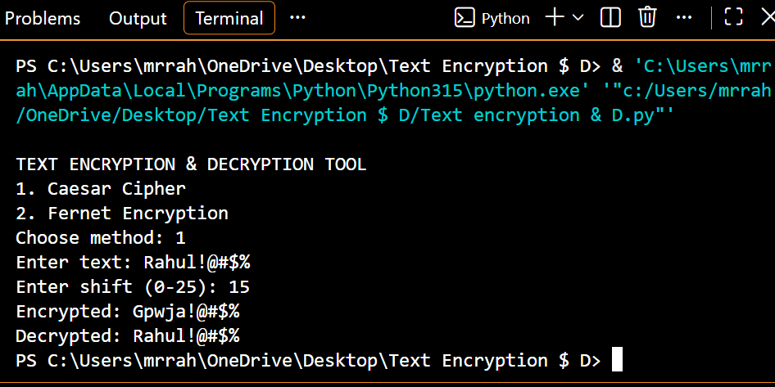
The first screenshot confirms that the program accepts a message containing letters and punctuation. With a shift of 15, the alphabetic characters change while the symbols remain unchanged. The decrypted output matches the original input exactly, which is the expected round-trip behaviour. This test confirms that the character-range checks and reverse-shift logic are operating correctly for the supplied example. It also illustrates why a simple substitution cipher is easy to demonstrate but unsuitable for real confidentiality.

CHAPTER 17

Output Screenshot – Fernet Encryption
The screenshot below shows Fernet encryption and decryption. The sample input is Rahul#425. The program displays a Fernet token, successfully decrypts it to the original message and saves the token in encrypted.txt.
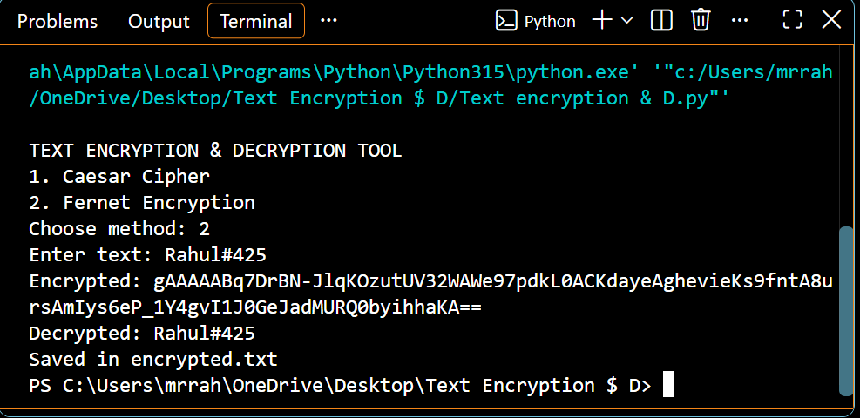
The second screenshot confirms that Fernet produced an encrypted token for the input Rahul#425. The decrypted output matches the original message, demonstrating that the token and key are compatible. The program also reports that the token was saved in encrypted.txt. Fernet tokens can look different when the same plaintext is encrypted more than once; this is expected and does not indicate an error. The important verification is that a valid token decrypts to the exact original text when the correct key is used.

FINAL CHAPTER

File Handling, Security, Conclusion and References

Key management and safe use
- Keep key.key private and restrict access to it.
- Back up the key securely; losing it means the matching ciphertext cannot be decrypted.
- Do not generate a new key if you still need to decrypt data encrypted with the old key.
- Do not use Caesar Cipher to protect real passwords or confidential data.
- Use trusted cryptographic libraries and secure storage for real applications.

Conclusion
The Text Encryption & Decryption Tool successfully demonstrates two approaches to transforming text. Caesar Cipher introduces the basic idea of shifting letters, while Fernet provides a stronger authenticated encryption option through a well-established Python library. The supplied terminal screenshots show successful encryption, decryption and ciphertext file saving. The project helped demonstrate Python functions, conditional statements, package installation and file handling.

Future enhancements
- Add a dedicated decrypt option and allow loading ciphertext from a file.
- Add a Tkinter graphical user interface.
- Add input validation and clearer error messages.
- Provide a safer key backup and access-control procedure.

References
- Python documentation: https://docs.python.org/3/
- Cryptography documentation – Fernet: https://cryptography.io/en/latest/fernet/
- NIST – Computer Security Resource Center: https://csrc.nist.gov/
— End of Report —
Project outcome: The completed demonstration provides a foundation for future work in secure application development. It connects fundamental programming skills with a practical cyber security topic and records the tested behaviour through actual terminal screenshots.

