CYBER SECURITY PROJECT REPORT

PASSWORD STRENGTH CHECKER
& GENERATOR

Submitted by: Rahul Kumar
Course: Cyber Security
Institution: Future Finder
Submitted to: __________________________
Date: _________________________________

CERTIFICATE
This is to certify that Rahul Kumar, a student of the Cyber Security course at Future Finder, has prepared the project report titled “Password Strength Checker & Generator” as part of the learning activities in Python programming and defensive cybersecurity.
The project demonstrates basic password-composition checks, secure random password generation, and an optional clipboard-copy feature. The work is intended for educational purposes and should be reviewed by the course instructor before final acceptance.
Teacher / Guide Signature: __________________________
Name: ____________________________________________
Date: _____________________________________________

ACKNOWLEDGEMENT
I would like to express my sincere gratitude to my Cyber Security instructor and Future Finder for providing the opportunity to learn about password security and Python programming through this project. Preparing this project helped me connect theoretical security concepts with a small, practical defensive tool.
I am also thankful to the developers and maintainers of Python and its standard-library documentation. The modules used in this project—string, secrets, and tkinter—made it possible to explore character sets, security-oriented random selection, and clipboard interaction without relying on many external packages. Finally, I appreciate the guidance and learning resources that helped me understand why long, unique passwords are important for protecting online accounts.

ABSTRACT
Passwords remain one of the most common methods used to protect online accounts, computer systems, and personal information. However, short, predictable, and reused passwords can make accounts easier to compromise. Common examples such as simple number sequences, dictionary words, and familiar keyboard patterns may be guessed by attackers using automated techniques. This creates a need for simple educational tools that help users understand password composition and practise creating less predictable passwords.
The Password Strength Checker & Generator is a beginner-friendly defensive cybersecurity project developed in Python. It provides two main functions. The first function checks a password against basic composition criteria, including length, lowercase letters, uppercase letters, digits, and special characters. Based on these checks, the application displays a simple score and classifies the password as WEAK, MEDIUM, or STRONG. The result is accompanied by a short suggestion intended to encourage safer password habits.
The second function generates a random password using Python’s secrets module. It selects at least one character from each of four categories—lowercase letters, uppercase letters, digits, and punctuation—and fills the remaining positions from a combined character set. The characters are then shuffled. The user can choose a length within the range supported by the program. An optional clipboard feature, implemented using Tkinter, allows the generated password to be copied for convenient use when the system supports clipboard access.
The project uses Python’s standard-library modules: string for character groups, secrets for security-appropriate random selection, and tkinter for clipboard interaction. Its command-line interface presents a simple menu for checking a password, generating a password, or exiting the program. Input validation helps prevent unsupported password lengths and invalid menu choices.
This project is designed for learning and demonstration rather than as a complete enterprise password-security product. Its strength labels are based on simple rules and do not measure every factor that affects real password security. A password labelled STRONG is not guaranteed to be safe if it has been reused, exposed in a data breach, or is otherwise predictable. In practical use, people should prefer long, unique passwords or passphrases, use a reputable password manager, and enable multifactor authentication where possible.
Overall, the project demonstrates how basic Python programming can support defensive cybersecurity awareness. It combines conditional logic, functions, loops, input validation, secure random generation, and a practical clipboard option in one small application. Future improvements could include a graphical user interface, passphrase generation, better strength estimation, and privacy-conscious checks against known compromised passwords.

1. INTRODUCTION
Digital services are used for communication, education, banking, shopping, entertainment, and work. Many of these services rely on passwords to verify a user's identity. A password is therefore an important part of protecting personal information and preventing unauthorized access.
A password is more effective when it is difficult to guess and is not reused across different accounts. Short passwords, common words, predictable substitutions, and repeated patterns can reduce security. Attackers may try likely passwords from lists, test many combinations, or use credentials exposed in previous data breaches. The risk is higher when users reuse the same password on multiple services.
Password security is not determined by character variety alone. Length, uniqueness, unpredictability, and whether a password has already been exposed all matter. A long, unique passphrase can be easier to remember and harder to guess than a short password that merely combines several character types.
This project introduces these ideas through a small Python application. The checker examines basic composition features and provides a simple educational label. The generator creates random passwords with characters from multiple categories. By testing examples and observing the results, learners can see how program logic turns input into feedback.
The tool is not intended to test passwords against real accounts or to perform password cracking. It focuses on defensive awareness: helping users create stronger credentials and understand why predictable passwords are risky.

2. BACKGROUND AND PROBLEM STATEMENT

2.1 Background
Password guessing can be automated. A brute-force method systematically tries possible combinations, while a dictionary method prioritizes likely words and commonly used passwords. Offline password-hash attacks may also use precomputed tables in some circumstances. Strong password storage practices, rate limits, multifactor authentication, and unique passwords all help reduce risk.

2.2 Problem Statement
Many users do not know whether their chosen password is predictable, and they may struggle to create a unique random password. A simple tool can offer immediate educational feedback and generate a new password without requiring an external service.

2.3 Proposed Solution
The proposed application checks basic password characteristics, shows a strength label, and generates a random password locally. It also offers an optional clipboard action to make the generated result easier to transfer to a password manager or account form.

3. OBJECTIVES AND SCOPE

3.1 Objectives
- Explain basic password-security concepts through a practical program.
- Check password length and the presence of lowercase, uppercase, digit, and punctuation characters.
- Display a simple score and WEAK, MEDIUM, or STRONG classification.
- Generate a random password with at least one character from each of the four categories.
- Validate the requested password length and handle invalid inputs.
- Offer an optional clipboard-copy feature.
- Use Python standard-library tools to practise functions, loops, conditions, and exception handling.

3.2 Scope
The project is a local command-line demonstration. It does not connect to websites, store user passwords in a database, test account login systems, or attempt to crack passwords. The strength result is a simple heuristic for learning and should not be treated as a definitive security rating.

4. WHY THIS PROJECT? / REAL-WORLD CONNECTION
Weak or reused passwords are a recurring source of account risk. Users may choose passwords that are easy to remember but also easy to predict. Attackers can use automated guessing methods, leaked credential lists, and common-password dictionaries. A tool that demonstrates password composition and creates random alternatives can help teach safer behaviour.

4.1 Common Attack Concepts
- Brute-force guessing: tries possible character combinations. Longer unpredictable passwords increase the search space.
- Dictionary guessing: tries common words, phrases, and known passwords first. Avoiding predictable choices reduces this risk.
- Rainbow tables: precomputed tables can help recover some passwords from hashes when the hashing setup is vulnerable; salts and modern password hashing reduce their usefulness.
- Credential reuse: a password exposed on one service may be tried against other services. Unique passwords help prevent this chain reaction.
The application does not execute any of these attacks. It provides a defensive learning demonstration and should be used with test passwords rather than real personal credentials.

5. SYSTEM REQUIREMENTS

5.1 Hardware
- A desktop or laptop capable of running Python 3.
- Keyboard and display.
- Clipboard support for the optional copy feature.

5.2 Software
- Python 3 installation.
- A code editor or IDE such as IDLE, VS Code, or another Python editor.
- Python standard-library modules: string, secrets, and tkinter.
- A terminal or command prompt to run the CLI program.

5.3 Installation
Save the program as password_project.py. Open a terminal in the same folder and run python password_project.py. On some systems, use python3 password_project.py. No third-party package is required for the main checker and generator. Tkinter availability depends on the Python installation and operating system.

6. TECHNOLOGY STACK AND MODULES

6.1 Python
Python is beginner-friendly and supports readable functions, conditional statements, loops, and exception handling. These features make it suitable for a small educational security application.

6.2 string Module
The string module provides predefined groups such as ascii_lowercase, ascii_uppercase, digits, and punctuation. These groups simplify category checks and password generation.

6.3 secrets Module
The secrets module is designed for generating values suitable for security-sensitive uses. The program uses secrets.choice to select characters and SystemRandom().shuffle to shuffle the generated sequence.

6.4 tkinter Module
Tkinter is Python's standard interface to the Tk GUI toolkit. In this project it is used only to access the system clipboard. Clipboard access may fail in headless environments or systems without GUI support.

7. SYSTEM DESIGN AND LOGIC

7.1 Main Modules
- check_strength(password): checks password composition and returns a label and score.
- generate_password(length): creates a random password and guarantees at least one character from each category.
- copy_password(password): attempts to place the generated password on the system clipboard.
- display_strength(password): prints the label, score, and advice.
- main(): displays the menu and routes the user's choice.

7.2 Logic Flow
- Start the program and display the menu.
- Read the user's menu choice.
- If checking is selected, accept a test password and calculate its score.
- If generation is selected, validate the requested length.
- Select one character from each category and fill remaining positions randomly.
- Shuffle the characters and display the generated password.
- Ask whether the user wants to copy the password.
- Return to the menu or exit when requested.

8. PASSWORD STRENGTH CHECKING
The checker evaluates five simple conditions: length of at least eight characters, lowercase letters, uppercase letters, digits, and punctuation. Each satisfied condition adds one point to a score out of five.
Condition | Rule | Score
Length | At least 8 characters | +1
Lowercase | Contains a-z | +1
Uppercase | Contains A-Z | +1
Digits | Contains 0-9 | +1
Symbols | Contains punctuation | +1
Classification in the supplied code: a password shorter than eight characters or scoring two points or less is WEAK; a score of three is MEDIUM; and a score of four or five is STRONG. These thresholds are chosen for demonstration and do not calculate true entropy or check for known breached passwords.

9. PASSWORD GENERATOR AND CLIPBOARD
The generator accepts lengths from 8 to 256 characters. It begins by choosing one random character from each of the lowercase, uppercase, digit, and punctuation groups. It then fills the remaining positions from the combined set and shuffles the list. This construction guarantees the presence of all four categories in each generated result.
The clipboard function creates a hidden Tkinter root window, clears the clipboard, appends the generated password, updates the clipboard, and closes the window. The user must explicitly choose the copy option. Because clipboard contents can remain available to other applications, users should be careful on shared devices and paste generated passwords directly into a password manager where possible.

10. ACTUAL PROGRAM OUTPUT SCREENSHOTS
Figure 1. Main menu displayed when the program starts.
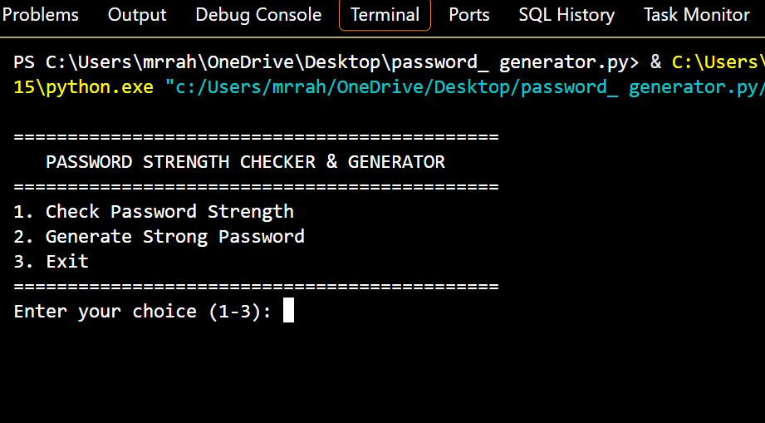
Figure 2. Weak password example and strength result.
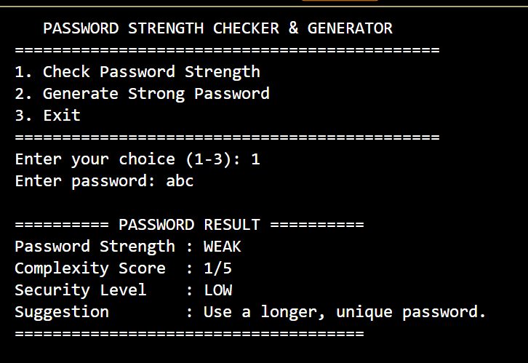

11. PASSWORD STRENGTH TEST RESULTS
Figure 3. Medium-strength password example and result.
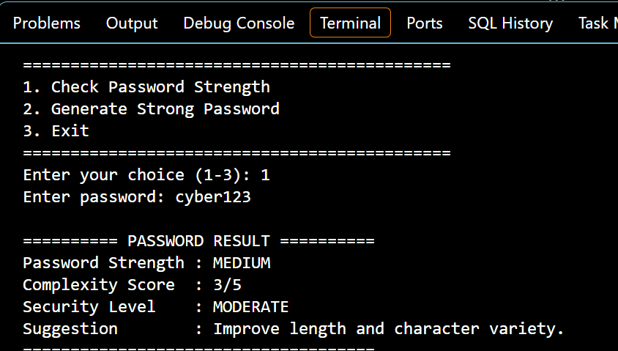
Figure 4. Strong password example and result.
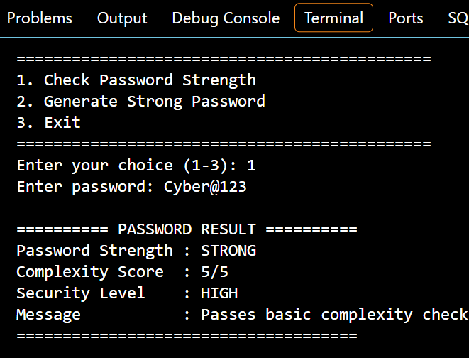

12. PASSWORD GENERATION OUTPUT
Figure 5. Generated password and strength analysis.
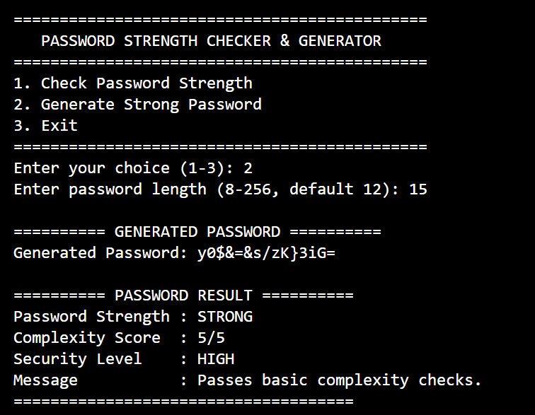
Figure 6. Invalid length is rejected and the program requests a valid length.
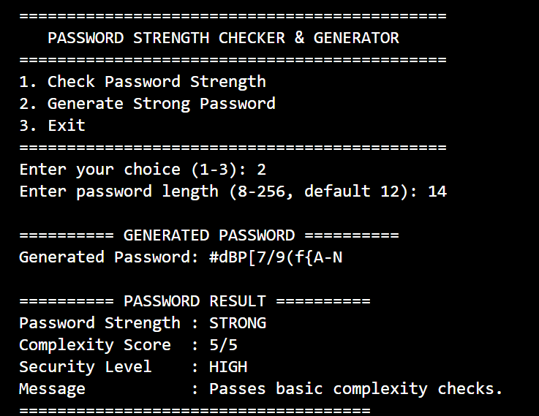

13. TEST CASES
No. | Input / Action | Expected Result | Purpose
1 | Check: abc | WEAK | Short password
2 | Check: password123 | MEDIUM | Letters and digits
3 | Check: MyP@ssw0rd2026! | STRONG | All categories, length > 12
4 | Generate length 6 | Rejected; prompt repeats | Length validation
5 | Generate length 16 | 16-character result with all categories | Generator
6 | Copy choice y | Clipboard copy attempted | Clipboard feature
7 | Menu choice 9 | Invalid-choice message | Menu validation
The screenshots above were captured from the project running in the Python terminal and show actual sample interactions with the program.

14. LIMITATIONS AND FUTURE IMPROVEMENTS

14.1 Limitations
- The score is a basic heuristic and cannot reliably predict how quickly every password could be guessed.
- The checker does not compare passwords with breached-password databases.
- It does not assess password reuse, user-specific information, or predictable patterns in depth.
- Clipboard support depends on the operating system and Tkinter installation.
- The application is a CLI prototype rather than a full graphical application.

14.2 Future Improvements
- Create a graphical interface with password visibility controls and clear status indicators.
- Add passphrase generation using random words.
- Provide an option to exclude confusing characters.
- Add a privacy-preserving compromised-password check.
- Use a well-tested strength estimator and provide safer guidance.
- Add automated unit tests and package the application for easier installation.

15. CONCLUSION
The Password Strength Checker & Generator is a practical introduction to defensive cybersecurity and Python programming. It checks common password-composition features, assigns a simple educational label, generates random passwords using the secrets module, validates user input, and offers an optional clipboard feature. The project demonstrates how functions, loops, conditionals, modules, and exception handling can be combined to create a useful tool.
The project also highlights an important security lesson: a label alone does not make a password safe. Users should choose long and unique credentials, avoid reuse, consider a password manager, and enable multifactor authentication. The application can be extended with a graphical interface and more robust password-strength analysis in future versions.

REFERENCES
Python documentation — secrets: https://docs.python.org/3/library/secrets.html
Python documentation — string: https://docs.python.org/3/library/string.html
Python documentation — tkinter: https://docs.python.org/3/library/tkinter.html

