COLLEGE PROJECT REPORT

Fake News Detection Web Application
Machine Learning Text Classification With Optional Gemini Analysis
A project report describing the dataset, model, web application, and evaluation
College submission details | To be completed
Student name | ____________________________________________
Enrollment or roll number | ____________________________________________
Programme and semester | ____________________________________________
Department and institution | ____________________________________________
Project guide | ____________________________________________
Academic year | ____________________________________________

Prepared from the project source code, notebooks, datasets, and saved evaluation results

Abstract
This report presents a web application that screens English news articles using supervised text classification. The project combines a cleaned news dataset, a TF-IDF feature representation, and a Linear Support Vector Classifier (LinearSVC). The original merged dataset contains 44,898 records; after removing duplicates and empty text, the processed dataset contains 44,680 records. The notebooks compare Logistic Regression, Multinomial Naive Bayes, Linear SVM, and Random Forest. The saved evaluation results report 99.83% accuracy and 99.82% F1 for Linear SVM on the project's internal test split. The Flask application loads the saved vectorizer and classifier, accepts article text, returns a fake-or-real label with an SVM decision score, and stores prediction history in PostgreSQL. It provides normal-user and administrator workflows. An optional Gemini API feature generates a summary, identifies claims, and suggests verification steps. The classifier and Gemini analysis are decision-support features; neither independently establishes whether a claim is true. The recorded scores describe performance on this dataset split and should not be treated as a guarantee for new sources or current news.
Keywords: fake news classification, natural language processing, TF-IDF, Linear SVM, Flask, Gemini API

Report contents
1 Introduction
2 Technical foundations
3 Dataset and preprocessing
4 Model development and evaluation
5 System design and implementation
6 Application features and user roles
7 Validation and operation
8 Limitations and responsible use
9 Future improvements
10 Conclusion
References
Appendix A Route guide
Appendix B Glossary

1 Introduction

1.1 Background
Digital news travels through websites, messaging applications, and social platforms. Readers may encounter unverified claims before they can check the source or supporting evidence. This project builds a practical screening tool that classifies the wording of a submitted article using examples labeled as fake or real.
The application is designed to demonstrate an end-to-end machine-learning workflow: prepare text, train and compare classifiers, save the selected model, serve predictions through a web interface, and retain prediction history for account-based review.

1.2 Problem statement
The project addresses the problem of organizing and screening article text at submission time. A user needs a simple way to submit text and receive a consistent model output. The tool does not inspect the publisher, open external sources, or verify claims against primary evidence.

1.3 Aim and objectives
The aim is to develop a web-based fake-news screening application using a trained text classifier.
- Prepare a labeled dataset and apply reproducible text cleaning.
- Convert text into TF-IDF features and compare several supervised classifiers.
- Select and serialize a model for use in a Flask application.
- Provide separate normal-user and administrator experiences with stored prediction history.
- Offer optional Gemini-generated analysis while clearly distinguishing it from the classifier result.

1.4 Scope
The current implementation accepts pasted English text and predicts one of two labels. It supports account registration, role-based login, dashboards, prediction history, and an optional Gemini analysis request. It does not ingest article URLs, images, video, or social-network activity, and it does not perform automated source retrieval or independent fact verification.

2 Technical foundations

2.1 Supervised text classification
The model learns from examples whose labels are already known. During training, it learns a relationship between text features and the dataset label. At prediction time, the application applies the same text preprocessing and feature mapping, then asks the saved classifier to choose a label.

2.2 Text preprocessing
Preprocessing reduces irrelevant differences between input documents. The application lowercases text, removes URLs and HTML tags, removes punctuation and digits, normalizes whitespace, removes English stop words, and applies NLTK WordNet lemmatization. Lemmatization maps a word to a dictionary form, such as 'stories' to 'story'. The training workflow also fills missing title or text fields, combines the title and article text, removes duplicates, and drops records with empty cleaned content. NLTK documents the lemmatizer behavior [7].

2.3 TF-IDF features
TF-IDF means term frequency multiplied by inverse document frequency. It represents a document as a numeric vector and gives relatively more weight to terms that are informative within that document and less weight to terms that appear across many documents. The project's TfidfVectorizer uses unigrams and bigrams, with a vocabulary capped at 50,000 features [1].

2.4 Linear Support Vector Machine
LinearSVC learns a linear decision boundary that separates the two classes in the TF-IDF feature space. It is a practical choice for high-dimensional, sparse text vectors. The application uses the model's predict() method for the label and decision_function() for a signed margin. The margin is not a calibrated probability [2].

2.5 Optional generative analysis
Gemini is called separately through Google's generate-content API. It receives article text and a prompt asking for a summary, key claims, analysis, and verification advice. It is not the source of the fake-or-real label and the current request does not include a search or retrieval tool [6].

3 Dataset and preprocessing

3.1 Dataset overview
The project folder includes Fake.csv and True.csv, a merged news_dataset.csv, a cleaned_news_dataset.csv, and saved train and test files. The project files do not record the original publisher or a citation for the source dataset, so this report does not assign one. The code maps label 0 to FAKE NEWS and label 1 to REAL NEWS.
Dataset stage | Total records | Fake label 0 | Real label 1
Merged dataset | 44,898 | 23,481 | 21,417
After cleaning | 44,680 | 23,469 | 21,211
Training split | 35,744 | 18,775 | 16,969
Test split | 8,936 | 4,694 | 4,242

The cleaned set is approximately 52.6% fake-labeled and 47.4% real-labeled. This is a reasonably balanced binary dataset, although class balance alone does not establish that the examples represent current news.

3.2 Cleaning sequence
Step | Operation | Purpose
1 | Fill missing title and article text with empty strings. | Keep text concatenation well-defined.
2 | Combine title and article body. | Use both available text fields as model input.
3 | Remove duplicate rows and empty cleaned documents. | Reduce repeated or unusable examples.
4 | Lowercase; remove URLs, HTML, punctuation, digits, and extra whitespace. | Normalize surface formatting.
5 | Remove English stop words and lemmatize tokens. | Reduce common tokens and inflectional variation.
6 | Shuffle with random_state 42 and split into train and test data. | Create a reproducible evaluation split.

3.3 Training and test separation
The feature-extraction notebook uses an 80/20 stratified train-test split with random_state 42. Stratification keeps the label proportions similar between the two partitions. The vectorizer is fitted on training text and then used to transform the test text, avoiding fitting the vocabulary directly on the held-out test documents.

4 Model development and evaluation

4.1 Feature extraction settings
Setting | Project value | Meaning
max_features | 50,000 | Limit the learned vocabulary size.
ngram_range | (1, 2) | Include single words and adjacent two-word phrases.
min_df | 2 | Ignore terms found in fewer than two documents.
max_df | 0.95 | Ignore terms appearing in more than 95% of documents.
sublinear_tf | True | Use logarithmic term-frequency scaling.

The final saved vectorizer contains 50,000 vocabulary entries. At runtime, the application calls transform() rather than fitting a new vocabulary, so new submissions use the feature space expected by the saved classifier.

4.2 Candidate classifiers
The model-training notebook compares Logistic Regression, Multinomial Naive Bayes, LinearSVC, and a RandomForestClassifier with 200 trees. It records accuracy, precision, recall, F1, and training time. The evaluation notebook also records ROC-AUC and confusion matrices.

4.3 Recorded results
Model | Accuracy | Precision | Recall | F1 | ROC-AUC
Logistic Regression | 99.31% | 98.97% | 99.58% | 99.27% | 99.97%
Multinomial Naive Bayes | 96.55% | 96.02% | 96.75% | 96.38% | 99.36%
Linear SVM | 99.83% | 99.74% | 99.91% | 99.82% | 100.00%
Random Forest | 99.66% | 99.58% | 99.72% | 99.65% | 99.97%

Precision, recall, and F1 in the notebook use label 1 (REAL NEWS) as the positive class, which is scikit-learn's default for binary scoring. Accuracy is the share of all predictions that match the test labels. Precision measures correctness among predicted positives; recall measures how many actual positives were found; F1 balances precision and recall. ROC-AUC measures ranking separation across thresholds [3].

4.4 Model selection and interpretation
Linear SVM had the highest recorded accuracy and F1 in the project comparison, so the deployment artifacts final_fake_news_model.pkl and final_tfidf_vectorizer.pkl contain the model and feature transformer used by the web app. In the recorded training run, Linear SVM trained in about 0.63 seconds while Random Forest took about 40.82 seconds; these timings depend on the machine and environment.
Interpretation of the score The SVM decision score is a signed margin from the learned decision boundary. The result page correctly explains that it is not a probability or a percentage confidence.

5 System design and implementation

5.1 Architecture
The browser sends form data to Flask routes. Flask validates the request, preprocesses the text, invokes the saved scikit-learn artifacts, stores the result through SQLAlchemy, and renders a Jinja template. Gemini is an optional, separate branch initiated from the result interface.
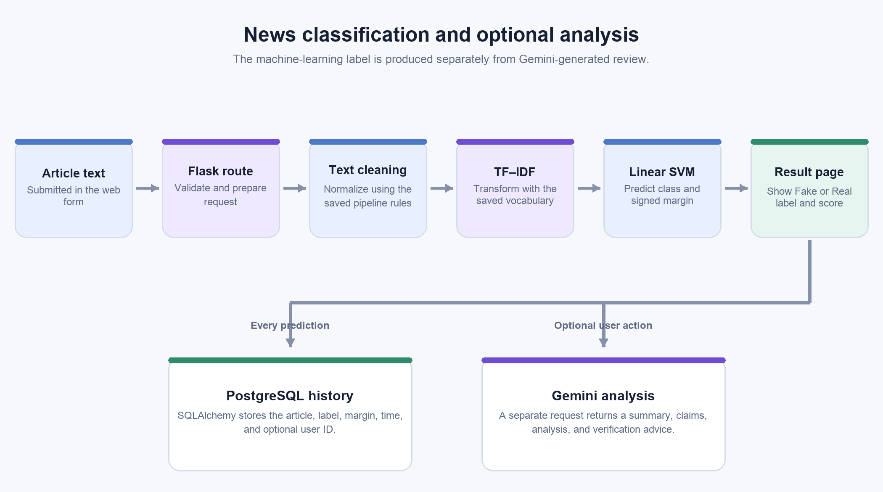
Figure 1. End-to-end application flow. Gemini is separate from the classifier label.
Stage | Component | Operation
1 | Browser and Jinja templates | Collect article text and display a result.
2 | Flask /predict route | Validate the form submission and call preprocessing.
3 | clean_text() | Normalize text using the training-time cleanup rules.
4 | TF-IDF vectorizer | Transform the article into the saved sparse feature space.
5 | LinearSVC | Return the fake/real label and decision margin.
6 | SQLAlchemy and PostgreSQL | Store article, label, margin, date, and optional user ID.
7 | Optional Gemini route | Request a separate generated analysis and display it.

5.2 Main technologies
Technology | Role in this project
Python and Flask | Application routes, request handling, sessions, and page rendering [4].
scikit-learn | TF-IDF vectorization, classifier training, prediction, and evaluation [1-3].
NLTK | English stop-word list and WordNet lemmatization [7].
Joblib | Save and load the trained classifier and vectorizer.
Flask-SQLAlchemy and PostgreSQL | Database models, queries, and persistent account and history records [5].
Jinja2 and CSS | Server-rendered pages and the responsive interface.
Google GenAI SDK | Optional Gemini generate-content request [6].
python-dotenv | Load environment-based configuration for local operation.

5.3 Database design
Table | Important fields | Purpose
users | id, username, email, password_hash, created_at | Stores normal-user accounts.
admin_users | id, username, password_hash, created_at | Stores administrator accounts separately.
prediction_history | id, user_id, news_text, prediction, decision_score, created_at | Stores results; user_id may be empty for an unlinked prediction.

A normal user's prediction rows reference that user's ID. Admin history queries can inspect predictions across users. The application calls SQLAlchemy's create_all() during startup to create missing tables; the code does not provide a database migration system for changing existing schemas.

6 Application features and user roles

6.1 Normal-user workflow
- Register an account with a username, email, and password; registration creates a normal-user account.
- Choose Normal user on the shared login page and sign in.
- Submit an article from the home page and view its classification result.
- Open a personal dashboard with prediction totals and recent activity.
- Review prediction history linked to the signed-in account.

6.2 Administrator workflow
- Choose Administrator on the shared login page and sign in with the separately provisioned admin account.
- View system-level user and prediction statistics, registered users, and recent predictions.
- Search and filter prediction history by article text, label, or date, and paginate the results.
- Delete individual history entries or clear stored history.
- Open the Gemini test page to check the configured AI service.

6.3 Access control and account handling
The login route checks the selected role and queries the corresponding users or admin_users table. Passwords are checked against stored hashes. Successful sign-in clears the prior session and sets role-specific session values. Route helpers restrict admin pages to administrators and personal dashboard/history pages to signed-in normal users. The administrator account is provisioned from environment configuration; public registration cannot create an administrator.
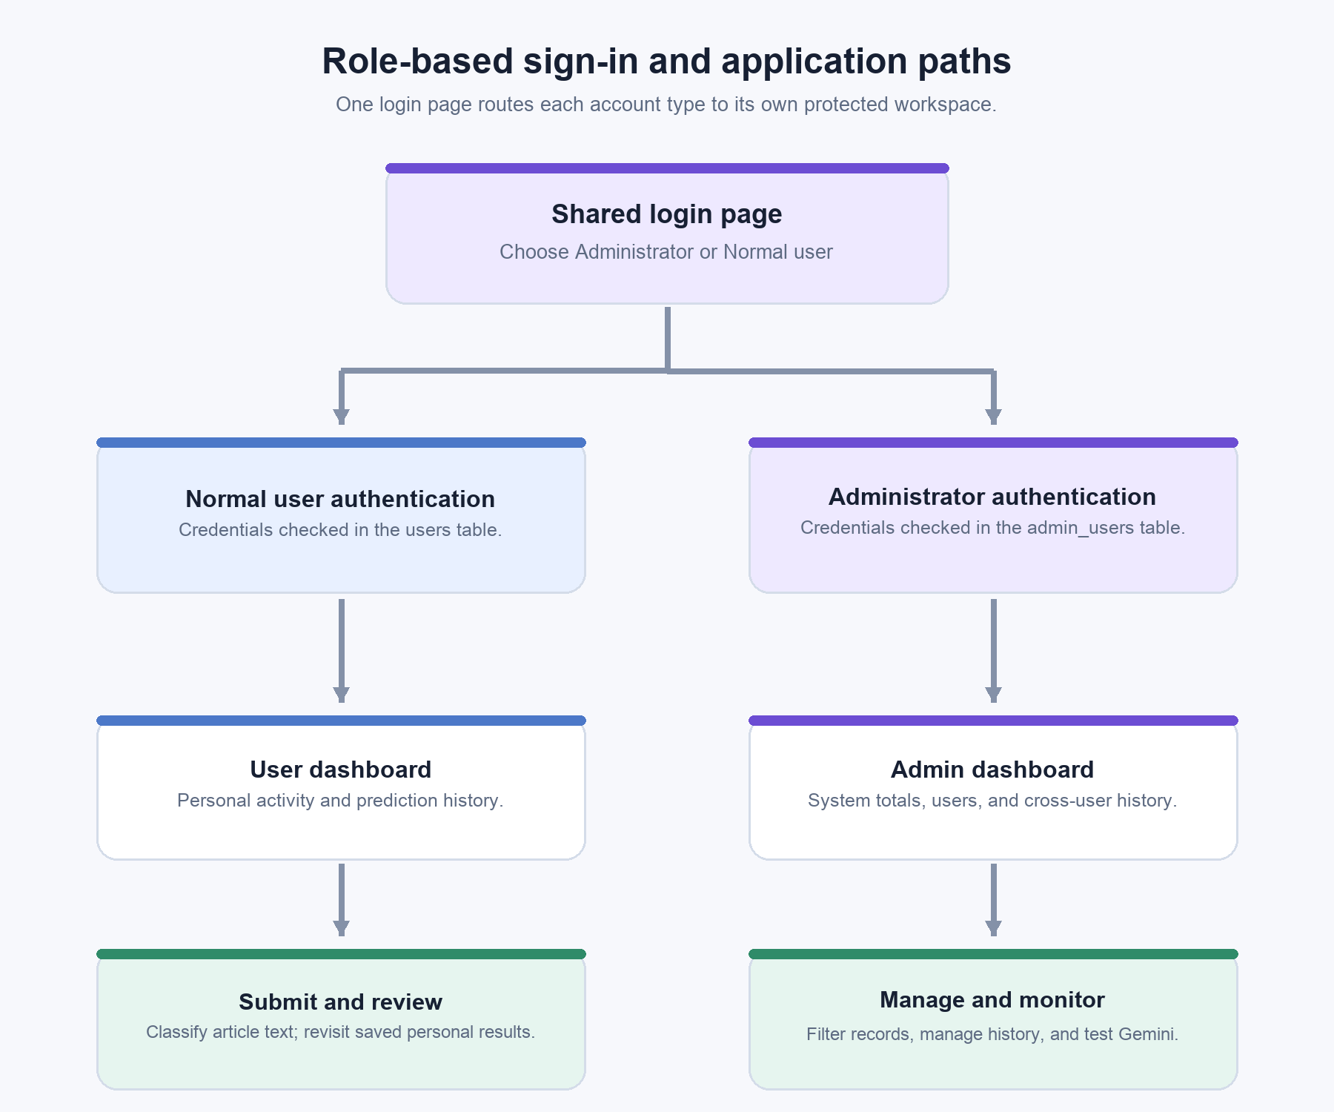
Figure 2. Shared login page and role-specific user and administrator workflows.

6.4 Gemini integration
The result page offers an Analyze with Gemini action. The /gemini-analyze route sends the submitted article and a structured prompt to the configured Gemini model. The prompt requests four sections: Summary, Key Claims, Analysis, and Verification Advice. It instructs the model not to label the article definitively true or false, not to invent facts or sources, and to distinguish text analysis from factual verification. The API key is read from environment configuration rather than written into the report. A failed Gemini request returns a friendly availability message; the machine-learning prediction is stored separately.
Data handling Article text is stored in prediction history. When the optional Gemini action is used, the article text is also sent to the configured Google Gemini API. The report contains no API keys, database credentials, or administrator passwords.

7 Validation and operation

7.1 Model validation
The project notebooks evaluate the candidate classifiers on the held-out test partition and save comparison results in model_comparison.csv and final_evaluation_results.csv. The final testing notebook loads the serialized SVM and vectorizer, runs example articles through the prediction path, and checks the saved artifacts.

7.2 Application checks
Check | Observed behavior
Gemini connection | The live test route returned a successful HTML status page when Gemini responded.
Gemini failure handling | A simulated API failure displayed an availability message and retry action.
Admin protection | An unauthenticated request to the admin-only Gemini test route redirected to login.
Browser delivery | The Gemini test page and shared stylesheet loaded successfully in the local browser.

These checks cover the Gemini test page and access guard. The project files do not include a separate automated web-application test suite. The main quantitative classifier evidence comes from the saved notebook evaluation.

7.3 Configuration and local operation
The application reads its secret key, PostgreSQL connection URL, administrator credentials, Gemini API key, and optional model name from environment configuration. The app's default port is 5000 and can be overridden with PORT. The local development entry point binds to 127.0.0.1 and uses Flask's development server. A production deployment would require a production WSGI server and production security settings [4].
The requirements file lists Flask, Flask-SQLAlchemy, scikit-learn, NLTK, Joblib, NumPy, the Google GenAI SDK, python-dotenv, and the PostgreSQL driver. The Jupyter notebooks document the research workflow and saved evaluation artifacts.

8 Limitations and responsible use
- The model learns associations in the training text. It does not check publishers, evidence, dates, or primary sources.
- The reported 99.83% accuracy comes from one internal test split. Articles from the same source, topic, or period can share writing patterns across a random split, so performance may differ on unseen sources.
- The original dataset's provenance is not documented in the project files. A verified source citation should be added before a formal research submission.
- The system supports a binary label and English-oriented preprocessing. It is not designed for multilingual or mixed-language input.
- Stop-word removal can discard useful context, including negation. This behavior should be reviewed and tested before relying on the model for sensitive decisions.
- The LinearSVC margin is not a probability. A displayed score should not be interpreted as a calibrated confidence estimate.
- Gemini can generate incorrect or unsupported text. Its analysis should be checked by a person and by reliable external sources.
- The optional Gemini request sends article text to an external API. Users should not submit confidential material.
For these reasons, the application is best presented as an educational screening prototype. It can help organize review but should not be used as the sole basis for a consequential decision about a person, publisher, or news claim.

9 Future improvements
- Document the dataset source, license, collection period, and label-generation process.
- Evaluate on a newer external dataset and use source-based or time-based splits to measure generalization.
- Preserve or explicitly model negation, test alternative tokenization, and compare word and character n-grams.
- Add explanations of influential terms while making clear that feature explanations do not establish factual evidence.
- Calibrate decision scores if probability-like output is needed, then validate calibration on separate data.
- Add a retrieval-based claim-checking component that cites dependable sources and shows publication dates.
- Expand language coverage only after collecting suitable labeled data and testing each language separately.
- Add CSRF protection, request limits, secure cookie settings, schema migrations, and a production WSGI deployment before public release.

10 Conclusion
The project connects a complete text-classification workflow to a Flask application. The notebooks clean and split the dataset, build TF-IDF features, compare four classifiers, and save the selected Linear SVM artifacts. The web app applies the same preprocessing at prediction time, presents a fake-or-real label and SVM margin, and records results in PostgreSQL. Separate user and administrator workflows support account-based history and system-level review. Gemini adds an optional generated analysis of claims and verification steps.
The recorded test-split metrics are strong, but they describe the project's dataset rather than all real-world news. The system does not verify facts or retrieve sources. Its most responsible use is as an educational screening aid followed by human review and independent source checking.

References
The first seven references are official technical documentation for the libraries and API used by the project. The final reference identifies the local project artifacts used for implementation and reported metrics.
[1] TfidfVectorizer API reference. scikit-learn documentation. Accessed 27 October 2026. Official documentation
[2] LinearSVC API reference. scikit-learn documentation. Accessed 27 October 2026. Official documentation
[3] Metrics and scoring. scikit-learn user guide. Accessed 27 October 2026. Official documentation
[4] Quickstart. Flask documentation. Accessed 27 October 2026. Official documentation
[5] SQLAlchemy ORM. SQLAlchemy documentation. Accessed 27 October 2026. Official documentation
[6] Text generation. Google AI Gemini API documentation. Accessed 27 October 2026. Official documentation
[7] WordNetLemmatizer API reference. NLTK documentation. Accessed 27 October 2026. Official documentation
[8] Project source and evaluation artifacts. Local Fake News Detection project. app.py; notebooks/02_Data_Preprocessing.ipynb; notebooks/03_Feature_Extraction.ipynb; notebooks/04_Model_Training.ipynb; notebooks/05_Model_Evaluation.ipynb; notebooks/06_Final_Model_Testing.ipynb; model/model_comparison.csv; model/final_evaluation_results.csv.

Appendix A Route guide
Route | Method | Purpose and access
/ | GET | Home page and article submission form.
/predict | POST | Runs the ML classifier and stores a prediction.
/register | GET, POST | Creates a normal-user account.
/login | GET, POST | Shared login form with administrator or normal-user selection.
/logout | GET | Clears the current session.
/user-dashboard | GET | Normal-user summary and recent personal predictions.
/user-history | GET | Normal-user prediction history.
/dashboard | GET | Administrator statistics and user overview.
/history | GET | Administrator prediction search, filters, and pagination.
/delete_prediction/<id> | POST | Administrator deletes one prediction record.
/clear_history | POST | Administrator clears prediction history.
/gemini-analyze | POST | Requests optional Gemini analysis of submitted article text.
/gemini-test | GET | Administrator-only Gemini connection test.

Appendix B Glossary
Term | Plain-language meaning
Classifier | A model that assigns an input to one of a set of labels.
TF-IDF | A numerical representation that weights terms by how informative they are across documents.
Unigram and bigram | A single word and a pair of adjacent words used as text features.
Lemmatization | Reducing a word to a dictionary form, such as 'stories' to 'story'.
Linear SVM | A classifier that separates classes with a linear decision boundary and maximum-margin objective.
Decision margin | A signed distance-like model score; it is not a probability.
Precision | Among examples predicted as positive, the share that are actually positive.
Recall | Among actual positive examples, the share the model identifies.
F1 score | The harmonic mean of precision and recall.
ROC-AUC | A threshold-independent measure of how well scores rank positive examples above negative ones.
ORM | An object-relational mapper that represents database rows as application objects.
Session | Server-side application state associated with a signed-in browser.

