Code History Database User Guide December 2025
ONS Geography
Version 1.0
December 2025


About Us
Office for National Statistics
The Office for National Statistics (ONS) is the executive office of the UK Statistics Authority, a non-ministerial department which reports directly to Parliament. The ONS is the UK government’s single largest statistical producer. It compiles information about the UK’s society and economy and provides the evidence-base for policy and decision-making, the allocation of resources, and public accountability. The National Statistician is the Chief Executive of the UK Statistics Authority.
Government Statistical Service
The Government Statistical Service (GSS) is a network of professional statisticians and their staff operating both within the ONS and across government departments, the devolved administrations and agencies.
Contacts
This publication
For information about the content of this publication, contact ONS Geography Customer Services:
Tel: 01329 444971
Email: ons.geography@ons.gov.uk
Other customer enquiries
For general enquiries, please see the General ONS enquiries page on the website.
Copyright and Reproduction
Please refer to our Licences page for the terms applicable to these products.

Contents
Background Information 3
Introduction 4
Geography Listings 6
Geography History 7
Geography Hierarchies 8
Geography Constitutions 9
Geography Equivalents 10
Geography Information 12
Version Notes 17
Glossary 31
Field Names 32

Background Information

The GSS Coding and Naming policy for some statistical geography was implemented on 1 January 2011. From this date, where new codes have been allocated, they should be used in all exchanges of statistics and published outputs that normally include codes.

The Code History Database (CHD) contains nine-character codes, where allocated, for current and new statistical geographies from 1 January 2009. The codes consist of a simple alphanumeric structure; the first three characters (ANN) represent the area entity (i.e., 'type' or 'category' of geography) and the following six characters (NNNNNN) represent the specific area instance. The CHD provides multiple functionalities including details of codes, relationships, hierarchies, and archived data. The CHD can be used in conjunction with the Register of Geographic Codes that summarises the range of area instances within each geographic entity.

Availability and contents of the zip file
The CHD is a Microsoft Access database available for download from the Open Geography Portal and can be accessed via the Products dropdown menu. Within the downloaded zip file there is a 2007 version of the Access database, a 2002 version of the Access database and CSV exports of the three main “behind the scenes” tables that hold the CHD data – changehistory.csv, changes.csv and equivalents.csv.

Support of old style ONS Geography codes
Since the allocation of nine-character codes for current and new statistical geographies, the CHD has provided the “old style” ONS Geography code equivalent, such as the 4-character code for local authorities or the 6-character code for wards. From January 2014, these old-style codes have no longer been supported in the CHD, although pre-2014 these old style ONS codes can still be found.

Introduction

You must save the CHD to your hard drive to ensure complete database functionality. Upon opening the CHD, you will be presented with the following screen.
NOTE: If using MS Access 2007 or later an Information bar appears warning that certain content in the database has been disabled. To rectify this, click on the Options button next to the warning message and then the radio button 'Enable this content'.

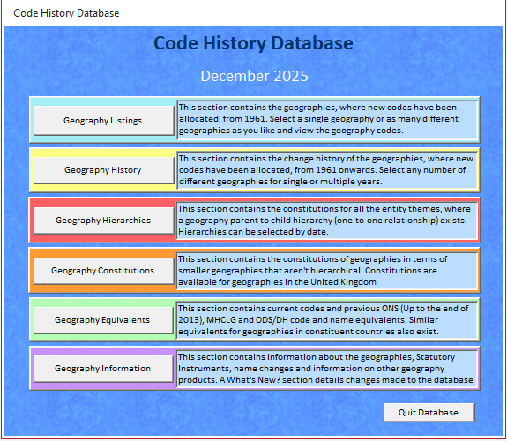

This is the main CHD Menu and will enable you to navigate to the area you require.
When viewing tables in the database there are several columns but there is an option to hide and unhide columns on the menu bar or under the Add-Ins tab, select the relevant columns, and click the Hide Columns button. If you save the design of the query when closing the table, the columns will remain hidden when opening subsequent tables. To retrieve the columns, select Unhide Columns and tick the required column names.

Geography Listings
This section contains the statistical geographies, where the new coding methodology is being used, from 1 January 2009.
To view all available geographies, click <View List> in the Complete Geography Listing section.
You can also select single or multiple geographies and view both live and terminated instance codes. To do this, highlight the appropriate geography/geographies in the Geography Search Facility window and click <View List> to view the query in table form.
Note: Terminated instance codes are only available for changes operative from the CHD creation date of 1 January 2009.
To search for ‘live’ geographies by a specific date (post 1 January 2009) highlight the appropriate geography/geographies in the Search Facility of ‘Live’ Geographies window, enter the appropriate date in the date window and click <View List> to view your query in table form.
As well as viewing your results in table format, you can export your results to an Excel or CSV file so you can manipulate data as required. Click <Export List>.

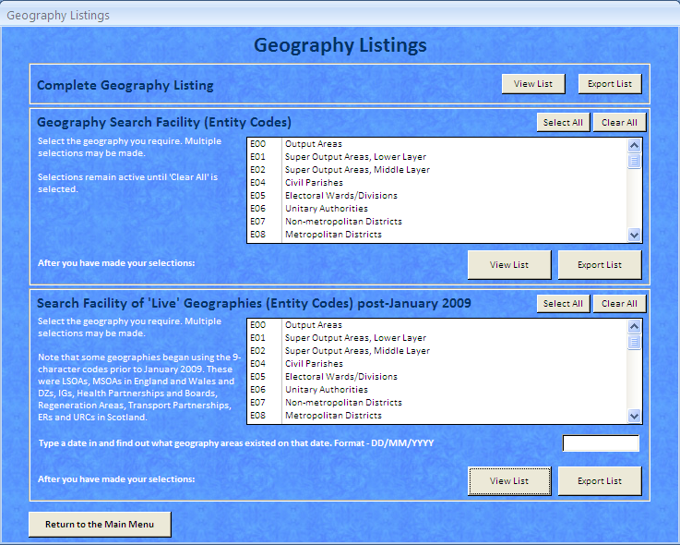
To return to the previous menu click <Return to the Main Menu>.

Geography History
This section contains the change history for geographies, where new coding is being used, from 1 January 2009 onwards. Select any number of geographies for single or multiple years and view both current and previous names and codes in a single table, i.e., geographies that have merged or split to form a new area.
There are two options available for viewing this data:
- ‘Split’ instance form displays each previous name and code in separate rows, and
- ‘Single’ instance form displays previous codes only in a single row
To view or export the Complete Change History table, either in split or single instance form, click <View List> or the relevant Export option. Warning: Viewing or Exporting the complete change history in ‘single’ instance form.
You can also view or export the change history for single or multiple geographies by year. Please note that the year is linked to operative dates only, termination dates cannot be viewed in this section. Select the appropriate geography/geographies in the Geography Search Facility window, select the appropriate year and click <View List> or the relevant Export option. These tables can be viewed in split or single instance form by selecting the appropriate option.

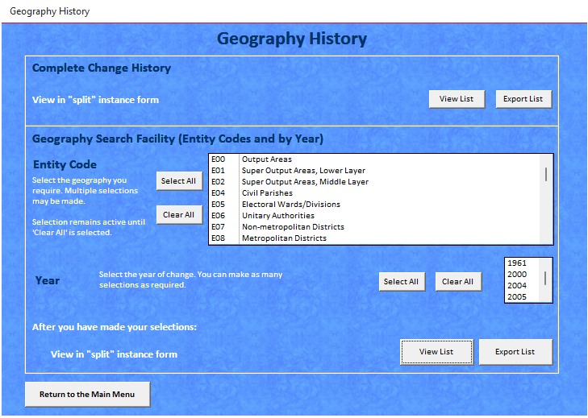
To return to the previous menu click <Return to the Main Menu>.

Geography Hierarchies
This section contains the constitutions for the entity themes where a parent to child hierarchy (one to one relationship) exists.
You can view or export geography hierarchies within specific entity themes, providing that one-to-one relationship, with no splits, exist. These can only be selected one at a time: select the appropriate geography, enter a date, and click either <View List> or the relevant Export option.
Note: If the cursor is placed over the entity text, a plain English translation will appear to explain the abbreviations.

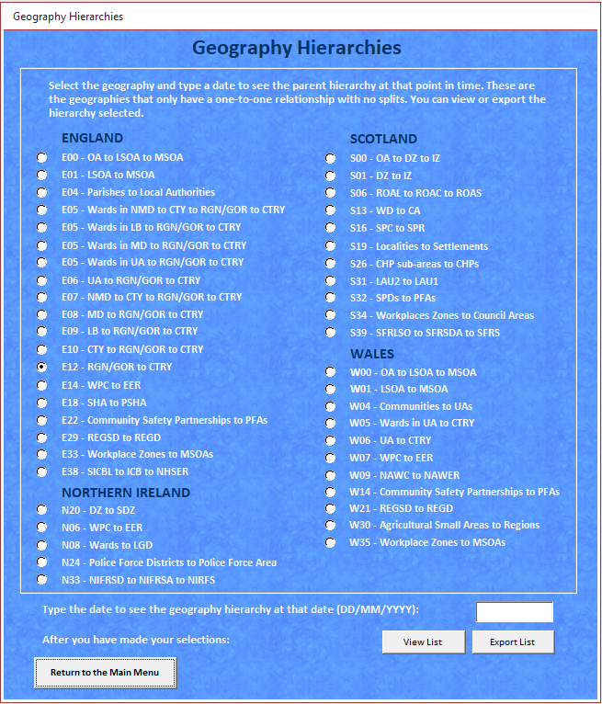
To return to the previous menu click <Return to the Main Menu>.

Geography Constitutions
This section contains the constitutions for some cross-theme geographies within the United Kingdom. You can only view or export the geography constitutions one at a time; select the appropriate geography and click either <View List> or the relevant Export option.

To return to the previous menu click <Return to the Main Menu>.

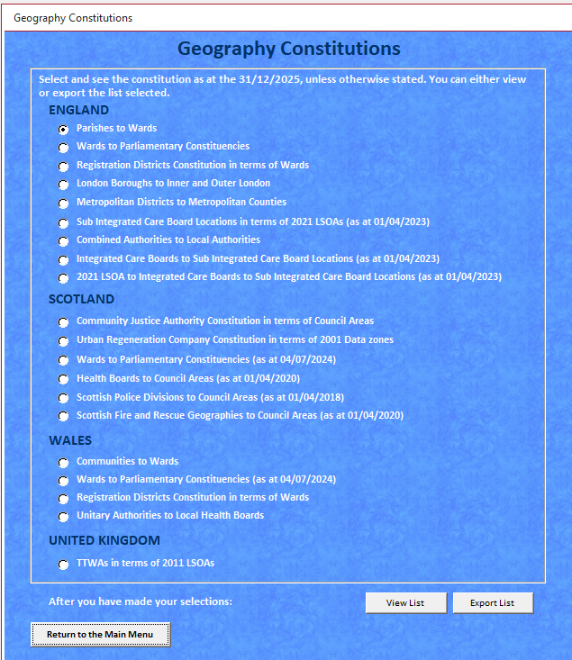

Geography Equivalents
This section contains both the current codes and names and the previous ONS, MHCLG, ODS/DH, Scottish and Welsh government code and name equivalents. Where available it also contains the appropriate code and name equivalents for geographies in the constituent countries.

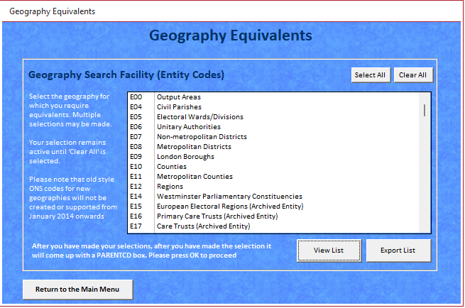
You can view or export as many geographies as you wish by highlighting them in the Search Facility window and clicking either <View List> or <Export List>. Records will be included for both live and archived geographies.
It is also possible to view just the live geographies:
- Select the required geography and click <View List>
- When the table opens the first cell will be highlighted; click in this cell to remove the highlight
- Click the 'Filter by Form' button (located under Advanced on MS Access 2007) and one blank record will appear.
Scroll across to the Date of Termination field, click in the blank cell and select ‘Is Null’ from the drop down option.
- Click on the 'Apply Filter' or ‘Toggle Filter’ button and only the live records will appear.

It is not possible to export filtered records only when choosing the Export function. However, if tables are exported into MS Excel a filter can then be applied.
To return to the previous menu click <Return to the Main Menu>.

Geography Information
This section provides metadata and other useful information.

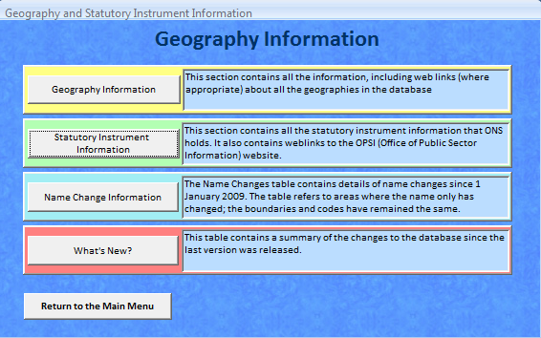

The Geography Information section contains metadata about the geographies including a summary description, source of boundaries, and the policy department contact name and web link. To view information for single or multiple geographies highlight them in the Search Facility window and click <View Information>.

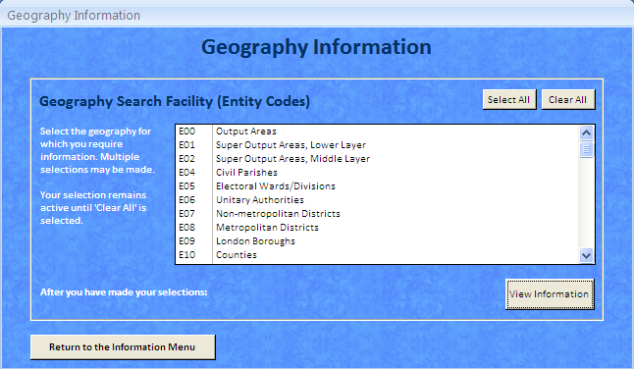
Upon making your selection you will be shown a form like the one on the next page.

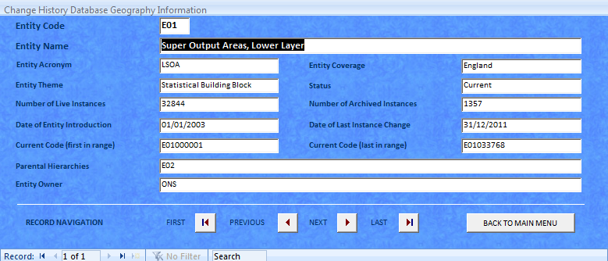

To return to the previous menu click <Back to Main Menu>.

Statutory Instrument Information
This section contains details of the Statutory Instruments including web links to the relevant SI on the Legislation website.
Occasionally more than one Statutory Instrument (SI) can affect the same instance, for example ward, on the same date. However, for the CHD functionality to work correctly it is not possible to have duplicate records, so the relevant operative/termination dates have been adjusted.
There are currently two ward records in the CHD where SI dates have been adjusted to ensure accurate functionality. Click on the SI number to view the full SI details but please note that a ‘dummy SI’, no 1111/1001, was set up for the GSS re-coding strategy.

Code | Name | Operative date | Termination date | SI number
E05007514 | Bidford and Salford | 01/01/2009 | 02/05/2011 | 1111/1001
E05008538 | Bidford and Salford | 03/05/2011 | 04/05/2011 | 748/2008
E05008586 | Bidford and Salford | 05/05/2011 | n/a | 533/2009
E05007540 | Welford | 01/01/2009 | 02/05/2011 | 1111/1001
E05008539 | Welford | 03/05/2011 | 04/05/2011 | 748/2008
E05008593 | Welford | 05/05/2011 | n/a | 533/2009

To view SI information, highlight the appropriate year and click <View Information>.

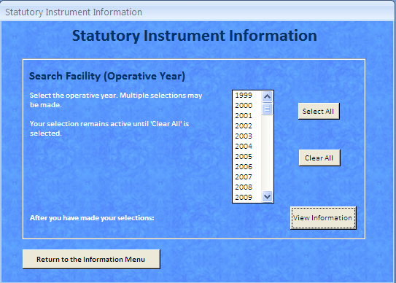

Upon making your selection you will be shown a form like the one below.

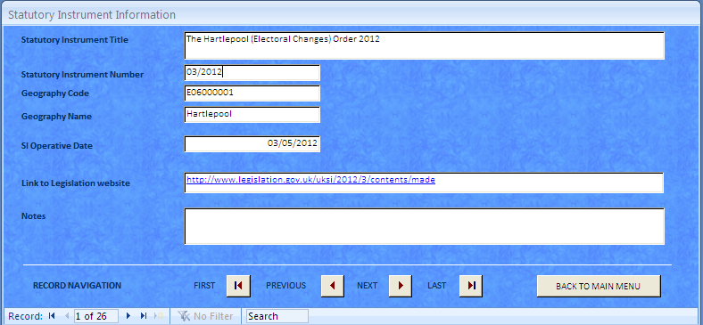

To return to the previous menu, click <Back to Main Menu>.

Name Change Information
This section contains details of name changes since 1 January 2009 and includes the current and previous names as well as the operative date of those changes.
Please note that, where only the name has changed without an associated change to the boundary or geography type, the code will remain the same. There are a minimal number of name changes, usually to wards or parishes, and details can be found in the table. Where an SI number has been allocated to define a 'legitimate' name change there are separate CHD records for the former and new names with relevant termination and operative dates. Name changes for minor amendments and corrections are also noted but separate records for former/new names do not exist in the various CHD geography lists. These changes include corrections where initial names supplied to ONS were incorrect. Some Scottish names that include the word 'and' have been amended to match the official SI although Scotland formerly preferred the use of ampersands. If further information is required please contact ONS Geography Customer Services.

What’s New?
What’s New? Provides a summary of the updates applied to the database since the previous version was released. The table also includes a historical record of all updates applied to the database since it was published in February 2010.

Version Notes
The Code History Database (CHD) version notes contain specific information about each release, including details of recent changes that have impacted on the data or database structure –

December 2025
Updated Geographies
- Updates in England to: Civil Parishes (E04), Non-metropolitan Districts (E07), Local Skills Improvement Plan areas (E69)
- Updates in Wales to: Communities (W04)
- SIs updated to the end of 2025
- Constitutions updated to the end of 2025
- Information table updated

June 2025
Updated Geographies
- Updates in England to: Civil Parishes (E04), Electoral Wards/Divisions (E05), Non-metropolitan Districts (E07), Metropolitan Districts (E08) Non-Civil Parished Areas (E43), Combined Authorities (E47), County Electoral Divisions (E58), Local Planning Authorities (E60)
- Updates in Wales to: Communities (W04)

December 2024
Updated Geographies
- Geography hierarchies and constitutions updated.
- E62 - Areas of Outstanding Natural Beauty renamed National Landscapes.
- K07 - Areas of Outstanding Natural Beauty renamed National Landscapes.
- S01 – Datazones
- S02 – Intermediate Zones
- W44 - Areas of Outstanding Natural Beauty renamed National Landscapes.

July 2024
Updated Geographies
- Updates in England to: Civil Parishes (E04), Electoral Wards/Divisions (E05), Westminster Parliamentary Constituencies (E14), Local Enterprise Partnerships (E37), NHS England Regions (E40), Non-Civil Parished Areas (E43), Combined Authorities (E47), LEP - overlapping part (E52), LEP - non overlapping part (E53), Cancer Alliances (E56), Built Up Areas (E63). Built Up Areas (K08), Non-Standard Geography Categories (K99).
- Updates in Northern Ireland to: Westminster Parliamentary Constituencies (N05), Westminster Parliamentary Constituencies (N06).
- Updates in Scotland to: Output Areas (S00), Westminster Parliamentary Constituencies (S14), Island Groups (S36), Built Up Areas (S45).
- New Entities introduced: Census Locality (S52), Census Settlement (S53).
- Updates in Wales to: Westminster Parliamentary Constituencies (W07), Built Up Areas (W45).

December 2023
Updated Geographies
- Updates in England to: Civil Parishes (E04), Local Enterprise Partnerships (E37), Non-Civil Parished Areas (E43), Development Corporations (E51), Cancer Alliances (E56), Local Planning Authorities (E60),
- New Entity introduced: Local Skills Improvement Plan areas (E69)
- Updates in Scotland to: Settlements (S20)
- New Entities introduced: Non-Standard Geography Categories (S47), Scottish Island Regions (S48)
- Updates in Wales to: Communities (W04), National Parks (W18)
- SIs updated to the end of 2023
- Constitutions updated to the end of 2023.
- Information table updated.

May 2023
Updated Geographies
- Updates in England to: Civil Parishes (E04), Electoral Wards/Divisions (E05), Unitary Authorities (E06), Non-metropolitan districts (E07), Counties (E10), National Parks (E26), Registration Districts (E28), Registration Sub-districts (E29), Sub Integrated Care Board Locations (E38), Non-Civil Parished Areas (E43), Local Resilience Forums (E48), Integrated Care Boards (E54), County Electoral Divisions (E58)
- New Entities introduced: Areas of Outstanding Natural Beauty (E62), England Non-National Park Area (E65), Grouped Local Authority Districts (Parishes) (E66), Census Merged Local Authority Districts 2021 ((E67), Grouped Local Tier Local Authorities (E68) Non-Standard Geography Categories (K99)
- Updates in Northern Ireland to: Small Areas (N00)
- New Entities introduced: Data Zones (N20), Super Data Zones (N21)
- Updates in Scotland to: National Parks (S21)
- Updates in Wales to: National Parks (W18)
- New Entities introduced: Areas of Outstanding Natural Beauty (W44), Grouped Local Authority Districts (Parishes) (W46), Grouped Lower Tier Local Authorities (W47)

December 2022
Updated Geographies
- Updates to Parishes (E04), Local Enterprise Partnerships (E37)
- New Entities introduced: 2022 Built Up Areas (E63), (K08), (S45) and (W45).
- 2011 Built Up Areas and Built Up Area sub-divisions (E34), (E35), (K05), (K06), (W37), (W38) archived.

August 2022
Updated Geographies
- Updates in England to: Output Areas (E00), Super Output Areas, Lower Layer (E01), Super Output Areas, Middle Layer (E02), Civil Parishes (E04), Electoral Wards/Divisions (E05), Locations (formerly Clinical Commissioning Groups) (E38), NHS England Regions (E40), Non-Civil Parished Areas (E43), Integrated Care Boards (formerly Sustainability and Transformation Partnerships) (E54)
- Updates in Scotland to: Electoral Wards (S13), Localities (S19), Settlements (S20), Scottish Fire and Rescue Local Senior Officer Areas (S39), Scottish Local Resilience Partnerships (S42)
- Updates in Wales to: Output Areas (W00), Super Output Areas, Lower Layer (W01), Super Output Areas, Middle Layer (W02), Communities (W04), Electoral Wards (W05)

December 2021
Updated Geographies
- Updates to Civil Parishes (E04), Non-Civil Parished Areas (E43)
- Public Health England Centres (E45) and Regions (E46) were disbanded on the 1st of October 2021.
- SIs updated to the end of 2021
- Constitutions updated to the end of 2021.
- Information table updated.

June 2021
Updated Geographies
- Updates to Civil Parishes (E04), Electoral Wards/Divisions (E05), European Electoral Regions (E15), Local Enterprise Partnerships (E37),Non-Civil Parished Areas (E43), County Electoral Divisions (E58), European Electoral Regions (N07), European Electoral Regions (S15), Scottish Parliamentary Constituencies (S16), Scottish Parliamentary Regions (S17), Communities W04), European Electoral Regions (W08)

April 2021
Updated Geographies
- Updates to Unitary Authorities (E06), Non-metropolitan districts (E07), Counties (E10), Fire and Rescue Authorities (E31), Local Enterprise Partnerships (E37), Clinical Commissioning Groups (E38), LEP overlapping parts (E52), LEP non-overlapping parts (E53), Local Planning Authorities (E60)

December 2020 v2
Updated Geographies
- Updates to Civil Parishes (E04)
- Updates to Electoral Wards/Divisions (E05)
- Update to Non-Civil Parishes (E43)
- SI Details updated to the end of 2020.

December 2020
Updated Geographies
- Updates to Civil Parishes (E04)
- Constitutions updated to the end of 2020.
- SI Details updated to the end of 2020.
- Information table updated.

November 2020
Updated geographies
- Updates to the Parent Codes for ONS owned and Live instances:
- MSOAs (E02) with Local Authority District (2011) Code.
- EERs (E15), Registration Districts (E28), Travel to Work Areas (E30), Built-up Areas (E34) with Country.
- Census Merged Wards (E36) with Census Merged LADs.
- Census Merged LADs (E41) and Census Merged Counties (E42) with Country.
- Non-Civil Parished Areas (E43) with Local Authority Code.
- Local Planning Authorities (E60) and Greater London Authority (E61) with Region.
- Travel to Work Areas (K01) with England and Wales (K04000001).
- Built-up Areas (K05) with England and Wales (K04000001).
- Travel to Work Areas (N12) and Local Planning Authorities (N13) with Country.
- Travel to Work Areas (S22) and Local Planning Authorities (S44) with Country.
- Registration Districts (W20), Travel to Work Areas (W22), Built-up Areas (W37) with Country.
- Census Merged Wards (W39) with Census Merged LADs.
- Census Merged LADs (W40) and Local Planning Authorities (W43) with Country.

September 2020
Updated Geographies
- Updates to Civil Parishes (E04), Non-Civil Parishes Areas (E43), Sustainability and Transformation Partnerships (E54) (Department of Health codes updated only) and Local Planning Authorities (E60). (Parish orders operative in 2020 - ward orders operative in 2020 are now to be implemented in May 2021)

June 2020 v2
Updated Geographies
- Updates to Local Enterprise Partnerships (E37), LEP overlapping parts (E52), LEP non-overlapping parts (E53), County Electoral Divisions (E58)
- All parish and ward orders operative in 2020 are now to be implemented in April 2021. Parishes and wards previously assigned to Aylesbury Vale, Chiltern, South Bucks and Wycombe now assigned to E06000060 - Buckinghamshire

June 2020
Updated Geographies
- Updates to Civil Parishes (E04), Electoral Wards/Divisions (E05), Local Enterprise Partnerships (E37), Non-Civil Parished Areas (E43), LEP overlapping parts (E52), LEP non-overlapping parts (E53), County Electoral Divisions (E58)

April 2020
Updated Geographies
- Updates to Unitary Authorities (E06), Non-metropolitan districts (E07), Counties (E10), Clinical Commissioning(E38), England (Region, Local Office) (E39), Sustainability and Transformation Partnerships (E54), Cancer Alliances (E56)

December 2019
Updated Geographies
- Updates to Civil Parishes (E04), Electoral Wards/Division (E05), Unitary Authorities (E06), Non-metropolitan districts (E07), Sustainability and Transformation Partnerships (E54), County Electoral Divisions (E58)
- New Geography Entity – City Regions (N34)

June 2019
Updated Geographies
- Updates to Civil Parishes (E04), Electoral Wards/Division (E05), Unitary Authorities (E06), Non-metropolitan districts (E07), Counties (E10), Registration Districts (E28), Registration Sub-district (E29), Clinical Commissioning Groups (E38), NHS England (Region, Local Office) (E39), NHS England Regions (E40), Non-Civil Parished Areas (E43), Combined Authorities (E47) and Cancer Alliances (E56) in England
- Updates to Health Board areas (S08), Council Areas (S12), Local Administrative Units 1 (S30), Scottish Police Divisions (S32), Integration Authorities (S37), Scottish Fire and Rescue Local Senior Officer Areas (S39) in Scotland.
- Updates to Local Health Boards (W11) in Wales.
- New Geography Entities - Local Planning Authorities (E60) and Greater London Authority (E61).
- New Geography Entity – Local Planning Authorities (N13)
- New Geography Entities - Scottish Local Resilience Partnerships (S42), Scottish Regional Resilience Partnerships (S43) and Local Planning Authorities (S44).
- New Geography Entity - Local Planning Authorities (W44)
- National Cancer Vanguards (E57) abolished

December 2018
Updated Geographies
- Updates to Parishes (E04), Wards (E05), Enterprise Zones (E49), and County Electoral Divisions (E58)
- Updates to Electoral Wards (S13)
- New Entity for Scottish Marine Regions (S41)
- Update to Community Safety Partnerships (W14)
- New Entities for 1961 Census Parishes (J02), 1961 Census Wards (J03), 1961 Census LADs (J04) and 1961 Census Counties (J05)

Database Changes
- Updates to form design to account for December 2018 version have been made.

August 2018
Updated Geographies
- Updates to Parishes (E04), Wards (E05), Non-Civil Parished Areas (E43), Sustainability and Transformation Partnerships (E54)
- New Entity for Integrated Care Systems (E59)
- Updates to Health Board areas (S08), Localities (S19), Settlements (S20), Local Administrative Units 1 (S30), Scottish Police Divisions (S32), Integration Authorities (S37), Scottish Fire and Rescue Local Senior Officer Areas (S39), Scottish Fire and Rescue Service Delivery Areas (S40)
- Updates to Registration Districts (W20) and Registration Sub-districts (W21)
- New Entity for City Regions (W42)

April 2018
Updated Geographies
- Updates to Parishes (E04) (name change), Wards (E05) (name change), NMD (E07) (name change), Clinical Commissioning Groups in England (E38), NHS (Region, Local Office) (E39) and NHS England Regions (E40)
- Updates to Council Areas (S13) and Wards (S13)
- Updates to the Change History, SI Details, Name Changes, Equivalents table and Information table.

December 2017
Updated Geographies
- New entity for County Electoral Divisions (E58)
- Updates to Electoral Wards in England (E05), Clinical Commissioning Groups in England (E38) (name changes) and Waste Authorities in England (E50).
- Updates to all Geography Constitutions to as at 31/12/2017
- Changes to the SI Details, Name Changes and Information table.

Database Changes
- Updates to form design to account for December 2017 version have been made.

September 2017
Updated Geographies
- Updates to Parishes (E04), LEPs (E37), LEPOPs (E52), LEPNOPs (E53), LRFs (E48) and Development Corporations (E51).
- Changes to the Information table.

Database Changes
- Updates to form design to account for September 2017 version have been made.

June 2017
Updated Geographies
- Updates to Parishes (E04) and Communities (W04), Wards (E05)(W05)(S13) for the 2017 SI changes. Updates to LEPS (37), LEPOPs (E52), LEPNOPs (E53). Updates as a result of NHS changes for CCGs (E38), NHSRLOs (E39), NHSERs (E40) and STPs (E54). Updates to Combined Authorities (E47). Updates to CCG lookups and Combined Authority lookups.
- Changes to the Information table.

Database Changes
- Updates to form design to account for June 2017 version have been made.

February 2017
Updated Geographies
- We were notified to a couple of amendments to the Sustainability and Transformation Plan footprints which meant amendments to the Cancer Alliances. The changes are as follows: North Durham CCG move from STP E54000003 to E54000001. Therefore, these two STPs have new codes: E54000045 (Durham, Darlington, Teesside, Hambleton, Richmondshire and Whitby) and E54000046 (Northumberland, Tyne and Wear and North Durham). Correction to the border between the West, North and East Cumbria STP and Lancashire and South Cumbria STP. Therefore, these two STPs have new codes: E54000047 (West, North and East Cumbria) and E54000048 (Lancashire and South Cumbria).
- One new lookup created in Constitutions - LSOA to CCG to STP lookup (as at 14/02/2017).
- Administrative geographies updated with 2016 Standard Area Measurements.
- Changes to the Information table.

Database Changes
- Updates to form design to account for February 2017 version have been made.

January 2017
Updated Geographies
- We have just been notified that an amendment is needed to the Strategic Clinical Networks. (E55000014) London replaced (E55000001) North West and South London and (E55000013) North and East London immediately after the Strategic Clinical Networks were created in 2013. Updates to the ChangeHistory, Changes, and Equivalents tables have been made.
- Changes to the Information table.

Database Changes
- Updates to form design to account for year 2017 have been made.

December 2016
Updated Geographies
- New Geography Entities in England added - Cancer Alliances (E56) and National Cancer Vanguards (E57)
- Updates to Community Safety Partnerships (E22) and Waste Authorities (E50) and Standard Area Measurements for CCGs (E38) NHSRGs (E39) and NHSCRs (E40)
- Updates to all Geography Constitutions to as at 31/12/2016

October 2016
Updated Geographies
- New geographies in Scotland and Northern Ireland – Workplace Zones (S34) and (N19).
- Updates to Scottish Police Divisions (S32) and 1 parish name change.
- LSOA and MSOA names in Wales amended from Vale of Glamorgan to The Vale of Glamorgan.

September 2016
Updated Geographies
- New geographies in England – Strategic Clinical Networks (E55) and Cancer Networks (E21) archived.
- Updates to ward, parish, non-civil parished areas, national parks, combined authority and name changes
- Name amendments on instance names across various entities.

April 2016
Updated Geographies
- New geographies in England - Waste Authorities (E50), Neighbourhood Planning Areas (E51), LEP - overlapping parts (E52), LEP - non overlapping parts (E53), and Sustainability and Transformation Plan Footprints (E54).
- New experimental geography called Major Towns and Cities using the J01 entity code.
- Updates to CCGs (E38) (due to parent geography changes), NHSRGs (E39), Combined Authorities (E47) and Enterprise Zones (E49).
- Updates to Scottish Parliamentary Regions (S17) and Constituencies (S16).

February 2016
Updated Geographies
- Up-to-date ward, parish and name changes.
- New Geographies in England - E49 Enterprise Zones
- New Geographies in Scotland - S36 Island Groups. S38 Scottish Fire and Rescue Service. S39 Scottish Fire and Rescue Local Senior Officer Areas. S40 Scottish Fire and Rescue Service Delivery Areas
- New Geographies in Northern Ireland - N23 Police Force Areas. N24 Police Force Divisions. N31 Northern Ireland Fire and Rescue Service. N32 Northern Ireland Fire and Rescue Service Areas. N33 Northern Ireland Fire and Rescue Service Districts.
- Geography Hierarchies updated to reflect the situation as at the end of 2015.
- Geography constitutions updated to reflect the situation as at the end of 2015. New constitutions added.
- Updated the LSOA, MSOA and USOA names to reflect the local authority names. NB – names not changed – Kingston upon Hull, Bristol and Herefordshire.
- Standard Area Measurements (in hectares) added to the Geography Listings.

Database Changes
- 4 new fields added to the ChangeHistory table - AREAEHECT,AREACHECT, AREAIHECT, AREALHECT (all number format to 2 decimal places)
- Changing the export function to export as Excel, because export as text didn’t work.

September 2015
Updated Geographies
- Updated and corrected 2011 Travel to Work Areas built from Census 2011 data for the United Kingdom.

Database Changes
- Removing the Custom toolbar
- Changing the export function to export as text (TXT, CSV, TAB, ASC), a non-proprietary open format.

July 2015
New Geographies
- New Combined Authorities (E47) and Local Resilience Forums (E48) geographies added for England
- New ISD Health Board of Treatment (S27), Census Detailed Characteristics (S28), Census Local Characteristics (S29) and Broad Rental Market Areas (S33) geographies added for Scotland
- New Local Resilience Forums (W41) geographies added for Wales
- New electoral wards (N08), local government districts (N09) and settlements (N11) geographies added for Northern Ireland
Updated Geographies
- Up-to-date ward, parish and name changes in England and Wales.
- New CCGs created and updated CCG names as well as the 15 NHS Area Teams becoming 9 NHS Region Geographies in England.
- Four LSOAs have been moved from Guildford and Waverley CCG to Coastal West Sussex CCG in order to align the county and CCG boundaries. They are: E01031502 Chichester 001A, E01031503 Chichester 001B, E01031504 Chichester 001C, E01031519 Chichester 001D
- Up-to-date Public Health England Centres (E45) and Community Safety Partnerships (E22) in England
- Closure of Community Health Partnerships (S03) and sub-areas (S26) in Scotland.
- New and updated 2011 TTWAs built from Census 2011 data for the United Kingdom. This version 2 of the CHD contains the correct names and codes for the 2011 TTWAs.
Database Changes
- A new field has been added to the Change History table. The name of the field is called STATUS and contains either “live” or “terminated” to reflect whether the instance is live or terminated. This was added as a requirement for our linked data portal and will remain on the Change History table from now on.
- New Geography hierarchies and constitutions added including Ward to LGD (NI) ; CCG to NHS Region Geography to NHS Commissioning Region; Public Health England (PHE) centre to PHE region, in terms of local authorities as at 01/07/2015; CCGs in terms of LSOAs as at 03/07/2015; LAD to Combined Authority, as at 15/04/2015; and 2011 TTWA in terms of 2011 LSOAs as at 31/07/2015.

Glossary
- CHD – Code History Database
- DLUHC – Department for Levelling Up, Housing and Communities
- CSV – Comma Separated Values
- DH – Department for Health
- DfE – Department for the Environment
- GSS – Government Statistical Service
- NRS – National Records of Scotland
- ONS – Office for National Statistics
- SNAC – Standard Names and Codes
- Statutory Instrument (SI) - A legal document that specifies the date on which a structural change comes into effect, subject to parliamentary procedure.
- WG – Welsh Government

Field Names
- OLD GEOGCD - This field refers to the terminated 9 character code.
- OLD GEOGNM – This field refers to the terminated geography name.
- ONSCODE_PREV – This field refers to the terminated ONS Geography code.
- ONSNAME_PREV – This field refers to the terminated ONS Geography name.
- TERM_DATE – This field refers to the date of termination.
- GEOGCD – This field refers to the new 9 character code.
- GEOGNM – This field refers to the new geography area name.
- ONSCODE – This field refers to the new ONS Geography code.
- ONSNAME – This field refers to the new ONS Geography name.
- SI NUMBER – This field refers to the number on the statutory instrument.
- SI TITLE – This field refers to the title on the statutory instrument.
- OPER_DATE – This field refers to the date of introduction.
- YEAR – This field refers to the year of introduction.
- ENTITYCD – This field is the code allocated from the Register of Geographic Codes.
- PARENTCD – This field is the code of the parent geography in the geography hierarchical system.
- OWNER – This field is the name of the entity owner.
- STATUS – This field refers to whether the geography is live or terminated.
- AREAEHECT – This field refers to ‘Extent of the Realm’ measurement, in hectares, to 2 decimal places.
- AREACHECT – This field refers to Area to Mean High Water, in hectares, to 2 decimal places.
- AREAIHECT – This field refers to Area of inland water, in hectares, to 2 decimal places.
- AREALHECT – This field refers to Area to Mean High Water excluding area of inland water (land area), in hectares, to 2 decimal places.

