May 2024

Repository <https://github.com/humanshield89/galaxy-fox-token>

Commit f0fc44d6a19a2cdfffc2fc86b696389ad0b88fca

Audited by © cyberscope

## Table of Contents

**Table of Contents 1**

**Review 3**

Audit Updates 3

Source Files 3

**Overview 4**

Owner Functionalities 4

Stake Functionality 4

Unstake Functionality 4

Early Unstake Functionality 5

Claim Pending Rewards Functionality 5

**Roles 6**

onlyAdmin 6

Users 6

**Findings Breakdown 7**

**Diagnostics 8**

IRM - Increased Rewards Miscalculation 9

Description 9

Recommendation 11

CR - Code Repetition 12

Description 12

Recommendation 14

MPV - Missing PoolID Validation 15

Description 15

Recommendation 15

CCR - Contract Centralization Risk 16

Description 16

Recommendation 17

MU - Modifiers Usage 18

Description 18

Recommendation 18

PBV - Percentage Boundaries Validation 19

Description 19

Recommendation 19

PTAI - Potential Transfer Amount Inconsistency 20

Description 20

Recommendation 20

RCO - Redundant Calculation Overhead 22

Description 22

Recommendation 23

TUU - Time Units Usage 24

Description 24

Recommendation 24

TSI - Tokens Sufficiency Insurance 25

Description 25

Recommendation 25

OCTD - Transfers Contract's Tokens 26

Description 26

Recommendation 26

L04 - Conformance to Solidity Naming Conventions 27

Description 27

Recommendation 28

L19 - Stable Compiler Version 29

Description 29

Recommendation 29

**Functions Analysis 31**

**Inheritance Graph 33**

**Flow Graph 34**

**Summary 35**

**Disclaimer 36**

**About Cyberscope 37**

## 

## Review

| **Repository** | https://github.com/humanshield89/galaxy-fox-token |
| --- | --- |
| **Commit** | f0fc44d6a19a2cdfffc2fc86b696389ad0b88fca |

### Audit Updates

| **Initial Audit** | 14 May 2024 |
| --- | --- |

### Source Files

| **Filename** | SHA256 |
| --- | --- |
| **GFoxStakingStorage.sol** | 512c005c9fd84abe5f85fc24b4f63d7002b51ba5c48391eb3a653497ccfc8601 |

## Overview

The GFOXStakeStorage contract implements a comprehensive staking system designed to manage user investments in cryptocurrency pools. It provides functionalities for admins to add, update, and remove pools, while allowing users to stake, claim rewards, and unstake their funds, including an option for early unstaking with a penalty. This contract uses a variety of parameters such as APY, lock periods, and staking limits to cater to diverse user preferences, ensuring flexibility and control in investment strategies while maintaining security and transparency in transactions.

### Owner Functionalities

The admin has the authority to manage the operational aspects of the staking pools, ensuring flexibility and control over the staking environment. This includes the ability to add new pools with specific parameters such as APY (Annual Percentage Yield) expressed in basis points, lock period durations, and minimum or maximum stake limits. Additionally, admins can update existing pools to adjust these parameters or remove pools if necessary. These functionalities are crucial for maintaining the relevance and attractiveness of the staking options available to users.

### Stake Functionality

Users can engage with the platform by staking their tokens into specific pools. When staking, users can select the pool that best fits their investment strategy based on the APY and lock period. The system calculates pending rewards based on the time the tokens are staked and the specific APY of the chosen pool. This allows users to potentially increase their earnings over time by benefiting from interest on their staked tokens.

### Unstake Functionality

The unstake functionality provides users with the option to withdraw their staked tokens once the lock period has expired. This process includes calculating any earned rewards up to the point of lock period time, which are then added to the principal amount for withdrawal. This functionality is integral to giving users access to their funds and rewards after fulfilling the conditions of the lock period.

### Early Unstake Functionality

For users who need to access their staked tokens before the end of the lock period, the early unstake functionality allows this action but with a penalty. The penalty, which is deducted from the total return, compensates for the shorter staking period and is transferred to a specified treasury account. This mechanism ensures that the integrity of the staking agreement is maintained, while still offering flexibility for users in urgent scenarios.

### Claim Pending Rewards Functionality

Users can claim their accumulated rewards without unstaking their principal investment through the claim pending rewards functionality. This feature calculates the rewards based on the staked amount, the duration of the stake relative to the lock period, and the pool’s APY. Users can claim these rewards at any point, providing them with liquidity and ongoing returns on their investment while still participating in the staking program.

## 

## Roles

### onlyAdmin

The onlyAdmin can interact with the following functions:

* function addPool
* function updatePool
* function setTreasury
* function stakeFor
* function recoverTokens
* function setPaused

### Users

The users can interact with the following functions:

* function stake
* function unstake
* function earlyUnstake
* function claimPendingRewards

## Findings Breakdown

| Findings Breakdown | | ⬤ | Critical | 1 | | --- | --- | --- | | ⬤ | Medium | 0 | | ⬤ | Minor / Informative | 12 | |
| --- | --- | --- | --- | --- | --- | --- | --- | --- | --- | --- |

| **Severity** | | **Unresolved** | **Acknowledged** | **Resolved** | **Other** |
| --- | --- | --- | --- | --- | --- |
| ⬤ | Critical | 1 | 0 | 0 | 0 |
| ⬤ | Medium | 0 | 0 | 0 | 0 |
| ⬤ | Minor / Informative | 12 | 0 | 0 | 0 |

## Diagnostics

|  |  |  | ⬤ | Critical | ⬤ | Medium | ⬤ | Minor / Informative |
| --- | --- | --- | --- | --- | --- | --- | --- | --- |

| **Severity** | **Code** | **Description** | **Status** |
| --- | --- | --- | --- |
| ⬤ | IRM | Increased Rewards Miscalculation | Unresolved |
| ⬤ | CR | Code Repetition | Unresolved |
| ⬤ | CCR | Contract Centralization Risk | Unresolved |
| ⬤ | MPV | Missing PoolID Validation | Unresolved |
| ⬤ | MU | Modifiers Usage | Unresolved |
| ⬤ | PBV | Percentage Boundaries Validation | Unresolved |
| ⬤ | PTAI | Potential Transfer Amount Inconsistency | Unresolved |
| ⬤ | RCO | Redundant Calculation Overhead | Unresolved |
| ⬤ | TUU | Time Units Usage | Unresolved |
| ⬤ | TSI | Tokens Sufficiency Insurance | Unresolved |
| ⬤ | OCTD | Transfers Contract's Tokens | Unresolved |
| ⬤ | L04 | Conformance to Solidity Naming Conventions | Unresolved |
| ⬤ | L19 | Stable Compiler Version | Unresolved |

### IRM - Increased Rewards Miscalculation

| **Criticality** | Critical |
| --- | --- |
| **Location** | GFoxStakingStorage.sol#L243,267 |
| **Status** | Unresolved |

#### Description

The contract contains the _claimPendingRewards function that enables users to claim rewards based on the time their funds have been staked. However, there is a significant oversight in the _unstake and _unstakeWithPenalty functions where both recalculate and disburse rewards for the entire staking period again without deducting any rewards previously claimed by the user through the _claimPendingRewards function. This flaw leads to the possibility of users claiming more than their rightful share of rewards, as each claim does not update the total rewards to reflect amounts previously claimed. Consequently, this could potentially result in the depletion of pool reserves faster than anticipated, undermining the financial stability and trust in the smart contract.

| function _claimPendingRewards(uint256 _poolId) internal {  Pool storage pool = pools[_poolId];  UserStake storage userStake = userStakes[_poolId][_msgSender()];  require(userStake.amount > 0, "GFOXStake: No stake");  uint256 timePassed = _min(  block.timestamp - userStake.stakedOn,  pool.lockPeriod  );  uint256 rewards = (userStake.amount * userStake.apy * timePassed) /  (BPS_DENOMINATOR * ONE_YEAR_SECONDS);  uint256 rewardsToTransfer = rewards - userStake.rewardsClaimed;  userStake.rewardsClaimed = rewards;  gfoxToken.safeTransfer(_msgSender(), rewardsToTransfer);  emit Claimed(_msgSender(), _poolId, rewardsToTransfer);  pool.reservedRewards -= rewardsToTransfer;  }  function _unstake(uint256 _poolId) internal {  Pool storage pool = pools[_poolId];  UserStake storage userStake = userStakes[_poolId][_msgSender()];  require(  userStake.stakedOn + pool.lockPeriod < block.timestamp,  "GFOXStake: Locked"  );  uint256 timePassed = _min(  block.timestamp - userStake.stakedOn,  pool.lockPeriod  );  uint256 rewards = (userStake.amount * userStake.apy * timePassed) /  (BPS_DENOMINATOR * ONE_YEAR_SECONDS);  pool.totalStaked -= userStake.amount;  pool.reservedRewards -= userStake.rewardsReserved;  emit Unstaked(_msgSender(), _poolId, userStake.amount);  emit Claimed(_msgSender(), _poolId, rewards);  uint256 transferAmount = userStake.amount + rewards;  delete userStakes[_poolId][_msgSender()];  gfoxToken.safeTransfer(_msgSender(), transferAmount);  }    function _unstakeWithPenalty(uint256 _poolId) internal {  ...  } |
| --- |

#### Recommendation

It is recommended to refactor the _unstake and _unstakeWithPenalty function to correctly account for any rewards already claimed through the _claimPendingRewards function. Specifically, the calculation of rewards during unstaking or unstaking with penalty should subtract any rewards previously claimed by the user. Implementing this change will ensure that rewards are not incorrectly disbursed multiple times for the same staking period, thereby protecting the integrity of the reward pool and maintaining equitable reward distribution among all participants. Additionally, enhancing the tracking of claimed rewards and integrating checks within the unstaking process will bolster the contract's robustness against potential abuses and errors.

### 

### CR - Code Repetition

| **Criticality** | Minor / Informative |
| --- | --- |
| **Location** | GFoxStakingStorage.sol#L |
| **Status** | Unresolved |

#### Description

The contract contains repetitive code segments. There are potential issues that can arise when using code segments in Solidity. Some of them can lead to issues like gas efficiency, complexity, readability, security, and maintainability of the source code. It is generally a good idea to try to minimize code repetition where possible.

Specifically the _claimPendingRewards , _unstake and _unstakeWithPenalty functions share similar code segments.

| function _claimPendingRewards(uint256 _poolId) internal {  ...  uint256 timePassed = _min(  block.timestamp - userStake.stakedOn,  pool.lockPeriod  );  uint256 rewards = (userStake.amount * userStake.apy * timePassed) /  (BPS_DENOMINATOR * ONE_YEAR_SECONDS);  uint256 rewardsToTransfer = rewards - userStake.rewardsClaimed;  userStake.rewardsClaimed = rewards;  gfoxToken.safeTransfer(_msgSender(), rewardsToTransfer);  emit Claimed(_msgSender(), _poolId, rewardsToTransfer);  pool.reservedRewards -= rewardsToTransfer;  }  function _unstake(uint256 _poolId) internal {  ...  require(  userStake.stakedOn + pool.lockPeriod < block.timestamp,  "GFOXStake: Locked"  );  uint256 timePassed = _min(  block.timestamp - userStake.stakedOn,  pool.lockPeriod  );  uint256 rewards = (userStake.amount * userStake.apy * timePassed) /  (BPS_DENOMINATOR * ONE_YEAR_SECONDS);  pool.totalStaked -= userStake.amount;  pool.reservedRewards -= userStake.rewardsReserved;  emit Unstaked(_msgSender(), _poolId, userStake.amount);  emit Claimed(_msgSender(), _poolId, rewards);  uint256 transferAmount = userStake.amount + rewards;  delete userStakes[_poolId][_msgSender()];  gfoxToken.safeTransfer(_msgSender(), transferAmount);  }  function _unstakeWithPenalty(uint256 _poolId) internal {  ...  uint256 timePassed = _min(  block.timestamp - userStake.stakedOn,  pool.lockPeriod  );  uint256 rewards = (userStake.amount * userStake.apy * timePassed) /  (BPS_DENOMINATOR * ONE_YEAR_SECONDS);  uint256 penalty = (userStake.amount * pool.penalty) / BPS_DENOMINATOR;  pool.totalStaked -= userStake.amount;  pool.reservedRewards -= userStake.rewardsReserved;  uint256 transferAmount = (userStake.amount + rewards) - penalty;  ...  delete userStakes[_poolId][_msgSender()];  gfoxToken.safeTransfer(_msgSender(), transferAmount);  gfoxToken.safeTransfer(treasury, penalty);  } |
| --- |

#### Recommendation

The team is advised to avoid repeating the same code in multiple places, which can make the contract easier to read and maintain. The authors could try to reuse code wherever possible, as this can help reduce the complexity and size of the contract. For instance, the contract could reuse the common code segments in an internal function in order to avoid repeating the same code in multiple places.

### 

### MPV - Missing PoolID Validation

| **Criticality** | Minor / Informative |
| --- | --- |
| **Location** | GFoxStakingStorage.sol#L156,161 |
| **Status** | Unresolved |

#### Description

The contract is currently structured to execute functions without first verifying the existence of the specified poolId . This oversight may lead to erroneous transactions where users attempt to interact with non-existent pool IDs, potentially causing disruptions in contract functionality and user experience. Such an issue can lead to failed transactions or unintended effects within the contract's logic, as the internal _stake and _unstake functions are called regardless of the validity of the poolId provided.

| function stake(uint256 _poolId, uint256 _amount) external {  require(!paused, "GFOXStake: Paused");  _stake(_msgSender(), _poolId, _amount);  }  function unstake(uint256 _poolId) external {  require(!paused, "GFOXStake: Paused");  _unstake(_poolId);  } |
| --- |

#### Recommendation

It is recommended to include an additional check within the functions to verify if the poolId exists before proceeding with further functionalities. This validation can be implemented by adding a mapping to track existing pool IDs or by ensuring that the poolId corresponds to a valid and active pool within the system. This check should be designed to reject any transactions involving invalid pool IDs, thereby safeguarding the contract against potential misuse and enhancing its overall robustness.

### CCR - Contract Centralization Risk

| **Criticality** | Minor / Informative |
| --- | --- |
| **Location** | GFoxStakingStorage.sol#L80,180 |
| **Status** | Unresolved |

#### Description

The contract's functionality and behavior are heavily dependent on external parameters or configurations. While external configuration can offer flexibility, it also poses several centralization risks that warrant attention. Centralization risks arising from the dependence on external configuration include Single Point of Control, Vulnerability to Attacks, Operational Delays, Trust Dependencies, and Decentralization Erosion.

The admin address has the authority to pause the contract, which consequently suspends the staking functionality. Additionally, the admin holds the power to add or update pool information concerning staking variables through functions like addPool and updatePool . As a result, it is crucial that the owner sets accurate values for these parameters to avoid disrupting the staking process. The ability to modify key parameters and control the operational state emphasizes the importance of diligent management by the admin to ensure the system functions smoothly and securely.

| function addPool(  uint256 _apyBPS,  uint256 _lockPeriod,  uint256 _minStake,  uint256 _maxStake,  uint256 _penaltyBPS  ) external onlyAdmin {  _addPool(_apyBPS, _lockPeriod, _minStake, _maxStake, _penaltyBPS);  }  function updatePool(  uint256 _poolId,  uint256 _apy,  uint256 _lockPeriod,  uint256 _minStake,  uint256 _maxStake,  uint256 _penalty  ) external onlyAdmin {  _updatePool(_poolId, _apy, _lockPeriod, _minStake, _maxStake, _penalty);  }    function setPaused(bool _paused) external onlyAdmin {  paused = _paused;  } |
| --- |

#### Recommendation

To address this finding and mitigate centralization risks, it is recommended to evaluate the feasibility of migrating critical configurations and functionality into the contract's codebase itself. This approach would reduce external dependencies and enhance the contract's self-sufficiency. It is essential to carefully weigh the trade-offs between external configuration flexibility and the risks associated with centralization.

### 

### MU - Modifiers Usage

| **Criticality** | Minor / Informative |
| --- | --- |
| **Location** | GFoxStakingStorage.sol#L152,157,162,167,172 |
| **Status** | Unresolved |

#### Description

The contract is using repetitive statements on some methods to validate some preconditions. In Solidity, the form of preconditions is usually represented by the modifiers. Modifiers allow you to define a piece of code that can be reused across multiple functions within a contract. This can be particularly useful when you have several functions that require the same checks to be performed before executing the logic within the function.

| require(!paused, "GFOXStake: Paused"); |
| --- |

#### Recommendation

The team is advised to use modifiers since it is a useful tool for reducing code duplication and improving the readability of smart contracts. By using modifiers to perform these checks, it reduces the amount of code that is needed to write, which can make the smart contract more efficient and easier to maintain.

### 

### PBV - Percentage Boundaries Validation

| **Criticality** | Minor / Informative |
| --- | --- |
| **Location** | GFoxStakingStorage.sol#L315 |
| **Status** | Unresolved |

#### Description

The contract utilizes variables for percentage-based calculations that are required for its operations. These variables are involved in multiplication and division operations to determine proportions related to the contract's logic. If such variables are set to values beyond their logical or intended maximum limits, it could result in incorrect calculations. This misconfiguration has the potential to cause unintended behavior or financial discrepancies, affecting the contract's integrity and the accuracy of its calculations.

| uint256 penalty = (userStake.amount * pool.penalty) / BPS_DENOMINATOR; |
| --- |

#### Recommendation

To mitigate risks associated with boundary violations, it is important to implement validation checks for variables used in percentage-based calculations. Ensure that these variables do not exceed their maximum logical values. This can be accomplished by incorporating require statements or similar validation mechanisms whenever such variables are assigned or modified. These safeguards will enforce correct operational boundaries, preserving the contract's intended functionality and preventing computational errors.

### 

### PTAI - Potential Transfer Amount Inconsistency

| **Criticality** | Minor / Informative |
| --- | --- |
| **Location** | GFoxStakingStorage.sol#L193 |
| **Status** | Unresolved |

#### Description

The transfer() and transferFrom() functions are used to transfer a specified amount of tokens to an address. The fee or tax is an amount that is charged to the sender of an ERC20 token when tokens are transferred to another address. According to the specification, the transferred amount could potentially be less than the expected amount. This may produce inconsistency between the expected and the actual behavior.

The following example depicts the diversion between the expected and actual amount.

| **Tax** | **Amount** | **Expected** | **Actual** |
| --- | --- | --- | --- |
| No Tax | 100 | 100 | 100 |
| 10% Tax | 100 | 100 | 90 |

| gfoxToken.safeTransferFrom(_msgSender(), address(this), _amount); |
| --- |

#### Recommendation

The team is advised to take into consideration the actual amount that has been transferred instead of the expected.

It is important to note that an ERC20 transfer tax is not a standard feature of the ERC20 specification, and it is not universally implemented by all ERC20 contracts. Therefore, the contract could produce the actual amount by calculating the difference between the transfer call.

Actual Transferred Amount = Balance After Transfer - Balance Before Transfer

### 

### RCO - Redundant Calculation Overhead

| **Criticality** | Minor / Informative |
| --- | --- |
| **Location** | GFoxStakingStorage.sol#L272,302 |
| **Status** | Unresolved |

#### Description

The contract is currently employing a require statement in both the _unstake and _unstakeWithPenalty functions to ensure that the staking period conditions are met before proceeding. This verification checks if the lockPeriod has passed or not, based on the stakedOn timestamp. Following this check, the contract uses the _min function to calculate the timePassed , comparing block.timestamp - userStake.stakedOn with pool.lockPeriod . However, since the eligibility for unstaking is already assured by the require statement, the use of _min function becomes unnecessary and introduces redundant computational overhead.

| function _unstake(uint256 _poolId) internal {  ...  require(  userStake.stakedOn + pool.lockPeriod < block.timestamp,  "GFOXStake: Locked"  );  uint256 timePassed = _min(  block.timestamp - userStake.stakedOn,  pool.lockPeriod  );  ...  }  function _unstakeWithPenalty(uint256 _poolId) internal {  ...  require(  userStake.stakedOn + pool.lockPeriod > block.timestamp,  "GFOXStake: Unlocked"  );  uint256 timePassed = _min(  block.timestamp - userStake.stakedOn,  pool.lockPeriod  );  ...  } |
| --- |

#### Recommendation

It is recommended to remove the _min function and directly return the lockPeriod for the _unstake function, and block.timestamp - userStake.stakedOn for the _unstakeWithPenalty function. This adjustment will streamline the code by eliminating superfluous calculations, thereby optimizing gas usage and reducing potential points of failure.

### 

### TUU - Time Units Usage

| **Criticality** | Minor / Informative |
| --- | --- |
| **Location** | GFoxStakingStorage.sol#L8 |
| **Status** | Unresolved |

#### Description

The contract is using arbitrary numbers to form time-related values. As a result, it decreases the readability of the codebase and prevents the compiler to optimize the source code.

| uint256 constant ONE_YEAR_SECONDS = 365 * 24 * 60 * 60; |
| --- |

#### Recommendation

It is a good practice to use the time units reserved keywords like seconds , minutes , hours , days and weeks to process time-related calculations.

It's important to note that these time units are simply a shorthand notation for representing time in seconds, and do not have any effect on the actual passage of time or the execution of the contract. The time units are simply a convenience for expressing time in a more human-readable form.

### 

### TSI - Tokens Sufficiency Insurance

| **Criticality** | Minor / Informative |
| --- | --- |
| **Location** | GFoxStakingStorage.sol#L261 |
| **Status** | Unresolved |

#### Description

The tokens are not held within the contract itself. Instead, the contract is designed to provide the tokens from an external administrator. While external administration can provide flexibility, it introduces a dependency on the administrator's actions, which can lead to various issues and centralization risks.

| gfoxToken.safeTransfer(_msgSender(), rewardsToTransfer); |
| --- |

#### Recommendation

It is recommended to consider implementing a more decentralized and automated approach for handling the contract tokens. One possible solution is to hold the presale tokens within the contract itself. If the contract guarantees the process it can enhance its reliability, security, and participant trust, ultimately leading to a more successful and efficient process.

### 

### OCTD - Transfers Contract's Tokens

| **Criticality** | Minor / Informative |
| --- | --- |
| **Location** | GFoxStakingStorage.sol#L176 |
| **Status** | Unresolved |

#### Description

The contract owner has the authority to claim all the balance of the contract. The owner may take advantage of it by calling the recoverTokens function.

| function recoverTokens(address _token, uint256 _amount) external onlyOwner {  IERC20(_token).safeTransfer(_msgSender(), _amount);  } |
| --- |

#### Recommendation

The team should carefully manage the private keys of the owner’s account. We strongly recommend a powerful security mechanism that will prevent a single user from accessing the contract admin functions.

Temporary Solutions:

These measurements do not decrease the severity of the finding

* Introduce a time-locker mechanism with a reasonable delay.
* Introduce a multi-signature wallet so that many addresses will confirm the action.
* Introduce a governance model where users will vote about the actions.

Permanent Solution:

* Renouncing the ownership, which will eliminate the threats but it is non-reversible.

### 

### L04 - Conformance to Solidity Naming Conventions

| **Criticality** | Minor / Informative |
| --- | --- |
| **Location** | GFoxStakingStorage.sol#L52,53,54,55,70,71,72,73,81,82,83,84,85,91,92,93,94,95,96,137,148,149,150,156,161,166,171,176,180 |
| **Status** | Unresolved |

#### Description

The Solidity style guide is a set of guidelines for writing clean and consistent Solidity code. Adhering to a style guide can help improve the readability and maintainability of the Solidity code, making it easier for others to understand and work with.

The followings are a few key points from the Solidity style guide:

1. Use camelCase for function and variable names, with the first letter in lowercase (e.g., myVariable, updateCounter).
2. Use PascalCase for contract, struct, and enum names, with the first letter in uppercase (e.g., MyContract, UserStruct, ErrorEnum).
3. Use uppercase for constant variables and enums (e.g., MAX_VALUE, ERROR_CODE).
4. Use indentation to improve readability and structure.
5. Use spaces between operators and after commas.
6. Use comments to explain the purpose and behavior of the code.
7. Keep lines short (around 120 characters) to improve readability.

| address _gfoxToken  address _owner  address _treasury  PoolCreation[] calldata _pools  function __init_GFOXStakeStorage(  address _gfoxToken,  address _owner,  address _treasury  ) internal {  gfoxToken = IERC20(_gfoxToken);  treasury = _treasury;  __GFAccessControlUpgradable_init(_owner);  }  uint256 _apyBPS  ... |
| --- |

#### Recommendation

By following the Solidity naming convention guidelines, the codebase increased the readability, maintainability, and makes it easier to work with.  
Find more information on the Solidity documentation [https://docs.soliditylang.org/en/v0.8.17/style-guide.html#naming-convention](https://docs.soliditylang.org/en/v0.8.17/style-guide.html#naming-conventions).

### 

### L19 - Stable Compiler Version

| **Criticality** | Minor / Informative |
| --- | --- |
| **Location** | GFoxStakingStorage.sol#L2 |
| **Status** | Unresolved |

#### Description

The ^ symbol indicates that any version of Solidity that is compatible with the specified version (i.e., any version that is a higher minor or patch version) can be used to compile the contract. The version lock is a mechanism that allows the author to specify a minimum version of the Solidity compiler that must be used to compile the contract code. This is useful because it ensures that the contract will be compiled using a version of the compiler that is known to be compatible with the code.

| pragma solidity ^0.8.23; |
| --- |

#### Recommendation

The team is advised to lock the pragma to ensure the stability of the codebase. The locked pragma version ensures that the contract will not be deployed with an unexpected version. An unexpected version may produce vulnerabilities and undiscovered bugs. The compiler should be configured to the lowest version that provides all the required functionality for the codebase. As a result, the project will be compiled in a well-tested LTS (Long Term Support) environment.

## Functions Analysis

| **Contract** | **Type** | **Bases** |  |  |
| --- | --- | --- | --- | --- |
|  | **Function Name** | **Visibility** | **Mutability** | **Modifiers** |
|  |  |  |  |  |
| **GFOXStakeStorage** | Implementation | GFAccessControlUpgradable |  |  |
|  | initialize | External️ | ✓ | initializer |
|  | __init_GFOXStakeStorage | Internal | ✓ |  |
|  | addPool | External️ | ✓ | onlyAdmin |
|  | updatePool | External️ | ✓ | onlyAdmin |
|  | _addPool | Internal | ✓ |  |
|  | _updatePool | Internal | ✓ |  |
|  | setTreasury | External️ | ✓ | onlyAdmin |
|  | stakeFor | External️ | ✓ | onlyAdmin |
|  | stake | External️ | ✓ | -️ |
|  | unstake | External️ | ✓ | -️ |
|  | earlyUnstake | External️ | ✓ | -️ |
|  | claimPendingRewards | External️ | ✓ | -️ |
|  | recoverTokens | External️ | ✓ | onlyOwner |
|  | setPaused | External️ | ✓ | onlyAdmin |
|  | _min | Internal |  |  |
|  | _stake | Internal | ✓ |  |
|  | _claimPendingRewards | Internal | ✓ |  |
|  | _unstake | Internal | ✓ |  |
|  | _unstakeWithPenalty | Internal | ✓ |  |

## Inheritance Graph

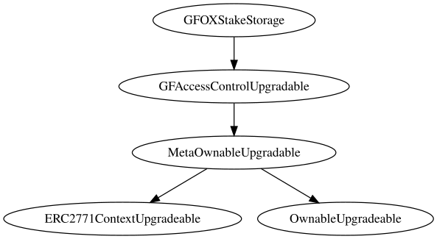

## Flow Graph

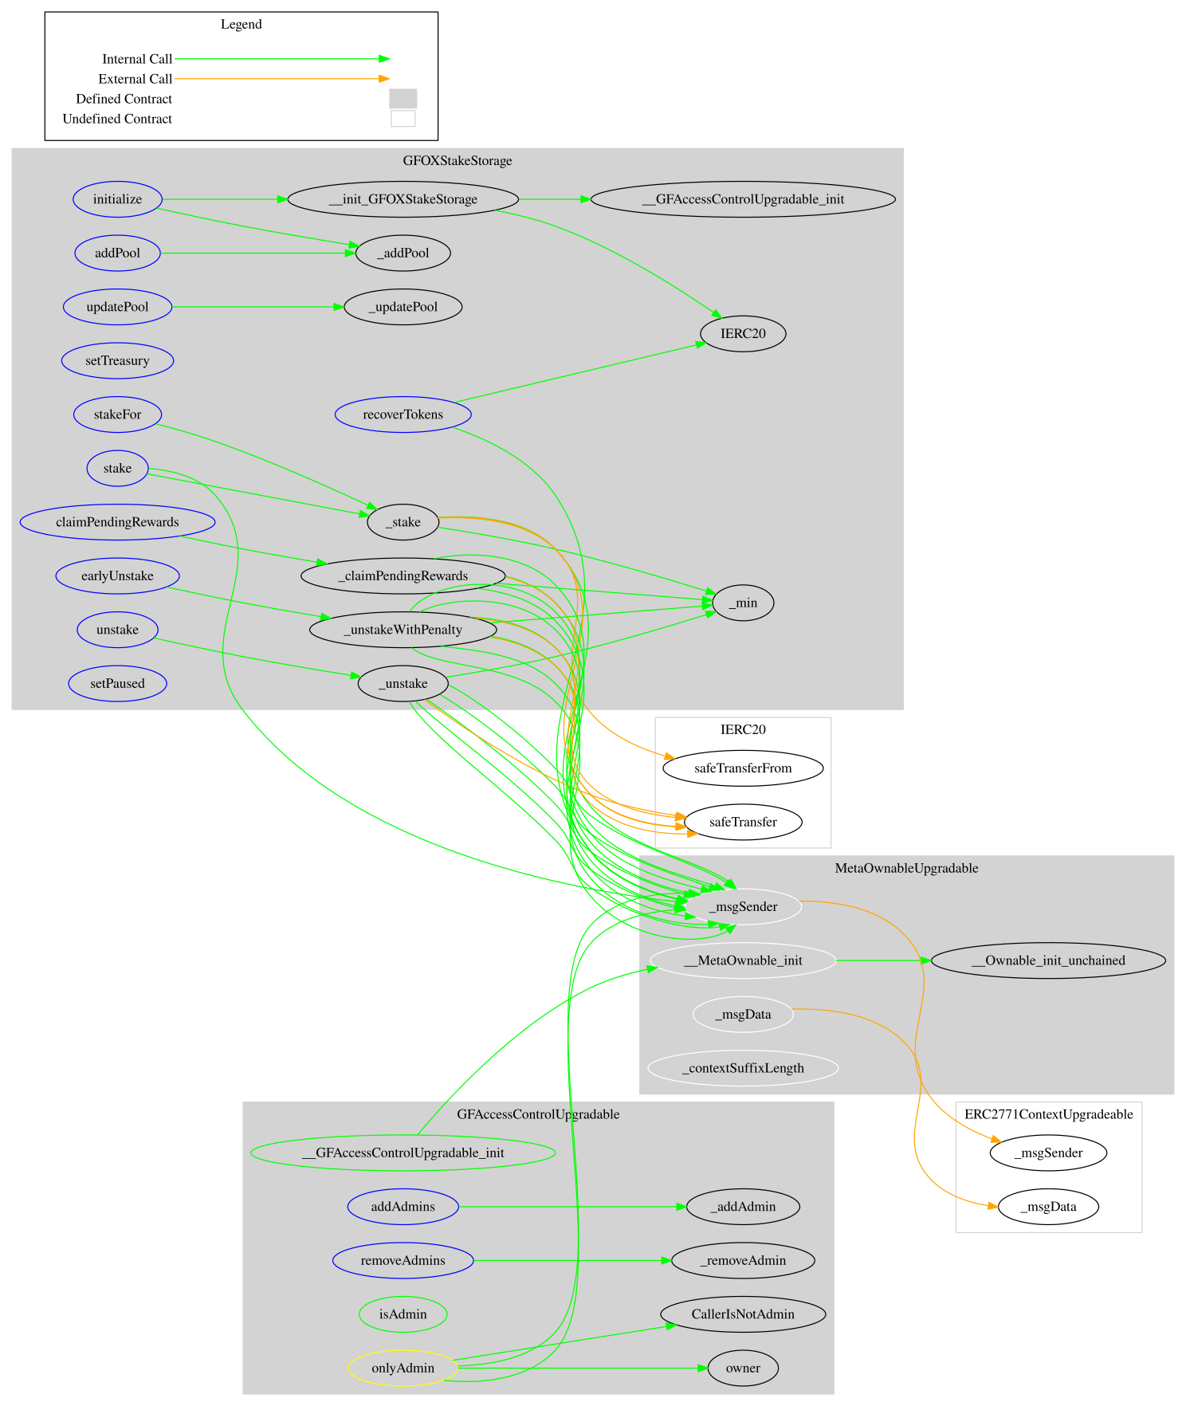

## Summary

The Galaxy Fox Stake contract implements a staking and rewards distribution mechanism designed to allow users to deposit tokens into designated pools, earn interest based on the time and amount staked, and manage their investments through functions like claiming rewards, unstaking, and unstaking with penalty. This audit investigates various aspects of the contract, including security vulnerabilities, business logic errors, and potential improvements to ensure that the contract operates efficiently and securely. Our review focuses on identifying issues that could affect the integrity of the staking process, the accuracy of reward calculations, and the overall user experience, aiming to enhance the contract’s robustness and reliability in a live environment. Overall, this audit investigates security issues, business logic concerns and potential improvements.

## Disclaimer

The information provided in this report does not constitute investment, financial or trading advice and you should not treat any of the document's content as such. This report may not be transmitted, disclosed, referred to or relied upon by any person for any purposes nor may copies be delivered to any other person other than the Company without Cyberscope’s prior written consent. This report is not nor should be considered an “endorsement” or “disapproval” of any particular project or team. This report is not nor should be regarded as an indication of the economics or value of any “product” or “asset” created by any team or project that contracts Cyberscope to perform a security assessment. This document does not provide any warranty or guarantee regarding the absolute bug-free nature of the technology analyzed, nor do they provide any indication of the technologies proprietors' business, business model or legal compliance. This report should not be used in any way to make decisions around investment or involvement with any particular project. This report represents an extensive assessment process intending to help our customers increase the quality of their code while reducing the high level of risk presented by cryptographic tokens and blockchain technology.

Blockchain technology and cryptographic assets present a high level of ongoing risk Cyberscope’s position is that each company and individual are responsible for their own due diligence and continuous security Cyberscope’s goal is to help reduce the attack vectors and the high level of variance associated with utilizing new and consistently changing technologies and in no way claims any guarantee of security or functionality of the technology we agree to analyze. The assessment services provided by Cyberscope are subject to dependencies and are under continuing development. You agree that your access and/or use including but not limited to any services reports and materials will be at your sole risk on an as-is where-is and as-available basis Cryptographic tokens are emergent technologies and carry with them high levels of technical risk and uncertainty. The assessment reports could include false positives false negatives and other unpredictable results. The services may access and depend upon multiple layers of third parties.

## About Cyberscope

Cyberscope is a blockchain cybersecurity company that was founded with the vision to make web3.0 a safer place for investors and developers. Since its launch, it has worked with thousands of projects and is estimated to have secured tens of millions of investors’ funds.

Cyberscope is one of the leading smart contract audit firms in the crypto space and has built a high-profile network of clients and partners.



**The Cyberscope team**

<https://www.cyberscope.io>