Submerged Vegetation Monitoring Project (SVMP)
ArcGIS Tools

Washington Department of Natural Resources
Division of Aquatic Resources

Version 2.0
Developed by Sound GIS
September 2010

Overview

The purpose of the SVMP ArcGIS tools is to automate the process of converting the SVMP’s annual underwater video ASCII data files to GIS format, to calculate individual transect and site statistics, and to generate soundwide Z. marina area and area change estimates with associated error estimates. The tools are written in Python (version 2.5.1) and provided as a custom toolbox for ArcGIS 9.3. This toolbox, SVMP Tools v.2.0, replaces the prior toolbox (SVMP Site Transect Analysis Tools) which is no longer maintained. The toolbox has two toolsets, one for data conversion tools, and one for tools to produce annual area estimates and year-to-year area change analysis.
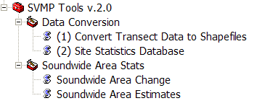

It is highly recommended to run the tools from ArcCatalog, rather than ArcMap. The tools are designed to overwrite existing datasets if they exist from previous runs. If any of the datasets, geodatabase, or shapefiles are open or being viewed, in any application (including ArcMap, ArcCatalog, MS Access, Excel), during processing, the tool will generate an error and abort.

The SVMP Site Transect Analysis Tools toolbox can be added to ArcToolbox in ArcCatalog by right-clicking Add Toolbox, and then navigating to the location of the file: SVMP Tools v.2.0.tbx. In the same directory as the .tbx file, there must be a directory named scripts, containing the following Python scripts: sitestatsdb.py, svmp_93.py, svmp_exceptions.py, svmp_spatial_93.py, svmpUtils.py, sw_area_change_93.py, sw_area_estimates_93.py, and trans2shp.py.

To visualize the processing steps, flow charts for each tool are provided as separate PowerPoint files included in the docs folder: svmpTool01_trans2shp_flowchart.ppt, svmpTool02_sitestatsdb_flowchart.ppt, svmpTool03_swarea_flowchart.ppt, svmpTool04_swareachg_flowchart.ppt, and svmpTool04a_montecarloCI_flowchart.ppt.
Tool 1: Convert Transect Data to Shapefiles

This tool batch converts the source ASCII files for a particular year’s survey to ArcGIS point shapefiles – one shapefile for each site. This tool can be run for all sites or a specific subset of the sites for that year. This tool runs the python script, trans2shp.py which accesses shared functions and variables from svmpUtils.py and svmp_exceptions.py.

Tool 1: Parameters

This tool has six input parameters. An example of the parameter input window is shown below:

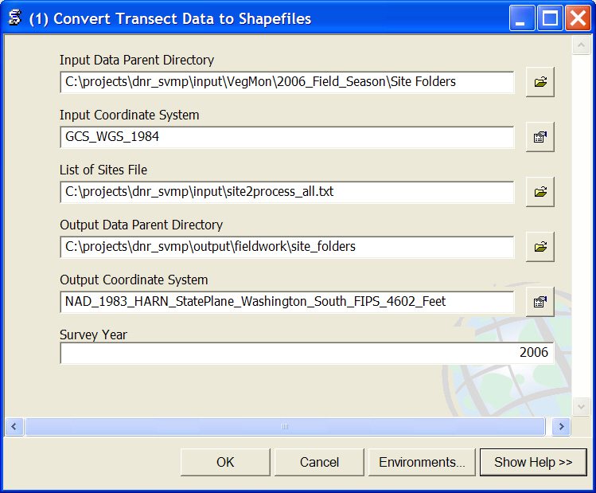

Input Data Parent Directory: Parent directory location of the input ASCII (.csv) files. This is the lowest level directory that is common to input data for all sites. Below this parent directory must be a subdirectory for each site to be processed for that year’s field data. The site subdirectory must contain the input .csv file. For example:
J:\AQR\DATA\NEARSHOR\VegMon\2006 Field Season\Site Folders\core002

Input Coordinate System: Coordinate system of the positions in the source .csv file. Because the data are provided as latitude/longitude coordinates, the default is Geographic Coordinate System, WGS-84 (GCS_WGS_84).

List of Sites File: An ASCII list of sites to be converted. One site listed per line.

Output Data Parent Directory: Parent directory location for the output shapefiles. This is the lowest level directory that is common to output data for all sites. Below this parent directory must be a single subdirectory for each site, containing further subdirectories, (sample_polygon and video_transect_data). For example:
\\Snarf\bss3\work\svmp\fieldwork\site_folders\core006\video_transect_data

Output Coordinate System: Coordinate system for output transect point shapefiles. DNR’s standard coordinate system is Washington State Plane South, NAD-83 HARN, survey feet. Therefore the default is NAD_1983_HARN_StatePlane_Washington_South_FIPS_4602_Feet

Survey Year: The year of survey data to be converted from ASCII to shapefile format.

Tool 1: Input Columns and Output Shapefile Fields

Input .csv column | Output Shapefile Field
trk | trk
date | date_samp
time | Time24hr
BSdepth | BSdepth
BSdepth_interp | BSdepIntrp
Zm | Zm
Zj | Zj
other | other
video | video
realtime | realtime
TrkType | TrkType
latitude | --
lon | --

Tool 1: Assumptions and Caveats

- This tool is highly dependent upon DNR’s existing directory structure which must be in place before running the tool.
- If a site is re-processed, (which may be necessary if an error is found in the source data), the tool will overwrite the existing output data.
- The source .csv files must be named with the site name, a suffix of ‘TD’, and the extension .csv. For example: core002TD.csv.
- The source .csv file must be comma delimited and contain standardized column names indicating the contents of each column. The number of columns may vary, but the columns required for the output shapefile must always be present in the source .csv file.
- The source .csv file coordinates must be provided as latitude/longitude in the format of the following example: “47d22.6455' N” and “122d38.6893' W”.
- Null values for depth are replaced with the value -9999
- Times are converted from 12 hour to 24 hour formats.
- The output shapefiles are named according to the following convention: <year>_<site>_transect_data.shp, for example: 2006_core002_transect_data.shp
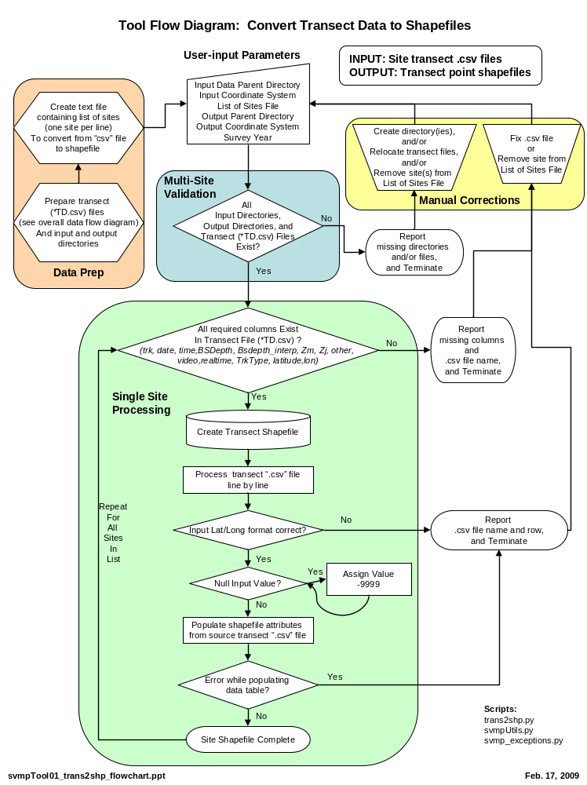
Tool 2: Site Statistics Database

This tool calculates transect and site statistics for one year of SVMP survey data and creates and populates two personal geodatabase tables (transects<year> and sites<year>) with these data. Other than for testing purposes, the tool is designed to be run once with an entire year of survey data. This tool runs the python script, sitestatsdb.py which accesses shared functions and variables from svmpUtils.py and svmp_exceptions.py.

Tool 2: Parameters

This tool has seven input parameters. An example of the parameter input window is shown below:

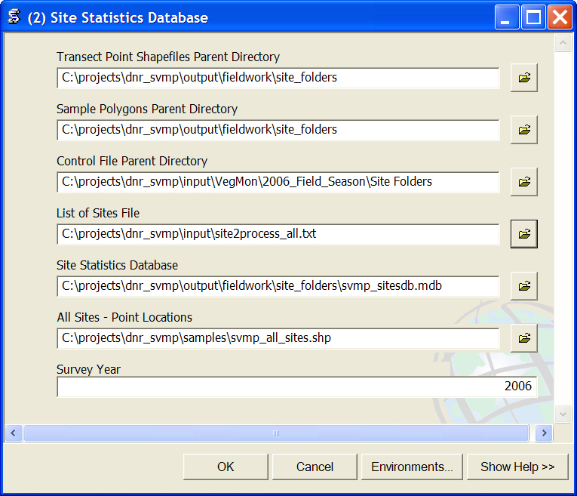

Transect Point Shapefiles Directory: Parent directory location of the input point transect shapefiles – these are the output from Tool 1, “Convert Transect Data to Shapefiles.” This is the lowest level directory that is common to input data for all sites. Below this parent directory must be a single subdirectory for each site with a subdirectory named video_transect_data containing the transect point shapefiles for that site. For example:
\\Snarf\bss3\work\svmp\fieldwork\site_folders\core002\video_transect_data

Sample Polygons Parent Directory: Parent directory location of the input sample polygon shapefiles. This is the lowest level directory that is common to input data for all sites. Below this parent directory must be a single subdirectory for each site with a subdirectory named sample_polygons containing the transect point shapefiles for that site. For example:
\\Snarf\bss3\work\svmp\fieldwork\site_folders\core002\sample_polygons

Control File Parent Directory: Parent directory location of the control files (<site>ctl.txt). This is the lowest level directory that is common to input data for all sites. Below this parent directory must be a subdirectory for each site to be processed for that year’s field data. For example:
J:\AQR\DATA\NEARSHOR\VegMon\2006 Field Season\Site Folders\core002

List of Sites File: An ASCII list of sites to processed. One site listed per line. For this tool, it should be the entire list of sites for the year.

Site Statistics Database: ArcGIS geodatabase containing template data tables, sites and transects.

All Sites – Point Locations: Shapefile containing approximate point locations for all SVMP sites surveyed.

Survey Year: The year of survey data to calculate transect and site statistics.

Tool 2: Process Description

For each site, the tool creates a temporary line shapefile from the input point data. Attributes are assigned from each point to the line segment “in front” of it, based on input order of the points. This line is then clipped with the sample polygon to get the portions of the transects used for statistical summaries. The site and transect statistics are calculated according to equations provided by Pete Dowty and described in Appendix L of Berry et. al. (2003).

The inclusion of data for a particular statistical summary is limited first by the geographic extent (delineated by the sample polygon), and further by various “flags” or criteria. These flags or attributes are either provided in the point transect shapefile or the control file.
- Only transects that run perpendicular to shore and are designated sample transects are included in any further transect statistics. (TrkType = ‘SLPR’)
- Sample length is the total length of the segments that have acceptable video quality (video = 1)
- Zostera marina length is the total length of segments that have acceptable video quality and Zostera marina presence (video = 1, Zm = 1)
- Inclusion of the transect in the maximum and minimum depth summaries is specified by flags in the site control file (MinDepth = Yes, MaxDepth = Yes)

For each transect within a site, the following information and statistics are stored in a data table named transects and the 4-digit year, (for example, transects2006).
Description | Field Name
Site identifier | site_code
Sampling start date for the site | date_samp_start
Sampling date for the transect | transect_date
Transect identifier | tran_num
Sample length (feet) | tran_len_ft
Zostera marina length (feet) | zm_len_m
Zostera marina fraction | tran_zm_frac
Maximum depth on the transect (ft) | tran_maxd_ft
Maximum depth of Zostera marina (ft) | tran_zm_maxd_ft
Minimum depth of Zostera marina (ft) | tran_zm_mind_ft
Minimum depth of the transect (ft) | tran_mind_ft
Maximum depth flag (indicates transect is used for site level Z. marina maximum depth) | tran_maxd_good
Minimum depth flag (indicates transect is used for site level Z. marina minimum depth) | tran_mind_good

For each site, the following information and statistics are stored in a data table named sites and the 4-digit survey year, (for example, sites2006).
Description | Field Name
Site identifier | site_code
Sampling start date | date_samp_start
Total number of transects at site | zm_area_n_tran
Estimated mean Zostera marina fraction | zm_frac
Estimated variance of Zostera marina fraction | zm_frac_var
Sample area (ft²) | samp_area_ft2
Estimated basal area coverage of Z. marina (ft²) | zm_area_ft2
Estimated variance of basal area coverage of Z. marina (ft⁴) | zm_area_var_ft4
Coefficient of variation of Z. marina basal area coverage | zm_area_cv
Standard error of Z. marina basal area coverage (ft²) | zm_area_se_ft2
95% confidence interval for Z. marina basal area coverage (ft) | zm_area_95_ci_ft
Number of transects used for Z. marina minimum depth | zm_mind_n_tran
Mean of Z. marina minimum depth (ft) | zm_mind_mean_ft
Site deepest value for Z. marina minimum depth (ft) | zm_mind_deepest_ft
Site shallowest value for Z. marina minimum depth (ft) | zm_mind_shallowest_ft
Standard deviation of Z. marina minimum depth | zm_mind_std
Variance of Z. marina minimum depth (ft²) | zm_mind_var_ft2
Standard error of Z. marina minimum depth | zm_mind_se_ft
95% confidence interval for Z. marina minimum depth | zm_mind_95_ci_ft
Number of transects used for Z. marina maximum depth | zm_maxd_n_tran
Mean of Z. marina maximum depth (ft) | zm_maxd_mean_ft
Site deepest value for Z. marina maximum depth (ft) | zm_maxd_deepest_ft
Site shallowest value for Z. marina maximum depth (ft) | zm_maxd_shallowest_ft
Standard deviation of Z. marina maximum depth | zm_maxd_std
Variance of Z. marina maximum depth (ft²) | zm_maxd_var_ft2
Standard error of Z. marina maximum depth (ft) | zm_maxd_se_ft
95% confidence interval for Z. marina maximum depth (ft) | zm_maxd_95_ci_ft
Approximate latitude of the site | approx_lat
Approximate longitude of the site | approx_lon

Tool 2: Assumptions and Caveats

- This tool is highly dependent upon DNR’s existing directory structure which must be in place before running the tool.
- The source point shapefiles must already exist and been created using the previous tool, “Convert Transect Data to Shapefiles”
- Sample polygon shapefiles are expected to have the following naming convention: <site>_<year>_sample_poly.shp
- The template tables, sites and transects, must already exist within an ArcGIS geodatabase, and have the specified field names in the order listed. Any changes in these tables will require modifications to the associated Python scripts.
- This tool creates annual tables for site and transect statistics for a full year of SVMP site surveys. If the tool is re-run for a particular year, the existing annual tables are overwritten with a completely updated set of data.
- The annual sites and transects tables can be joined by the site identifier (site_code) and sampling start date (date_samp_start).
- The annual tables allow an intermediate location for data staging, review, and quality control prior to uploading these data to DNR SVMP’s master, multi-year database.
- The tool can handle sites with multiple sample polygons. However, it performs all calculations as if it is a single entity. (For example, sample area is reported as total area of all sample polygons).

Tool 2: References

Berry, H.D., A.T. Sewell, S. Wyllie-Echeverria, B.R. Reeves, T.F. Mumford Jr., J.R. Skalski, R.C. Zimmerman, and J. Archer. 2003. Puget Sound Submerged Vegetation Monitoring Project: 2000-2002 Monitoring Report. Nearshore Habitat Program, Washington State Department of Natural Resources. Olympia, WA. 60 pp. plus appendices.

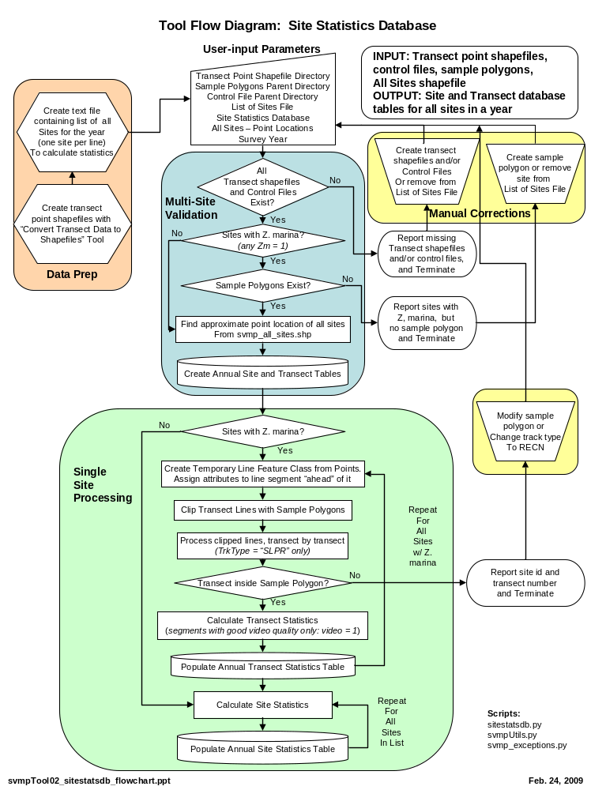
Tool 3: Soundwide Area

This tool creates two comma-delimited text files with annual soundwide Z. marina area estimates and associated input values and error estimates. One output file contains the results for sites grouped by stratum: core, persistent flats, rotational flats, fringe, and wide fringe sites. The other output file contains the results for all strata combined. Other than for testing purposes, this tool is designed to be run once, after the annual database tables (transects<year> and sites<year>) have been populated using the tool, “Site Statistics Database,” these data have been QCed, trace and obstructed sites have been add, and all data have been merged into DNR’s master multi-year data table. This tool runs the python script, sw_area_estimates_93.py which accesses shared functions and variables from svmp_exceptions.py, svmp_93.py, svmp_spatial_93.py, and svmpUtils.py.

Tool 3: Parameters

This tool has six input parameters and two output parameters. An example of the parameter input window is shown below:

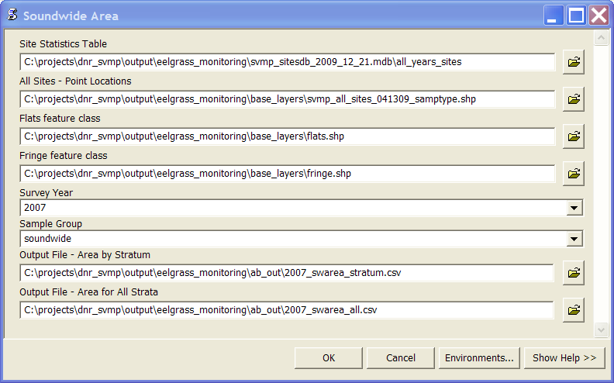

Site Statistics Table: The table containing the site statistics for that year. (This table is created when running the previous tool, “Site Statistics Database”). Provides Z. marina area and variance for each site.

All Sites – Point Locations: Shapefile containing approximate point locations for all SVMP sites surveyed. Provides master list of all sites, strata information, and year(s) surveyed.

Flats feature class: Master polygon shapefile depicting all flats sites in Puget Sound. Used for determining total sites in stratum (N_{i}), total stratum area (A₂), and total area sampled (A_{ij}).

Fringe feature class: Master polygon shapefile depicting all fringe sites in Puget Sound. Used for determining total sites in stratum (N_{i}), total stratum length (LT), and total length sampled (LN).

Survey Year: The year of survey data to calculate annual area estimates.

Sample Group: A placeholder for potential future modifications of the tool to perform calculations for other site groupings, such as focus sites or special projects. Currently, the only implemented option is “soundwide.”

Output File – Area by Stratum: Output comma-delimited text file containing Z. marina area estimates, input values, and error estimates for one year’s surveyed sites by stratum.

Output File – Area for All Strata: Output comma-delimited text file containing Z. marina area estimates, input values, and error estimates for one year’s surveyed sites for all strata combined.

Tool 3: Assumptions and Caveats

- This tool assumes that site data are in the units of DNR’s standard coordinate system (survey feet). The tool converts these values to metric units using the following conversion factor:
1 meter = 0.304800609601219 survey feet
- This tool is highly dependent upon existing table and feature class structure and columns for various queries. If the source dataset structure is changed, the scripts may need to be modified.
- The following columns from All Sites – Point Locations feature class are used: NAME, y<YEAR>, STRATA_GEO, and STRATUM.
- The following columns from the Flats feature class are used: NAME and focus_stra
- The following columns from the Fringe feature class are used: 2002TYPE and REGION
- All equations for calculations provided by DNR via spreadsheets and Skalski (2003).

Tool 3: References

Berry, H.D., A.T. Sewell, S. Wyllie-Echeverria, B.R. Reeves, T.F. Mumford Jr., J.R. Skalski, R.C. Zimmerman, and J. Archer. 2003. Puget Sound Submerged Vegetation Monitoring Project: 2000-2002 Monitoring Report. Nearshore Habitat Program, Washington State Department of Natural Resources. Olympia, WA. 60 pp. plus appendices.

Skalski, J.R. 2003. Statistical Framework for Monitoring Zostera marina (Eelgrass) Area in Puget Sound. Appendix L in Berry et. al. (2003).
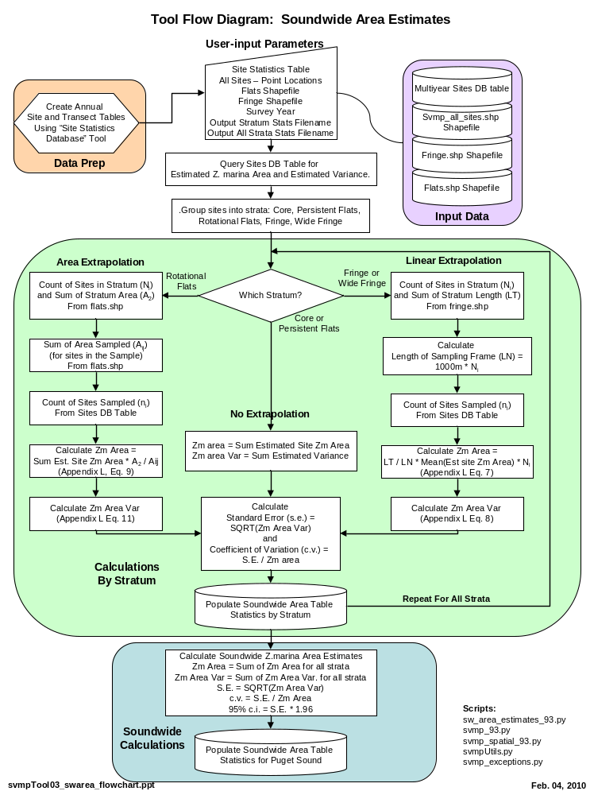
Tool 4: Soundwide Area Change

This tool creates two comma-delimited text files with year-to-year, soundwide Z. marina area change estimates and associated input values and error estimates. One output file contains the results for sites grouped by stratum: core, persistent flats, rotational flats, fringe, and wide fringe sites. The other output file contains the results for all strata combined. This tool also calculates Monte Carlo confidence interval estimates for all strata by simulating sampling and measurement error (Dowty, 2005) for a large number (20,000) of iterations.

Other than for testing purposes, this tool is designed to be run once, after the annual database tables have been populated using the tool, “Site Statistics Database.” and all data have been merged into DNR’s master multi-year data table (including trace and obstructed sites. This tool runs the python script, sw_area_change_93.py which accesses shared functions and variables from svmp_exceptions.py, svmp_93.py, svmp_spatial_93.py, and svmpUtils.py.

Tool 4: Parameters

This tool has seven input parameters and two output parameters. An example of the parameter input window is shown below:

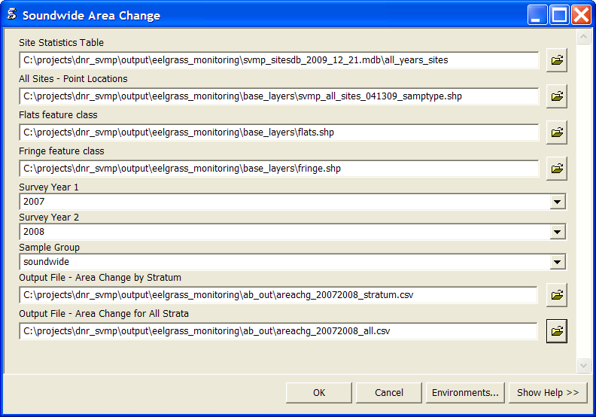

Site Statistics Table: The table containing the site statistics for that year. (This table is created when running the previous tool, “Site Statistics Database”). Provides Z. marina area and variance for each site.

All Sites – Point Locations: Shapefile containing approximate point locations for all SVMP sites surveyed. Provides master list of all sites, strata information, and year(s) surveyed.

Flats feature class: Master polygon shapefile depicting all flats sites in Puget Sound. Used for determining total sites in stratum (N_{i}), total stratum area (A₂), and total area sampled (A_{ij}).

Fringe feature class: Master polygon shapefile depicting all fringe sites in Puget Sound. Used for determining total sites in stratum (N_{i}), total stratum length (LT), and total length sampled (LN).

Survey Year 1: The base year for the change analysis calculations.

Survey Year 2: The year that is being compared to Year 1 for change analysis

Sample Group: A placeholder for potential future modifications of the tool to perform calculations for other site groupings, such as focus sites or special projects. Currently, the only implemented option is “soundwide.”

Output File – Area by Stratum: Output comma-delimited text file containing Z. marina area change estimates, proportion change, input values, and error estimates for the year-to-year change analysis by stratum.

Output File – Area for All Strata: Output comma-delimited text file containing Z. marina area change estimates, proportion change, input values, and error estimates for the year-to-year change analysis for all strata combined.

Tool 4: Assumptions and Caveats

- This tool assumes that site data are in the units of DNR’s standard coordinate system (survey feet). The tool converts these values to metric units using the following conversion factor:
1 meter = 0.304800609601219 survey feet
- This tool is dependent upon the calculations used for Soundwide Area Analysis, and therefore the caveats about presence of certain input data columns applies to this tool
- All equations for calculations provided by DNR via spreadsheets, personal communications (Pete Dowty and Jeff Gaeckle), and Skalski (2003). For general description of the Monte Carlo approach, see Dowty (2005).

Tool 4: References

Berry, H.D., A.T. Sewell, S. Wyllie-Echeverria, B.R. Reeves, T.F. Mumford Jr., J.R. Skalski, R.C. Zimmerman, and J. Archer. 2003. Puget Sound Submerged Vegetation Monitoring Project: 2000-2002 Monitoring Report. Nearshore Habitat Program, Washington State Department of Natural Resources. Olympia, WA. 60 pp. plus appendices.

Dowty, P. 2005. Assessment of Sound-Wide Change Estimates from Paired-Site Analysis. unpublished white paper. Washington Department of Natural Resources, Olympia, WA.

Skalski, J.R. 2003. Statistical Framework for Monitoring Zostera marine (Eelgrass) Area in Puget Sound. Appendix L in Berry et. al. (2003).

