Submerged Vegetation Monitoring Project (SVMP)
ArcGIS Tools

Washington Department of Natural Resources
Division of Aquatic Resources

Version 3.0
Developed by Sound GIS
August 2013

Overview

The purpose of the SVMP ArcGIS tools is to automate the process of converting the SVMP’s annual underwater video ASCII data files to GIS format and to calculate individual transect and site statistics. The tools are written in Python (version 2.6) and provided as a custom toolbox for ArcGIS 10.0. This toolbox, SVMP Tools v.3.0, replaces the prior toolbox (SVMP Tools v.2.0) which is no longer maintained. The toolbox has one toolset containing the data conversion tools.
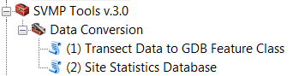

It is highly recommended to run the tools from ArcCatalog, rather than ArcMap. The tools are designed to overwrite existing datasets if they exist from previous runs. If any of the datasets, geodatabase, or shapefiles are open or being viewed, in any application (including ArcMap, ArcCatalog, MS Access, Excel), during processing, the tool may generate an error and abort.

The SVMP Tools v.3.0 toolbox can be added to ArcToolbox in ArcCatalog by right-clicking Add Toolbox, and then navigating to the location of the file: SVMP Tools v.3.0.tbx. In the same directory as the .tbx file, there must be a directory named scripts, containing the following Python scripts: sitestatsdb.py, svmp_exceptions.py, svmpUtils.py, trans2shp.py, transect_csv.py, and transect_datasource.py.

To visualize the processing steps, flow charts for each tool are provided in this document as well as separate PowerPoint files included in the docs folder: svmpTool01_trans2shp_flowchart_v3.0.ppt, svmpTool02_sitestatsdb_flowchart_v3.0.ppt.

Detailed description of modifications to the tool from version 2.0 to version 3.0 are provided at the end of this document.
Tool 1: Transect Data to GDB Feature Class

This tool batch converts the source ASCII files for a particular sampling occasion’s survey to ArcGIS geodatabase feature classes – one feature class for each site. This tool can be run for all sites or a specific subset of the sites for that sampling occasion. This tool runs the python script, trans2shp.py which accesses shared functions and variables from svmpUtils.py, transect_csv.py, transect_datasource.py and svmp_exceptions.py.

Tool 1: Parameters

This tool has eight input parameters. An example of the parameter input window is shown below:

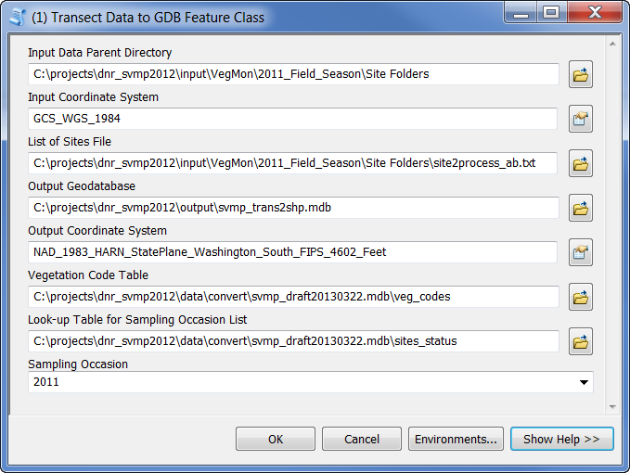

Input Data Parent Directory: Parent directory location of the input ASCII (.csv) files. This is the lowest level directory that is common to input data for all sites. Below this parent directory must be a subdirectory for each site to be processed for that sampling occasion’s field data. The site subdirectory must contain the input .csv file. For example:
J:\AQR\DATA\NEARSHOR\VegMon\2006_Field_Season\site_folders\core002

Input Coordinate System: Coordinate system of the positions in the source .csv file. Because the data are provided as latitude/longitude coordinates, the default is Geographic Coordinate System, WGS-84 (GCS_WGS_84).

List of Sites File: An ASCII list of sites to be converted. One site listed per line.

Output Geodatabase: Geodatabase location for output transect point feature classes.

Output Coordinate System: Coordinate system for output transect point feature classes. DNR’s standard coordinate system is Washington State Plane South, NAD-83 HARN, survey feet. Therefore the default is NAD_1983_HARN_StatePlane_Washington_South_FIPS_4602_Feet

Vegetation Code Table: A table that contains the column, veg_code. The veg_code column must contain codes/column names for all of the vegetation types that were recorded in the transect .csv files.

Look-up Table for Sampling Occasion List: A table that contains the column, samp_occasion. Used to populate the pull-down list for Sampling Occasion parameter.

Sampling Occasion: The sampling occasion of survey data to be converted from ASCII to geodatabase feature class.

Tool 1: Input Columns and Output Feature Class Fields

Input .csv column | Output Feature Class Field
-- | site_code
trk | tran_num
date | date_samp
time | Time24hr
BSdepth | depth_obs
BSdepth_interp | depth_interp
Zm * | Zm *
Zj * | Zj *
Phyllo * | Phyllo *
Native_SG * | Native_SG *
undiff * | undiff *
video | video
TrkType | TrkType
latitude | --
lon | --

* Note: Vegetation columns in the csv file (shown in italics above) may vary. In order to be included in the output feature class, the column name in the input csv file must match an entry in the veg_code column of the Vegetation Code Table.

Tool 1: Assumptions and Caveats

- This tool is dependent upon DNR’s existing source data directory structure which must be in place before running the tool.
- If a site is re-processed, (which may be necessary if an error is found in the source data), the tool will overwrite the existing output data.
- The source .csv files must be named with the site name, a suffix of ‘TD’, and the extension .csv. For example: core002TD.csv.
- The source .csv file must be comma delimited and contain standardized column names indicating the contents of each column. The number of columns may vary, but the columns required for the output shapefile must always be present in the source .csv file.
- Vegetation column names in the .csv file must match the vegetation codes in the master SVMP geodatabase (veg_code column in the veg_codes table). Not all vegetation columns must be present, (only those that were surveyed), however, if the column does not have a corresponding entry in the vegetation code table, it will not appear in the output feature class.
- The source .csv file coordinates must be provided as latitude/longitude in the format of the following example: “47d22.6455' N” and “122d38.6893' W”.
- Null values for depth are replaced with the value -9999
- Times are converted from 12 hour (hh:mm:ss AM/PM) to 24 hour format.
- The output feature classes are named according to the following convention: <site>_<samp_occasion>_transect_pt, for example: core002_2006_transect_pt
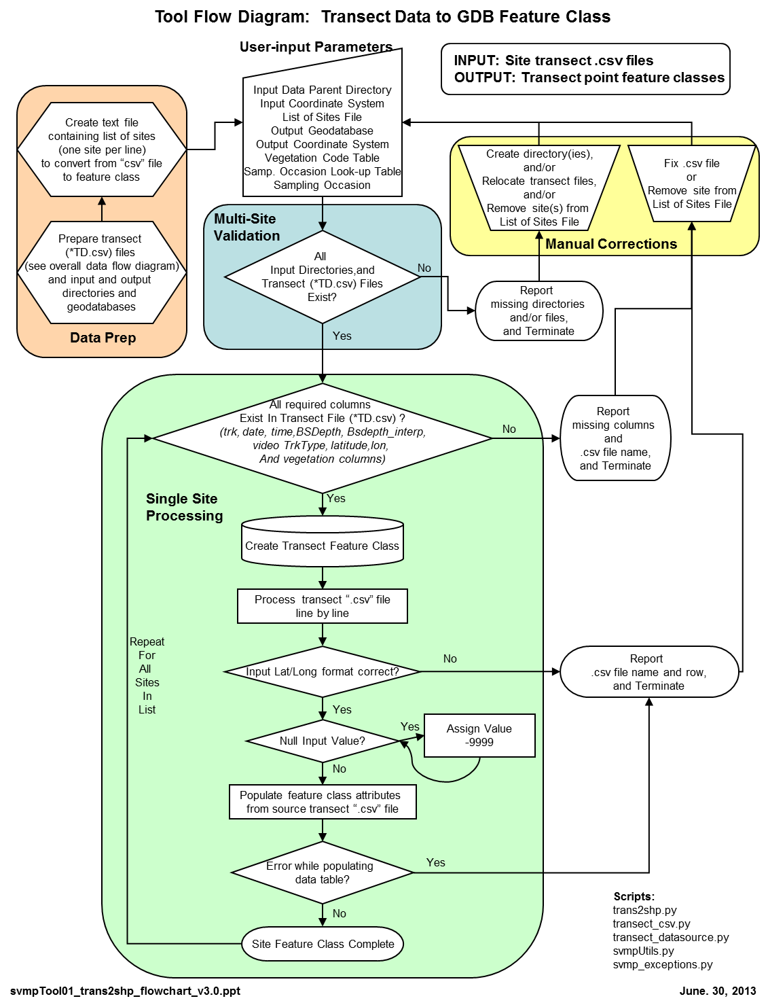
Tool 2: Site Statistics Database

This tool calculates transect and site statistics for an SVMP sampling occasion and selected vegetation type. It creates and populates two personal geodatabase tables (transects<samp_occasion>_<veg_code> and sites<samp_occasion>_<veg_code>) with these data. Other than for testing purposes, the tool is designed to be run once with an entire sampling occasion of survey data. This tool runs the python script, sitestatsdb.py which accesses shared functions and variables from svmpUtils.py and svmp_exceptions.py.

Tool 2: Parameters

This tool has nine input parameters. An example of the parameter input window is shown below:

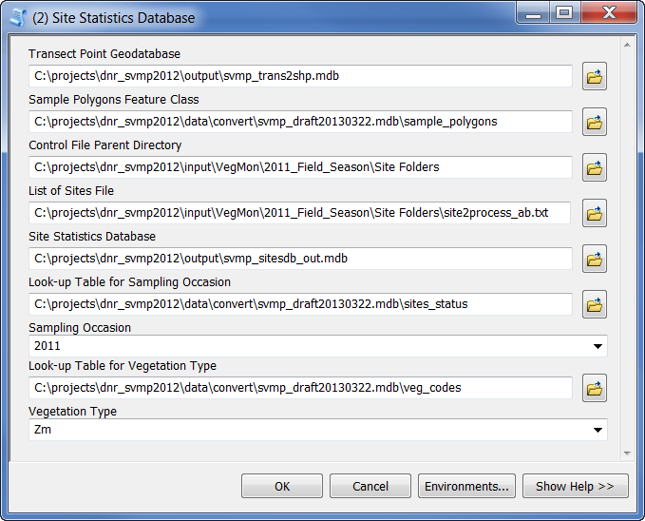

Transect Point Geodatabase: Geodatabase containing the input point transect feature classes – these are the output from Tool 1, “Transect Data to GDB Feature Class.”

Sample Polygons Feature Class: Geodatabase feature class with input sample polygons.

Control File Parent Directory: Parent directory location of the control files (<site>ctl.txt). This is the lowest level directory that is common to input data for all sites. Below this parent directory must be a subdirectory for each site to be processed for that sampling occasion’s field data. For example:
J:\AQR\DATA\NEARSHOR\VegMon\2006_Field_Season\site_folders\core002

List of Sites File: An ASCII list of sites to processed. One site listed per line. For this tool, it should be the entire list of sites for the sampling occasion.

Site Statistics Database: ArcGIS geodatabase containing template data tables, sites and transects. Output tables labelled with the sampling occasion will be created in this geodatabase.

Look-up Table for Sampling Occasion: A table that contains the column, samp_occasion. Used to populate the pull-down list for Sampling Occasion parameter.

Sampling Occasion: The sampling occasion of survey data to calculate transect and site statistics.

Look-up Table for Vegetation Type: A table that contains the column, veg_code. Used to populate the pull-down list for Vegetation Type parameter

Vegetation Type: The vegetation type to calculate transect and site statistics

Tool 2: Process Description

For each site, the tool creates a temporary line feature class from the input point data. Attributes are assigned from each point to the line segment “in front” of it, based on input order of the points. This line is then clipped with the sample polygon to get the portions of the transects used for statistical summaries. The site and transect statistics are calculated according to equations provided by Pete Dowty and described in Appendix L of Berry et. al. (2003).

The inclusion of data for a particular statistical summary is limited first by the geographic extent (delineated by the sample polygon), and further by various “flags” or criteria. These flags or attributes are either provided in the point transect feature class or the control file.
- Only transects that run perpendicular to shore and are designated sample transects are included in any further transect statistics. (TrkType = ‘SLPR’ from the site control file).
- Sample length is the total length of the segments that have acceptable video quality (video = 1)
- Vegetation length is the total length of segments that have acceptable video quality (video = 1) and presence of selected vegetation type (for example, Zm = 1 or Zj = 1)
- Inclusion of the transect in the maximum and minimum depth summaries is specified by flags in the site control file (MinDepth = Yes, MaxDepth = Yes)

For each transect within a site, the following information and statistics are stored in a data table named transects with the sampling occasion and vegetation type suffix, (for example, transects2006_Zm).
Description | Field Name
Unique transect results identifier | tran_results_id
Site identifier | site_code
Sampling start date for the site | date_samp_start
Sampling date for the transect | transect_date
Vegetation type assessed | veg_code
Transect identifier | tran_num
Sample length (feet) | tran_len_ft
Vegetation length (feet) | veg_len_ft
Vegetation fraction | tran_veg_frac
Maximum depth on the transect (ft) | tran_maxd_ft
Maximum depth of vegetation (ft) | tran_veg_maxd_ft
Minimum depth of vegetation (ft) | tran_veg_mind_ft
Minimum depth of the transect (ft) | tran_mind_ft
Maximum depth flag (indicates transect is used for site level Z. marina maximum depth) | tran_maxd_qual
Minimum depth flag (indicates transect is used for site level Z. marina minimum depth) | tran_mind_qual
Foreign key to sites table | site_results_id

For each site, the following information and statistics are stored in a data table named sites with the sampling occasion and vegetation type suffix, (for example, sites2006_Zm).
Description | Field Name
Unique site results identifier | site_results_id
Site identifier | site_code
Sampling start date | date_samp_start
Vegetation type assessed | veg_code
Total number of transects used in area calculations | veg_area_n_tran
Estimated mean vegetation fraction | veg _frac
Sample area (ft²) | samp_area_ft2
Estimated basal area coverage of vegetation (ft²) | veg _area_ft2
Standard error of vegetation basal area coverage (ft²) | veg _area_se_ft2
Number of transects used for vegetation minimum depth | veg _mind_n_tran
Mean of vegetation minimum depth (ft) | veg _mind_mean_ft
Site deepest value for vegetation minimum depth (ft) | veg _mind_deepest_ft
Site shallowest value for vegetation minimum depth (ft) | veg _mind_shallowest_ft
Standard error of vegetation minimum depth | veg _mind_se_ft
Number of transects used for vegetation maximum depth | veg _maxd_n_tran
Mean of vegetation maximum depth (ft) | veg _maxd_mean_ft
Site deepest value for vegetation maximum depth (ft) | veg _maxd_deepest_ft
Site shallowest value for vegetation maximum depth (ft) | veg _maxd_shallowest_ft
Standard error of vegetation maximum depth (ft) | veg _maxd_se_ft
Foreign key to sites_status table | sitestat_id

Tool 2: Assumptions and Caveats

- This tool is dependent upon DNR’s existing directory structure (for control file locations) which must be in place before running the tool.
- The source point feature classes must already exist and been created using the previous tool, “Transect Data to GDB Feature Class.”
- The sample polygon feature class must have a column named sitestat_id, which is a unique identifier for each site/sampling occasion combination.
- This tool is dependent upon DNR’s existing source data directory structure, specifically for control file locations, which must be in place before running the tool.
- The template tables, sites and transects, must already exist within an ArcGIS geodatabase, and have the specified field names in the order listed. Any changes in these tables will require modifications to the associated Python scripts.
- This tool creates tables for site and transect statistics for a full sampling occasion of SVMP site surveys and a single vegetation type. If the tool is re-run for a particular sampling occasion/vegetation combination, the existing tables are overwritten with a completely updated set of data.
- The sites and transects tables allow an intermediate location for data staging, review, and quality control prior to uploading these data to DNR SVMP’s master, multi-year database.
- The tool can handle sites with multiple sample polygons. However, it performs all calculations as if it is a single entity. (For example, sample area is reported as total area of all sample polygons).

Tool 2: References

Berry, H.D., A.T. Sewell, S. Wyllie-Echeverria, B.R. Reeves, T.F. Mumford Jr., J.R. Skalski, R.C. Zimmerman, and J. Archer. 2003. Puget Sound Submerged Vegetation Monitoring Project: 2000-2002 Monitoring Report. Nearshore Habitat Program, Washington State Department of Natural Resources. Olympia, WA. 60 pp. plus appendices.

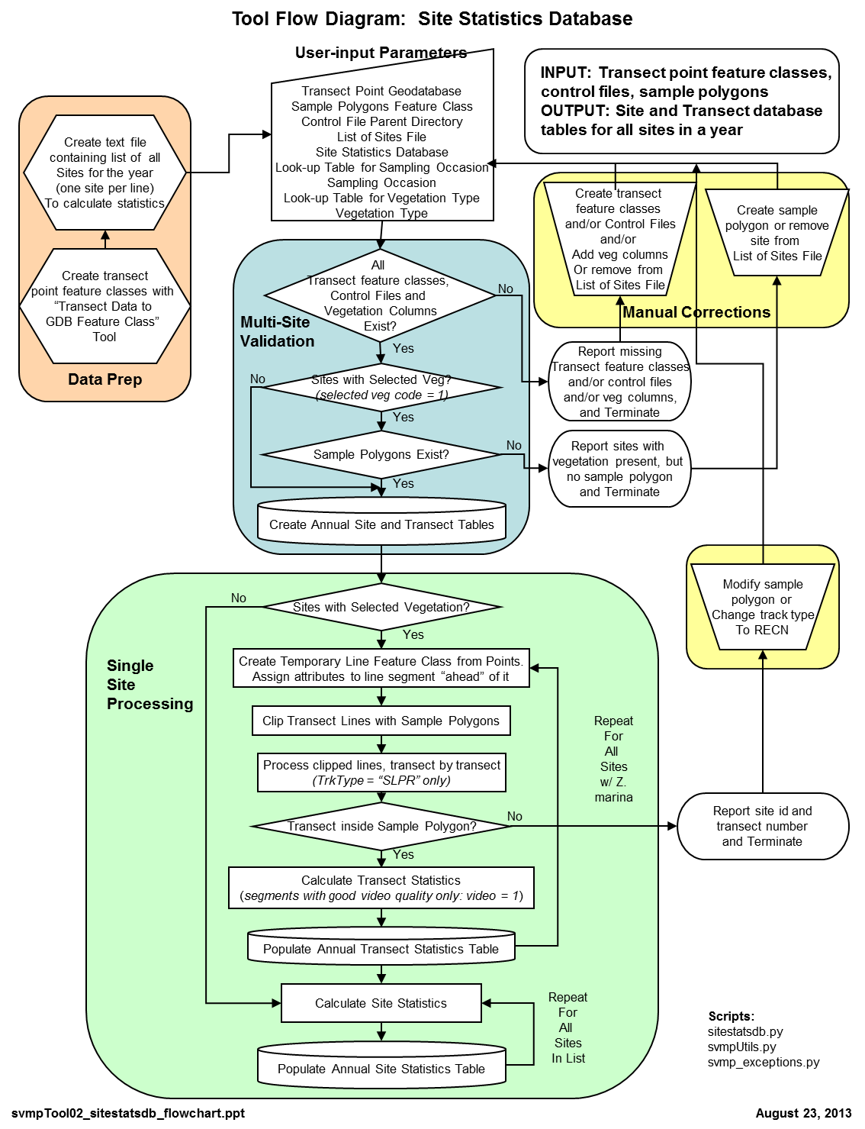
Changes from Version 2.0 Tools to Version 3.0 Tools

Transect Data to GDB Feature Class tool

- Updated all Python scripts to use ArcGIS version 10.0 syntax, including replacing the arcgisscripting module with ArcPy Python site package
- Convert each csv file to a geodatabase feature class, instead of a shapefile
- Transect feature classes are now named according to the following convention: <site>_<samp_occasion>_transect_pt, for example: core002_2011_transect_pt
- Created two new helper modules, transect_csv.py and transect_datasource.py. These include custom error handling
- Changed input/output Coordinate System parameter data types to Spatial Reference data types
- Output column changes:
  - Added “site_code” column
  - Changed “Bsdepth” column to “depth_obs”
  - Changed “BsdepIntrp” to “depth_interp”
  - Removed columns: “other” and “realtime”
  - Determine vegetation columns interactively during import, by comparing csv column names to vegetation codes in the Vegetation Code table. Vegetation Code Table is a new required tool parameter
- Tool parameter changes
  - Added Vegetation Code Table parameter. Used to look up input csv column names for vegetation-specific columns. This table must have a field named veg_code
  - Added Look-up Table for Sampling Occasion List parameter. Populates the drop-down list for Sampling Occasion parameter. This table must have a field named samp_occasion
  - Added Sampling Occasion parameter as a pull-down menu. Populates list with unique values from the associated Look-up Table parameter
- Additional validation:
  - Return an error when there are no vegetation codes in the csv file
  - Report vegetation columns that are found in the csv file
  - Warn user if the sampling occasion value does not match the input parent directory

Site Statistics Database Tool

- Updated all Python scripts to use ArcGIS version 10.0 syntax, including replacing the arcgisscripting module with ArcPy Python site package
- Update code to match new geodatabase design
  - Input transect points pulled from geodatabase feature classes instead of shapefiles. (Output from Transect Data to GDB Feature Class tool)
  - Sample polygons pulled from master geodatabase feature classes instead of shapefiles.
  - Populate new primary keys and foreign keys for site_results and transect_results tables
- Allow user to select vegetation type to calculate statistics, rather than assuming the vegetation type is “Zm”. Uses veg_code column from veg_codes table.
- Output sites and transects tables named with sampling occasion and selected vegetation code suffix.
- Show a count of sites for processing, with/without selected vegetation, and for missing feature classes (transect points, sample polygons) or control files.
- Populate site statistics for trace sites that have selected vegetation in RECN transects and a sample polygon, but no vegetation present in SLPR transects.
- Modify template database fields and field names to match new site_results and transect_results tables:
  - sites template table modifications:
    - Added primary key and foreign key: “site_results_id, “sitestat_id”
    - Add “veg_code” column
    - Renamed all fields starting with, “zm” to start with “veg”
    - Retained standard error fields (se), but removed all other uncertainty value fields, including variance (var), coefficient of variation (cv), and 95% confidence intervals (95_ci)
    - Removed “approx_lat” and “approx_lon” fields
  - transects template table modifications
    - Added primary key and foreign key: “tran_results_id, “site_results_id”
    - Add “veg_code” column
    - Renamed all fields starting with or containing, “zm” to use “veg”
- Tool parameter changes
  - Transect Point Shapefiles Parent Directory changed to a geodatabase parameter, Transect Point Geodatabase
  - Sample Polygons Parent Directory changed to a feature class parameter, Sample Polygons Feature Class.
  - All Sites - Point Locations parameter removed.
  - Added Look-up Table for Sampling Occasion List parameter. Populates the drop-down list for Sampling Occasion parameter. This table must have a field named samp_occasion
  - Added Sampling Occasion parameter as a pull-down menu. Populates list with unique values from the associated Look-up Table parameter
  - Added Vegetation Code Table parameter. Populates the drop-down list for Vegetation Type parameter. This table must have a field named veg_code
  - Added Vegetation Code paramter. Populates list with unique values from the associated Vegetation Code Table parameter
- Additional validation:
  - Warn user if the sampling occasion value does not match the input control file directory
  - Validate existence of the selected vegetation code column in input transect point feature classes. List sites that do not have that column and terminate processing

