**Watch and Warning (WWA) ArcGIS Toolbox**

**version 1.0**

Developed for Dr. Lisa Pfeiffer, NOAA, NMFS, NWFSC

by Allison Bailey, Sound GIS

September 2018

**Overview**

An ArcGIS Python Toolbox was developed to support Dr. Lisa Pfeiffer’s research into commercial fishing behavior as related to hazardous weather. The toolbox is focused on processing historic National Weather Service Watches and Warnings spatial data along with coastal port locations. Currently, the toolbox has a single tool, Associate Watches/Warning with Ports, but additional tools may be added based on future needs. The tool was developed in ArcGIS 10.5.1 and was written in Python (v.2.7).

Macintosh HD:Users:allison:Desktop:Screen Shot 2018-08-27 at 10.45.43 AM.png

The WWA Tools v.1.0 toolbox can be downloaded from Github, <https://github.com/cybersea/wwa_tools>. Users without Git (version control software) can download a ZIP file of the folder containing the toolbox, tool, and associated scripts and xml files. The WWA Tools v.1.0 toolbox can be added to ArcToolbox in ArcCatalog by right-clicking Add Toolbox, and then navigating to the location of the file: WWA Tools v.1.0.pyt. In the same directory as the .pyt file, there must be the following additional files: port_wwa_join.py, WWA Tools v.1.0.pyt.xml, and WWA Tools v.1.0.WwaToPorts.pyt.xml.

**Tool: Associate Watches/Warnings with Ports**

This tool associates National Weather Service (NWS) historic weather Watch and Warning (wwa) polygons with selected port locations given a user-specified maximum distance from the ports. The output of the tool is a comma-delmited text file (.csv) of the port locations associated with all of the historic watch/warning events that occurred within the specified distance from the port.

The ports and watch/warning polygons are associated using ArcMap’s Spatial Join tool. Specifically, the WWA tool uses a one-to-many join (JOIN_ONE_TO_MANY), outputs only ports that have associated watch/warning polygons (KEEP_COMMON), and uses a straight-line distance to match ports and watch/warning polygons (WITHIN_A_DISTANCE). See ESRI’s documentation for further detail on the Spatial Join tool: <http://desktop.arcgis.com/en/arcmap/10.5/tools/analysis-toolbox/spatial-join.htm>. All columns from the input port and watch/warning data are retained in the output csv file.

Tool Parameters

This tool has four parameters. An example of the parameter input window is shown below:

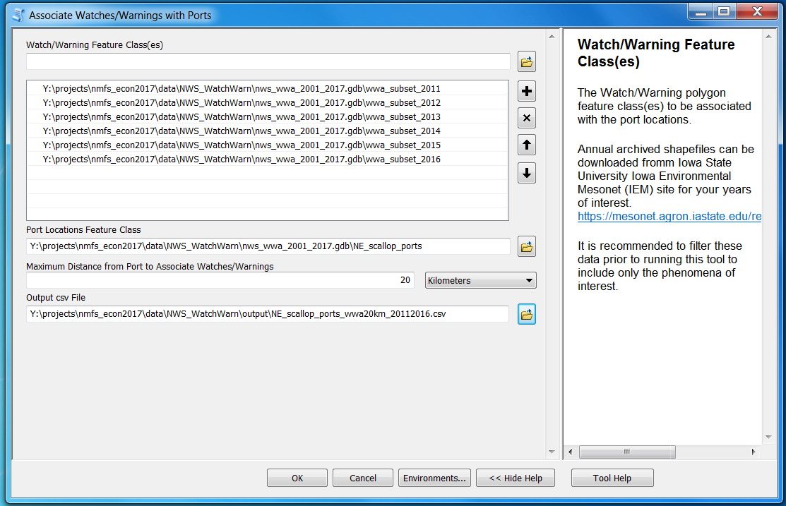

Watch/Warning Feature Class(es): One or more shapefile(s), geodatabase feature class(es), etc. of the historic weather watch/warning polygons. The tool was specifically developed to use annual spatial data from Iowa State University’s Environmental Mesonet (IEM) site, but this does not preclude use of other data sources. It is recommended to filter these data prior to running the tool to include only watch/warning phenomena of interest. The data could also be spatially subset to include only your area of interest. Filtering out unneeded data records will increase speed of the tool and minimize extraneous data in your output file. If the columns in the feature classes are not identical, the output file will retain only those that match the columns in the first feature class in the list.

Port Locations Feature Class: A feature class with the the port locations. Each port must have a unique identifier, which could be its name or some other numeric or alphanumeric id. This tool was developed for ports represented as point locations, but polygon boundaries should also work.

Maximum Distance from Port to Associate Watch/Warnings: The maximum distance (with units) from the port location to associate a weather warning/watch event. The distance you choose will depend on how localized the weather event is expected to have an impact on fishing behavior. It is recommended to use a planar distance unit (i.e., anything but Decimal degrees or Unknown).

Output csv File: The output csv file which will contain a row for each watch/warning event associated with each port. There will likely be multiple entries for a single port because, depending on the time extent of the weather data, each port could have multiple watch/warning events within the specified distance.

**Data Preparation**

These are steps that may need to be taken to acquire and prepare the data for input to the tool.

Ports:

If port locations are provided in a spreadsheet or comma-delimited text file, they can be converted to a feature class by right clicking on the file in ArcCatalog and selecting “Create Feature Class from XY Table” in the menu. Specify the fields to use as the X and Y coordinates. (Remember, longitude is the X-coordinate and latitude is the Y-coordinate). Set the Coordinate System. If the data are provided as lat/long coordinates, it is Geographic, and likely either NAD-83 or WGS-84.

NWS Watch and Warning Polygons

The historic National Weather Service (NWS) Watch and Warning polygons can be downloaded for Iowa State University’s Environmental Mesonet (IEM) site: <https://mesonet.agron.iastate.edu/request/gis/watchwarn.phtml>

The simplest approach is to download the annual zipped shapefiles, (“All”), for the years of interest.

Below is the database schema for the source data (from IEM site):

|  |  |
| --- | --- |
| **Attribute** | **Description** |
| WFO | Three letter ID for issuing Weather Forecast Office |
| ISSUED | String representing product initial valid UTC timestamp YYYYMMDDHHMM |
| EXPIRED | String representing product expiration, this is not the original product expiration, but the actual time the product was no longer valid. For example, the product could have been extended in time or cancelled. |
| INIT_ISS | String representing the issuance time of the product UTC timestamp YYYYMMDDHHMM |
| INIT_EXP | String representing the initial time of the product expiration UTC timestamp YYYYMMDDHHMM |
| PHENOM | VTEC phenomena code. Ex) SV == Severe Thunderstorm , TO == Tornado |
| GTYPE | Geographical type of polygon. C == County, P == Polygon |
| SIG | VTEC significance. Ex) A == Watch, W == Warning |
| ETN | VTEC Event Tracking Number |
| STATUS | The three character code for the VTEC status field. ie EXP, CAN, NEW. For the case of polygons of GTYPE='P' (Storm Based Warnings), the STATUS code is always NEW. For all other cases, this STATUS is the last status parsed for the associated WWA product. |
| NWS_UGC | NWS code used for a zone of a county |
| AREA_KM2 | Area of the geometry in sq kilometers (Projection: EPSG 2163) |

The NWS watches and warnings have changed over time, so it is important to understand the source data limitations to make sure they will meet your needs. In our review of the source data we made the following observations about some changes over time:

|  |  |
| --- | --- |
| **Attribute** | **Data Changes over time** |
| PHENOM | 1996-2000: include 3 Warning types only: Flash Flood (FF), Severe Thunderstorm (SV) and Tornado (TO)  2001-2004: Marine (MA) was added the Warnings  2005-2007: Includes a greater number of types of phenomena;  max number of codes used was 44 in 2007, but I do not know the list of all possible codes  2008-2017: More phenomena included, with a maximum of 53 different ones used in 2008, but it appears that there were some that were never issued after 2008 or 2009.   The current NWS directive doc, (<http://www.nws.noaa.gov/directives/sym/pd01017003curr.pdf>), lists 59 different phenomena.  See pages A-38 and A-39 |
| SIG | 1996-2005: Only Warnings (W) recorded  2006-2017: Added Watch (A), Outlook (O) (maybe not until 2009), Statement (S), and Advisory (Y) |
| GTYPE | 1996-2001: County (C) only.  This appears to refer to a standardized jurisdictional polygon, which could include an offshore area.  They all have a unique code to identify the specific area (NWS_UGC) which starts with the abbreviation for the state.  2001-2017: added Polygon (P) type.   I think these are free-form shapes. They don’t have a value for NWS_UGC |

Data Filtering

It is recommended to filter the watch/warning data to include only time periods and phenomena of interest. It may also be desired to filter the data based on location. These data reductions will increase the speed of the tool and reduce extraneous data in the output data file.

For our project, we used the following Marine-specific phenomena. Due to the changes over time, only data from 2009 to present were included in the analysis.

|  |  |
| --- | --- |
| **PHENOM** | **Description** |
| GL | Gale |
| HU | Hurricane |
| MA | Marine |
| MF | Dense Fog |
| RB | Small Craft - Rough Bar |
| SC | Small Craft |
| SE | Hazardous Seas |
| SI | Small Craft - Wind |
| SR | Storm |
| SU | High Surf |
| SW | Small Craft - Hazardous Seas |
| TR | Tropical Storm |
| TS | Tsunami |
| UP | Heavy Freezing Spray |

To subset the data to include only these phenomena in ArcGIS Desktop, there are two methods:

1. In ArcCatalog or ArcMap, use the Select Tool (Analysis Tools Toolbox) with the following SQL statement: "PHENOM" IN ( 'GL', 'HU', 'MA', 'MF', 'RB', 'SC', 'SE', 'SI', 'SR', 'SU', 'SW', 'TR', 'TS', 'UP' ) to create a new feature class with just those records.

OR

1. In ArcMap,
   1. Open the data table and use the Select by Attributes tool with the same expression as above: "PHENOM" IN ( 'GL', 'HU', 'MA', 'MF', 'RB', 'SC', 'SE', 'SI', 'SR', 'SU', 'SW', 'TR', 'TS', 'UP' )
   2. Right click the layer and select Data -> Export Data from menu and export Selected features to a new feature class.

You can filter the data to include only specific locations via the Weather Forecasting Office (WFO) column, the NWS_UGC column (for specific counties), or with a spatial selection using GIS tools.

In some of the data records, the watch/warning events had an expiration date (EXPIRED column) that was earlier than the date it was issued (ISSUED column). For 2016, this was approximately 8% of the total records. These events should be filtered out prior to final data processing.

A unique identifier for each watch/warning event can be constructed for each record using the Weather Field Office (WFO), phenomenon (PHENOM), significance (SIG), and year (first four characters of ISSUED) and event tracking number (ETN). There may be multiple records for a unique event identifier when the event applied to multiple geographies (counties and/or polygons). Below is a sample SQL query to construct a unique event id. (Note: || is used to concatenate each part of the id):

SELECT WFO, ISSUED, EXPIRED, PHENOM, SIG, ETN, printf("%04d", ETN) as ETNpadded, substr(ISSUED,1,4) as YR,

PHENOM || '_' || SIG || '_' || WFO || '_' || substr(ISSUED,1,4) || '_' || printf("%04d", ETN) as ETNfull

FROM wwa_200901010000_200912312359

ORDER BY ISSUED;

Further research and review of the official NWS documentation can help to clarify what type of information is appropriate to use for your purposes. Below is some additional documentation from the NWS about Marine-specific events::

* Tables 1, 3, and 5 in [NWSI 10-315](http://www.nws.noaa.gov/directives/sym/pd01003015curr.pdf) show the possible combinations of phenomenon and significance for the Marine Weather Message product (MWW) which includes marine watches, warnings, and advisories.
* [NWSI 10-314](http://www.nws.noaa.gov/directives/sym/pd01003014curr.pdf) describes the Marine Weather Statement product (MSW). They are described as either (1) non-severe, short-term (2 hours or less) wind events or (2) non-severe, long-term events, such dense fog, volcanic impacts, or to advise for potential development of warning conditions.
* There is also the Special Marine Warning product (SMW), [NWSI 10-313](http://www.nws.noaa.gov/directives/sym/pd01003013curr.pdf). This is used for “short duration (2 hours or less) sustained marine thunderstorm winds or associated frequent gusts of 34 knots (KT) or greater; and / or hail 3/4 inch or more in diameter; and / or waterspouts. Forecasters should also issue the SMW for sustained non-convective short duration winds or associated frequent gusts of 34 KT or greater (gale force or stronger).”

Below are some links to information about the VTEC codes used by the NWS to represent the events:

* One-page [VTEC explanation](https://www.weather.gov/media/vtec/VTEC_explanation4-18.pdf)
* VTEC [Primer](https://www.weather.gov/media/vtec/VTEC_primer.ppt)
* Detailed instructions about VTEC, [NWSI 10-1703](http://www.nws.noaa.gov/directives/sym/pd01017003curr.pdf)