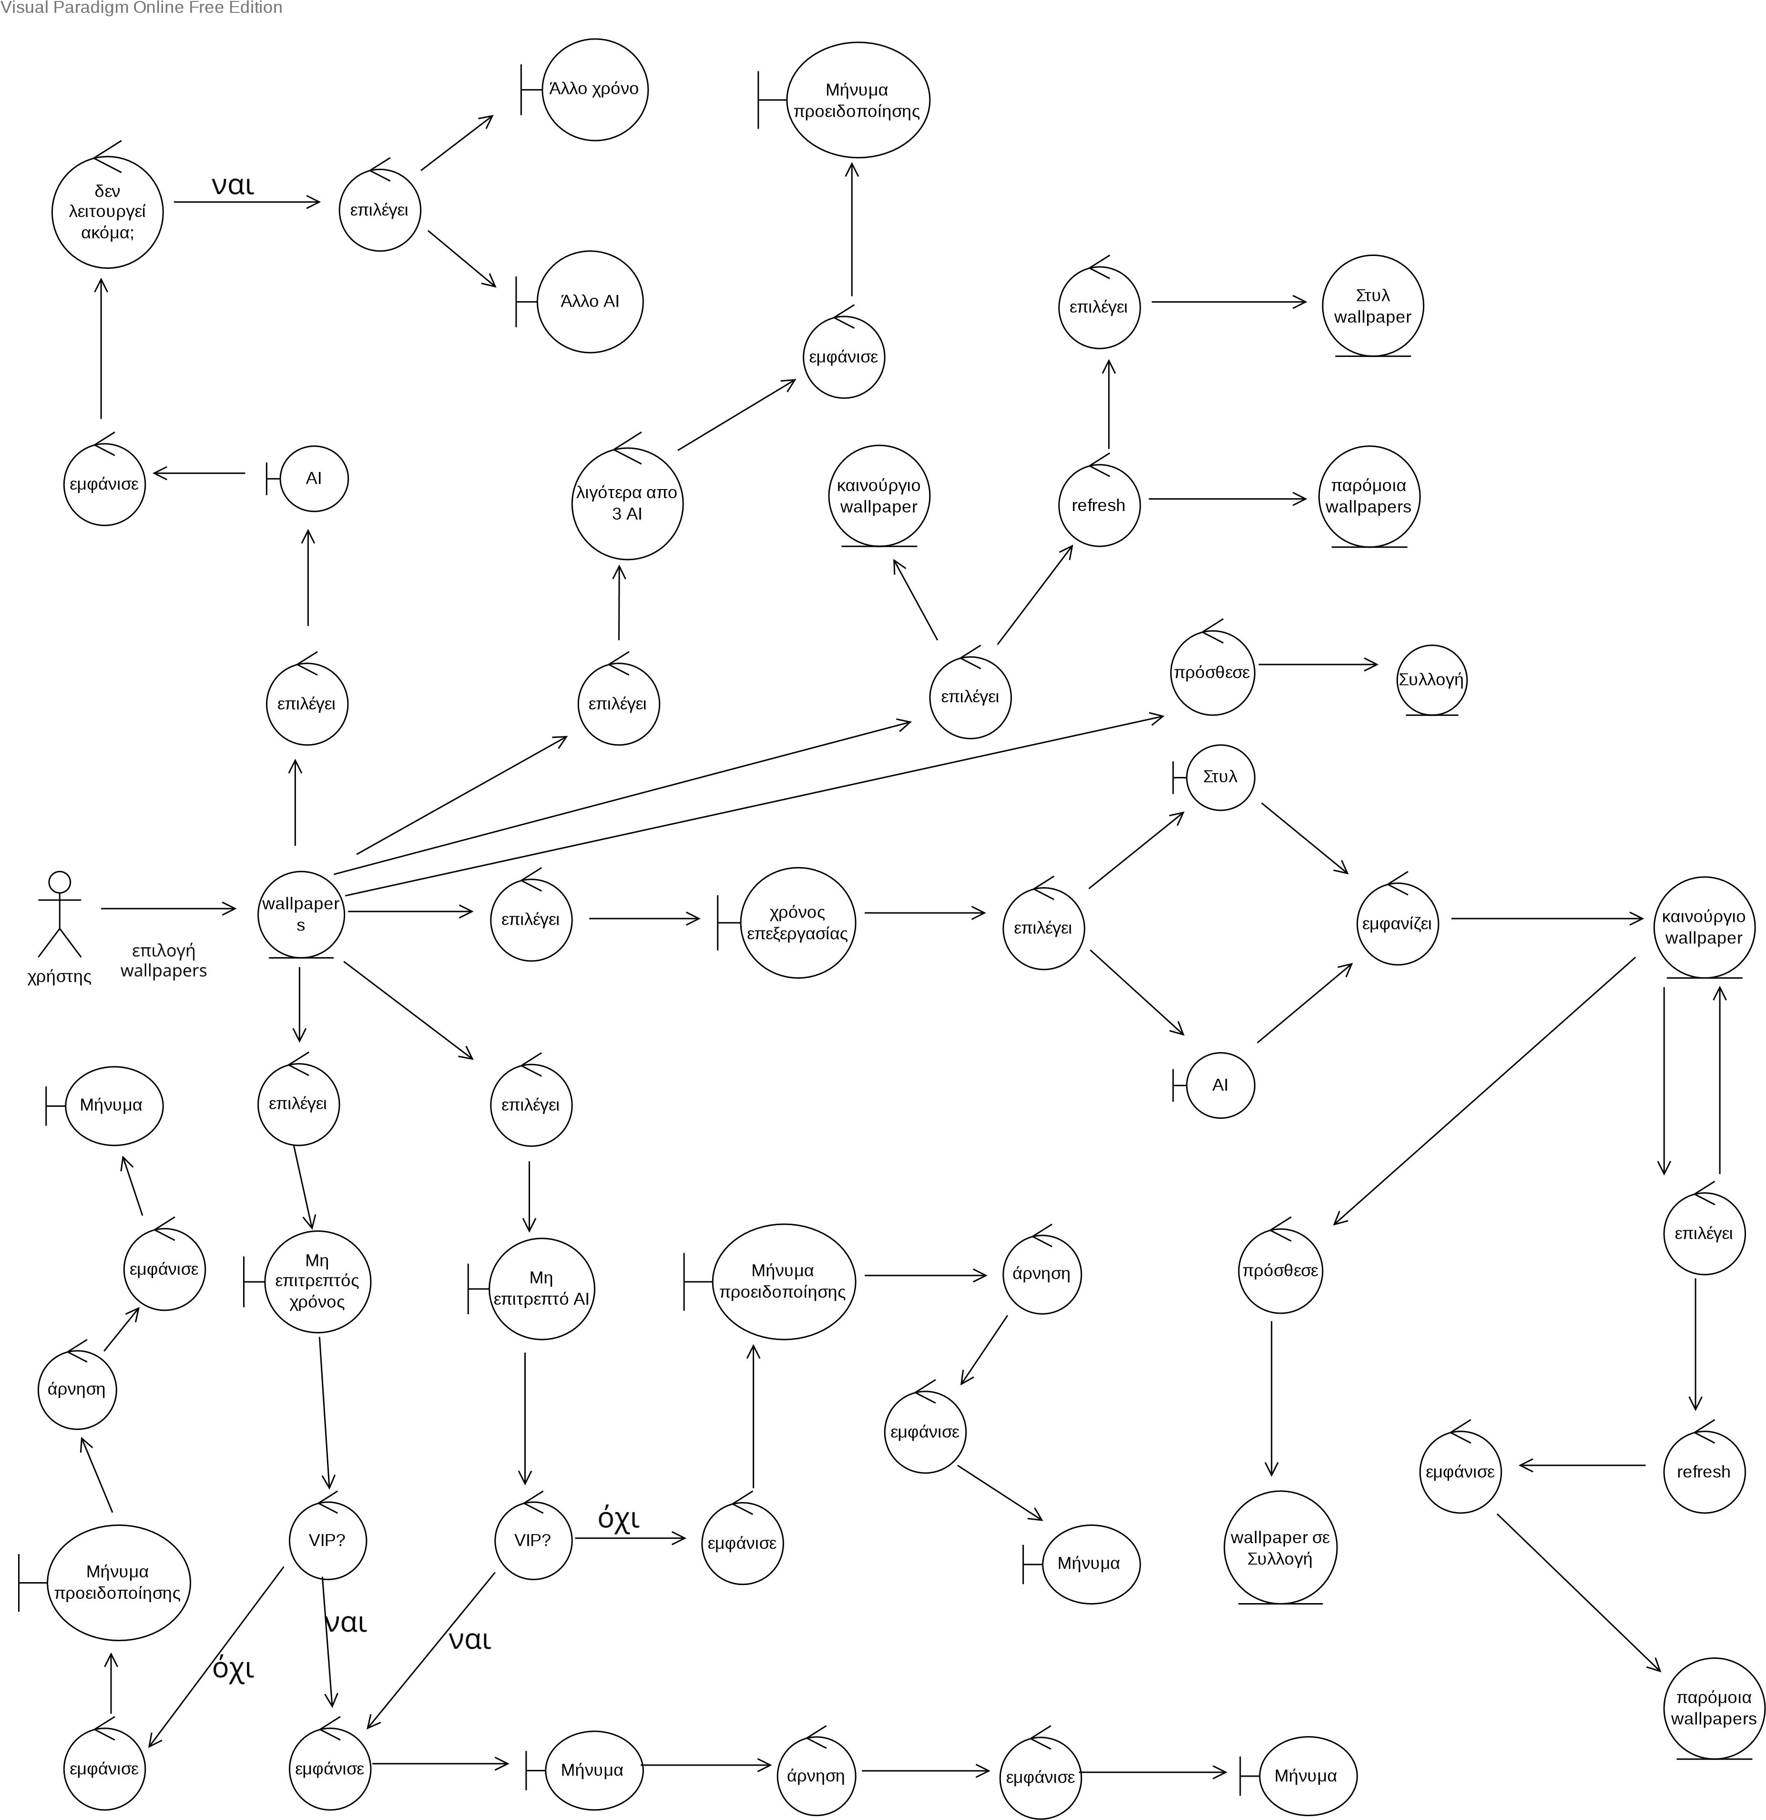Visual Paradigm Online Free Edition