**Answer 2:**

1. **NORMALIZATION.**

The tables for the database are not normalized.

After applying 1st, 2nd and 3rd normal forms the refined database is as follows:

* + **Participant:** Fields (id(primary key),  name, email);
  + **Duty Station:** Fields (id (references(id) , duty_station_id(primary key));
  + **Lunch Venues:** Fields (id (references(id), venue_id(primary key));
  + **Schedule**: Fields (id(references(id)), schedule_id(primary key),participant1, participant2, participant3, participant4, venue(references(venue_id)), duty station(references(duty_station_id));

**TABLE CREATION IN MYSQL**.

1). Table: DUTY STATION.

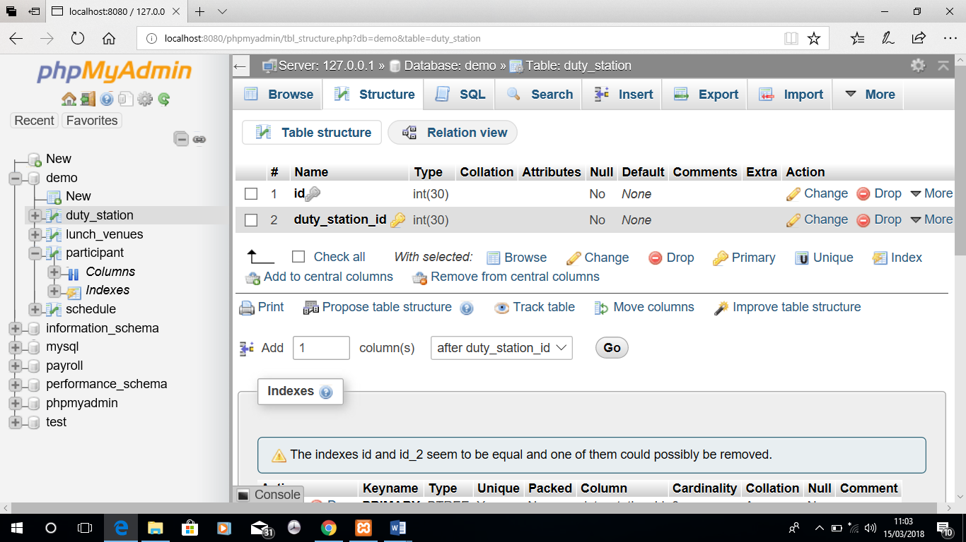

2). Table: PARTICIPANT.

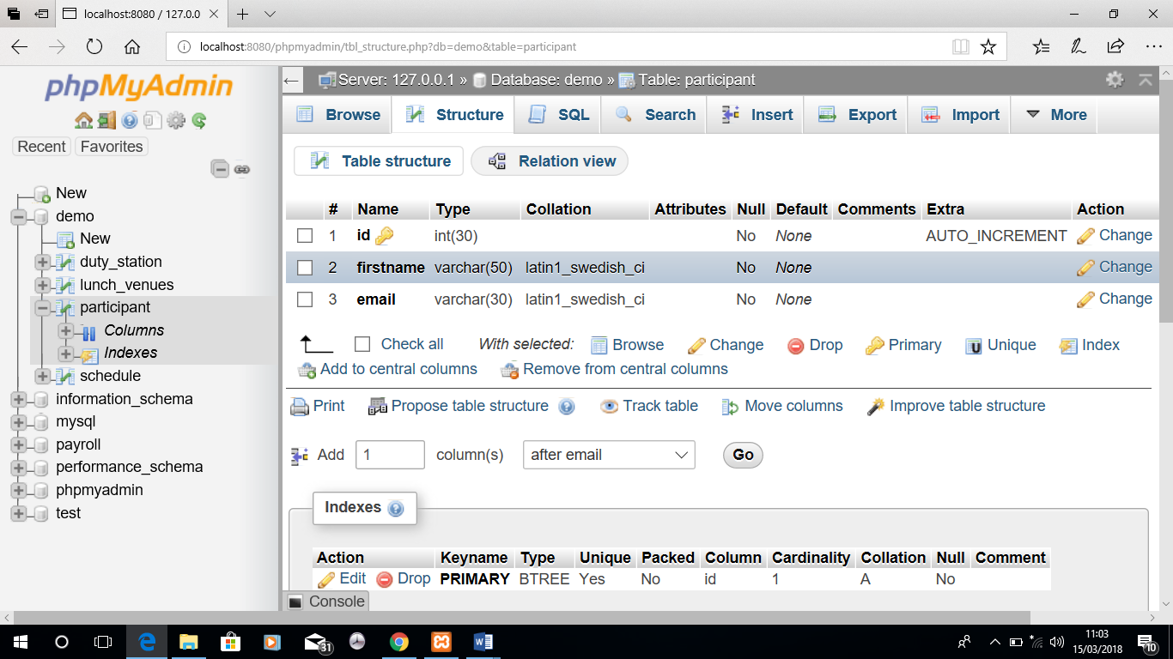

3). Table: SCHEDULE.

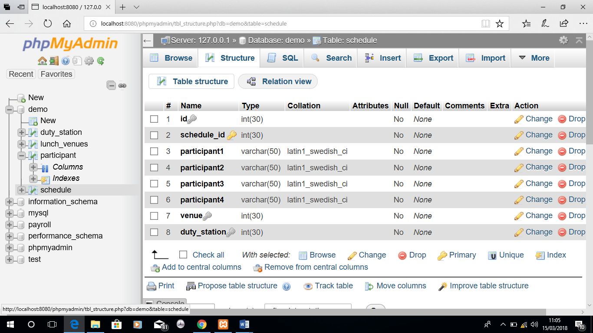

3). Table: LUNCH_VENUE