[Note This exam contains 6 questions in 3 pages]
Q1) Select True or False for the followings:
- Let N be an unordered array of integers. The maximum number of compares required to find the minimum value is N-1. [True/False]
- The number of exchanges required to perform Selection Sort of an array on N integers is N. [True/False]
- The maximum number of compares to binary search for a key in a sorted array is log2 n [True/False]
- The minimum height of a binary search tree win n keys is log2 n [True/False]
- We can insert any batch of N keys into an empty binary search tree using at most 2N compares [True/False]
- Each subtree rooted at any node of a 2-3 tree is itself a 2-3 tree [True/False]
- Tilde notation of 10 N²+8 N log N is 10N² [True/False]
- The Big Theta of (5 N²+12 N log N and 0.5 N²+ 3 N) is N² [True/False]
- The Big Oh of (100 N³+ N and 10 N) is N [True/False]

Q2) Symbol Table
- Compare the performance of symbol table using linked list and ordered array in terms of search and insert.
- Given the following keys
5,8,4,20,3
Do the following by showing the steps for:
- Construct binary search tree
- Insert the key 10
3- Why 2-3 tree is a perfect balance tree?

Q3) Given the following BST

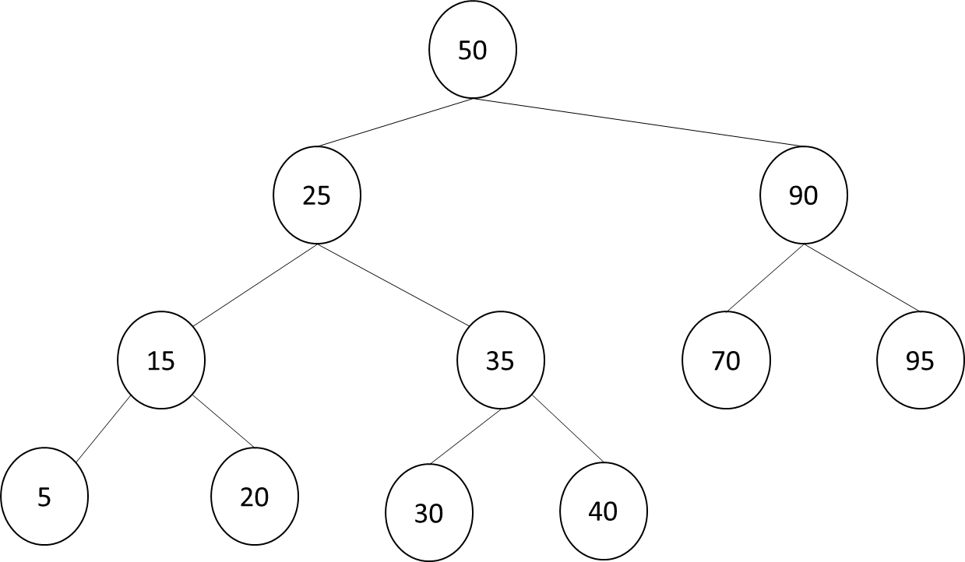
Show the steps for performing the followings:
- Search 75
- Insert 100
- min and max
- Delete 5

Q4) Given the following LLRB tree
- What is the problem of this tree?
- How to fix this problem?
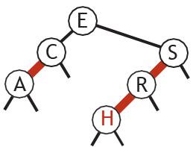

Q5) Hash Tables
- What is the best definition of the collision in a hash table implementation of a symbol table? [select one]
a- Two key-value pairs that have equal keys but different values.
b- Two key-value pairs that have different keys and hash to different indices.
c- Two key-value pairs that have different keys but hash to the same index.
d- Two key-value pairs that have equal keys but hash to the different indices.

- A linear probing hash table of length 10 uses the hash function h(x) = x mod 10 + 1. mod is the reminder operator. For example the h(42) = 42 mod 10 + 1 = 2 + 1 = 3 so we insert 42 in the position 3 in the array.
After inserting 6 integer keys into an initially empty hash table, the array of keys is
a- insert the key 35
b- insert the key 12
c- insert the key 10
Q6) Graphs
1- Compare the required space for graph representation in terms of edges and vertices using
a) list of edges, b) adjacency matrix, and adjacency list
2- Explain the Adjacency-list graph representation code
