Annex A

REQUIREMENT SPECIFICATIONS

DEVELOPMENT OF 2 NEW SYSTEMS NAMELY THE ONLINE APPOINTMENT SYSTEM FOR ONE STOP DOCUMENT CENTRE (OSDC) AND ONLINE REQUEST FOR GARBAGE COLLECTION SPECIAL SERVICE

1. INTRODUCTION

1.1 These requirements specification consists of 2 projects, namely Online Appointment System for One Stop Document Centre (OAS) and Online Request for Garbage Collection Special Service (GACSS).

2. SCOPE OF WORK

2.1 This ITQ calls for the development of the new Online Appointment System for One Stop Document Centre (OAS) & Online Request for Garbage Collection Special Service (GACSS) using the java architecture platform (J2EE) which will be referred to as the System hereupon, and shall include the following activities:

- Study business process and gather detailed users’ requirements
- System analysis and design
- Programming and integration
- System testing and load testing
- User acceptance testing
- Documentation
- Implementation
- Post implementation support

3. PROJECT MANAGEMENT

3.1 Project Management will be done by MPA.

Project Team

Project team members should possess the following technical skill sets:

- Experienced and good understanding of J2EE web application platform
- Experience in implementing itext tools for report generation and data integration between Sybase tables.
- Good knowledge on Weblogic application and Sybase database.

3.2 Resumes and education certificates of Project team personnel are required to be submitted for evaluation purposes.

3.3 Two reference sites/projects where the Personnel has worked for at least 1½ years in the area of IT application development involving the technical skills stated above. The information on the reference site shall include the company’s name, project name, contact person and contact number.

4. FUNCTIONAL REQUIREMENTS

4.1 ONLINE APPOINTMENT SYSTEM FOR ONE STOP DOCUMENT CENTRE (OAS)

4.1.1 The Marine Licensing & Prosecution (MLP) facilitate the planning, managing and issuing of craft licensing, composite fines, port clearance permit etc of maritime related activities in Singapore. The processing of transaction is currently performed via walk-in ticketing system. MLP will increase their productivity by replacing the current processes through e-appointment services. This allows them to estimate the number of appointments and better planning in allocating of resources.

4.1.2 This Online Appointment System will consist of 3 main modules: Appointment Module (Internet & Intranet), Reporting Module, and Administration Module.

4.1.3 The breakdown of the functions as follows:

Appointment Module - Internet
- Booking of Appointment Function
- Cancellation of Appointment Function
- Rescheduling of Appointment Function

Appointment Module - Intranet
- Check-In of Appointment Function
- Processing of Appointment Function

Administrating Module - Intranet
- Administrating of Booking Period Function
- Administrating of Booking Slot Function

Reporting Module - Intranet
- Generating of Appointment Report Function

4.2 Business Process 1: Registration of Appointment

4.2.1 All public customers intending to engage MPA for issuing of craft licensing, composite fines, port clearance permit etc services are encourage registering an appointment, which is available 24/7. The customer could submit an appointment booking one day in advance (only before 1700 hours) for the next day. Otherwise, it would be the day after next onwards. Customers are able to book more than one appointment per day and appointment date of up to one month in advance. And there will be no appointment scheduled for weekends and public holidays.

4.2.2 For each appointment time slot, it allows up to 2 bookings (default) of different customers i.e. customer A booked 930hrs slot and customers B also booked 930hrs slot. However, customer C could not book 930hrs slot (hidden from the system) as it is full. And customer who has booked a slot is not allowed to book the same time slot.

4.2.3 The customers are required to provide this information: NRIC/passport/FIN, Craft number/s, Name of Company, Types of Appointment, Types of transaction, Date & time, Contact number, email address, Remarks (if any).

4.2.4 Customer is able to input more than one craft numbers. And there will be 2 types of appointments: (1) Single Appointment & (2) Group Appointment. For single appointment, the appointment time slots interval is 15 mins and caters for only one transaction. While for group appointment, the appointment time slots interval is 30 mins and caters up to 3 transactions (qty), customers are required to input at least 2 or 3 transactions; validate and alert customers if only 1 or more than 3 transactions (qty) entered. However, if customers have more than 3 transactions (qty), customers are to submit a new appointment. Time slots that are unavailable will not be displayed.

4.2.5 For each registration of appointments submission, there will be a list of system validation checks (refer to table 1a) before proceeding to the confirmation page for verification of appointment information.

4.2.6 For all successful registration of appointment, the system will display the confirmation receipt and send a Short Message Service (SMS) notification to the customer. The confirmation receipt will contain information like NRIC/passport/FIN, Craft number/s, Name of Company, Types of Appointment, Types of transaction, Date & time, Contact number, email address, Remarks (if any), Reference Number (refer to table 1b) and could be save as pdf. Refer to diagram 1a.

4.2.7 And for SMS messages, it contains date & time of appointment and the reference number. Refer to diagram 1b.

4.2.8 Refer to diagram 1c 1d & 1e for Sample Screens of Registration of Appointment.

Table 1a – System Validation Check
S/N | System Validation Check | Remark
1. | Check for Mandatory Fields | NRIC/passport/FIN, Craft number/s, Name of Company, Types of Appointment, Transaction Types, Date & time of Appointment, Contact Number, Email Address
2. | Check for NRIC/ Passport Number | Ensure valid NRIC/ Passport Number
3. | Check for valid Craft Number | Check if craft number/s is registered with MPA
4. | Check for Types of Appointment:  a. Single Appointment  b.Group Appointment | a.Check 1 transactions types selected only  b.Check 2 or more transactions qty input but no more than 3
5. | Check Appointment Date & Time | Check date and time is one day in advance (only before 1700 hours) and date cannot be <= current date
6. | Check for Duplicate Appointment Booking | Check appointment slot booked cannot be book on the same time.
7. | Check for Declaration & Confirmation | Check for checkbox selected in the confirmation page

Table 1b – Format of Reference Number
No. | Types of Transaction | Format of Reference Number
1. | Harbour craft
a. | New / Renewal of licence | HCLNLYYYYMMDDHHMMSS
b. | Application to de-licence | HCLADYYYYMMDDHHMMSS
c. | Update of craft particulars | HCLUCYYYYMMDDHHMMSS
d. | Change of ownership | HCLCOYYYYMMDDHHMMSS
e. | New / Renewal of Manning licence | HCLNMYYYYMMDDHHMMSS
f. | Return of HARTS | HCLRHYYYYMMDDHHMMSS
2. | Pleasure Craft
a. | New / Renewal of licence | PCLNLYYYYMMDDHHMMSS
b. | Application to de-licence | PCLADYYYYMMDDHHMMSS
c. | Update of craft particulars | PCLUCYYYYMMDDHHMMSS
d. | New / Renewal of PPCDL or APPCDL | PCLNPYYYYMMDDHHMMSS
3. | Port Clearance
a. | General Declaration | PCGDYYYYMMDDHHMMSS
b. | Application for launching permit | PCALYYYYMMDDHHMMSS
c. | Application for Break-up permit | PCABYYYYMMDDHHMMSS
4. | Others | OTHSYYYYMMDDHHMMSS
5. | Multiple Selection - MULTYYYYMMDDHHMMSS

Diagram 1a - Registration of Appointment
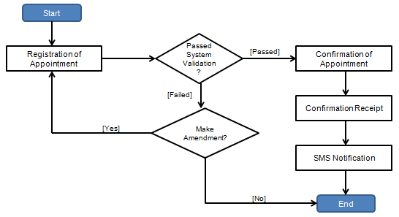

Diagram 1b – SMS Template – Registration of Appointment (Successful)
To: <<Customer Mobile Number>>
From: <<MPA>>
Body:

Your appointment has been successfully registered as below:

Date & Time : <<Date & time>>
Reference No.: <<Reference No.>>

For change of appointment, please visit our MPA website.
Note that all changes are to be made one day before appointment date (before 1700hrs).

Diagram 1c – Sample Screen of Registration of Appointment Submission
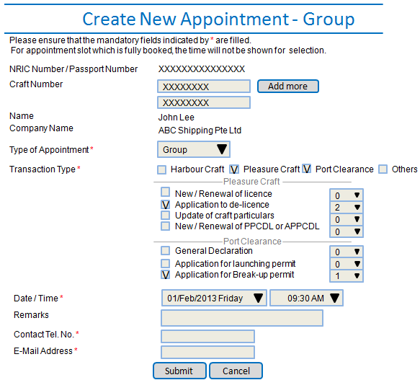

Diagram 1d – Sample Screen of Appointment Confirmation
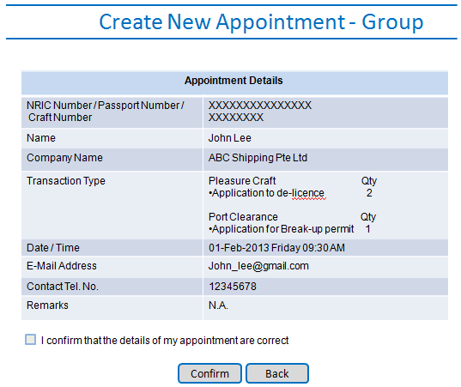

Diagram 1e – Sample Screen of Appointment Confirmation Receipt
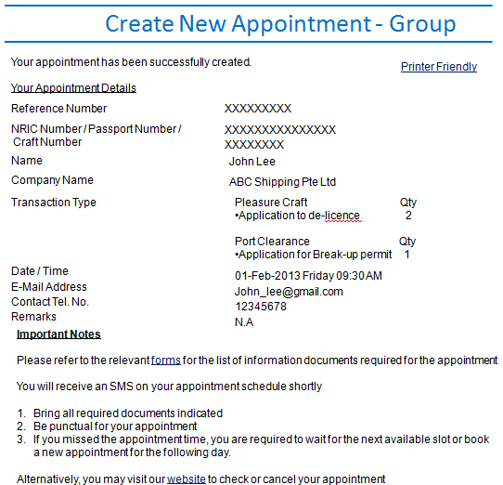

4.3 Business Process 2: Cancellation of Appointment

4.3.1 The customers could only submit a cancellation of appointment one day (only before 1700 hours) before the actual appointment timing. Otherwise, cancellation of appointment is not allowed. Refer to Table 2a for cancellation conditions

4.3.2 Cancelled appointment slots are available and opened up for booking.

4.3.3 For cancellation of appointment, there will also be a SMS notification. Refer to diagram 2a & 2b.

Diagram 2a - Cancellation of Appointment
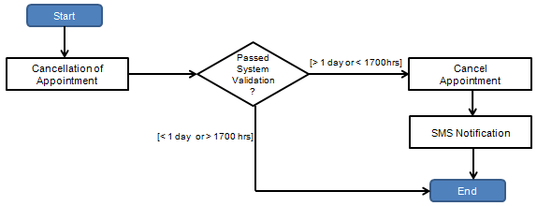

Diagram 2b - SMS Template - Cancellation of Appointment
To: <<Customer Mobile Number>>
From: <<MPA>>
Body:

Please note that you have successfully cancelled the following appointment:

Date & Time : <<Date & time>>
Reference No.: <<Reference No.>>

Table 2a – System Validation Check
S/N | System Validation Check | Remark
1. | Check Appointment Exist | Check if there is any appointment made
2. | Check Appointment Date & Time | Check date and time as cancellation is only allowed for one day in advance (only before 1700 hours)

4.4 Business Process 3: Reschedule of Appointment

4.4.1 The customers are allowed to reschedule their appointment for all appointment previously registered. However, rescheduling is only allowed at least one day (only before 1700 hours) before the actual appointment timing. Otherwise, rescheduling of appointment is not allowed.

4.4.2 Customers are allows to make changes to the Types of Appointment, Types of transaction, Date & time, Craft number/s, Contact number, email address, Remarks (if any) during rescheduling of appointment. No new reference number will be generated.

4.4.3 For every rescheduling of appointments, there will be a list of system validation check (refer to table 3a) before proceeding to the confirmation page for verification of appointment information.

4.4.4 All successful rescheduling of appointment, the system will display the confirmation receipt and a SMS notification will be sent to the customer. The confirmation receipt will contain information like NRIC/passport/FIN, Craft number/s, Name of Company, Types of Appointment, Types of transaction, Date & time, Contact number, email address, Remarks (if any), Reference Number, others. Refer to diagram 3a.

4.4.5 And for SMS messages, it contains from & to of the date & time of appointment and the reference number. Refer to diagram 3b.

4.4.6 Rescheduled appointment slots are available and opened up for booking.

Diagram 3a - Reschedule of Appointment
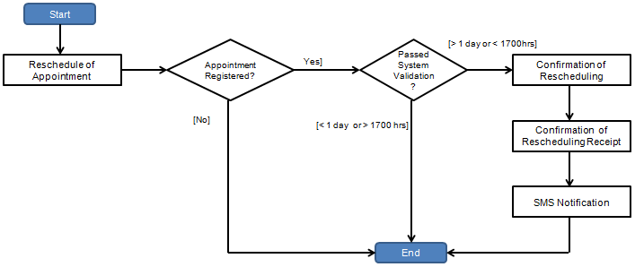

Diagram 3b - SMS Template - Reschedule of Appointment
To: <<Customer Mobile Number>>
From: <<MPA>>
Body:

Please note that you have successfully rescheduled the below appointment:

From Date & Time : <<Date & time>>
To Date & Time : <<Date & time>>
Reference No.: <<Reference No.>>

If you wish to view or make any changes to your appointment, you may do so at our MPA website.
Please take note that all changes are to be made one day before appointment date (before 1700hrs).

Table 3a – System Validation Check
S/N | System Validation Check | Remark
1. | Check for Mandatory Fields | Types of Appointment, Transaction Types, Date & time of Appointment, Contact Number, Email Address Remark
2. | Check for NRIC/ Passport Number | Ensure valid NRIC/ Passport Number
3. | Check for valid Craft Number | Check if craft number/s is registered with MPA
4. | Check for Types of Appointment:  a. Single Appointment  b.Group Appointment | a.Check 1 transactions types selected only  b.Check 2 or more transactions qty input but no more than 3
5. | Check Appointment Date & Time | Check date and time is one day in advance (only before 1700 hours) and date cannot be <= current date
6. | Check for Declaration & Confirmation | Check for checkbox selected in the confirmation page

4.5 Business Process 4: Check-In of Appointment

4.5.1 Customers who have made an online register for appointment could scan any of their identification card with their NRIC barcode or input the NRIC or reference number generated for their appointment. The system will check that valid NRIC or reference number was keyed in. Refer to table 4a.

4.5.2 If the customers have more than one appointment per day, customers are required to select the scheduled appointments registered for check-in. The system will log down the check-in date and time of the customer to be used for calculation of waiting time. System will display successful check-in messages. Refer to diagram 4b, 4c, and 4d.
4.5.3 If customer who check-in later than the appointment time, system will still registered the check-in and a successful message will be shown but tag with a late appointment indicator. For late appointment, customer has to wait for next available slot where their names will be called. Refer to diagram 4e.

4.5.4 The counter module will refresh every 1 mins to retrieve new check-in and alert counter service. The list of appointment records are sorted in appointment date and time in ascending order. Staff is able to click on individual check-in to view the record in more details. Refer to diagram 4f and 4g.

Diagram 4a – Check-In of Appointment
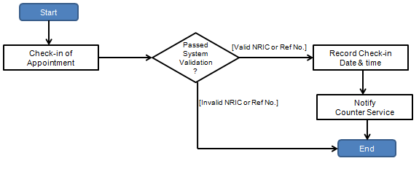

Diagram 4b – Sample Screen of Check-In Appointment
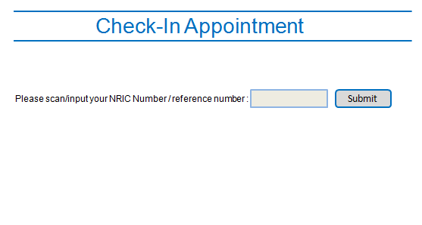

Diagram 4c – Sample Screen for Multi Appointments
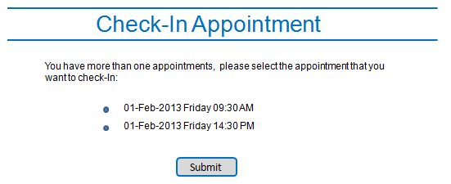

Diagram 4d – Sample Screen for Successful Check-In
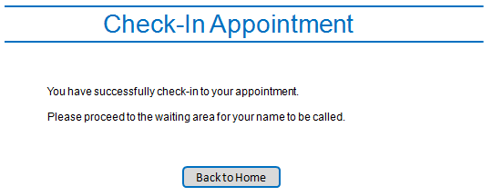

Diagram 4e – Sample Screen of Successful Check-In (Late Appointment)
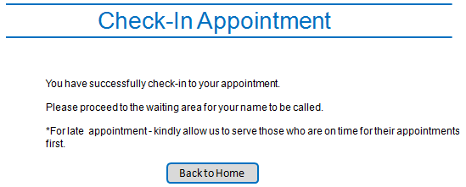

Diagram 4f – Sample Screen of New Check-In (Counter)
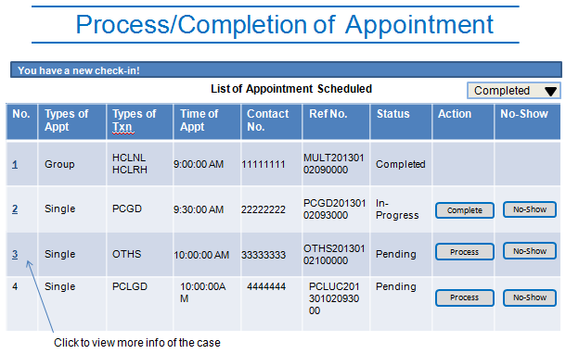

Diagram 4g – Sample Screen of Detailed Info (Counter)
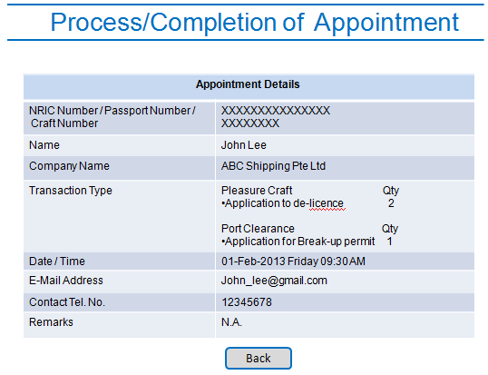

Table 4a – System Validation Check
S/N | System Validation Check | Remark
1. | Check for mandatory field | Check NRIC or reference number is input
2. | Check for NRIC or reference number | Check NRIC or reference number exist and valid

4.6 Business Process 5: Process of Appointment

4.6.1 Counter staff will select the process button and the case will be updated as in-progress. If the other counter staffs see the case is in progress status, they will skip this progressing case and proceed to the next.

4.6.2 At the same time, the system will trigger a sound and update the queue appointment panel instantly. This panel will notify customers of their appointment queue and the counter to go to. Refer to diagram 5c.

4.6.3 There will be 4 different types of status namely: Pending, In-progress, Completed and No-show.

4.6.4 The system will log down the queue number served date and time of the case to be used for calculation of waiting time. Refer to diagram 5a & 5b.

Diagram 5a – Process of Appointment
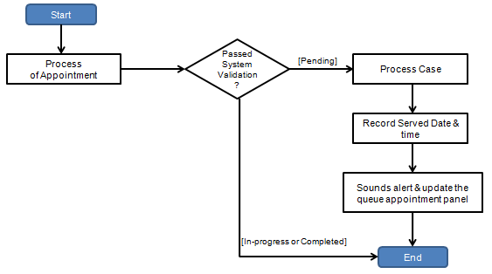

Diagram 5b – Processing Screen (Counter)
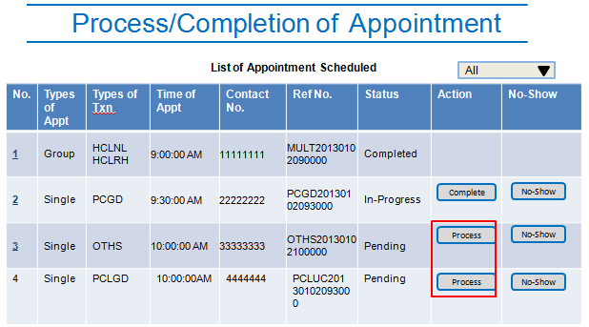

Diagram 5c – Queue Appointment Screen
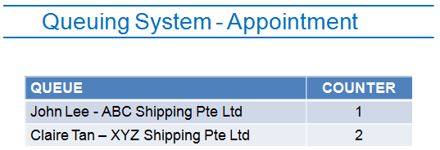

Table 5a – System Validation Check
S/N | System Validation Check | Remark
1. | Check for status | Check the appointment is in pending status

4.7 Business Process 6: Completion of Appointment

4.7.1 Counter staff will close the case after it is completed. The system will log down the completion date and time of the case to be used for calculation of the service time. Completed and no show cases will not be displayed unless the staff selected the filtering criteria as completed.

4.7.2 Refer to diagram 6a & 6b.

4.7.3 If customer did not turn up for the appointment, staff is able to mark it as no-show and recorded into the system. Refer to diagram 6c.

Diagram 6a – Completion of Appointment
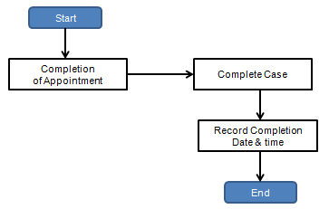

Diagram 6b – Completion Screen (Counter)
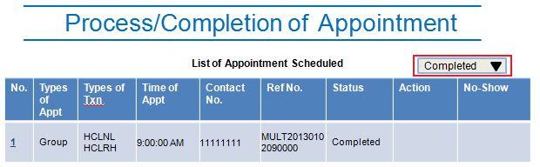

Diagram 6c – No-Show Screen (Counter)
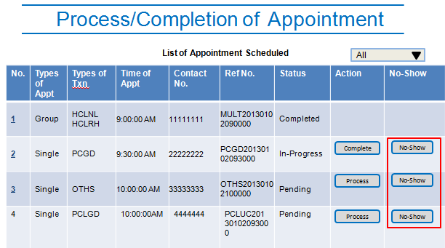

4.8 Business Process 7: Administer of Booking Period

4.8.1 Only system administrator is able to allocate the appointment time slots of the booking. This is to disallowed customers to book the unavailable time slots. The system allows the user to administer the below time slots:

No. | Block Out Time Slot
1. | All slots to be open from 830 to 4pm (default)
2. | Flexibility for adjusting slots to be blocked out

4.8.2 Refer to diagram 7a & 7b.

4.8.3 User are only allows to administer the time slot one day for the next day and up to one month in advance. Refer table 7a

4.8.4 However, in the event of special circumstances, if the block period has appointments booked by customers, user is still able to block out the period but there will be an alert notification prior to that. System will cancel the booked appointment and a SMS notification sent to inform customers. Refer to diagram 7c.

Diagram 7a – Administer of Booking Period
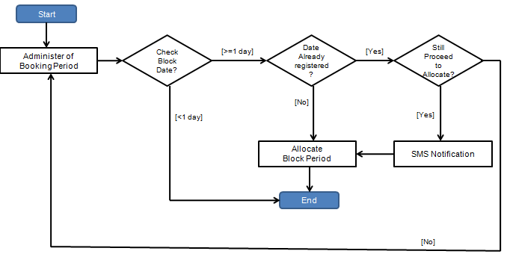

Diagram 7b – Administration of Booking Period Screen
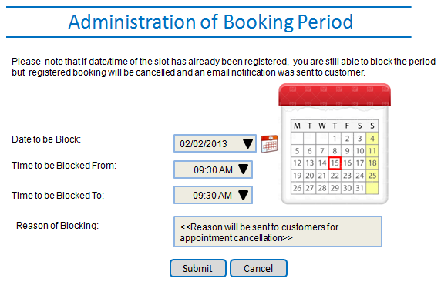

Diagram 7c – SMS Template – Cancellation of Appointment (Block Period)
To: <<Customer Mobile Number>>
From: <<MPA>>
Body:

Your appointment has been cancelled due to <<reason for cancellation>>:

Date & Time : <<Date & time>>
Reference No.: <<Reference No.>>

Please visit our MPA website to make another appointment booking.
We apologies for the inconvenience caused.

Table 7a – System Validation Check for Administration of Booking Period
S/N | System Validation Check | Remark
1. | Check for Mandatory Fields | Check Date to be Block, Time to be blocked from/to have input
2. | Check for blocked date | Check blocked date must be > current date
3. | Check for Registered Date | Check blocked date is booked by customer and alert user

4.9 Business Process 8: Administer of Booking Slot

4.9.1 Only system administrator is able to allocate the number of appointment slots for the system.

4.9.2 This function is dependent on the manpower and the counters availabilities. The system has the flexibility to allow increasing or decreasing the slot/s given the manpower or resources allocated. The minimum slot to be allocated is 1 and the maximum is 5. And user is only able to update the booking slot given date+1 month onwards. This is to prevent conflicts with other registered appointments booked by the customers within the month. Refer to diagram 8a and 8b.

Diagram 8a – Administration of Booking Slots
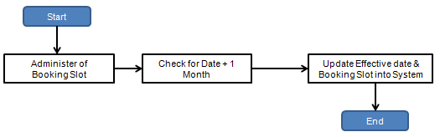
Diagram 8b – Administration of Booking Slots Screen
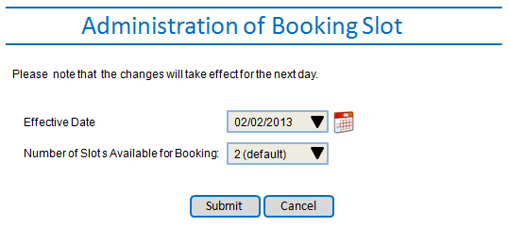

4.10 Business Process 9: Generate Appointment Report

4.10.1 System administrator and counter staff are able to query the following list of reports:

(1) Appointment Scheduled Report
(2) Appointment Rescheduled Report
(3) Appointment Cancelled Report
(4) Statistic of Waiting Time Report
(5) Statistic of Service Time Report
(6) Appointment Late Report
(7) Appointment No-Show Report

4.10.2 Refer to diagram 9a for the system flow.

4.10.3 For appointment scheduled report, it displays the list of scheduled appointment of a particular date i.e. user is able to manually generate the list of appointments scheduled for next day. The selection criterion is via a particular date. Likewise, for appointment rescheduled report and appointment cancelled report.

4.10.4 While for statistic of waiting and service time report, it displays the information of the average waiting and service time. The formula computation for these 2 reports is as follows:

Waiting Time = Ticket Served Time - Check-In time (refer to business process 5)
Service Time = Completion Time - Ticket Served Time (refer to business process 6)

4.10.5 The selection criterion is via per month basis i.e. Jan 2013, Feb 2013 etc.

4.10.6 For appointment late report, it displays the list of scheduled appointments which has late check-in. The selection criterion is via a particular date range i.e. 01 Jan 2013 to 14 Jan 2013.

Late Report = Check-In Date/Time > Appointment Date/Time

4.10.7 And for appointment no-show report, it displays the list of scheduled appointment tagged with no-show status. The selection criterion is via a particular date range i.e. 01 Jan 2013 to 14 Jan 2013.

4.10.8 The system also allows the option for the reports to be generated in pdf format.
4.10.9 All batch report generated as per the schedules (refer to table 8a) and will be sent via email to MPA-PT_OSDC@mpa.gov.sg domain group with reports attached. Information Technology Department staff will be included in the carbon copy list. Refer to diagram 9b and attached doc for the report template.

Table 9a – Report Generation
S/N | Types of Report | Batch or Manual | Remark for Batch
1. | Appointment Scheduled Report | Both | Generated on each closing time 1730hrs
2. | Appointment Rescheduled Report | Manual | -
3. | Appointment Cancelled Report | Manual | -
4. | Statistic of Waiting Time Report | Both | Generated on 1st day of the month
5. | Statistic of Service Time Report | Both | Generated on 1st day of the month
6. | Appointment Late Report | Manual | -
7. | Appointment No-Show Report | Manual | -

Diagram 9a – Generate Appointment Report
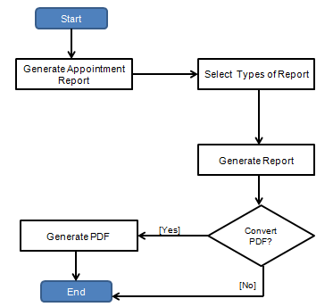

Diagram 9b – Email Template - Batch Report
To: MPA-PT_OSDC@mpa.gov.sg
Cc: <<IT Department>>
Attachment: << Appointment_Scheduled_Report_DDMMYY >>
Body:

Hi,

Please find attached the Daily Report for Appointment Scheduled Report for DD MM YYYY.

Thank you.

This is a system generated email. Please do not reply to this email.

Sample Report Template

Appointment Scheduled Report Template
Appointment Rescheduled Report Template
Appointment Cancelled Report Template
Statistic of Waiting Time Report Template
Statistic of Service Time Report Template
Appointment Late Report Template
Appointment No-Show Report Template

4.11 Business Process 10: Security Access

4.11.1 Only Marine Licensing & Prosecution (MPL) Department users are allows accessing this application. The system will check against MPA active directory and their roles given.

4.11.2 There are 2 types of roles:

- Administrator Role (AS_MP_ADMIN) – Able to access all the modules and functions.

- Counters Staff Role (AS_MP_COUNTER) – Able to access all the modules and functions except Administrating Module
4.11.3 Authorized users with the above roles were granted access to the system.

4.12 Business Process 11: Online Appointment System Audit Trail

4.12.1 For every action performed for an update (except for register/reschedule/cancel of appointment), there is an audit trail to track the operations performed by the user. For rescheduling and cancellation, the system will log down the previous registered date and time of appointment. This is for tracking purposes if there are any conflicts.

Sample Information Table

Appointment Information
Field Name | Description
Reference No | Reference number to identify the appointment
NRIC/FIN/Passport | National Registration Identity Card or Foreigner identification number
Appt Types | Types of appointment i.e. Group or Single
Appointment  Date | The date for the scheduled appointment
Appointment  Time | The time for the scheduled appointment
Contact No | Contact number of customers
Email Address | Email address of customers
Company | Name of the company of the customers
Remark | Free text for customers to input
Appt Status | Status of the scheduled appointment
Check-In Date | The check-in date for the scheduled appointment
Check-In Time | The check-in time for the scheduled appointment
Process Date | The process date for the scheduled appointment
Process Time | The process time for the scheduled appointment
Complete Date | The complete date for the scheduled appointment
Complete Time | The complete time for the scheduled appointment
Queue Number | System auto generated sequential number

Transaction Information
Field Name | Description
Reference No | Reference number to identify the appointment
Transaction Types | Types of transactions i.e. Harbour craft, pleasure craft, Port Clearance, Others
Transaction Sub Types | Sub-types of transactions i.e. New/Renewal of license, changes of ownership etc
Others | Others transaction types input by the user
Quantity | The number of transactions to be scheduled

Block Period/Booking Period Availability Information
Field Name | Description
Period Start Date | The start date for the block out period
Period Start Time | The start time for the block out period
Period End Date | The end date for the block out period
Period End Time | The end time for the block out period
Period Status | Status of the period to be blocked
Remarks | Remarks for user to input free text

Transaction Log Information
Field Name | Description
Reference No | Reference number to identify the appointment
Log Type | The type of transaction log
Staff ID | The unique identifier of an MPA staff
Log Date | The date for the action performed
Log Time | The time for the action performed

Craft Information
Field Name | Description
Reference No | Reference number to identify the appointment
Craft No | Craft number to identify the craft

5. FUNCTIONAL REQUIREMENTS

5.1 Online Request for Garbage Collection Special Service (GACSS)

5.1.1 The Online Request for Garbage Collection Special Service System will be a web based workflow application for submission/transmission/processing of requests to another party electronically. This new system shall provide electronic and facilitate better workflow solution between the Marinet, contractors and MPA – REM users.

5.1.2 The new system shall replace the existing manual hardcopies processes with new system capabilities to fully support the operational needs and requirements.

5.1.3 The Online Request for Garbage Collection Special Service System will consist of 2 main modules: Service Request Module (Internet) and Administration module.

5.1.4 The 2 modules shall provide the following functions:

Service Request Module – Internet (Marinet Login)
- Submission of Service Request
- Cancellation of Service Request

Administration Module - Intranet
- Accounts Management Function
  - Add MPA Staff Account
  - Update MPA Staff Account
  - Delete MPA Staff Account
- Reporting Function
  - Generate Monthly Special Service Request Report

5.2 Business Process 1: Garbage Special Service (GACSS) Request Submission/Processing

5.2.1 All arriving vessel intending to engage the special service request for garbage collections is required to contact MPA. The shipping agents are required to login through Marinet to submit the electronic request at least 6 hours in advance on the same day and depending on the below situations:

- For request in the morning (before 1200 hrs), submission request online to be made on the previous working day by 1600hrs.

- For request on weekend, submission request online to be made on the previous working day by 1600hrs.

- For request on the public holiday i.e. Chinese New Year, Christmas etc, submission request online to be made on the eve of the public holiday by 1200hrs.

5.2.2 And shipping agents are only allowed to submit request of up to 3 days in advance.

5.2.3 Refer to diagram 1a for the system flow.

5.2.4 The shipping agents are required to provide this information: Vessel name, Type of vessel, Call Sign, Flag, Location, Date & time, Estimated amount of garbage (cubic metre), Agent’s MPA account number, Agent’s NRIC, Agent’s name, Agent’s mobile number and Agent’s email. The system will check against vessel table to ensure the callsign and the vessel name are valid.

5.2.5 The new GACSS system only allowed shipping agents to submit 2 submission requests per day for 2 different sectors for the same day. Any request of more than 2 on the same day is not allowed. However, shipping agents are allowed to submit more than 2 submission requests on different days and same/different sectors within the indicated timing. If any of the 4 sectors were booked for 2 service requests on the same day, no subsequent bookings are to be made available i.e. booking slots are full.

5.2.6 The following list down the different sectors, anchorages and the operation timings:

Anchorages | Booking Timing | Sectors
Changi Barge Temporary Holding Anchorage (ACBTH) | 1100hrs | Garbage Craft Changi
Changi General Purposes Anchorages (ACGP) | 1100hrs | Garbage Craft Changi
Man-of-War (AMOW) | 1100hrs | Garbage Craft Changi
Eastern Bunkering A Anchorage (AEBA) | 1100hrs | Garbage Craft Changi
Eastern Bunkering B Anchorage (AEBB) | 1045hrs | Garbage Craft Changi
Eastern Bunkering C Anchorage (AEBC) | 1030hrs | Garbage Craft Changi
Small Craft B Anchorage (ASCB) | 1030hrs | Garbage Craft Changi
Small Craft A Anchorage (ASCA) | 1030hrs | Garbage Craft Changi
Eastern Petroleum B Anchorage (AEPB) | 1030hrs | Garbage Craft Changi
Eastern Special Purposes A Anchorage (AESPA) | 1030hrs | Garbage Craft Changi
Eastern Bunkering C Anchorage (AEBC) | 1030hrs | Garbage Craft Changi
Eastern Holding A Anchorage (AEHA) | 0930hrs | Garbage Craft Eastern
Eastern Petroleum A Anchorage (AEPA) | 0930hrs | Garbage Craft Eastern
Eastern Anchorage (AEW) | 0930hrs | Garbage Craft Eastern
Eastern Holding B Anchorage (AEHB) | 0930hrs | Garbage Craft Eastern
Eastern Holding C Anchorage (AEHC) | 0930hrs | Garbage Craft Eastern
Western Quarantine & Immigration Anchorage (AWQI) | 0900hrs | Garbage Craft Western
Western Anchorage (AWW) | 0900hrs | Garbage Craft Western
Western Petroleum A Anchorage (AWPA) | 0900hrs | Garbage Craft Western
Western Holding Anchorage (AWH) | 0900hrs | Garbage Craft Western
Western Petroleum B Anchorage (AWPB) | 0900hrs | Garbage Craft Western
Raffles Reserved Anchorage (ARAFR) | 0930hrs | Garbage Craft Western
Raffles Petroleum Anchorage (ARP) | 0930hrs | Garbage Craft Western
Selat Pauh Anchorage (ASPLU) | 0930hrs | Garbage Craft Western
Selat Pauh Petroleum Anchorage (ASPP) | 0930hrs | Garbage Craft Western
Sudong Petroleum Holding Anchorage (ASPH) | 0945hrs | Garbage Craft Tuas
Sudong Bunkering Anchorage B (ASUBB) | 0945hrs | Garbage Craft Tuas
Sudong Explosives Anchorage (ASUEX) | 0945hrs | Garbage Craft Tuas
Sudong Special Purpose Anchorage (ASSPU) | 0945hrs | Garbage Craft Tuas
Sudong Bunkering Anchorage A (ASUBA) | 0945hrs | Garbage Craft Tuas
Sudong Holding Anchorage (ASH) | 0945hrs | Garbage Craft Tuas
Very Large Crude Carrier Anchorage (AVLCC) | 1000hrs | Garbage Craft Tuas
LNG/LPG/Chemical Gas Carrier Anchorage (ALGAS) | 1000hrs | Garbage Craft Tuas
West Jurong Anchorage (AWJ) | 1000hrs | Garbage Craft Tuas
Tuas View Temporary Anchorage (ATTV) | 1100hrs | Garbage Craft Tuas

5.2.7 Each anchorage identifies the booking time available for special service request and the system will only display the available booking date and time. Unavailable dates and times will not be shown.

5.2.8 All submitted special service requests are processed and approved via certain conditions. Refer to table 1a. Otherwise, all requests which do not satisfied the conditions are not allowed to proceed, which will display the error message.

5.2.9 For approved requests, the system will generate a Request Number i.e. DDMMYYYYXXX, where DD is the date, MM is the year, YYYY is the year and XXX is a running number and display the service request receipt which Shipping agent is able to save as pdf.

5.2.10 It will then followed by sending an approved Short Message Service (SMS) and an email notification to REM – MPA, shipping agent and contractor. The SMS and email will contain information like Vessel name, Type of vessel, Location, Date & time, Estimated amount of garbage (cubic metre), Call Sign, Flag. Refer to diagram 1b.

5.2.11 The contractor is required to acknowledge the SMS upon receiving the approved SMS. This acknowledgement indicates that they will follow up to carry out the request. The acknowledgment will then be updated into the system and an SMS and email notification sent to the MPA – REM users. Contractor will also receive an SMS notification of successful acknowledgement. Refer to diagram 1c, 1d, 1f, 1h, 1i and 1j.

5.2.12 There will also be a SMS reminder sends to contractor at 1800 hours daily. And contractor is required to reply the total number of requests completed for the day. After contractor replied the SMS messages as per a standard format, the system will update the request and send an email notification to MPA staff. Refer to diagram 1e and 1g.

5.2.13 Table 2 lists the Contact Info of the MPA Staff and Contractor.

Diagram 1a – GACSS Request Submission/Processing

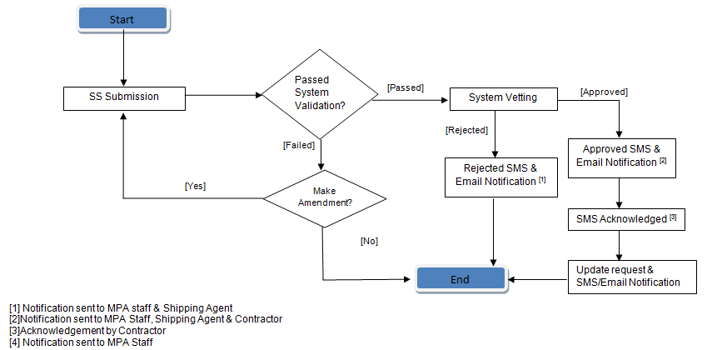

Diagram 1b – Sample Screen of Special Service Request Submission
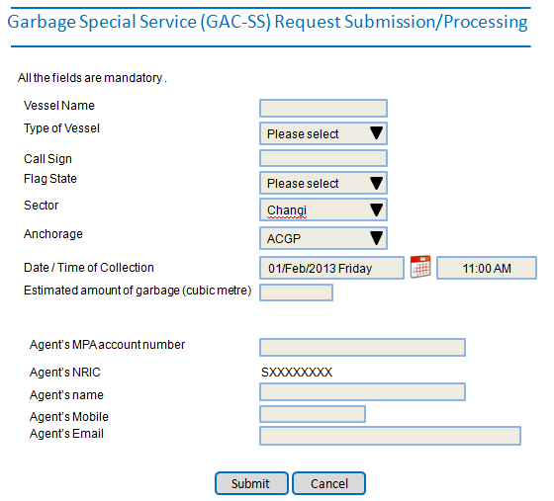

Table 1a – Summary of Approved VS Rejection Conditions
No. | General Conditions – in Sequential Orders
1. | All mandatory fields i.e. Vessel name, Type of vessel, Call Sign, Flag, Location, Date & time, Estimated amount of garbage (cubic metre) provided
2. | Estimated amount of garbage <= 16 cubic metre (equivalent to 1 bin)
3. | Submitted request >= 6 hours- Go to sub-condition 1  Note: If condition passed, go to condition 4, 5, 6 or 7
4. | 2 different locations not yet allocated  Note: if condition passed, go to condition 6 or 7
5. | 2 different locations already allocated - Go to sub-condition 4  Note: if condition passed, go to condition 6 or 7
6. | 2 submission requests per day - Go to sub-condition 2
7. | >2 submission requests per day - Go to sub-condition 3

No. | Main Conditions | Sub Approved Condition | Sub Reject Condition | Rejection Reason
1. | Submitted request >= 6 hours | Morning request (before 1200), submitted before 1600hrs of previous working days | Morning request (before 1200), submitted after 1600hrs of previous working days | Submitted request is less than 6 hours
1. | Submitted request >= 6 hours | Weekend request, submitted before 1600hrs of previous working days | Weekend request, submitted after 1600hrs of previous working days | Submitted request is less than 6 hours
1. | Submitted request >= 6 hours | PH request, submitted before 1200hrs of eve of PH | PH request, submitted after 1200hrs of eve of PH | Submitted request is less than 6 hours
2. | 2 submission requests per day | 2 submission requests per day for same day, different time, different sectors | 2 submission requests per day for same day same time and same sector | You have already submitted this request previously.
2. | 2 submission requests per day | 2 submission requests per day for same day, different time, same sectors |  | You have already submitted this request previously.
2. | 2 submission requests per day | 2 submission requests per day for same day, same time, different sectors |  | You have already submitted this request previously.
2. | 2 submission requests per day | 2 submission requests per day for different days, same time, different sectors |  | You have already submitted this request previously.
2. | 2 submission requests per day | 2 submission requests per day for different days, same time, same sectors |  | You have already submitted this request previously.
2. | 2 submission requests per day | 2 submission requests per day for different days, different time, same sectors |  | You have already submitted this request previously.
2. | 2 submission requests per day | 2 submission requests per day for different days, different time, different sectors |  | You have already submitted this request previously.
3. | >2 submission requests per day | >2 submission requests per day for different days, same time, different sectors | >2 submission requests per day for same day | You have already submitted 2 requests for this <<date/time>> for sector <<sector>>.
3. | >2 submission requests per day | >2 submission requests per day for different days, same time, same sectors | >2 submission requests per day for same day
3. | >2 submission requests per day | >2 submission requests per day for different days, different time, same sectors | >2 submission requests per day for same day
3. | >2 submission requests per day | >2 submission requests per day for different days, different time, different sectors | >2 submission requests per day for same day
4. | 2 different locations already allocated | 2 different locations already allocated, date allocated, time not allocated | 2 different locations already allocated, date allocated, time allocated | Sector <<sector>> has already been allocated.
4. | 2 different locations already allocated | 2 different locations already allocated, date not allocated, time not allocated |  | Sector <<sector>> has already been allocated.

Diagram 1c – SMS Template – Processing (Approved)
To: <<contractor number>>
From: <<MPA Number>>
Body:

Please arrange and provide the special services for the below vessel:

Request No: << Request No >>
Vessel Name: << Vessel Name >>
Vessel Type: <<Vessel Type>>
Sector: <<Sector>>
Location: <<Location>>
Date & Time: <<Date>> <<Time>>

Kindly reply ‘GACACKA<<space>>Request No i.e. DDMMYYYY001’ to acknowledge this SMS request.

Diagram 1d – Email Template – Processing (Approved)
Subject : Garbage Collection Special Service Request <<Request No>> (New)

Body:

To: XXX Shipping (Pte) Ltd
Cc: <<MPA & Shipping Agent>>

Please arrange and provide the special services for the below vessel:

Request No: << Request No >>
Vessel Name: << Vessel Name >>
Vessel Type: <<Vessel Type>>
Sector: <<Sector>>
Location: <<Location>>
Date & Time: <<Date>> <<Time>>
Collection Quantity: <<Quantity>>

Please print, sign and fax this email to Resource Management Dept, MPA @ XXXXXXXX.
Thank you.

=====================================================================================
To: Resource Management Dept, MPA

Special Services provided on _____________ @ ________ hrs.
Number of bins: ___________
Craft: _______________

Name: ______________________________

Signature: __________________________

Date: _____________________________
=====================================================================================

Note: This is a computer-generated email. Please do not reply to this message

Diagram 1e – SMS Reminder Template
To: <<contractor number>>
From: <<MPA Number>>
Body:

You are reminded to submit your daily request report.

Kindly reply ‘GACDRPT’ <<space>> <<No of request completed>> <<space>> <<date>> to this SMS request.

Diagram 1f – SMS Reply Table (Service Request Acknowledgement)
Position | Field Name | Field Description | Example
1-7 | Reply type | Contains the types of replies i.e. acknowledgement or daily report | GACACKA – Acknowledge Approved  GACACKC – Acknowledge Cancellation
9-19 | Request No | Unique identifier of the service request | DDMMYYYYXXX  XXX is an system generated running number

Diagram 1g – SMS Reply Table (Report Submission)
Position | Field Name | Field Description | Example
1-7 | Reply type | Contains the types of replies i.e. acknowledgement or daily report | GACDRPT – Report Daily Request
9 | Total Request | Total number of request completed | 2
11 | Date of Daily Report | Date of the number of request completed | DDMMYYY, 01022013

Diagram 1h – SMS Template – Acknowledged Approved
To: <<MPA Number>>
Body:

Please note that the request <<Request No>> has been approved and acknowledgement by the contractor.

Diagram 1i –Email Template – Acknowledged Approved
Subject : Garbage Collection Special Service Request <<Request No>> (Acknowledged Approved)

Body:

To: <<MPA>>

Please note that the request <<Request No>> has been approved and acknowledgement by the contractor.

Note: This is a computer-generated email. Please do not reply to this message

Diagram 1j – SMS Template – Successful Acknowledged by Contractor
To: <<Contractor Number>>
Body:

You have successfully acknowledged the request <<Request No>>.

Table 2 – MPA Staff & Contractor Contact Info
S/N. | Name | Email | Tel Number
1 | Staff A | - | -
2 | Staff B | - | -
3 | Staff C | - | -

S/N. | Name | Email | Tel Number
1 | Contractor | - | -

5.3 Business Process 2: Garbage Special Service (GACSS) Request Cancellation

5.3.1 The shipping agents are encouraged to submit cancellation request at least 2 hrs before the services request was carried out. Otherwise, additional fees will be charged for last minutes cancellation.

5.3.2 The REM – MPA and contractor will also receive a SMS and email for each successful submitted cancellation request.

5.3.3 For cancelled service request, the SMS and email will contain information like i.e. Vessel name, Type of vessel, Location, Date & time, Estimated amount of garbage (cubic metre), Call Sign, Flag will be sent to REM – MPA and contractor in the cancellation SMS and email notification.

5.3.4 The contractor is required to acknowledge the SMS upon receiving the cancellation SMS. This acknowledgement indicates that they will not follow up to carry out the cancelled request. And it will be updated into the system and an SMS and email notification sent to the MPA – REM users. Refer to diagram 1h – SMS Reply Table above.

5.3.5 Assumption: the additional fees for last minutes cancellation will be processed separately, which is out of scope for this system.

5.3.6 Refer to diagram 2a, 2b and 2c.

Diagram 2a – GACSS Request Cancellation
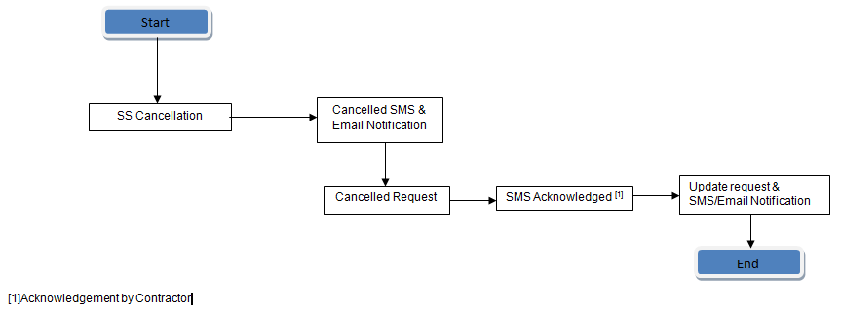

Diagram 2b – SMS Template – Cancellation
To: <<contractor number>>
From: <<MPA Number>>
Body:

Please note that the request <<Request No>> has been cancelled by the shipping agent.

Request No: << Request No >>
Vessel Name: << Vessel Name >>
Call Sign: <<Call Sign>>
Sector: <<Sector>>
Location: <<Location>>
Date & Time: <<Date>> <<Time>>

Please do not follow up this special service request.

Kindly reply ‘GACACKC<<space>>Request No i.e. DDMMYYYY001’’ to acknowledge this cancellation request.

Diagram 2c – Email Template – Cancellation
Subject : Garbage Collection Special Service Request <<Request No>> (Cancelled)

Body:

To: XXX Shipping (Pte) Ltd,
Cc: <<MPA & Shipping Agent>>

Please note that the request <<Request No>> has been cancelled by the <<shipping agent>>.

Request No: << Request No >>
Vessel Name: << Vessel Name >>
Vessel Type: <<Vessel Type>>
Call Sign: <<Call Sign>>
Flag State: <<Flag State>>
Sector: <<Sector>>
Location: <<Location>>
Date & Time: <<Date>> <<Time>>
Collection Quantity: <<Quantity>>

Please do not follow up this special service request.
For further enquiry, please contact Resource Management Dept, MPA @ XXXXXXXX.

Note: This is a computer-generated email. Please do not reply to this message

Diagram 2d – SMS Template – Acknowledged Cancellation
To: <<contractor number>>
From: <<MPA Number>>
Body:

Please note that the request <<Request No>> has been cancelled and acknowledgement by the contractor.

Diagram 2e –Email Template – Acknowledged Cancellation
Subject : Garbage Collection Special Service Request <<Request No>> (Acknowledged Cancellation)

Body:

To: <<MPA>>

Please note that the request <<Request No>> has been cancelled and acknowledgement by the contractor.

Note: This is a computer-generated email. Please do not reply to this message

Diagram 1f – SMS Template – Successful Acknowledged by Contractor
To: <<Contractor Number>>
Body:

You have successfully acknowledged the cancellation request <<Request No>>.

5.4 Business Process 3: Garbage Special Service (GACSS) Administration module

5.4.1 The administration module consists of 2 functions: (1) Accounts Management Function & (2) Reporting Function

5.4.2 In accounts management function, MPA – REM staff is able to add/update/delete their staff accounts. These accounts will receive the email and sms notifications given the special service request status update. The staff is also able to update their accounts i.e. name, email, and mobile number if there are any changes to their personal particulars. (Refer to table 2 above)

5.4.3 For reporting function, MPA - REM staff is able to query the following report: Monthly Special Service Request Report

5.4.4 For monthly special service request report, it displays the list of submitted special service requests i.e. rejected, cancelled, completed, and approved. The selection criterions is via year, month, request status, sector. Refer to sample report 1.

5.4.5 User is also able to generate the reports in pdf format through the system.

Sample Report 1

5.5 Business Process 3: Security Access

5.5.1 Only REM Department users are allows accessing this application. The system will check against MPA active directory followed by the system own staff table.

5.5.2 Authorized users found in the active directory and staff table will be granted access to the system.

5.6 Business Process 4: Garbage Special Service (GACSS) Audit Trail

5.6.1 For every action performed i.e. submission, approval, rejection, SMS and email for a special service request and accounts management, the system will logged these information. Hence, there is an audit trail to track the operations performed by the user and system.

5.7 Business Process 5: Garbage Special Service (GACSS) Upload e-Receipt

5.7.1 This function is to migrate the existing uploading of e-Receipt into this new GACSS system. MPA – REM staff will upload an excel sheet i.e. xls or xlxs given by contractor. The system will process it and save it into the system. Refer to table 5a and 5b for the validation check and input for the existing store procedure.

5.7.2 Diagram 5a and 5b shows the sample screens of file upload and the file data.

5.7.3 The statistic of the e-Receipt would still be displayed from the Marinet. Hence, no changes to the Marinet required.

5.7.4 Note that the existing source codes available for referencing

Table 5a – System Validation Check
S/N | System Validation Check | Remark
1. | Check for file exist | Check if a file is selected for upload
2. | Check for valid date | Refer to diagram 5b (circled in blue) i.e. DD/MM/YYYY
3. | If valid date, check start time | Check if start time is valid i.e HH:MM
4. | Check end time | Check if end time is valid HH:MM
5. | Check bags does not contains negative ‘-‘ sign | Check the quantities not negative
6. | Check if bags contains the word ‘BIN’  If bags contains the word ‘BIN’, assign Collection Type as ‘SPC’ | Check if bags contains of the word ‘BIN’, assign ‘SPC’ to Collection Type
7. | Check all fields are not empty | Check fields i.e. Ship Name, Grid, Start Time, End Time, Bags, Craft, Locations are not empty

Table 5b – Input to Store Procedure (p_GAC_i_loadEreceipt)
No | Field | Data Types
1 | Ship Name | String
2 | Grid | Code
3 | Start Time | Time HH:MM
4 | End Time | Time HH:MM
5 | Bags | Integer
6 | Craft | Code
7 | Collection Type | String
8 | Empty Field | “empty”
9 | Locations | String
10 | Types.INTEGER | Integer

Diagram 5a – Sample Screen of File Upload
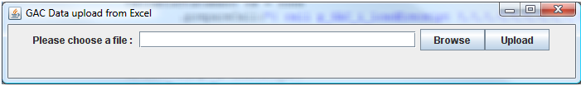

Diagram 5b – Sample Screen of File Data
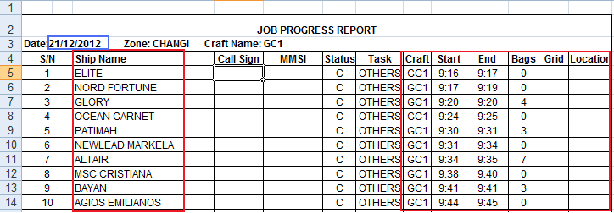

Sample Information Table

Special Service Request Information
Field Name | Description
Request No | Request number to identify the request i.e. DDMMYYY001, DDMMYYY002, DDMMYYY003 etc
Vessel Name | Name of the vessel requested for special service
Vessel Type | Type of the vessel requested for special service
Call Sign | Unique designation for the vessel for telecommunication
Flag State | State which the vessel is registered or licensed under
Sector | Sector the vessel residing
Location | Location/anchorage of the vessel residing in the sector
Collection Date | The date for the garbage collection
Collection Time | The time for the garbage collection – 15 minutes interval
Collection Quantity | The quantity of the garbage to be collected
Request Status | Status of the special service request

Shipping Agent Information
Field Name | Description
Agent MPA Account No | Account number of shipping agent
Agent NRIC | NRIC of shipping agent
Agent Name | Name of shipping agent
Agent Mobile | Contact number of shipping agent
Agent Email | Email address of shipping agent
No. of Request | The number of request submitted

Transaction Log Information
Field Name | Description
Request No | Request number to identify the request
Log Type | The type of transaction log
Staff ID | The unique identifier of an MPA staff
Log Date | The date for the action performed
Log Time | The time for the action performed

Staff Information
Field Name | Description
Staff ID | The unique identifier of an MPA staff
Name | Name of the staff
Email | Email address of the staff
Mobile Number | Contact number of the staff

6. TECHNICAL REQUIREMENTS

6.1 Software Design Requirements

6.1.1 The Online Appointment System for One Stop Document Centre (OAS) System & the Online Request for Garbage Collection Special Service (GACSS) System shall be designed to execute with high performance, maintainability, integrity, reliability, availability as well as tight security and controls as the primary consideration.

6.1.2 Both the systems System shall have the following features:

  - Structured templates for reporting
  - Graphical interface with scrolling capability
  - Prompt invalid entry with meaningful error message
  - Field and transaction validation checks
  - Allow online printing
  - Configure the level of security

6.1.3 The program names, form names, database tables, data fields, stored procedures and triggers shall follow MPA naming standards.

7. SYSTEM PERFORMANCE, RELIABILITY & INTEGRITY REQUIREMENTS

7.1 System Performance

7.1.1 A 100Mbps network infrastructure is in place for internal staff to access the System.

7.1.2 The system response time for 3 concurrent internal staff shall not exceed 3 sec for navigation, 5 sec for query/search and 10 sec for any transaction (submit).

7.1.3 Based on a 100Mbps network infrastructure as benchmark, the system response time for 3 concurrent external staff shall not exceed 3 sec for navigation, 5 sec for query/search and 10 sec for any transaction (submit).

7.2 System Reliability/Integrity

7.2.1 The Online Appointment System for One Stop Document Centre (OAS) System & Online Request for Garbage Collection Special Service (GACSS) System shall be fully tested and quality assured before implementation so as to ensure maximum reliability.

7.2.2 A software fault in any of the functions in the System shall not lead to the loss of other functions in the System.

7.2.3 Failure of a transaction or reporting at one workstation shall not affect users at other workstations.

7.2.4 The effect of a failed transaction on the database shall be automatically rolled back. Test cases shall be built for this provision.

7.2.5 It shall be possible to recover all data stored up to the last successfully completed transaction before a system failure occurs.

8. SYSTEM SECURITY AND CONTROL REQUIREMENTS

8.1.1 For internal users, the Online Appointment System for One Stop Document Centre (OAS) System & Online Request for Garbage Collection Special Service (GACSS) System shall be accessed through MPA’s Intranet Portal via MPA’s sign-on software. Individual user roles within both the systems shall be controlled through allocating access rights for different user roles. These shall be discussed during the user requirements study stage.

8.1.2 Both the systems shall log all transactions and audit trail report shall be provided where applicable.

9. TESTING

9.1 The objective of testing is to ensure that the system meets the user and technical specifications in respect of functionality, performance, stability and resilience. Testing shall begin with the relatively simple elements that form the basis of the System and gradually extend to the larger structures. The testing shall be organized into a number of hierarchical levels as follows:

- Unit testing covering individual programs
- System testing covering modules each comprising a number of units
- Integration testing covering the integration or interface of all the modules
- Acceptance testing covering the operational performance of the System

9.2 A week before the commencement of each type of test, the Contractor shall submit a test specification for approval. The objectives of the test plan are:

- To define the nature and extent of the tests deemed necessary to provide a basis for evaluation of the System
- To provide an orderly sequence of test events, specification of organizational requirements and the methodology of testing
- To provide a written record of the testing process, including test input, test output, observations, diagnosis and remedial actions

9.3 The specifications shall include the following:

- Test database setup
- Test performance requirements
- Test procedures including error-handling procedures
- Test scenarios
- Test items, functions to be tested
- Test conditions including constraints and limitations
- Test input
- Expected test output

9.4 The Contractor shall maintain and submit a test log that records all major test activities and events in chronological sequence. It shall contain brief information on the date and time of each activity or event, overall test results, observations, deviations, problems, remedial actions etc.

9.5 The system shall be subject to load testing conducted for a minimum of 3 internal users. System response times are to be monitored and the Contractor shall fix the system to match appropriate standards set by MPA

9.6 The Test Analysis Report shall contain a summary of all the test results on each test unit. It shall provide a summary and diagnosis of the errors and deficiencies discovered and the follow up action to be taken, including the urgency of each correction, how it is to be done and the parties responsible for each correction. A "sign-off" by the users is required for the test items that have successfully passed all necessary tests and ready for production.

10. DOCUMENTATION

10.1 General Requirements

10.1.1 The Contractor shall supply all software documentations to enable MPA to operate the System.

10.1.2 MPA shall have the right to reproduce any documentation supplied with the System for its own use at no cost.

10.2 Application Software Documentation

10.2.1 The documentation shall include but not limited to the following:

- User requirement Specifications
- Functional specification, program functions and interfaces
- Detailed Design Specifications
- User Acceptance Test Plan
- User Acceptance Test Results
- User / training guide
- Adequate comments in the system code to allow third party understanding.

10.2.2 Integrity controls and error handling built into the System, and comprehensive listing of all error messages which may be encountered when interacting with the System. Against each error message, an understandable explanation of the error or problem, fallback or recovery procedures where applicable and any other recommended remedial action.

11. COPYRIGHTS

11.1 With regard to software developed by the Contractor, all original materials but not limited to source codes and documentation produced by the Contractor under this Contract shall belong exclusively to the MPA. The Contractor hereby agrees to assign and does assign all copyrights to these materials to the MPA.

11.2 The MPA shall only make copies of the software or any portion thereof as are reasonably necessary for operational security and use.

11.3 Any form of publicity and publication associated to the System must be approved by MPA.

12. DELIVERABLES

12.1 The deliverables for this development are:

- The 2 new systems i.e. the Online Appointment System for One Stop Document Centre (OAS) System & Online Request for Garbage Collection Special Service (GACSS) System

- Complete set of all source codes developed for the system.

- Documentation and User Guide manuals.

13. IMPLEMENTATION SCHEDULE

13.1 The successful Contractor shall commission the System in not more than four (4) months from the time of award.

13.2 A work schedule shall be submitted as part of this ITQ covering the entire scope of work, and stating the time effort and manpower resources required for each task. The Contractor must meet all the deadlines as stated in the schedule.

14. QUOTATION

14.1 Please state the price in SGD (please state GST amount separately, if applicable) of your quotation

14.2 Refer to Annex B to enclose the price breakdown of the contract price. Please submit details of prices in the Breakdown of Price Table below.

14.3 Your quotation should be valid for 30 days.

15. TERMS OF PAYMENT

15.1 The successful Contractor shall be paid in four (4) progress payments as follows:

(a) 15% upon award of contract
(b) 30% upon completion of requirement study
(c) 50% upon completion of user acceptance test
(d) 5% upon commissioning of System

16. STATEMENT OF COMPLIANCE

16.1 The Contractor shall clearly indicate in Appendix 1 – Statement of Compliance, its compliance by providing a paragraph-by-paragraph statement according to every section and paragraph reference to the Requirements Specifications as specified in the below section.

- For uniformity, only the following responses are acceptable;
- Provide explanatory notes whenever possible.

Response | Meaning
“C” – Full Compliance | Able to fully comply with the requirements. The Contractor shall not add comments against the clause that vary the meaning of full compliance to the clause. However, comments indicating references to literature to substantiate the response is permissible. Any other comments which will vary the meaning of full compliance will be ignored.
“NC” – Non-Compliance | Unable to comply with the requirements. Explanatory note shall be provided to explain how by not complying, to what extent the requirement will be met.
“N” – Noted | Noted, for statements that do not call the Contractor to meet a specific requirement but merely inform the Contractor of a fact. Where a blank is given in answer to a requirement or where “N” is used against clauses requiring response other than “Noted”, the Contractor’s response will be treated as full compliance or make conservative assumptions concerning the state of compliance.

16.2 In cases where the description of the proposed system differs from the compliance statement, the Authority may treat it as compliance or make conservative assumptions concerning the state of compliance.

16.3 If the Contractor believes that any paragraph in this document is unclear or open to more than one interpretation, the Contractor must indicate the ambiguity or uncertainty and explain clearly the condition in the applicable response.

16.4 It is imperative that all the information requested be supplied accurately and concisely. Failure to supply such information may render the Contractor proposal disqualified for further consideration.

Annex B

CONTRACT PRICE

For vendor to enclose the price breakdown of the contract price

S/N | Project Title | Effort  (Days per Consultant/ Developer) | Unit Price (S$ per day per Consultant/ Developer) | Total Price  (S$) | Delivery Date | Remarks  (Please provide no. of Consultant & Developer for each item)
1 | Online Appointment System for One Stop Document Centre (OAS)
2 | Online Request for Garbage Collection Special Service (GACSS)
 | Total

APPENDIX 1 – Statement of Compliance

Paragraph No. | C / NC / N | Explanation if NC
1 Introduction
1.1
….
2 Scope of Work
2.1
…
…
3 Project Management
3.1
…
4 Functional Requirements
4.1
…
5 Functional Requirements
5.1
….
….

*Abbreviations to be used - C Full Compliance
NC Non-compliance
N Noted

