**Artificial Intelligence in Health**

Artificial Intelligence has influenced most of the sectors in the world like health, agriculture, sports and so much more. In the last decade, one of the most influenced sector is healthcare. In the beginning, AI was considered only a technology to help in the medical decision-making. Little were we aware that it will bring a tremendous transition in the healthcare industry. From simple decision making it advanced to autonomous surgical robots, image diagnosis, virtual nursing assistants etc. Most of the websites/apps are now offering symptom checkers which enable the patients to limit the number of hospital visits drastically.

**AI in Cancer Diagnosis**

Chronic health conditions like cancer, diabetics, heart diseases etc. are mostly benefited from artificial intelligence as shown in Figure 1.

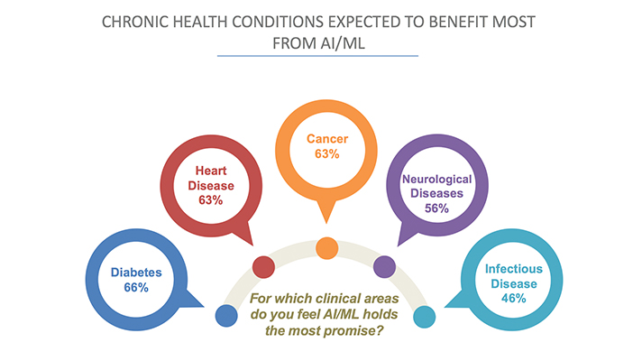

Cancer is an aggressive disease with high mortality rate. But if the disease is diagnosed in early stages most of the cancers can be cured. A decade ago, doctors spent hours just for diagnosing cancer. Now with the introduction of AI this has reduced considerably.

*References:*

1. <https://www.roboticsbusinessreview.com/ai/infographic-how-ai-is-being-deployed-across-industries>.
2. <https://www.healthcareitnews.com/news/3-charts-show-where-artificial-intelligence-making-impact-healthcare-right-now>