Cyber Youth Singapore

nametag

horizontal line

**Creator Name: Kok Rui**

# Setup:

## **Static Files:**

* 1. nametag.c (source for participants)
  2. nametag (binary for participants)
  3. nametagreal (binary @ host)

## **Usage:**

* 1. Host chall: nohup sudo tcpserver -t 50 -RHl0 0.0.0.0 <port> ./nametagreal
  2. In CTFd, give participants nametag.c and nametag

# Description:

* **Description:**
  + Wow! This super high-tech, online store gives out free nametags!
  + Give them the netcat command here thx
* **Hint:**
  + <https://en.wikipedia.org/wiki/C_string_handling>
  + <https://en.wiktionary.org/wiki/canary_in_a_coal_mine>
  + When I compiled the program, it told me this: 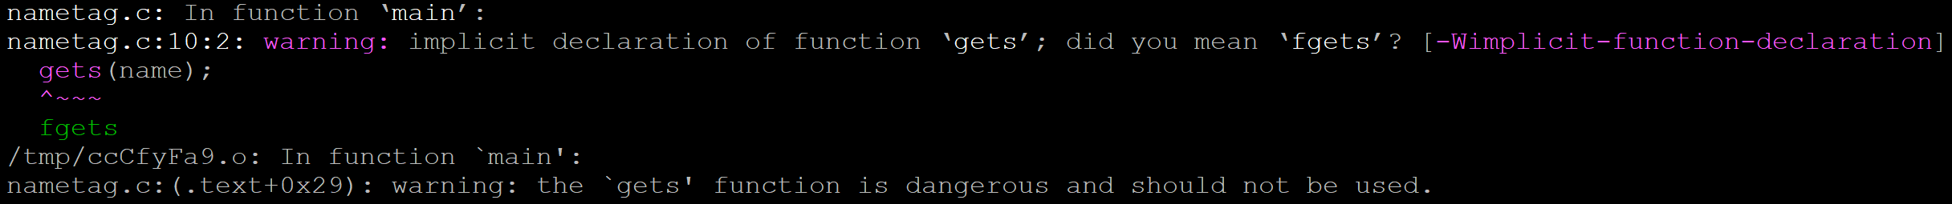

# Solution

1. Basic bof. 45+1 chars, for the string, next 2 chars are canary and secret.