**Program structure:**

When you first log in, there will be a prompt saying “it seems like this is your first time to log in the system.”



When you log in afterwards, it will ask you to choose your identity (left picture).

**For admin**, after entering your username and password, you can choose among two sections (Course Management and Reports)(right picture)

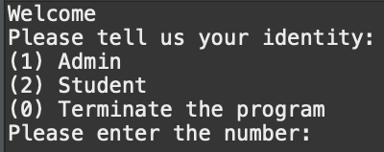 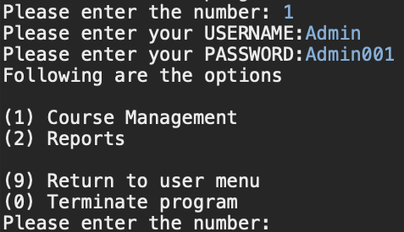

For course management (left picture), and reports (right picture)

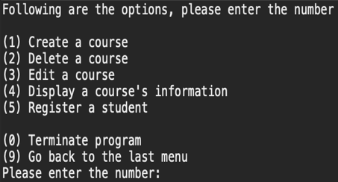 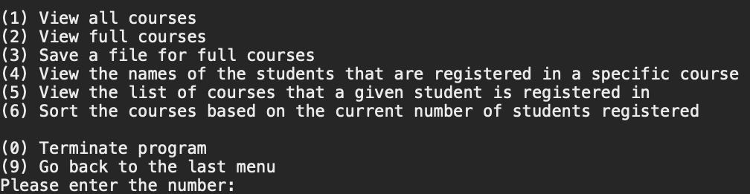

**For student**, after logging in, you will have,

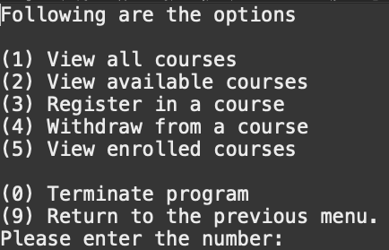

***Method overriding:***

1. Student Class
   1. Student class **overrides** the method viewCourse() inherited from StudentInterface interface.
   2. Student class **overrides** the method viewAvailableCourse() inherited from StudentInterface interface.
2. Admin Class
   1. Admin class **overrides** the method viewFullCourse() inherited from AdminInterface interface
   2. Admin class **overrides** the method createStudent() inherited from AdminInterface interface

***Abstract class:***

1. User is the abstract class

***Inheritance:***

1. Student Class inherits from User class, and implements StudentInterface
2. Admin Class inherits from User class, and implements AdminInterface

***Encapsulation:***

1. All attributes of Student class are **private**
2. All attributes of Course class are **private**
3. All attributes of Admin class are **private**

***Abstract data type:***

1. The program uses ArrayList<Student>, ArrayList<Course> to store Students, Courses
2. Within each Course object, the course uses ArrayList<String>to save the student information.

