**(Use direct Drag n Drop method in Design Window instead of xml code given below**

**Drag n Drop method auto generates xml code)**

**MainActivity.xml**

*<?***xml version="1.0" encoding="utf-8"***?>*<**androidx.constraintlayout.widget.ConstraintLayout xmlns:android="http://schemas.android.com/apk/res/android"  
 xmlns:app="http://schemas.android.com/apk/res-auto"  
 xmlns:tools="http://schemas.android.com/tools"  
 android:layout_width="match_parent"  
 android:layout_height="match_parent"  
 tools:context=".MainActivity"**>  
  
 <**ImageView  
 android:layout_width="142dp"  
 android:layout_height="99dp"  
 android:src="@drawable/ic_launcher_foreground_lock"  
 app:layout_constraintBottom_toTopOf="@+id/username"  
 app:layout_constraintEnd_toEndOf="parent"  
 app:layout_constraintStart_toStartOf="parent"  
 app:layout_constraintTop_toTopOf="parent"** />  
  
 <**EditText  
 android:id="@+id/username"  
 android:layout_width="wrap_content"  
 android:layout_height="wrap_content"  
 android:ems="10"  
 android:inputType="textPersonName"  
 android:text=""  
 android:hint="username"  
 app:layout_constraintBottom_toBottomOf="parent"  
 app:layout_constraintEnd_toEndOf="parent"  
 app:layout_constraintStart_toStartOf="parent"  
 app:layout_constraintTop_toTopOf="parent"  
 app:layout_constraintVertical_bias="0.185"** />  
  
 <**EditText  
 android:id="@+id/password"  
 android:layout_width="wrap_content"  
 android:layout_height="wrap_content"  
 android:ems="10"  
 android:inputType="textPassword"  
 android:hint="password"  
 app:layout_constraintBottom_toBottomOf="parent"  
 app:layout_constraintEnd_toEndOf="parent"  
 app:layout_constraintStart_toStartOf="parent"  
 app:layout_constraintTop_toBottomOf="@+id/username"  
 app:layout_constraintVertical_bias="0.134"** />  
  
 <**Button  
 android:id="@+id/login"  
 android:layout_width="wrap_content"  
 android:layout_height="wrap_content"  
 android:text="Login"  
  
 app:layout_constraintBottom_toBottomOf="parent"  
 app:layout_constraintEnd_toEndOf="parent"  
 app:layout_constraintHorizontal_bias="0.498"  
 app:layout_constraintStart_toStartOf="parent"  
 app:layout_constraintTop_toBottomOf="@+id/password"  
 app:layout_constraintVertical_bias="0.178"** />  
  
 <**TextView  
 android:id="@+id/textView3"  
 android:layout_width="wrap_content"  
 android:layout_height="wrap_content"  
 android:text="No of attempts remaining: 3"  
 app:layout_constraintBottom_toBottomOf="parent"  
 app:layout_constraintEnd_toEndOf="parent"  
 app:layout_constraintStart_toStartOf="parent"  
 app:layout_constraintTop_toBottomOf="@+id/login"  
 app:layout_constraintVertical_bias="0.335"** />  
</**androidx.constraintlayout.widget.ConstraintLayout**>

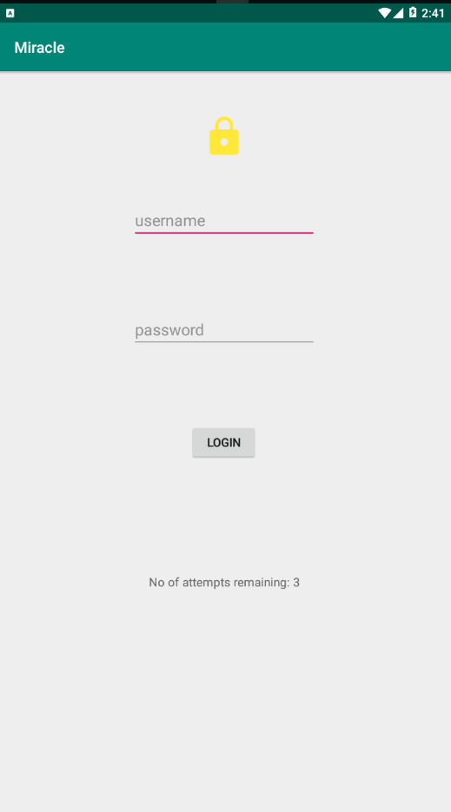

**MainActivity.java**

**package** com.example.miracle;  
  
**import** androidx.appcompat.app.AppCompatActivity;  
  
**import** android.content.Intent;  
**import** android.os.Bundle;  
**import** android.view.View;  
**import** android.widget.Button;  
**import** android.widget.EditText;  
**import** android.widget.TextView;  
  
**public class** MainActivity **extends** AppCompatActivity {  
 **private** EditText **username**;  
 **private** EditText **password**;  
 **private** Button **login**;  
 **private** TextView **txt**;  
 **private int counter**=3;  
  
 @Override  
 **protected void** onCreate(Bundle savedInstanceState) {  
 **super**.onCreate(savedInstanceState);  
 setContentView(R.layout.***activity_main***);  
  
 **username**=(EditText)findViewById(R.id.***username***);  
 **password**=(EditText)findViewById(R.id.***password***);  
 **login**=(Button)findViewById(R.id.***login***);  
 **txt**=(TextView)findViewById(R.id.***textView3***);  
  
 **login**.setOnClickListener(**new** View.OnClickListener() {  
 @Override  
 **public void** onClick(View view) {  
 validate(**username**.getText().toString(),**password**.getText().toString());  
 }  
 });  
  
  
 }  
  
  
  
 **private void** validate(String username,String password)  
 {  
 **if**((username.equals(**"Admin"**))&&(password.equals(**"1234"**)))  
 {  
 Intent intent=**new** Intent(MainActivity.**this**,SecondActivity.**class**);  
 startActivity(intent);  
  
 }  
 **else** {  
 **counter**=**counter**-1;  
 **txt**.setText(**"No of attempts remaining: "**+**counter**);  
 **if**(**counter**==0)  
 {  
 **login**.setEnabled(**false**);  
 }  
 }  
 }  
}

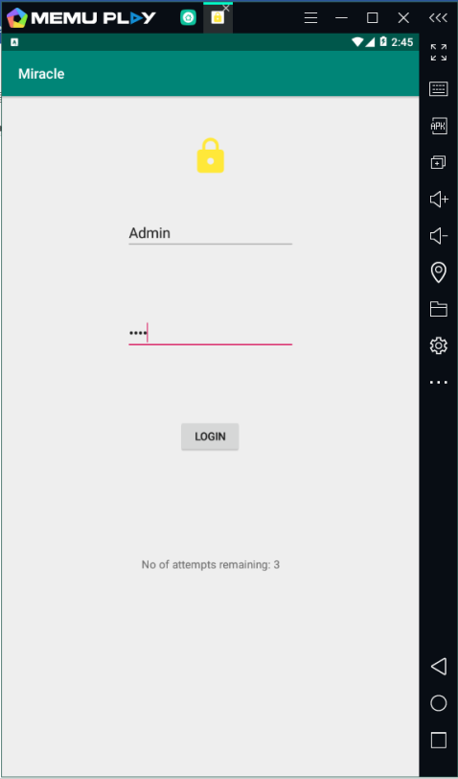

**(when password is correct)**

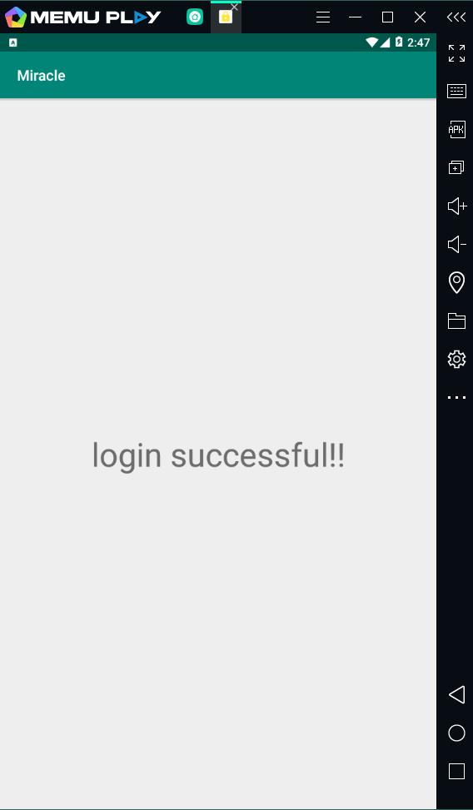

**(when password is incoreect counter decreases and when reaches 0 login button gets disabled)**

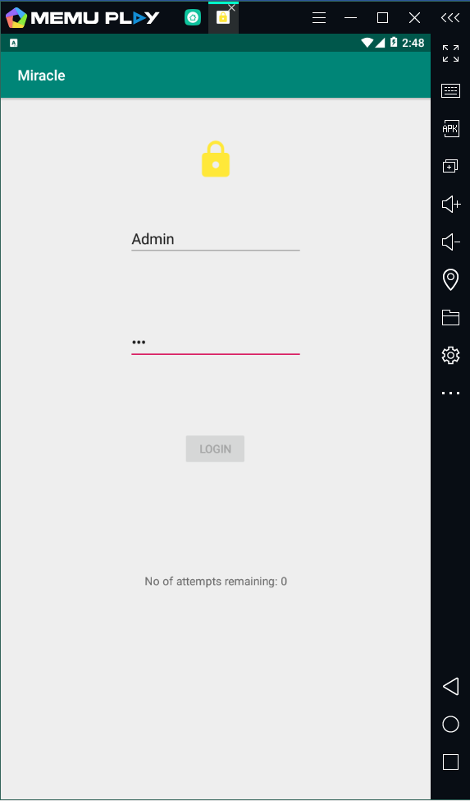

**SecondActivity.xml**

*<?***xml version="1.0" encoding="utf-8"***?>*<**androidx.constraintlayout.widget.ConstraintLayout xmlns:android="http://schemas.android.com/apk/res/android"  
 xmlns:app="http://schemas.android.com/apk/res-auto"  
 xmlns:tools="http://schemas.android.com/tools"  
 android:layout_width="match_parent"  
 android:layout_height="match_parent"  
 tools:context=".SecondActivity"**>  
  
 <**TextView  
 android:id="@+id/textView"  
 android:layout_width="wrap_content"  
 android:layout_height="wrap_content"  
 android:text="login successful!!"  
 android:textSize="45dp"  
 app:layout_constraintBottom_toBottomOf="parent"  
 app:layout_constraintEnd_toEndOf="parent"  
 app:layout_constraintStart_toStartOf="parent"  
 app:layout_constraintTop_toTopOf="parent"** />  
</**androidx.constraintlayout.widget.ConstraintLayout**>

**(this provides the layout of second activity. No changes were made to SecondActivity.java)**

**POINTERS:**

* **To add new activity go to**

**Project Menu > Right click on your package name just below java folder > select new > select Activity > Empty Activity(or any other) > activity_second.xml gets created where you can design your page**

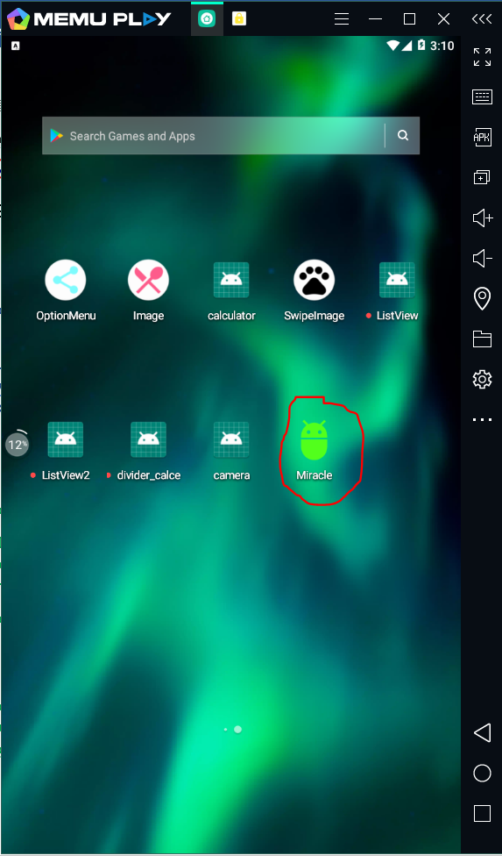

* **To change icon of your application**

**Right click on drawable folder > select new > Vector Asset >click on clip art >choose your favourite clip art >choose color for the same(I chose green) >click on ok**

**(in your res folder a xml file for your vector image gets created)**

**Go to AndroidManifest.xml > make the changes as shown in 3rd picture (put icon file name as the name of your newly created vector image xml file )**

